RHYTHMIC TUNES:YOUR MELODIC COMPANION

**Team ID :** NM2025TMID40175

**Team Size: 4**

* Team Leader : KIRUTHICK M

* Team Member : MUKESH M

* Team Member : PRAVEEN R

* Team Member : ROHITH S

**PROJECT OBJECTIVE**

**Rhythmic Tunes** web application is designed to create a user-friendly music streaming website where users can listen to, search for, and manage their favorite songs. The platform will support playlist creation, user accounts, and admin music uploads, offering a smooth and engaging music experience online. It will include music categorization by genre, artist, and mood to enhance discoverability. A responsive design will ensure seamless access across desktop and mobile devices. The application will also focus on performance, security, and scalability to support a growing user base.

**PLATFORM AND TECHNOLOGY USED**

The Rhythmic Tunes music web application is developed using **Node.js** as the backend runtime environment to handle server-side operations and API requests. **Visual Studio Code (VS Code)** is used as the primary code editor for writing and managing the project files efficiently. **NPM (Node Package Manager)** is utilized to manage dependencies and install essential packages required for the application. The frontend is built using standard web technologies like **HTML**, **CSS**, and **JavaScript** to create an interactive and responsive user interface. Additionally, tools like **Express.js** are used to simplify backend routing, and data can be managed using **JSON Server** or integrated databases depending on the project requirements.

**SETUP INSTRUCTION**

● Download Node.js LTS version from https://nodejs.org/en/download/

● After downloading, install Node.js by opening the downloaded file and

follow the instructions below.

● After installing Node.js, open Windows PowerShell As

Administrator

● Type set-executionPolicy unrestricted and press enter

● In the next step type Y and press enter

Steps To Download And Execute Project:

● From your SmartInternz portal Go To Projects → Access Resources

→ Guided Projects → Go To Workspace

● Inside Guided Project you can find Project Flow

● Now you can see two links one is the demo video and the other is

the code drive link.

● Click on the code drive link or copy paste that link in your new

chrome tab.

● Type npm install in your terminal and press Enter and wait till all the

dependencies gets download

● After all the downloads finishes, now type npm start and press Enter

● Now your application will be opened in your browser with url

http://localhost:3000

**PROJECT STRUCTURE**

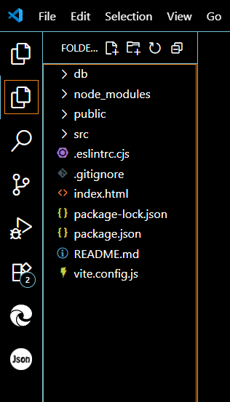

**RUNNING THE APPLICATION**

Provide commands to start the frontend server locally.

Frontend: npm start in the client directory.

**COMPONENT DOCUMENTATION**

In this project, we’ve split the files into 4 major folders, Components, Context, Pages and Styles. In the pages folder, we store the files that acts as pages at different URLs in the application. The components folder stores all the files, that returns the small components in the application. The context Api will be coded in the context folder. All the styling css files will be stored in the styles folder.

**STYLING**

CSS Frameworks/Libraries: Describe any CSS frameworks, libraries, or pre-processors (e.g., Sass, Styled-Components) used.

Theming: Explain if theming or custom design systems are implemented.

**SCREENSHOTS AND DEMO LINK**

Before starting to work on this project, let’s see the demo.

Demo link:

**PRE-REQUISITE**

*Download Node.js LTS version from <https://nodejs.org/en/download/>

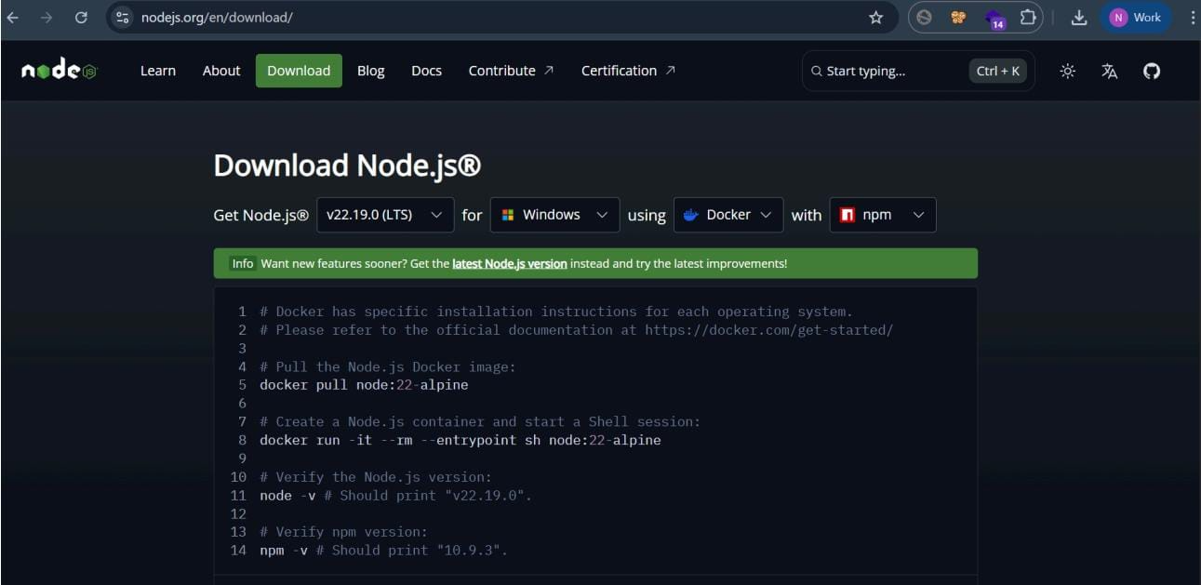

● After downloading, install Node.js by opening the downloaded file and

follow the instructions below.

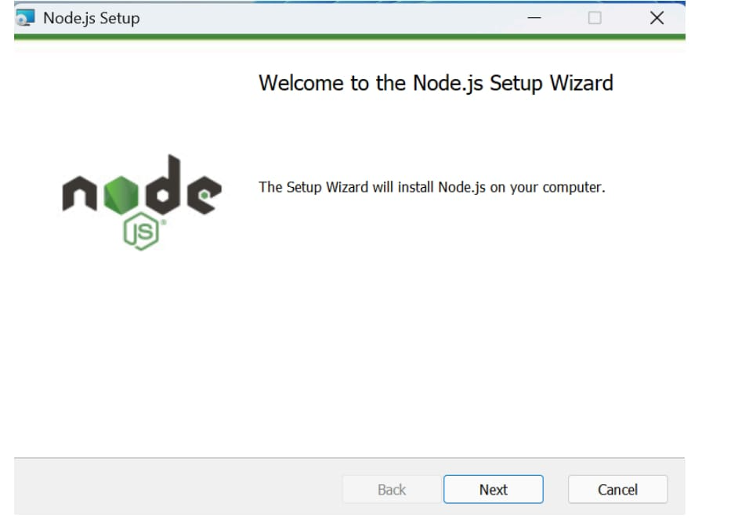

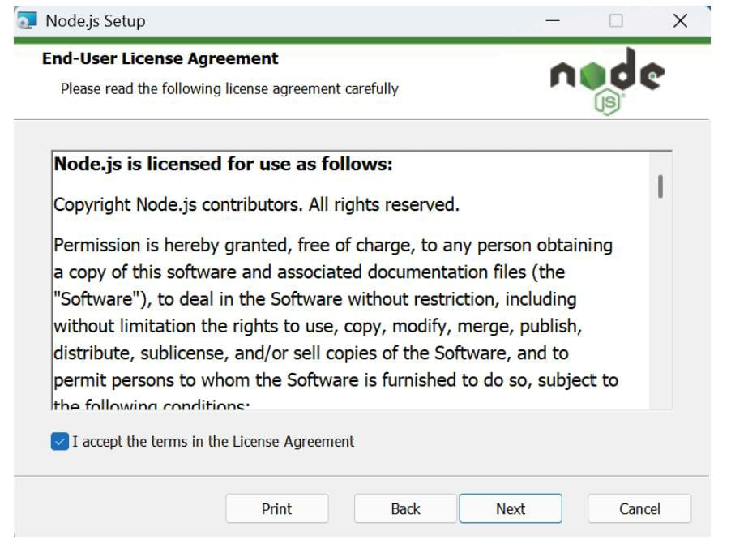

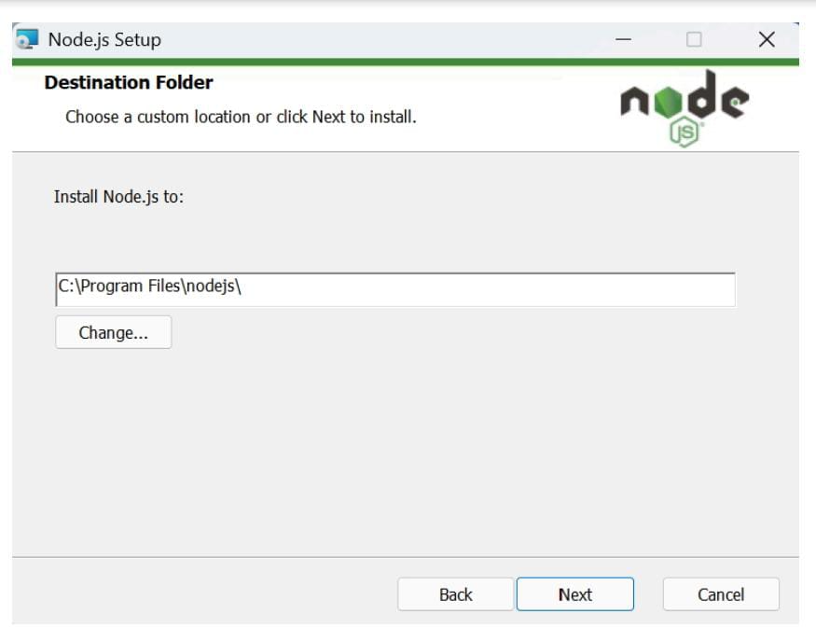

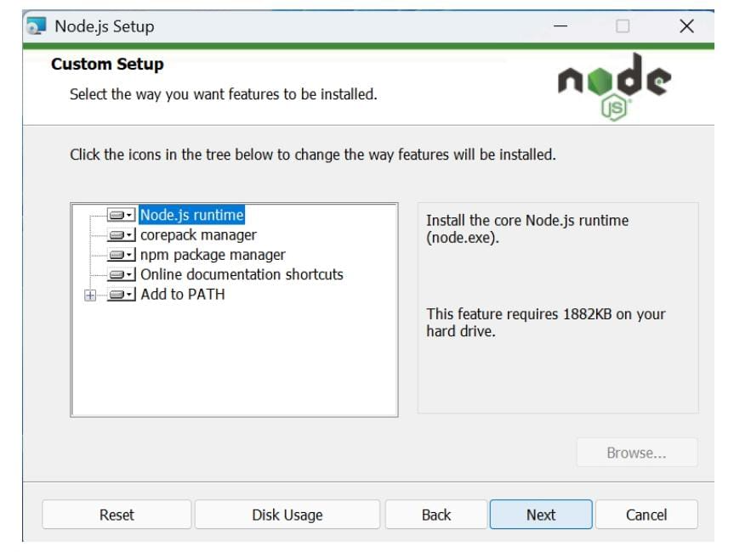

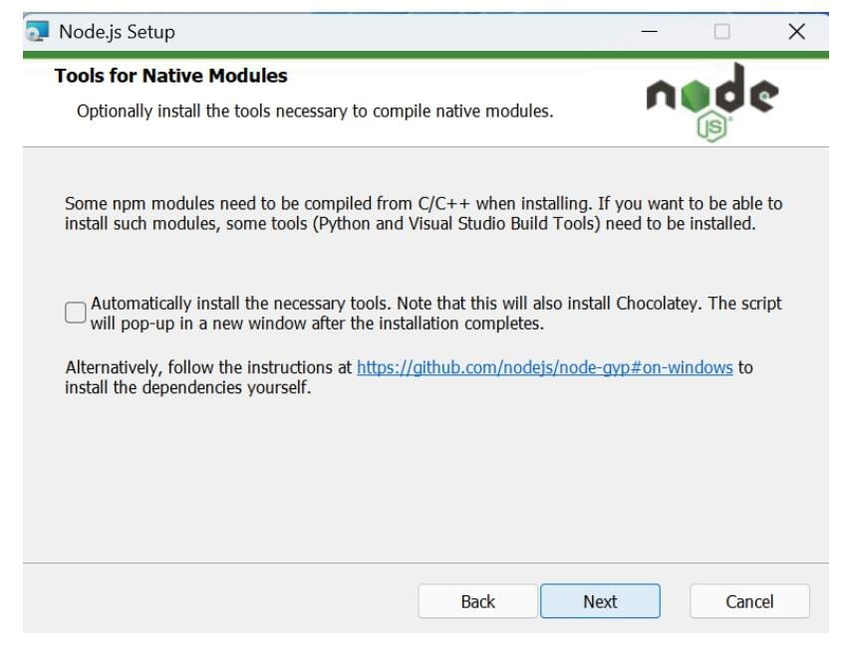

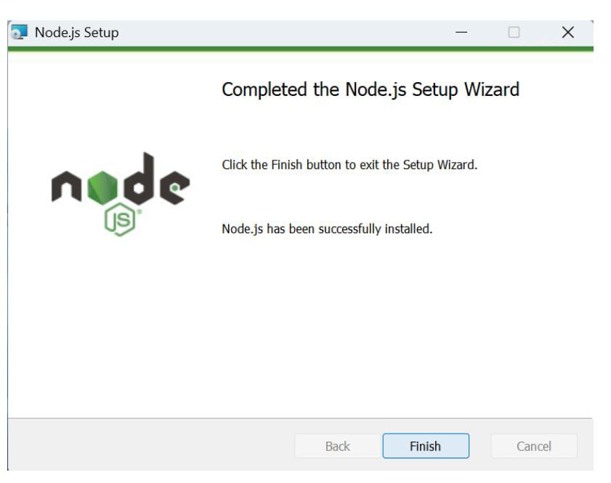

● After installing Node.js, open Windows PowerShell As Administrator

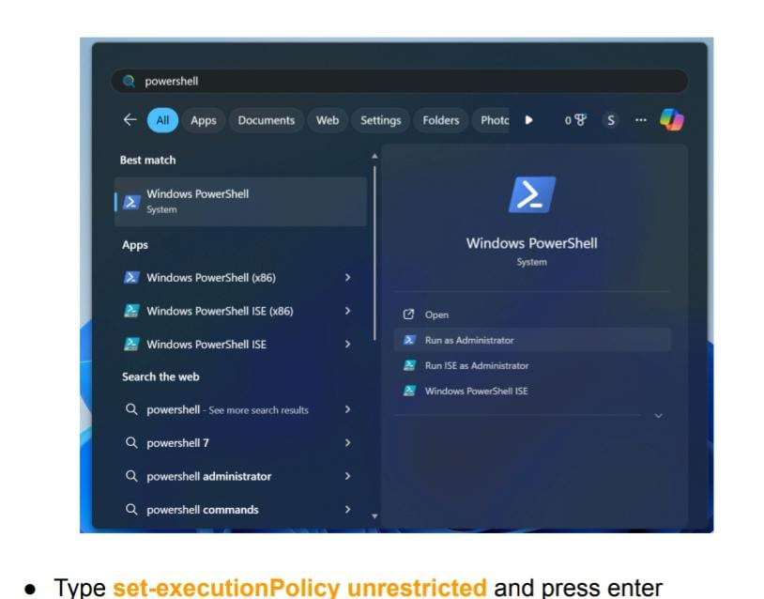

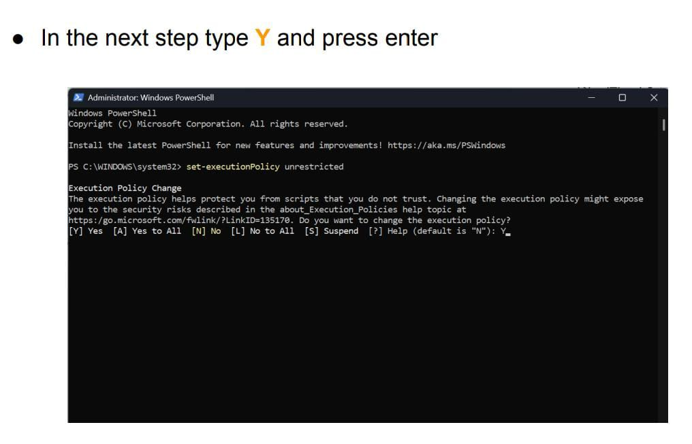

**STEPS TO DOWNLOAD AND EXECUTE THE PROJECT**

● From your SmartInternz portal GoTo Projects → Access Resources

→ Guided Projects → Go To Workspace

● Inside Guided Project you can find Project Flow

● Now you can see two links one is the demo video and the other is

the code drive link.

● Click on the code drive link or copy paste that link in your new

chrome tab.

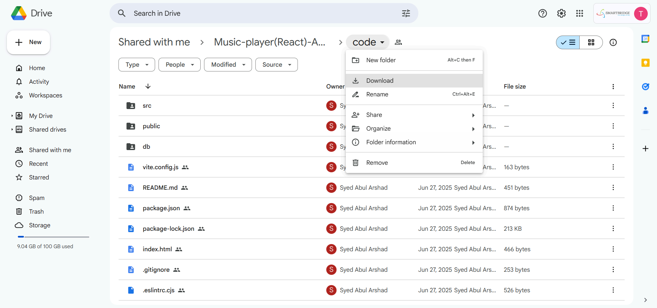

● Now go to downloads and right click on the downloaded zip folder

and click on extract all

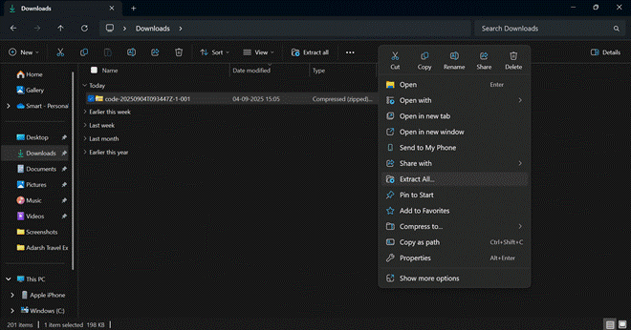

● Now open VS code and open the code folder from the extracted folder.

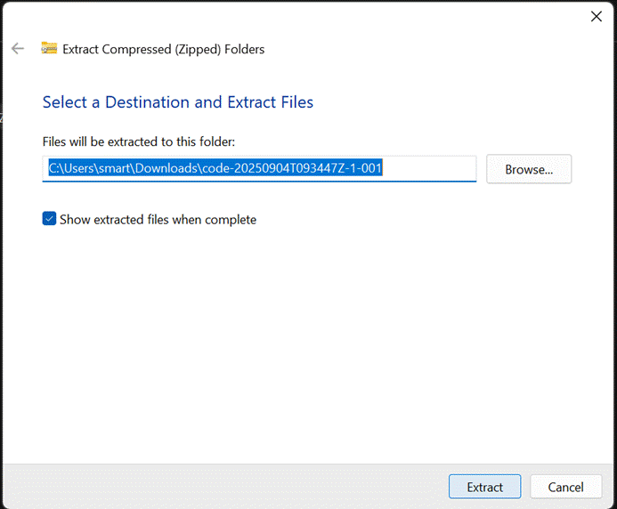

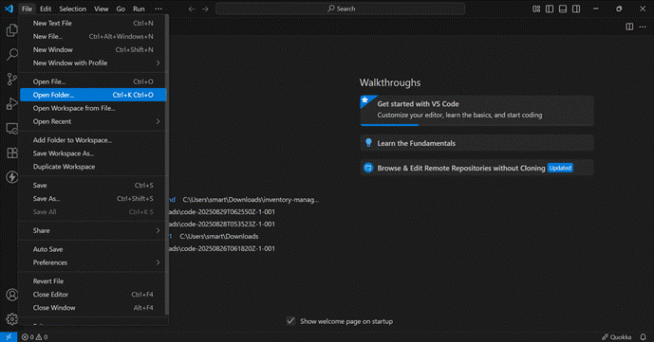

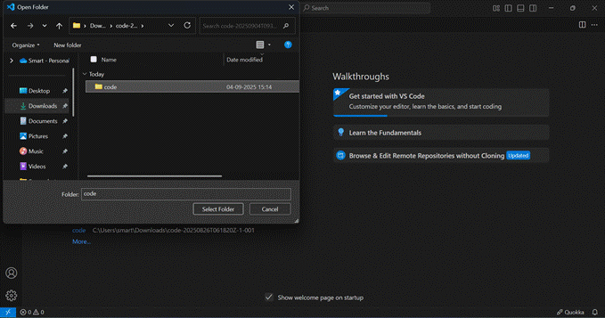

● Now open a new terminal.

● Type npm install in your terminal and press Enter and wait till all the

dependencies gets download

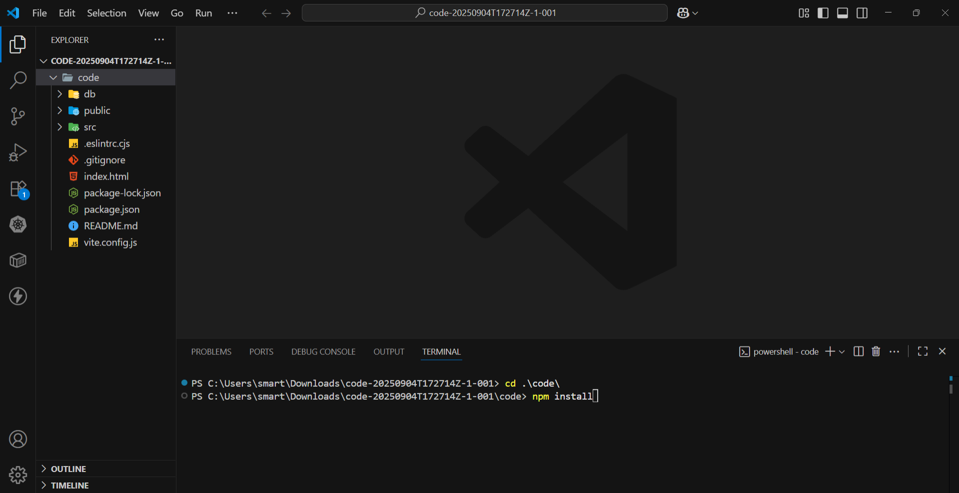

● After all the downloads finishes, now type npm run dev

and press Enter

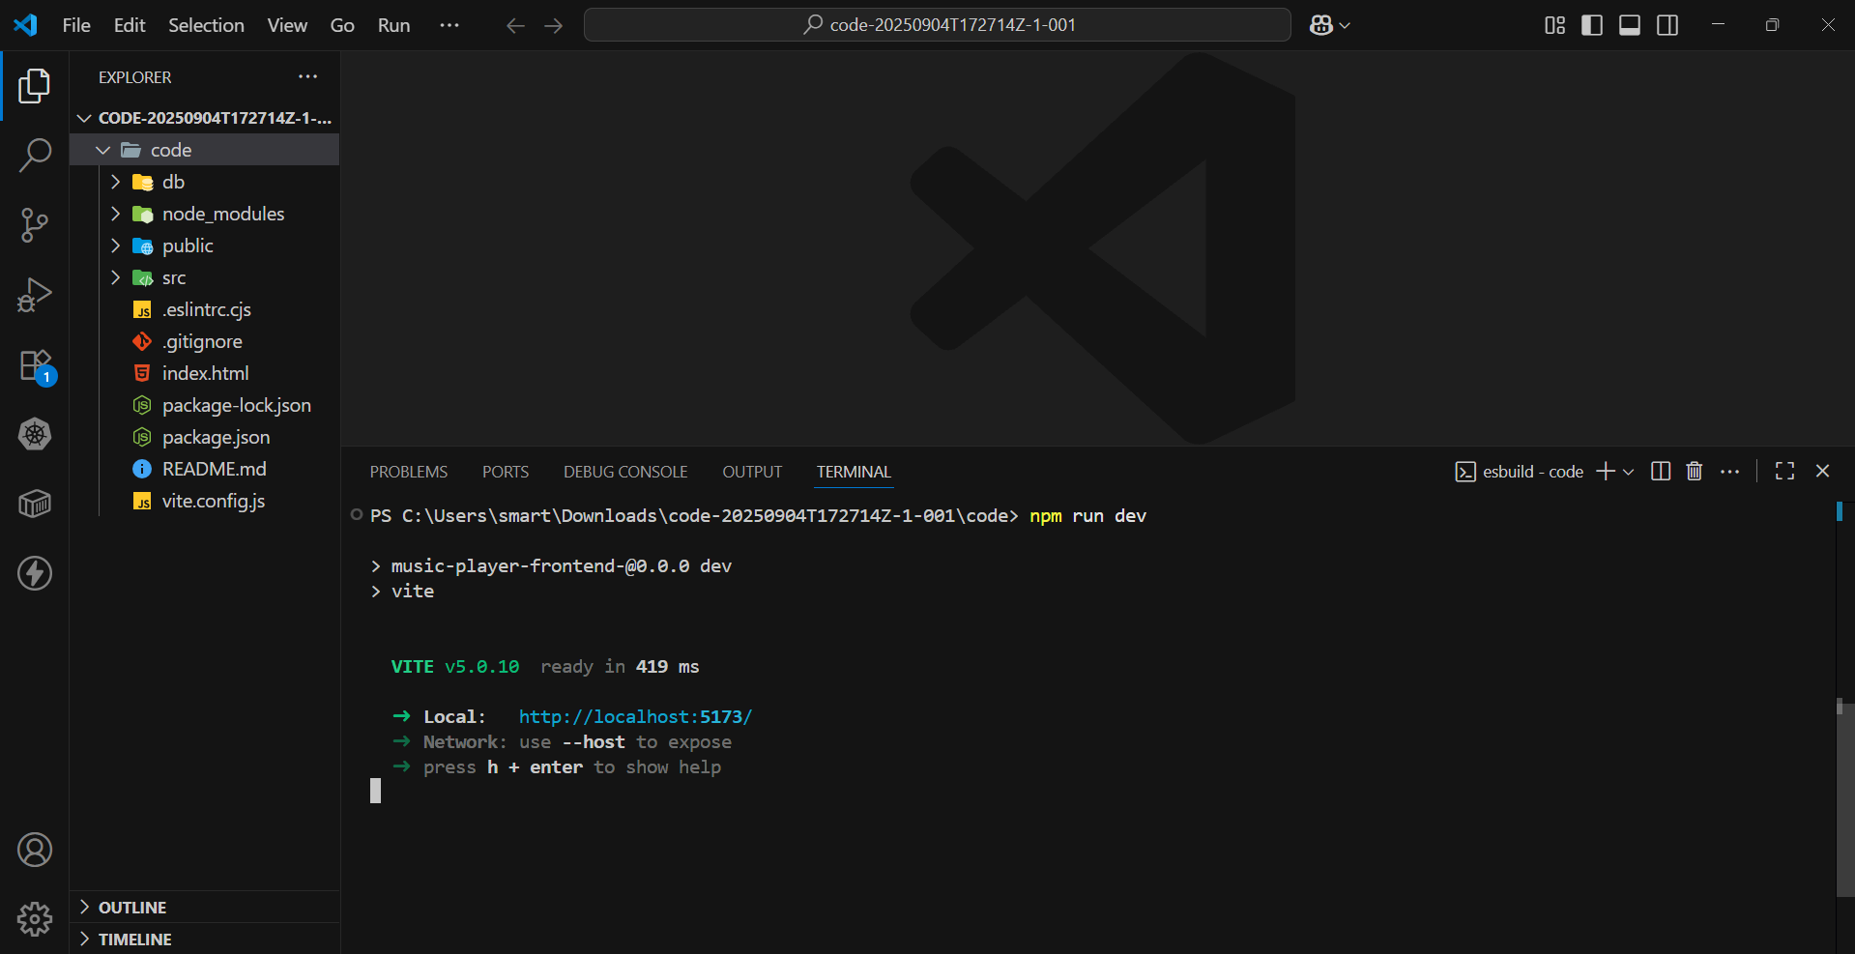

● Now your application will be opened in your browser with url

http://localhost:5173/