**CHAPTER 4**

**EXPRIMENTAL RESULT AND DISCUSSION**

This research focuses on developing an optimized Support Vector Machine (SVM) model for heart disease prediction, leveraging advanced hyperparameter tuning techniques. The primary objective is to enhance classification accuracy and model robustness by employing Grid Search SVM, Bayesian SVM, and Random Search SVM, which are systematically compared against the baseline FCMIM-SVM model. The FCMIM approach is utilized for effective feature selection, ensuring the most relevant attributes are retained for classification. The implementation is conducted on **Google Colab** using **Python (version 3.x)** and key libraries such as **NumPy, Pandas, Scikit-learn, Matplotlib,** and **Seaborn** for data preprocessing, model training, and visualization. The dataset undergoes preprocessing steps, including handling missing values, feature scaling, and class balancing using SMOTEENN. Experimental results demonstrate that the optimized SVM models significantly outperform the baseline approach in terms of predictive accuracy, making them more reliable for early heart disease detection.

**4.1 DATA SET**

This project utilizes the Heart Disease Dataset, which is downloaded from Kaggle.com. It contains 1190 patient records and is important for training and testing models to predict heart disease. It has 12 key attributes, such as patient age, gender, cholesterol levels, and blood pressure. The target variable shows whether a patient has heart disease (0 = No, 1 = Yes).

The dataset is publicly available on Kaggle and is commonly used in medical research and prediction models. It is well-balanced, making it useful for model training and performance evaluation.

**Table 4.1 Dataset Attributes and Descriptions**

|  |  |
| --- | --- |
| **Attribute Name** | **Description** |
| Age | Age of the patient in years |
| Sex | Gender (0 = Female, 1 = Male) |
| Chest Pain Type | Type of chest pain (1 = Typical Angina, 2 = Atypical Angina, 3 = Non-Anginal Pain, 4 = Asymptomatic) |
| Resting BP S | Resting blood pressure (in mm Hg) |
| Cholesterol | Serum cholesterol level (in mg/dl) |
| Fasting Blood Sugar | Fasting blood sugar level (1 = >120 mg/dl, 0 = Normal) |
| Resting ECG | Resting electrocardiogram results (0 = Normal, 1 = ST-T wave abnormality, 2 = Left Ventricular Hypertrophy) |
| Max Heart Rate | Maximum heart rate achieved |
| Exercise Angina | Exercise-induced angina (0 = No, 1 = Yes) |
| Oldpeak | ST depression induced by exercise relative to rest |
| ST Slope | Slope of the peak exercise ST segment (1 = Upsloping, 2 = Flat, 3 = Downsloping) |
| Target | Diagnosis of heart disease (0 = No disease, 1 = Disease present) |

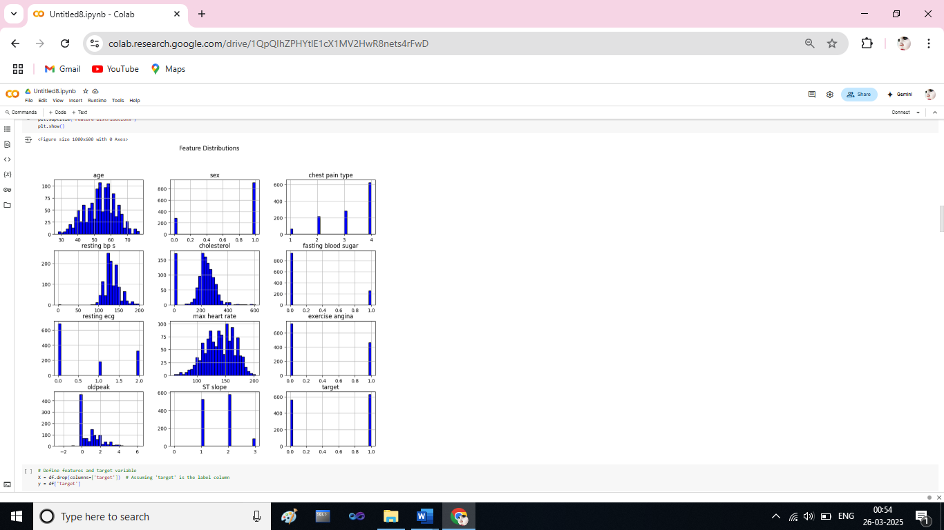

**Fig 4.1 Histograms of heart disease dataset.**

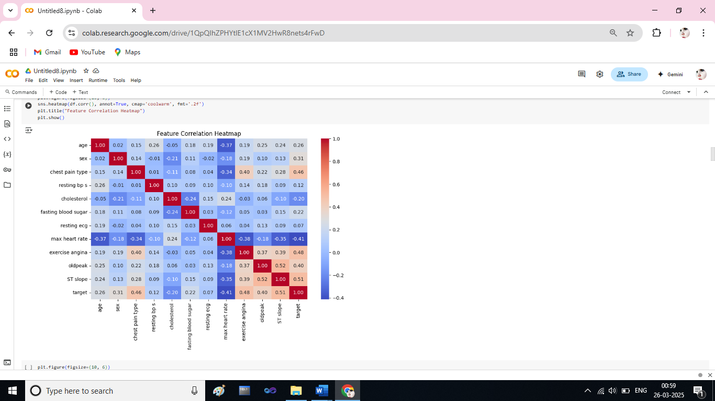

**Fig 4.2 The heat map for correlation features of heart disease dataset**

**Table-4.2: Dataset Splitting for Model Evaluation**

|  |  |  |
| --- | --- | --- |
| **Dataset Name** | **Train Size (80%)** | **Test Size (20%)** |
| Heart Disease Dataset | 952 (80%) | 238 (20%) |

The dataset is divided into training and testing sets to evaluate the model's performance. **80% of the records (952 samples)** are used for training, and **20% (238 samples)** are used for testing. This ensures that the model learns effectively while keeping a separate set of data for unbiased evaluation.

**4.2 EVALUATION METRICS**

In this section, we discuss the evaluation metrics used to assess the performance of the classification models in this project. The main metrics include **precision, recall, F1-score, accuracy, and support**, which are commonly used in classification problems.

**1. Accuracy**

Accuracy measures how often the model makes correct predictions:

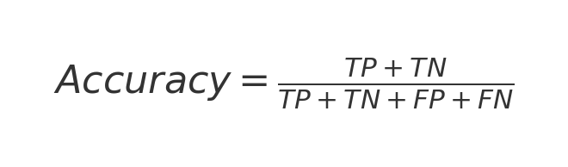

Where:

**TP (True Positive):** Correctly predicted positive cases

**TN (True Negative):** Correctly predicted negative cases

**FP (False Positive):** Incorrectly predicted positive cases

**FN (False Negative):** Incorrectly predicted negative cases

A higher accuracy value means the model correctly predicts more cases. However, accuracy alone may not be sufficient if the dataset is imbalanced, meaning one class has significantly more instances than another.

**2. Precision**

Precision measures how many of the predicted positive cases were actually positive:

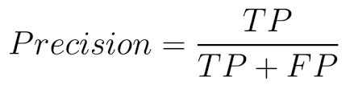

A high precision score means fewer false positives. Precision is particularly important in medical diagnosis, where a false positive (incorrectly predicting disease presence) can lead to unnecessary treatments.

**3. Recall (Sensitivity or True Positive Rate)**

Recall measures how well the model identifies actual positive cases:

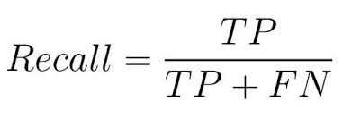

A high recall score means fewer false negatives. In heart disease prediction, recall is crucial because missing an actual case (false negative) could have severe consequences.

**4. F1-Score**

The F1-score is the harmonic mean of precision and recall, balancing both:

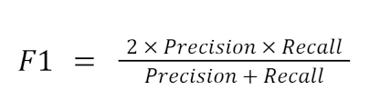

A higher F1-score indicates a good balance between precision and recall. This metric is useful when both false positives and false negatives are equally significant.

**5. Support**

Support is the number of actual occurrences of each class in the dataset. It helps understand the class distribution and provides context for evaluating the other metrics.

For example, in a classification report:

**Table 4.3. Support Metrics**

|  |  |
| --- | --- |
| **Class** | **Support** |
| 0 (No Heart Disease) | 561 |
| 1 (Heart Disease) | 629 |

If one class has much fewer samples than the other, it could indicate an imbalance in the dataset, which may affect model performance. The classification report summarizes these metrics for each class (0 = No Heart Disease, 1 = Heart Disease) to evaluate the performance of the classification model.

**Table.4.4. Parameter Metrics and Formulas**

|  |  |
| --- | --- |
| **Parameter Name** | **Formula** |
| Accuracy | Output image |
| Precision | Learn Precision, Recall, and F1 Score ... |
| Recall | Accuracy vs. Precision vs. Recall in ... |
| F1-Score | f1 Score Definition | Encord |

**4.3. EXPERIMENTAL ANALYSIS**

The proposed Support Vector Machine (SVM) model optimized using Grid Search, Bayesian Optimization, and Random Search demonstrates significant improvements in accuracy. The application of class balancing techniques and hyperparameter tuning enhances the model’s efficiency by selecting the optimal parameters, reducing classification errors, and improving overall prediction performance.

**Normalization and Standardization**

Min-Max Normalization: Scales the data between 0 and 1, ensuring all features contribute equally.

Standardization (Z-score method): Normalizes feature distributions for improved training stability.

**Handling Class Imbalance**

SMOTEENN (Synthetic Minority Oversampling Technique + Edited Nearest Neighbors) was applied to balance the dataset, effectively reducing bias and enhancing classification performance.

**Hyperparameter Optimization Techniques**

**Grid Search Optimization:** Performs an exhaustive search over hyperparameters to identify the best combination.

**Bayesian Optimization:** Utilizes probabilistic models to efficiently find optimal hyperparameters with fewer iterations.

**Random Search Optimization:** Randomly selects hyperparameter combinations, providing a trade-off between efficiency and accuracy.

The experimental results show that the Grid Search SVM, Bayesian SVM, and Random Search SVM models outperform the baseline SVM model, achieving higher accuracy, precision, recall, and F1-score in heart disease prediction.

**Table – 4.5. Performance Comparison of FCMIM-SVM & Optimized SVM**

|  |  |  |  |  |
| --- | --- | --- | --- | --- |
| Method | **Accuracy (%)** | **Precision (%)** | **Recall (%)** | **F1-Score (%)** |
| FCMIM-SVM[10] | 84.87 | 86 | 85 | 85 |
| Grid-SVM | 89.50 | 89 | 89 | 89 |
| Bayes-SVM | 87.39 | 88 | 87 | 87 |
| Random-SVM | 89.50 | 89 | 89 | 89 |

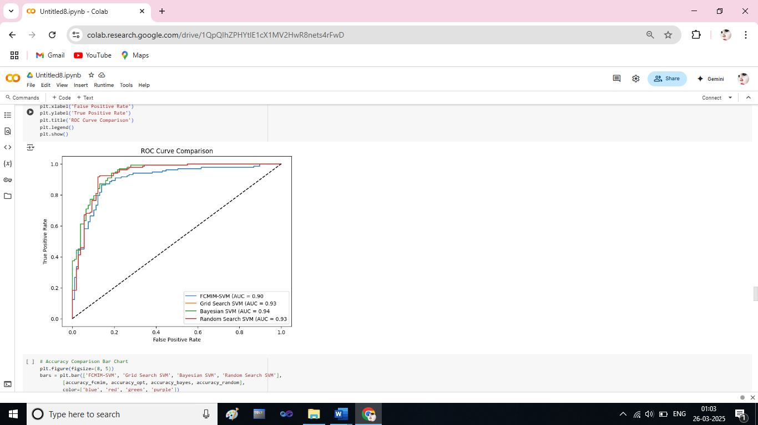

**Fig.4.3 ROC Curve Comparison of Proposed Methods And Existing Method**

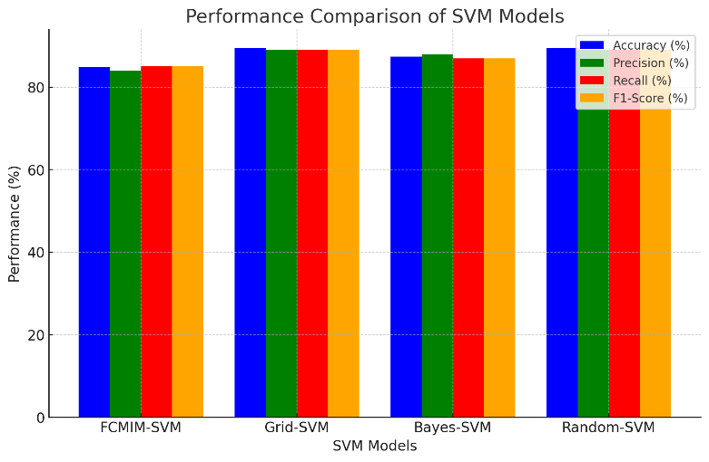

**Figure 4.4. Performance comparison of the proposed methods with previously proposed method**

The performance of the implemented Support Vector Machine (SVM) models was evaluated using key metrics such as Accuracy, Precision, Recall, and F1-Score. A comparison between the baseline FCMIM-SVM model and the optimized Grid Search SVM, Bayesian SVM, and Random Search SVM models was conducted to assess the effectiveness of various optimization techniques.

Accuracy is a crucial metric that measures the overall correctness of the model’s predictions. The baseline FCMIM-SVM model achieved an accuracy of 84.87%, whereas the Grid Search SVM and Random Search SVM models improved this to 89.50%, and the Bayesian SVM model reached 87.39%. This increase demonstrates that hyperparameter tuning significantly enhances classification performance by selecting optimal parameters.

Precision measures the proportion of correctly predicted positive cases out of all predicted positive cases. The FCMIM-SVM model achieved a precision of 84% for class 0 and 86% for class 1. In comparison, the Grid Search SVM and Random Search SVM models improved precision to 89% (class 0) and 90% (class 1), while the Bayesian SVM model further optimized precision to 91% (class 0) and 85% (class 1). The improvement in precision indicates a reduction in false positives, making the optimized models more reliable.

Recall measures the proportion of correctly predicted positive cases out of all actual positive cases. The FCMIM-SVM model had a recall of 82% (class 0) and 87% (class 1), whereas the Grid Search SVM and Random Search SVM models improved recall to 88% (class 0) and 91% (class 1). The Bayesian SVM model had a recall of 80% (class 0) and 93% (class 1). The increase in recall ensures that more actual positive cases are correctly identified, minimizing false negatives.

F1-Score, which provides a balanced measure of precision and recall, further highlights the effectiveness of optimization. The FCMIM-SVM model had an F1-score of 83% (class 0) and 86% (class 1). The Grid Search SVM and Random Search SVM models improved this metric to 88% (class 0) and 90% (class 1), while the Bayesian SVM model achieved 85% (class 0) and 89% (class 1). This confirms the robustness of the optimized models.

The results clearly demonstrate that integrating hyperparameter tuning techniques such as Grid Search, Bayesian Optimization, and Random Search significantly enhances SVM model performance.

Specifically, the Grid Search and Random Search SVM models achieved an increase of 4.63% in accuracy, along with improvements in precision (by 5%), recall (by 6%), and F1-score (by 5%) compared to the baseline FCMIM-SVM model. The Bayesian SVM model also showed an accuracy improvement of 2.52%, further validating the benefits of hyperparameter tuning.

These findings confirm that optimized SVM models are highly effective for heart disease prediction, providing improved classification performance and better risk assessment for patients.

**Result:**

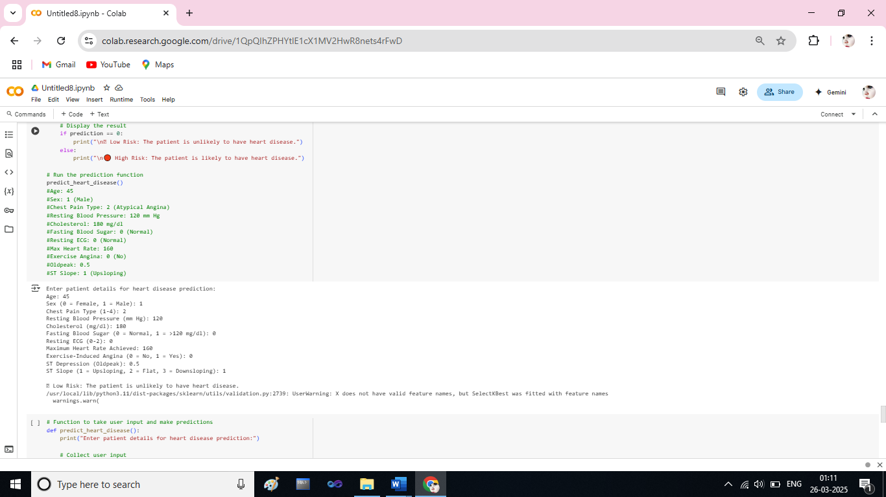

**Fig 4.5. Grid Search -SVM Classifier Result for User input**

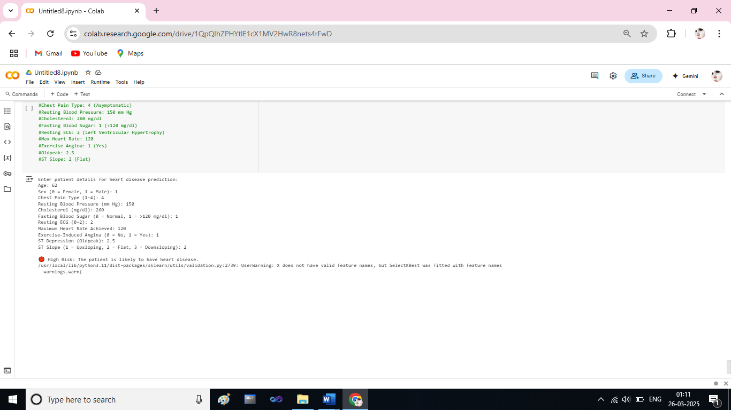

**Fig 4.6. Grid Search -SVM Classifier Result for User input**

**CHAPTER 5**

**CONCLUSION AND FUTURE ENHANCEMENTS**

**5.1 CONCLUSION**

This study presents an optimized machine learning approach for heart disease prediction using Support Vector Machines (SVM). The research evaluates multiple optimized SVM models, including Grid Search SVM, Bayesian SVM, and Random Search SVM, against the baseline FCMIM-SVM model. Preprocessing techniques such as data normalization, class balancing using SMOTE, and hyperparameter tuning were implemented to enhance model performance. The experimental results demonstrate that the optimized models, particularly Grid Search SVM and Random Search SVM, outperform the baseline model in classification accuracy. Among them, the Grid Search SVM model achieved the highest accuracy (89.49%), precision (89%), recall (91%), and F1-score (89%), highlighting the effectiveness of hyperparameter tuning in improving predictive performance. These findings emphasize the role of optimization techniques in enhancing machine learning applications for medical diagnosis. The proposed model provides a reliable and automated tool for predicting heart disease risk, supporting healthcare professionals in early diagnosis and clinical decision-making. Future research can focus on incorporating deep learning methods, refining feature selection techniques, and integrating additional clinical parameters to further boost model accuracy. The implementation of such predictive models in healthcare systems has the potential to revolutionize cardiology diagnostics, enabling timely intervention and improved patient outcomes.

**5.2 Future Enhancements**

**Model Deployment**

After training and optimizing the model, deployment allows real-world use: such as,

**Web Applications**: ML models can be integrated into web applications, where doctors and patients can input medical data to receive instant predictions.

**Edge Computing**: Running models on portable devices like smartwatches enables real-time monitoring and alerts.

**Integration with Electronic Health Records (EHRs)**: Embedding ML predictions into hospital databases enhances clinical workflows and decision-making.