Week 1 – Day 2 – Home Assignment

Question 1: From the Groq and Openairouter
https://console.groq.com/home
https://developers.openai.com/api/docs/models/all
--List down the Multimodels

Answer:
Platform | Model | Service Provider | Modalities  (Input->Output)
Groq | 1.Whisper Large v3  2.Whisper Large v3 Turbo | OpenAI | Audio -> Text
Groq | 1.Orpheus English  2.Orpheus Arabic Saudi | Groq | Text -> Audio
Groq | Llama 4 Scout | Meta | Text + Image  ->Text
OpenRouter | GPT-4 (Vision) | OpenAI | Text + Image  ->Text
OpenRouter | GPT-4o Mini | OpenAI | Audio -> Text  Text -> Audio
OpenRouter | Gemini 1.5 Pro | Google | Text + Image + Audio → Text
OpenRouter | Claude 3 Opus | Anthropic | Text + Image → Text

Question 2: Take 3 models from each service provider
https://openrouter.ai/models
Context window,Input output token cost

Answer:
Model | Provider | Context Window | Input cost ($/1M tokens) | Output cost ($/1M tokens)
GPT-5.4 Nano | OpenAI | 400k | $0.20/M | $1.25/M
GPT-5.4 Mini | OpenAI | 400k | $0.75/M | $4.50/M
GPT-3.5 Turbo | OpenAI | 16k | $0.50/M | $1.50/M
MiMo-V2-Omni | Xiaomi | 262k | $0.40/M | $2/M
MiMo-V2-Pro | Xiaomi | 1.05M | $1/M | $3/M
Mistral Large | mistralai | 128k | $2/M | $6/M
Mixtral 8x7B Instruct | mistralai | 33k | $0.54/M | $0.54/M
Claude 3 Haiku | Anthropic | 200k | $0.25/M | $1.25/M

Question 3: use the Tokenizer with different prompt and see how the tokens are generated
https://platform.openai.com/tokenizer
Answer:
Prompt Message | Token Count | Token IDs
Assume you are a QA tester, suggest all functional scenarios for login page | 15 | [9095, 3095, 481, 553, 261, 103333, 51819, 11, 6108, 722, 20483, 42318, 395, 9464, 3011]
Suggest me some good tourist places to visit in Kerala and I wanted to extract all the tourist spots in excel spreadsheet | 22 | [44264, 668, 1236, 1899, 33461, 9610, 316, 4030, 306, 82403, 326, 357, 7201, 316, 13424, 722, 290, 33461, 25522, 306, 19383, 74158]
I wanted to prepare for my interview for selenium automation tester role, Suggest best answers for the following topics  1) JAVA oops concepts  2) Selenium Locators  3) Action class  4) Arrays  5)Cucumber Framework structure  6) Handling multiple windows | 55 | [40, 7201, 316, 13708, 395, 922, 12459, 395, 75548, 37314, 51819, 5430, 11, 62122, 1636, 14716, 395, 290, 3992, 15083, 198, 16, 8, 160505, 293, 4645, 23753, 198, 17, 8, 156768, 17861, 4840, 198, 18, 8, 9905, 744, 198, 19, 8, 34394, 793, 20, 8, 34, 95416, 43459, 8866, 198, 21, 8, 93478, 7598, 14387]

Snapshots:

Prompt 1:
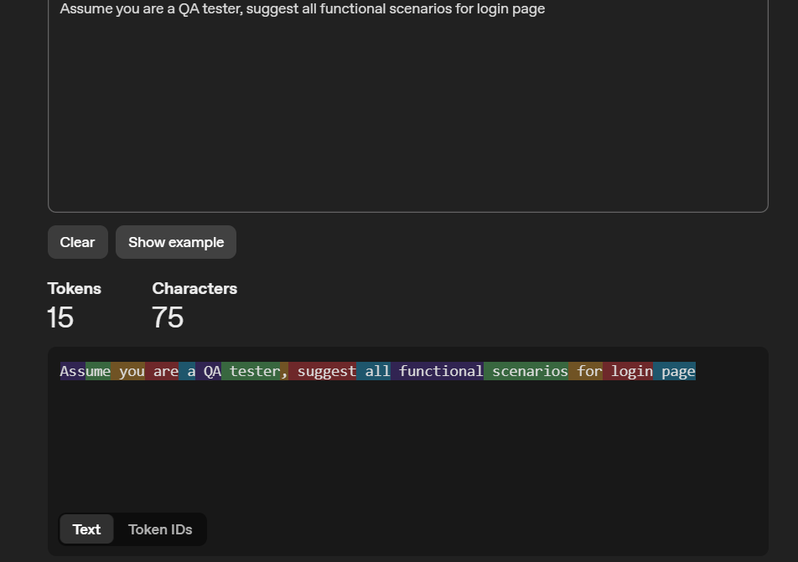

Prompt 2:
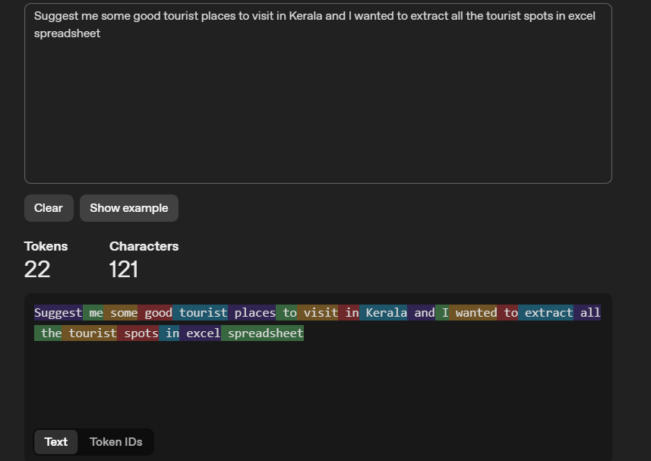

Prompt 3:
