Assignment -07

Creating a Virtual Machine, SQL Server Database, and VPN Configuration in Azure Portal

1. Creating VPN Configuration in Azure Portal:

- Step 1: Choose Create resource and create.

- Step 2: Sign Up and Set Up VPN

- Step 3: Then Review and create.

-Step 4: Taken Screenshots for the outputs.

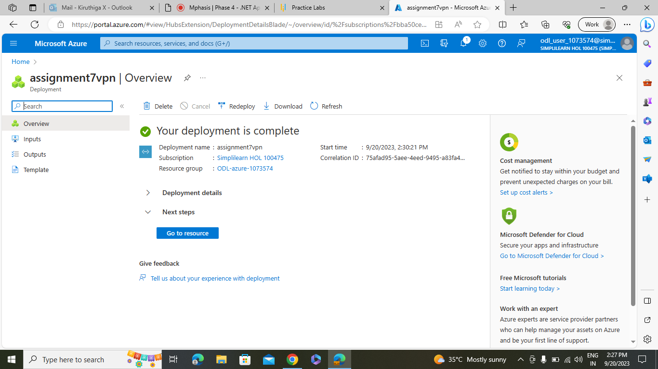

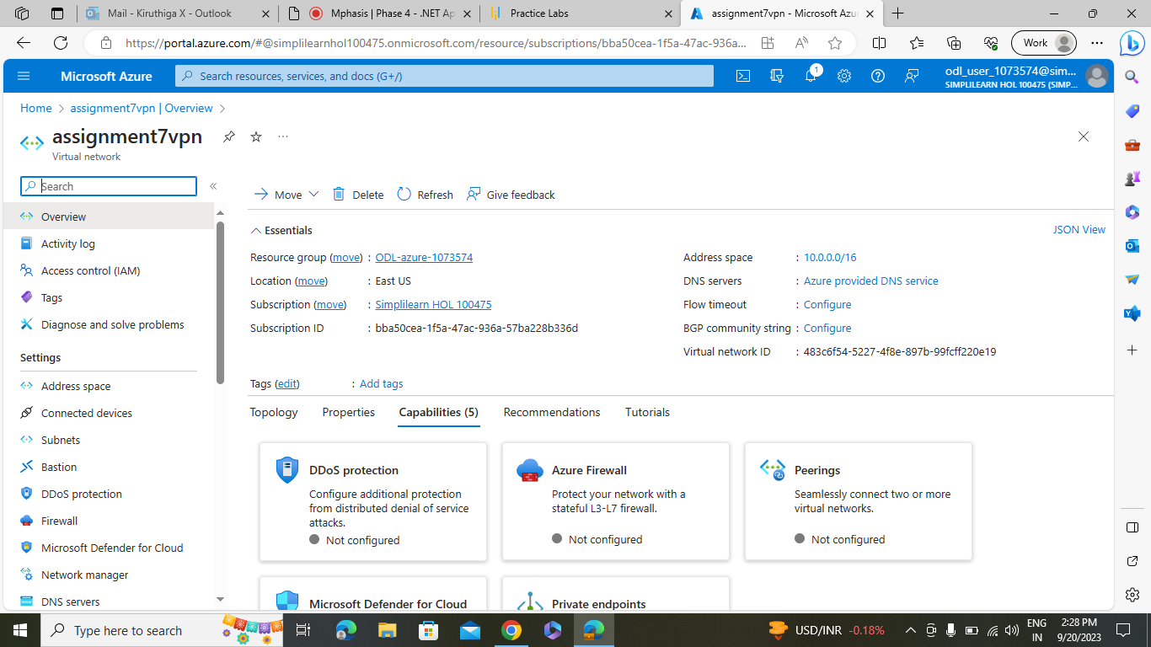

1. Creating SQL Database in Azure Portal:

- Step 1: Choose Create resource and create Sql Database.

- Step 2: Set Up the server name and database name

-Step 3: Go to Disk and make that as public end point.

- Step 4: Then Review and create.

-Step 5: Taken Screenshots for the outputs.

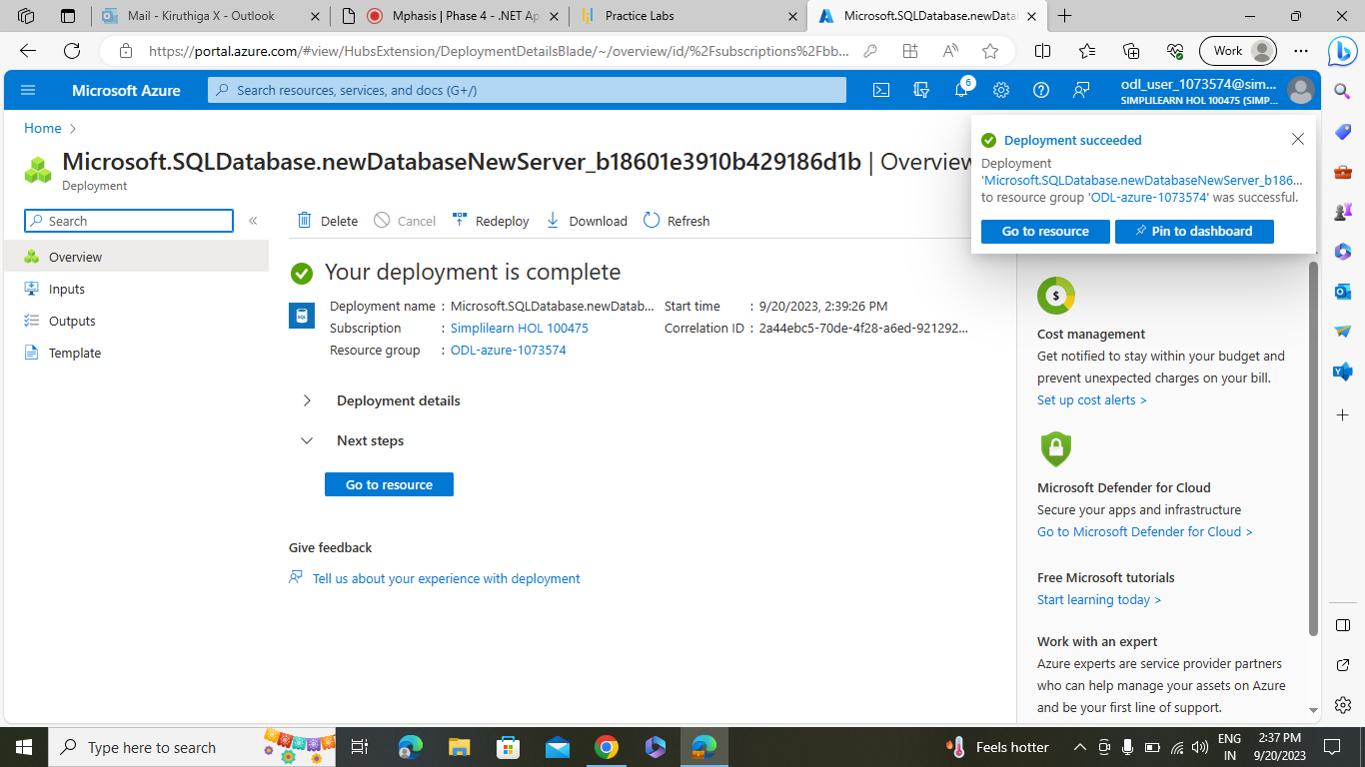

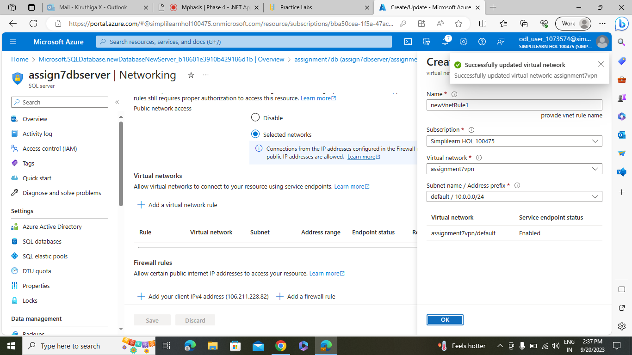

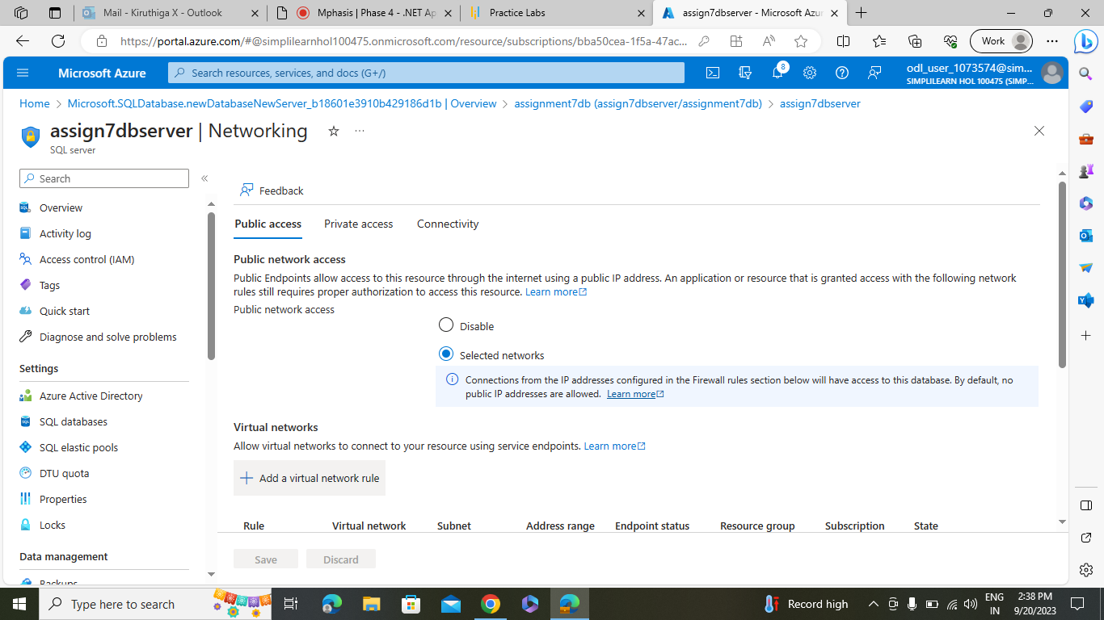

1. Creating Virtual Machine in Azure Portal:

- Step 1: Choose Create resource and create Virtual Machine.

- Step 2: Set Up and set up the Virtual Machines Name.

- Step 4: Then Review and create.

-Step 5: Taken Screenshots for the outputs.

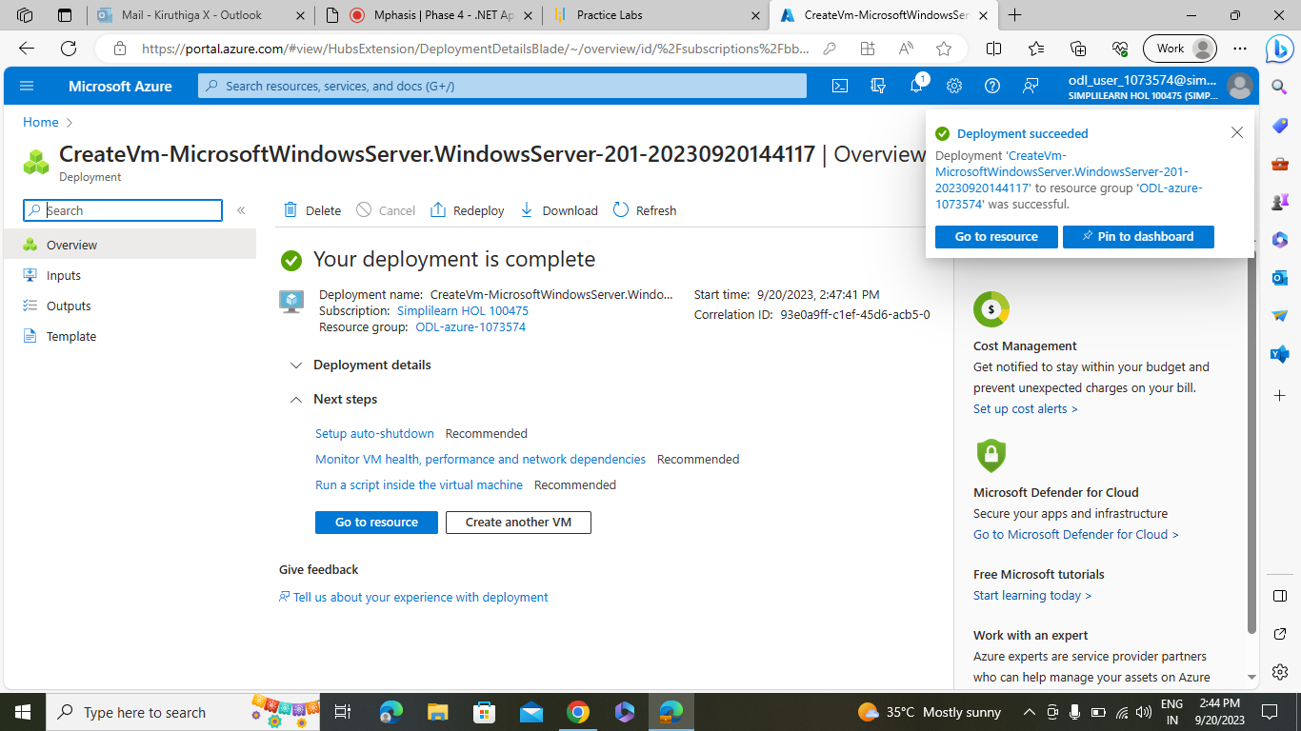

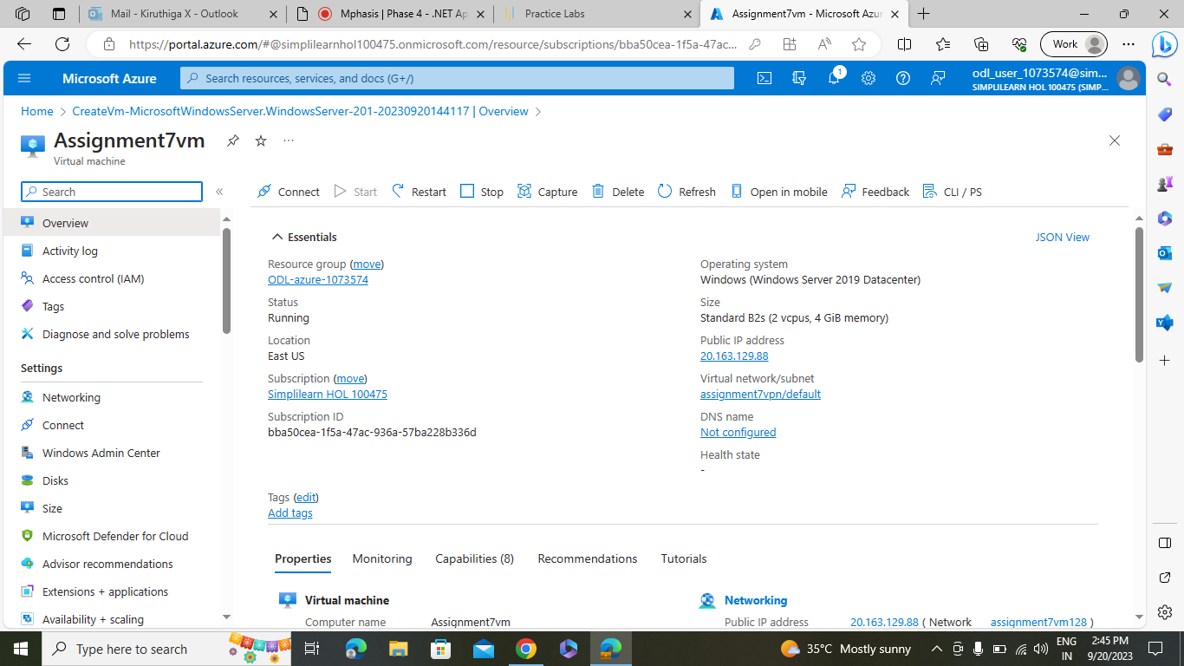

1. Connecting VPN with Virtual Machines Outputs:

