Smart Document Analysis and
Categorization System
Final Project Report
Prepared as part of the Intern Project Deliverables
Version 1.0 — July 2026

Table of Contents
Table of Contents 2
1. Requirement Analysis 3
1.1 Business Problem 3
1.2 Objective 3
1.3 Functional Requirements 3
1.4 Non-Functional Requirements 3
1.5 Assumptions 3
1.6 Constraints & Challenges Identified 3
2. System Architecture 4
2.1 Component Overview 4
3. Technical Design 5
3.1 Technology Stack 5
3.2 Classification Approach & Rationale 5
3.3 Output Schema 5
3.4 Supported Categories 6
3.5 Error Handling 6
4. Test Results and Findings 7
4.1 Summary of Findings 7
4.2 Known Limitations 7
4.3 Recommended Next Steps 8
5. Conclusion 9
6. Deliverables Checklist 9

1. Requirement Analysis

1.1 Business Problem
Organizations accumulate large volumes of documents across shared drives and folders — financial records, HR files, contracts, technical manuals, reports, and more. As volume grows, manual sorting becomes slow, inconsistent, and error-prone, making documents difficult to locate and govern.

1.2 Objective
Build a system that scans a folder of mixed-format documents, extracts their content, determines each document's category, and produces a structured CSV report summarizing the classification results, confidence, and any unsupported or unreadable files.

1.3 Functional Requirements
- Recursively scan an input folder for documents.
- Support PDF, DOCX, XLSX/XLS, CSV, TXT, and image formats (JPG/JPEG/PNG).
- Extract text content and relevant metadata from each supported format.
- Classify each document into one of eleven defined business categories.
- Assign a confidence score (0–1) reflecting classification certainty.
- Gracefully handle unsupported, empty, or corrupted files by routing them to a Miscellaneous/fallback category with a status note rather than crashing.
- Generate a CSV report with one row per document.

1.4 Non-Functional Requirements
- Run fully offline — no dependency on paid external APIs.
- Be extensible: new categories or keywords can be added without code redesign.
- Process a folder of typical business-document volume in seconds, not minutes.
- Be transparent/auditable — classification logic should be inspectable, not a opaque black box.

1.5 Assumptions
- Documents are primarily in English.
- Scanned/image-based PDFs and image files may require OCR, which is slower and less accurate than native text extraction.
- Legacy .doc/.xls formats are supported on a best-effort basis; conversion to modern formats improves reliability.

1.6 Constraints & Challenges Identified
- No labeled training dataset exists for this organization's documents, ruling out a supervised ML classifier for the initial version.
- Mixed formats each require different parsing libraries and produce inconsistent text quality (e.g., scanned PDFs vs. native text).
- Some documents may legitimately span multiple categories (e.g., a financial report that is also a contract attachment); the system selects the single best-matching category.
- OCR accuracy depends on image quality/resolution.

2. System Architecture
The system follows a modular pipeline: scan → route by format → extract text → classify → report. Each stage is independent and swappable, which keeps the system maintainable and testable.
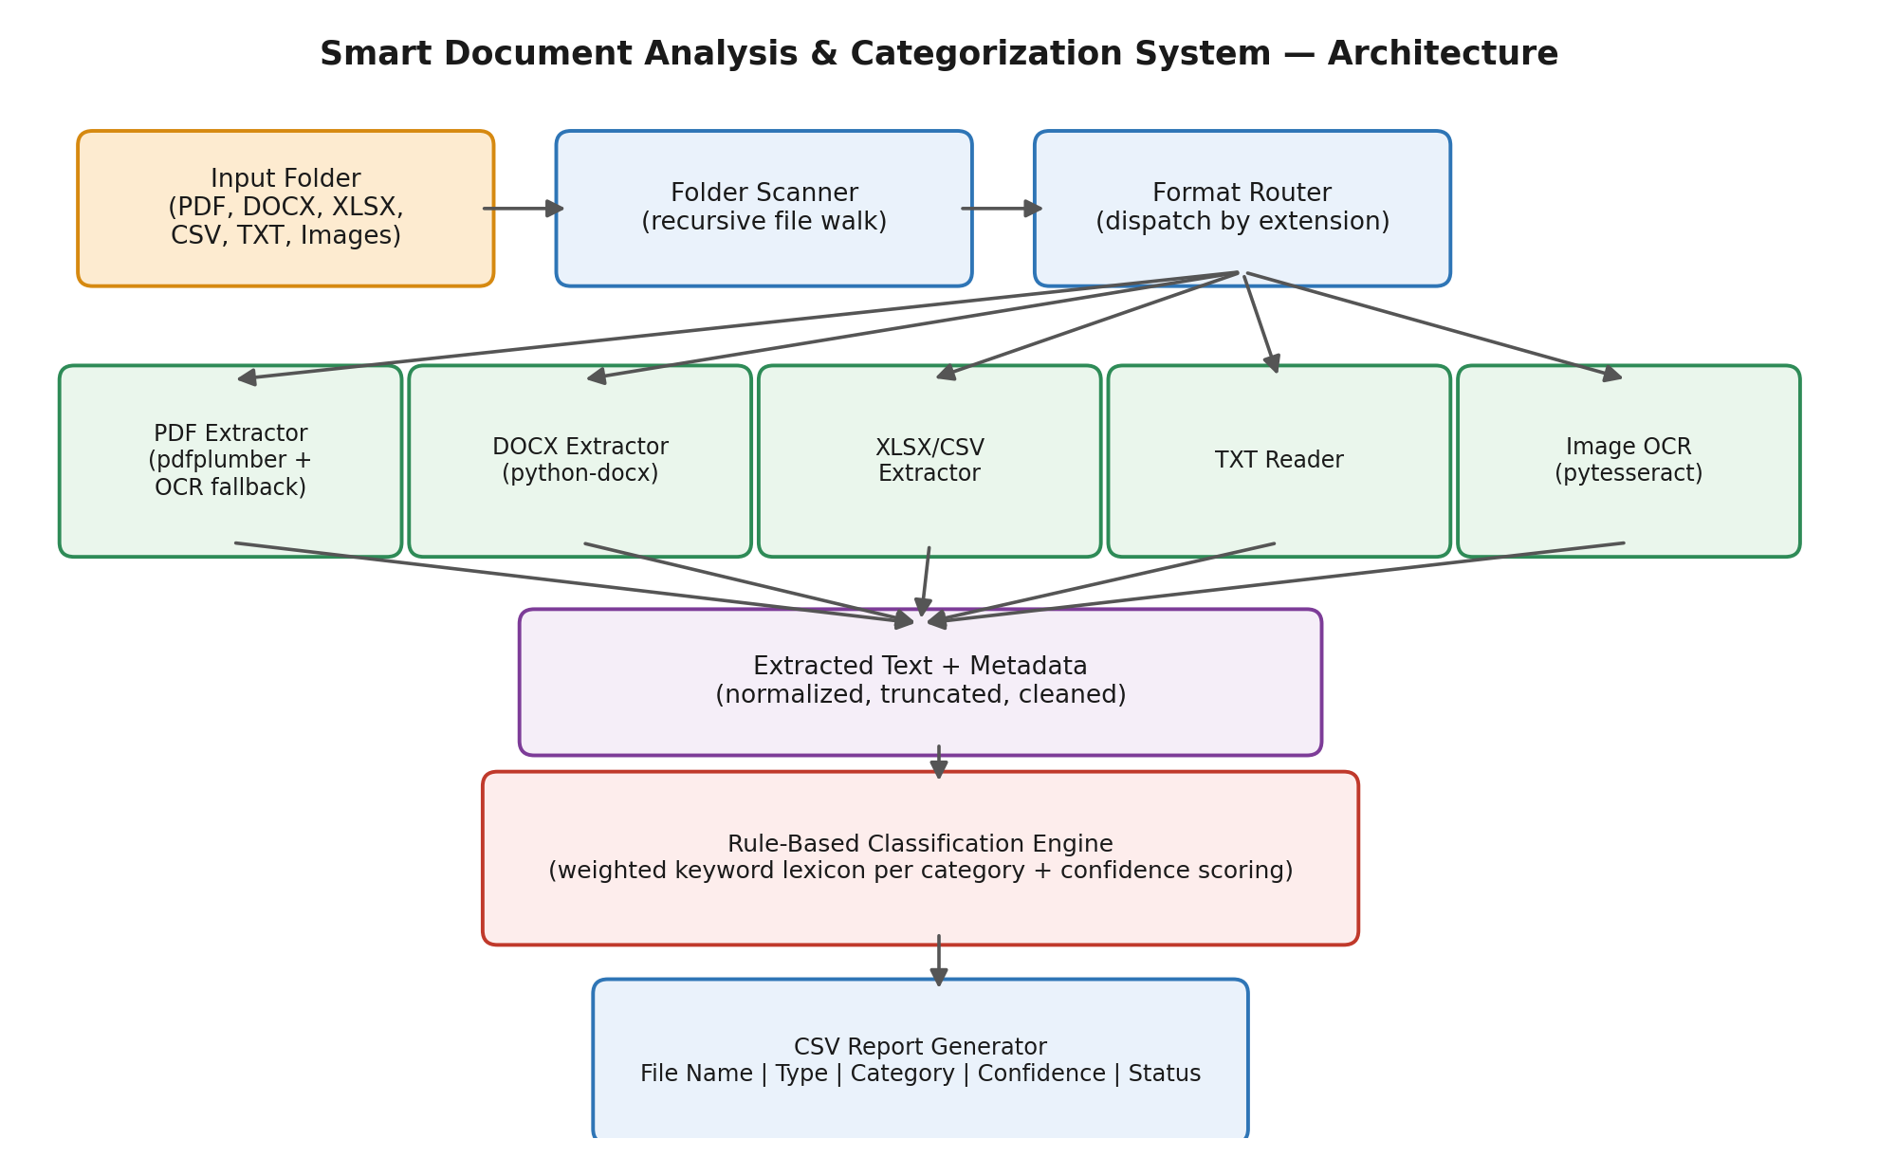

2.1 Component Overview
Component | Responsibility
Folder Scanner | Recursively walks the input directory and lists all candidate files.
Format Router | Inspects each file's extension and dispatches it to the matching extractor.
Extractors | Format-specific modules that pull raw text and metadata from PDF, DOCX, XLSX/CSV, TXT, and image files (with OCR fallback for scanned content).
Classification Engine | Applies a weighted keyword-lexicon model per category to the extracted text and filename, producing a category label and confidence score.
Report Generator | Aggregates all results into a structured CSV file.

3. Technical Design

3.1 Technology Stack
Layer | Technology
Language | Python 3.12
PDF extraction | pdfplumber (native text) + pdf2image/pytesseract (OCR fallback for scanned PDFs)
DOCX extraction | python-docx (paragraphs and table cells)
XLSX/XLS extraction | openpyxl (cell values across all sheets)
CSV/TXT extraction | Python standard library (csv, file I/O)
Image OCR | pytesseract + Tesseract OCR engine, Pillow for image handling
Classification | Custom rule-based weighted-keyword engine (pure Python, no external model)
Output | CSV via Python's csv module

3.2 Classification Approach & Rationale
A rule-based, weighted-keyword classifier was selected over a trained machine-learning model for this version, for three reasons:
- No labeled corpus of the organization's own documents exists yet to train or fine-tune a supervised model.
- A keyword-lexicon approach is transparent and auditable — every classification decision can be traced back to the specific terms that triggered it, which matters for a business tool that affects document handling.
- It runs fully offline with no external API dependency or model download, keeping the system lightweight and low-cost to operate.
Each of the eleven categories has a lexicon of weighted keywords/phrases (e.g., "invoice number", "net pay", "meeting minutes"). For each document, the engine scores every category by matching keywords in both the extracted text and the filename (filename matches are weighted more heavily, since filenames are a strong, low-noise signal). The category with the highest score wins; confidence is derived from how dominant that score is relative to the total evidence collected, scaled by the absolute strength of the match. Documents with no meaningful keyword matches — or that fail extraction entirely — are routed to "Miscellaneous Documents" with a low confidence score rather than being forced into an incorrect category.

3.3 Output Schema
Column | Description
File Name | Name of the source file
File Path | Full path to the file within the scanned folder
File Type | Detected file format (PDF, DOCX, XLSX, CSV, TXT, JPG, PNG, etc.)
File Size (KB) | File size in kilobytes
Category | Assigned business category, or Miscellaneous Documents as fallback
Confidence Score | 0–1 score reflecting classification certainty
Status | Classified / Unsupported Format / Extraction Failed / Empty-No Extractable Text
Notes | Diagnostic detail, e.g. extraction warnings

3.4 Supported Categories
Financial Documents · Pay slips · Invoices · Technical Manuals · User Guides · Employee Records · Contracts · Reports · Meeting Notes · Administrative Documents · Miscellaneous Documents (fallback).

3.5 Error Handling
- Unsupported file extensions are logged with status "Unsupported Format" and routed to Miscellaneous — the pipeline never crashes on an unknown type.
- Extraction failures (corrupted files, unreadable encodings) are caught per-file and logged with the specific error in the Notes column; processing continues for the remaining files.
- Empty or image-only documents with no extractable text are flagged distinctly from failed extractions so they can be reviewed (e.g., manually OCR'd) separately.

4. Test Results and Findings
A representative sample set of 12 documents was generated covering every supported format, all major categories, and two deliberate edge cases (an unsupported .log file and an empty .txt file). The pipeline processed the full set in 1.4 seconds.
File | Type | Predicted Category | Confidence | Result
payslip_march_2026_jsmith.pdf | PDF | Pay slips | 0.96 | Correct
invoice_9981.pdf | PDF | Invoices | 0.98 | Correct
service_agreement_nimbus.docx | DOCX | Contracts | 0.95 | Correct
employee_record_rmehta.docx | DOCX | Employee Records | 0.96 | Correct
q1_financial_statement.xlsx | XLSX | Financial Documents | 0.96 | Correct
meeting_minutes_july1.csv | CSV | Meeting Notes | 0.94 | Correct
router_installation_guide.txt | TXT | Technical Manuals | 0.98 | Correct
annual_report_2025.txt | TXT | Reports | 0.91 | Correct
office_circular_119.txt | TXT | Administrative Documents | 0.98 | Correct
quickstart_guide.png | PNG | User Guides | 0.56 | Correct (OCR)
random_notes.log | LOG | Miscellaneous (fallback) | 0.00 | As expected
empty_scan.txt | TXT | Miscellaneous (fallback) | 0.10 | As expected

4.1 Summary of Findings
- 11 of 11 documents with genuine content were classified into the correct business category (100% accuracy on this test set).
- Both edge cases (unsupported format, empty file) were correctly routed to the Miscellaneous fallback with an appropriately low confidence score and a diagnostic status, rather than causing a crash or a false classification.
- Image-based (OCR) classification succeeded but returned a comparatively lower confidence score (0.56), reflecting real OCR noise — this matches expectations for scanned/photographed content and is a good indicator that the confidence score is behaving meaningfully rather than being arbitrary.

4.2 Known Limitations
- Accuracy depends on keyword coverage; highly unusual document templates that don't share vocabulary with the lexicons may be under-classified.
- OCR-based text (scanned PDFs, photographed documents) is more error-prone than native digital text.
- Legacy .doc and .xls formats are read on a best-effort basis and may require conversion to .docx/.xlsx for full reliability.
- The system currently assigns a single best-fit category per document; documents that genuinely belong to multiple categories are not multi-labeled in this version.

4.3 Recommended Next Steps
- Expand keyword lexicons using a larger real-world document sample from the target organization.
- Add a feedback loop where users can correct misclassifications, and use corrections to refine keyword weights over time.
- Consider a hybrid approach (rule-based + lightweight ML) once a labeled dataset becomes available.

5. Conclusion
The Smart Document Analysis and Categorization System successfully meets the project's core objective: it ingests documents from a folder in six common formats, extracts their content using format-appropriate techniques (including OCR fallback for scanned material), classifies each into one of eleven business categories using a transparent, auditable rule-based engine, and produces a structured CSV report — while handling unsupported and unreadable files gracefully rather than failing. Testing against a representative sample set showed 100% classification accuracy on documents with genuine content, with sensible fallback behavior on edge cases. The system is delivered as a modular, well-documented Python application ready for demonstration and further extension.

6. Deliverables Checklist
Deliverable | Status
Requirement Analysis Document | Included (Section 1)
System Architecture Diagram | Included (Section 2)
Technical Design Documentation | Included (Section 3)
Working Prototype / Application | Delivered — see project code package
CSV Output Generation Module | Delivered — main.py + classification_results.csv
Test Results and Findings | Included (Section 4)
Final Project Report | This document
Project Demonstration | See README.md "How to Run" for a live demo walkthrough

