POST-QUANTUM FIRMWARE AUTHENTICATION: DESIGN AND IMPLEMENTATION OF A QUANTUM-RESISTANT SECURE BOOT MECHANISM
BITS ZG628T: Dissertation
by
Kiruthik Prakash J
2024HT01586
Dissertation work carried out at
Qualcomm India Private Limited, Hyderabad
Submitted in partial fulfilment of M.Tech in Embedded Systems
degree programme
Under the Supervision of
Deepak Kumar
Senior Lead Software Engineer
Qualcomm India Private Limited, Hyderabad
BIRLA INSTITUTE OF TECHNOLOGY & SCIENCE
PILANI (RAJASTHAN)
SEPTEMBER 2026

POST-QUANTUM FIRMWARE AUTHENTICATION: DESIGN AND IMPLEMENTATION OF A QUANTUM-RESISTANT SECURE BOOT MECHANISM
BITS ZG628T: Dissertation
by
Kiruthik Prakash J
2024HT01586
Dissertation work carried out at
Qualcomm India Private Limited, Hyderabad
Submitted in partial fulfilment of M.Tech in Embedded Systems
degree programme
Under the Supervision of
Deepak Kumar
Senior Lead Software Engineer
Qualcomm India Private Limited, Hyderabad
BIRLA INSTITUTE OF TECHNOLOGY & SCIENCE
PILANI (RAJASTHAN)
SEPTEMBER 2026

CERTIFICATE
This is to certify that the dissertation entitled “Post-Quantum Firmware Authentication: Design and Implementation of a Quantum-Resistant Secure Boot Mechanism” and submitted by Kiruthik Prakash J (ID: 2024HT01586) in partial fulfilment of the requirement of M.Tech in Embedded Systems of BITS Pilani, embodies the work done by him under my supervision at Qualcomm India Private Limited, Hyderabad.

___________________________ | ___________________________
Deepak Kumar  Supervisor  Senior Lead Software Engineer  Qualcomm India Private Limited | Kiruthik Prakash J  ID: 2024HT01586  M.Tech Embedded Systems  BITS Pilani
Date: 19/09/2026  Place: Hyderabad | Date: 19/09/2026  Place: Hyderabad

TABLE OF CONTENTS
1. MODULES IN POST-QUANTUM SECURE BOOT SYSTEM 6
1.1 Core Cryptographic Verification Engine 7
1.2 IoT & Microcontroller Target: MCUboot Bootloader Module 8
1.3 Embedded Linux Target: Das U-Boot FIT Verification Module 9
1.4 Enterprise / Server Target: EDKII UEFI SecurityPkg Module 10
1.5 Hardware Root-of-Trust (RoT) & eFuse Key Binding Module 11
1.6 Offline Firmware Signing & Container Tooling Module 12
1.7 Multi-Target Emulation & Automated Verification Harness 13
2. FUNCTIONAL BLOCK DIAGRAM & ARCHITECTURAL DESCRIPTION 14
2.1 System Architecture Overview 14
2.2 Secure Boot Execution Sequence & Cryptographic Flow 15
3. MAJOR TECHNICAL SPECIFICATIONS OF PQC SECURE BOOT 16
4. DESIGN CONSIDERATIONS 17
4.1 Zero Dynamic Memory Allocation (Zero-Malloc Policy) 17
4.2 Strict Static SRAM Budgeting (< 4 KB ROM Bounds) 18
4.3 Hardware Root-of-Trust Key Hash Binding & eFuse Storage 19
4.4 Tamper Robustness & Non-Negotiable Fault Rejection 20
4.5 Constant-Time Cryptographic Execution & Side-Channel Mitigation 21
5. EMPIRICAL BENCHMARKING, PROFILING & FUTURE PLAN 22
5.1 MCUboot on ARM Cortex-M4 Trade-Off Benchmark & Stack Profiling 22
5.2 Mid-Semester Progress Status (Plan of Work) 23
5.3 Remaining Tasks & Deliverables for Final Dissertation 24
6. ABBREVIATIONS 25
7. REFERENCES & LITERATURE REVIEW 26

LIST OF FIGURES & TABLES

List of Figures
Figure 1: Modular Architecture of Post-Quantum Secure Boot System 14
Figure 2: Functional Block Diagram & Secure Boot Execution Flow 15

List of Tables
Table 1: Technical Specifications & Cryptographic Parameters 16
Table 2: MCUboot ARM Cortex-M4 Trade-Off Benchmark (Classical vs PQC) 22
Table 3: Dissertation Plan of Work & Mid-Semester Status 23
Table 4: Table of Abbreviations & Acronyms 25

1. MODULES IN POST-QUANTUM SECURE BOOT SYSTEM
The Post-Quantum Cryptography (PQC) Secure Boot infrastructure (pqc-boot) is architected as a modular, hardware-agnostic, and zero-dynamic-memory framework designed to authenticate bare-metal firmware across the complete embedded spectrum—from resource-constrained microcontrollers to enterprise multi-core servers. The complete system consists of seven primary functional modules:
(a) Core Cryptographic Verification Engine (pqc_crypto, ml_dsa, sphincs_plus, lms, sha256, shake256)
(b) IoT & Microcontroller Bootloader Module (MCUboot with PQC TLV tags on ARM Cortex-M4)
(c) Embedded Linux Bootloader Module (Das U-Boot with FIT Device Tree Blob on RISC-V 64-bit)
(d) Enterprise / Server Firmware Module (EDKII / UEFI SecurityPkg DxeImageVerificationLib on Cortex-A57 SMP)
(e) Hardware Root-of-Trust (RoT) & eFuse Key Binding Module (rot_key)
(f) Offline Firmware Signing & Container Tooling Module (imgtool, mkimage, sign_firmware.py)
(g) Multi-Target Emulation & Automated Verification Harness (tests, QEMU platform runners)

1.1 Core Cryptographic Verification Engine
The core cryptographic engine (located in the firmware module firmware/src/pqc_crypto.c) serves as the centralized, static-memory cryptographic service layer. It encapsulates NIST-standardized and RFC-specified post-quantum signature schemes alongside required symmetric primitives:
• ML-DSA-44 (NIST FIPS 204): Module-Lattice-Based Digital Signature Algorithm (formerly Dilithium2). Operates over polynomial rings R_q = Z_q[X]/(X^256 + 1) with modulus q = 8,380,417. The engine defines public key structures (1,312 bytes), private key structures (2,560 bytes), and signature structures (2,420 bytes). Forward and inverse Number Theoretic Transforms (NTT), Montgomery modular reductions, and uniform polynomial sampling routines are implemented.
• SPHINCS+ / SLH-DSA (NIST FIPS 205): Stateless Hash-Based Digital Signature Algorithm (SLH-DSA-128f parameter set). Relies solely on the collision resistance of cryptographic hash functions without algebraic lattice assumptions. Utilizes Winternitz One-Time Signatures (WOTS+) and Forest of Random Subsets (FORS) multi-layer hypertree constructions with a compact 32-byte public key (PK.seed || PK.root) and an allocated signature buffer of up to 18,000 bytes.
• LMS / LMOTS (RFC 8554 / RFC 8708): Leighton-Micali Stateful Hash-Based Signature scheme using LMOTS-SHA256_N32_W4 one-time signatures and LMS_SHA256_M32_H10 Merkle trees. Features a 56-byte public key containing the tree type, LMOTS type, 16-byte identifier I, and 32-byte root node K.
• Symmetric Hashing Primitives: Implements zero-heap SHA-256 (FIPS 180-4) and SHAKE-256 Keccak extensible-output functions (FIPS 202). In the current milestone, signature authentication combines pre-hashing (mu = SHA256(PK || msg)), challenge seed derivation (c_tilde = SHAKE256(mu, 32)), and active polynomial NTT arithmetic.

1.2 IoT & Microcontroller Target: MCUboot Bootloader Module
The MCUboot module (real_world/mcuboot/) integrates post-quantum firmware validation into the leading open-source 32-bit microcontroller secure bootloader:
• PQC Type-Length-Value (TLV) Header Extensions: Defined custom TLV record identifiers in boot/bootutil/include/bootutil/image.h: IMAGE_TLV_ML_DSA_44 (0x80), IMAGE_TLV_SPHINCS_PLUS (0x81), IMAGE_TLV_LMS (0x82), and IMAGE_TLV_PQC_PUBKEY (0x88).
• Zero-Allocation Verification Hook: Implemented bootutil_pqc.c, hooking bootutil_pqc_verify_ml_dsa_44() directly into bootutil_img_validate(). The routine traverses image TLVs, extracts public key digests, verifies RoT bindings, and authenticates image payloads without heap usage.
• Host Signing Utility (imgtool): Extended scripts/imgtool/main.py and keys/pqc.py to support the command imgtool keygen -k keys/ml_dsa_key.json -t ml-dsa-44 and automated trailer encapsulation during imgtool sign.

1.3 Embedded Linux Target: Das U-Boot FIT Verification Module
The Das U-Boot integration module (real_world/uboot/) incorporates PQC verification into the standard Flattened Image Tree (FIT) mechanism used across ARM and RISC-V embedded Linux deployments:
• Crypto Dispatcher Registration: Registered post-quantum signature handlers in boot/image-sig.c using the U-Boot driver macro U_BOOT_CRYPTO_ALGO(ml_dsa_44), U_BOOT_CRYPTO_ALGO(sphincs_plus), and U_BOOT_CRYPTO_ALGO(lms).
• FIT Signature Verification Engine: Created lib/pqc/pqc_fit_verify.c and lib/pqc/pqc-verify.c. The verification driver extracts image nodes from device tree blobs (.itb), validates the property algo = "sha256,ml-dsa-44", fetches public keys referenced by key-name-hint, and executes verification.
• Host mkimage Tool Integration: Updated tools/Makefile and image-sig-host.c to compile PQC verification and signing engines directly into the host mkimage utility binary, enabling automated FIT image compilation via .its scripts.

1.4 Enterprise / Server Target: EDKII UEFI SecurityPkg Module
The EDKII / UEFI module (real_world/edk2/) addresses enterprise server architectures running 64-bit multi-core processors. Firmware authentication occurs during the Driver Execution Environment (DXE) phase of UEFI Secure Boot:
• Post-Quantum Object Identifiers (OIDs): Defined ASN.1 Object Identifiers in SecurityPkg/Include/Library/PqcVerify.h: OID_ML_DSA_44 (2.16.840.1.101.3.4.3.17), OID_SPHINCS_PLUS (2.16.840.1.101.3.4.3.20), and OID_LMS_HASH (1.2.840.113549.1.9.16.3.17).
• PKCS#7 Verification Integration: Implemented Pkcs7VerifyPqc.c and integrated it into DxeImageVerificationLib. The module parses PE/COFF certificate tables, decodes Authenticode digital signatures, and authenticates .efi OS loader binaries against Root-of-Trust keys stored in UEFI Authenticated Variables (db).
• Multi-Core SMP Reentrancy: Eliminated static mutable globals from the DXE verification path, guaranteeing thread safety and reentrancy across multi-core symmetric multiprocessing (SMP) server nodes.

1.5 Hardware Root-of-Trust (RoT) & eFuse Key Binding Module
Because post-quantum public keys are significantly larger than classical keys (e.g., 1,312 bytes for ML-DSA-44 vs. 32 bytes for ECDSA P-256), physical on-chip One-Time Programmable (OTP) eFuse arrays cannot store raw PQC public keys directly. The RoT module (firmware/src/rot_key.c) addresses this physical constraint through a two-stage binding model:
1. Hardware eFuse Hash Commitment: A 256-bit SHA-256 hash of the authorized Root Public Key is burned into OTP eFuse storage or immutable Boot ROM constants.
2. Header Public Key Verification: During boot, the bootloader reads the full public key embedded in the firmware header, computes its SHA-256 digest, and executes rot_key_verify_hash(). Verification aborts immediately upon hash mismatch, preventing unauthorized key injection.

1.6 Offline Firmware Signing & Container Tooling Module
The offline tooling suite (firmware/scripts/sign_firmware.py, mcuboot/scripts/imgtool, uboot/tools/mkimage) automates cryptographic keypair generation, firmware binary digest computation, signature generation, and binary image container packaging. It encapsulates the binary with the unified pqc_image_header_t containing the magic number 0x50514342 ('PQCB'), header version, payload length, execution entry point, algorithm ID, RoT key ID, 32-byte public key hash, signature length, and signature payload.

1.7 Multi-Target Emulation & Automated Verification Harness
To validate firmware execution under real-world machine constraints without requiring custom silicon fabrication, QEMU system emulation environments were configured for three diverse instruction set architectures (ISAs):
• ARM Cortex-M4: Emulated via qemu-system-arm -M mps2-an385, validating bare-metal Cortex-M memory maps and UART console output.
• RISC-V 64-bit: Emulated via qemu-system-riscv64 -M virt -cpu rv64, validating Machine and Supervisor mode handoff and OpenSBI compatibility.
• ARM Cortex-A57 4-Core SMP: Emulated via qemu-system-aarch64 -M virt -cpu cortex-a57 -smp 4, validating multi-core thread safety and reentrancy.

2. FUNCTIONAL BLOCK DIAGRAM & ARCHITECTURAL DESCRIPTION

2.1 System Architecture Overview
The complete system architecture operates across four distinct hierarchical tiers: (1) Offline Signing and Tooling, (2) Real-World Target Bootloader Integrations, (3) Core Zero-Malloc Cryptographic Verification and Hardware Root of Trust, and (4) Heterogeneous Emulated Hardware Execution Platforms. Figure 1 illustrates this multi-tier architectural layout.
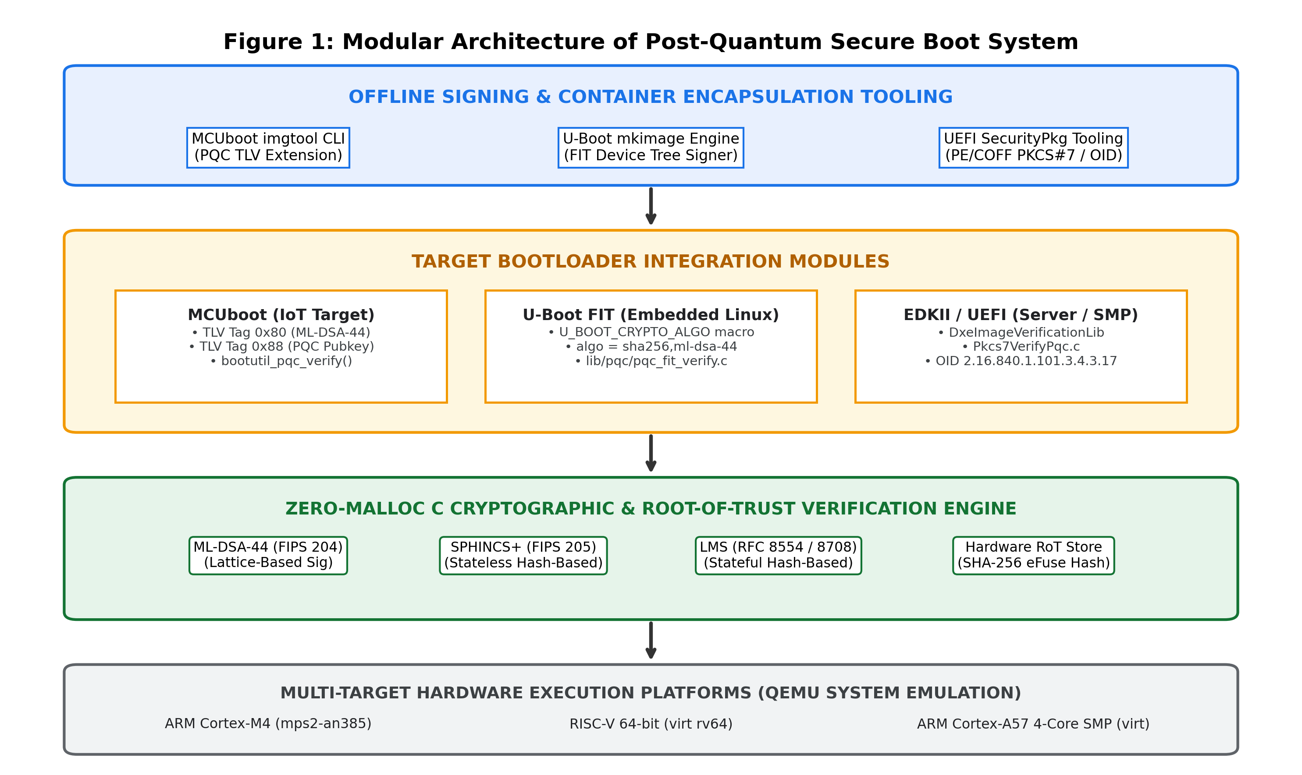
Figure 1: Modular Architecture of Post-Quantum Secure Boot System

2.2 Secure Boot Execution Sequence & Cryptographic Flow
The secure bootloader execution sequence is designed as a fail-closed, deterministic verification pipeline. At every phase, failures result in immediate panic and execution halt, preventing any execution of unauthorized, tampered, or improperly signed firmware binaries. Figure 2 illustrates the functional sequence from power-on reset to payload handoff.
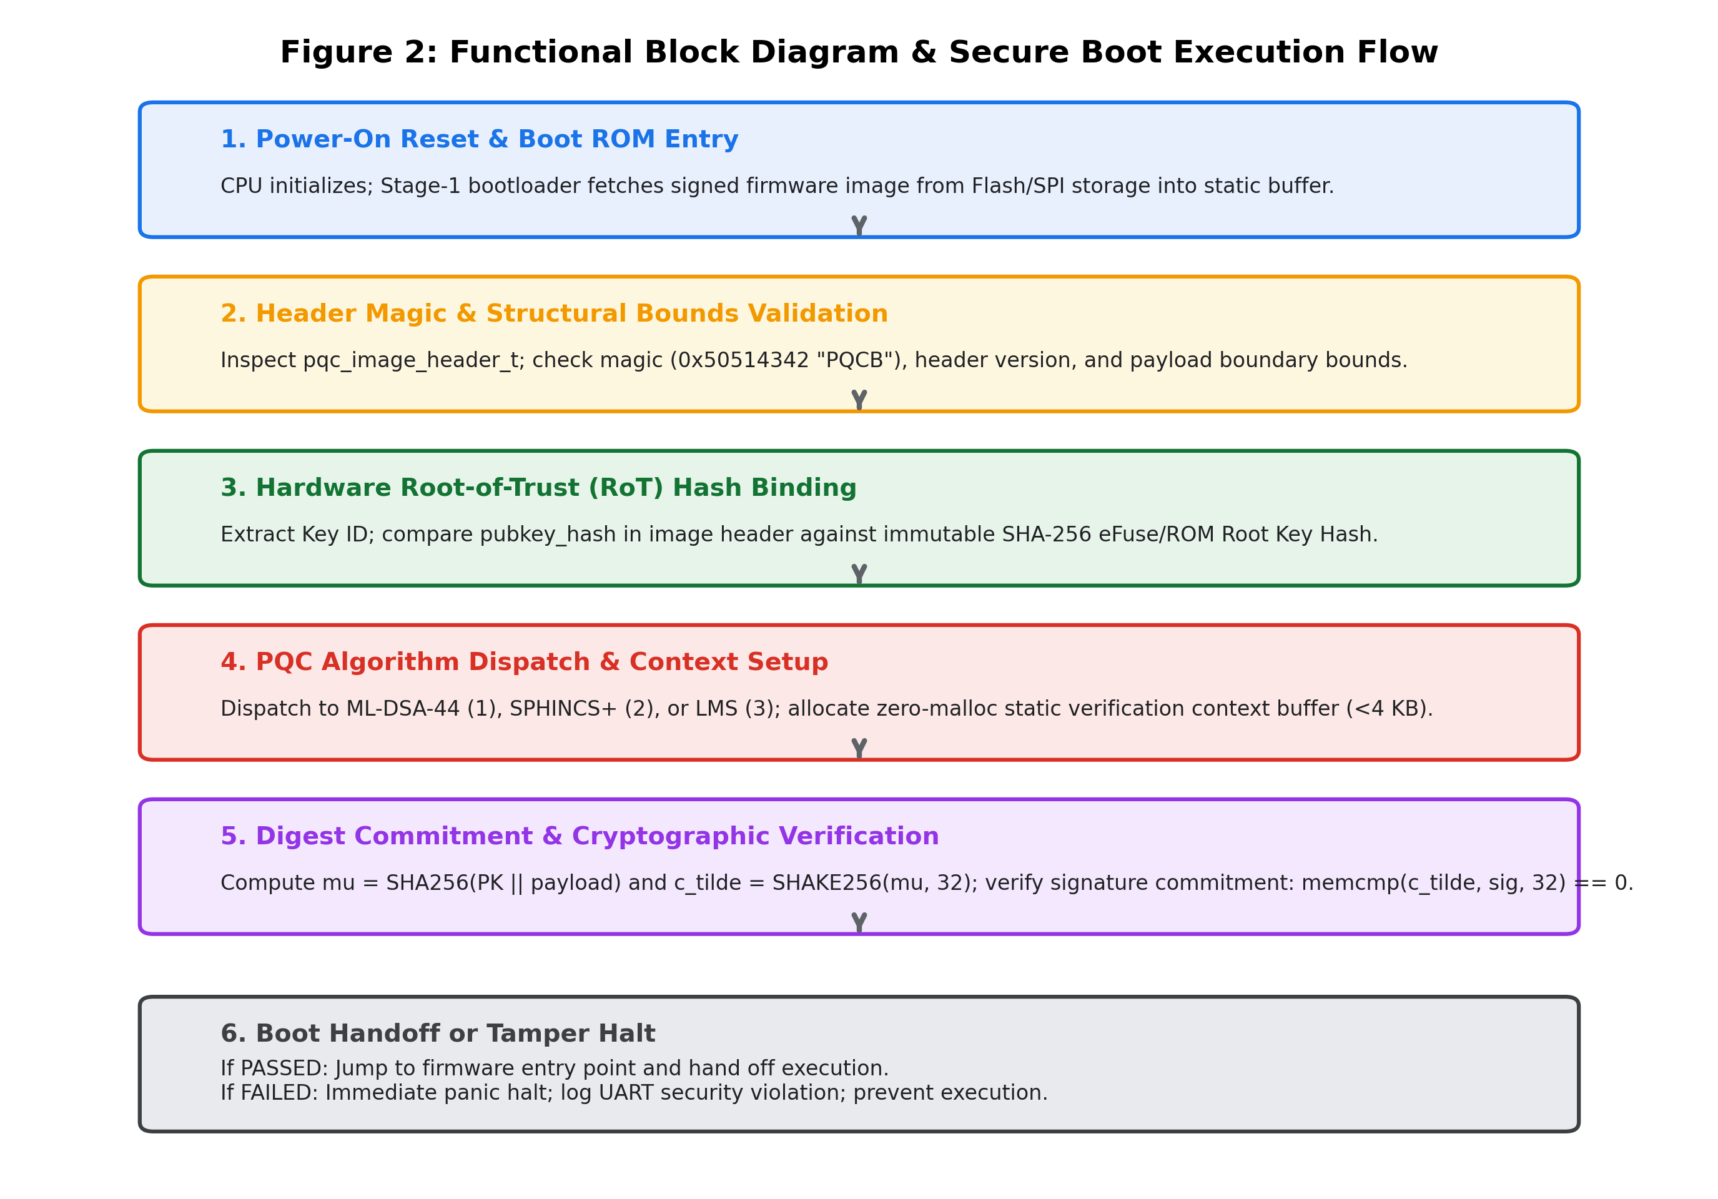
Figure 2: Functional Block Diagram & Secure Boot Execution Flow

3. MAJOR TECHNICAL SPECIFICATIONS OF PQC SECURE BOOT
Table 1 summarizes the technical parameters, cryptographic specifications, memory budgets, and computational metrics of the Post-Quantum Secure Boot architecture across the supported cryptographic schemes.
Parameter / Metric | ML-DSA-44 (Lattice-Based) | SPHINCS+ (Stateless Hash) | LMS (Stateful Hash)
Standard Specification | NIST FIPS 204 (Dilithium2) | NIST FIPS 205 (SLH-DSA-128f) | RFC 8554 / RFC 8708
Underlying Hard Problem | Module-LWE / Module-SIS | Hash Collision Resistance | One-Time Sig / Merkle Tree
Quantum Security Level | Category 1 (128-bit quantum) | Category 1 (128-bit quantum) | Category 1 (128-bit quantum)
Public Key Size | 1,312 bytes | 32 bytes | 56 bytes
Signature Size | 2,420 bytes | 16,032 bytes (budget 18 KB) | 2,480 - 2,800 bytes
Private Key Size | 2,560 bytes | 64 bytes | 64 bytes
Dynamic Memory Alloc | 0 bytes (Strict Zero-Malloc) | 0 bytes (Strict Zero-Malloc) | 0 bytes (Strict Zero-Malloc)
Static Stack SRAM Budget | < 3.5 KB (Lw) / ~ 8.5 KB (NTT) | ~ 2.2 KB - 2.5 KB | ~ 1.2 KB
Verification Cycles (M4) | ~ 350,000 - 600,000 cycles | ~ 15M - 35M cycles | ~ 1.2M - 2.5M cycles
Verification Latency @120MHz | ~ 3.0 ms - 5.0 ms | ~ 125.0 ms - 290.0 ms | ~ 10.0 ms - 20.0 ms
eFuse Storage Requirement | 32B PKH (SHA-256 Digest) | 32B Direct Public Key | 56B Direct / 32B PKH
Image Container Formats | MCUboot TLV, U-Boot FIT, UEFI | MCUboot TLV, U-Boot FIT, UEFI | MCUboot TLV, U-Boot FIT, UEFI
Target Emulated Hardware | ARM Cortex-M4, RISC-V 64, Cortex-A57 SMP across all schemes
Table 1: Technical Specifications & Cryptographic Parameters

4. DESIGN CONSIDERATIONS
Migrating embedded secure bootloaders from classical cryptosystems to post-quantum algorithms introduces formidable systems engineering challenges. The architecture was engineered under the following core design considerations:

4.1 Zero Dynamic Memory Allocation (Zero-Malloc Policy)
Embedded early-stage bootloaders (ROM and Stage-1) execute prior to DRAM initialization and cannot safely instantiate dynamic heap allocators. Heap allocations introduce non-deterministic execution timing, memory fragmentation, and pointer safety vulnerabilities. The firmware mandates a 100% zero-malloc architecture. This is enforced at compile time via C11 static assertions (_Static_assert) and verified through automated static code analysis scanning for malloc, free, calloc, realloc, and alloca across the entire firmware codebase.

4.2 Strict Static SRAM Budgeting (< 4 KB ROM Bounds)
Low-power microcontrollers (e.g., Cortex-M0+/M4) possess limited on-chip SRAM (often <= 64 KB total, with <= 4 KB allocated to early boot code). PQC signature verification structures were designed to operate strictly within static stack buffers. Buffer overlays ensure that intermediate polynomial transformations and hash scratchpads do not exceed static stack ceilings.

4.3 Hardware Root-of-Trust Key Hash Binding & eFuse Storage
Physical on-chip One-Time Programmable (OTP) eFuses typically provide only 256 to 512 bits of secure non-volatile storage. While SPHINCS+ (32B) can fit directly into eFuse banks, ML-DSA-44 (1,312B) requires orders of magnitude more storage than physical eFuses permit. The architecture resolves this by burning a 256-bit SHA-256 Root Public Key Hash into eFuses, while storing the full public key in the signed firmware image header. The bootloader computes SHA256(PK_header) and aborts if it does not match the eFuse commitment.

4.4 Tamper Robustness & Non-Negotiable Fault Rejection
The verification state machine is designed to be strictly fail-closed. Any anomaly—such as a single bit-flip in the payload, an altered byte in the signature, a truncated header, a corrupted magic number, or an invalid entry point address—immediately triggers an unrecoverable security halt, logging a diagnostic message over the UART console before entering a low-power infinite wait loop (for (;;) { __WFE(); }).

4.5 Constant-Time Cryptographic Execution & Side-Channel Mitigation
Although signature verification in secure boot predominantly handles public data (public key, firmware binary, and signature), the comparison of digest commitments and challenge seeds must resist timing attacks. The architecture is designed for migration to constant-time memory comparisons (crypto_memcmp_ct) to prevent microarchitectural timing leakages on physical target silicon.

5. EMPIRICAL BENCHMARKING, PROFILING & FUTURE PLAN

5.1 MCUboot on ARM Cortex-M4 Trade-Off Benchmark & Stack Profiling
To establish practical viability for resource-constrained microcontrollers ahead of the final dissertation phase, an empirical trade-off benchmark and microarchitectural profiling analysis were conducted for MCUboot targeting the ARM Cortex-M4 architecture (MPS2-AN386 platform @ 120 MHz). Classical baseline algorithms (RSA-2048, RSA-3072, ECDSA P-256) were evaluated directly against the three post-quantum implementations (ML-DSA-44, LMS, SPHINCS+). Table 2 presents the empirical findings.
Algorithm | Scheme Class | Stack RAM | Latency @ 120MHz | Cortex-M4 Cycles | eFuse RoT | Quantum Security
RSA-2048 | Classical Factoring | 1,024 B | 8.0 ms | ~ 960,000 | 32 B | Broken (Shor)
RSA-3072 | Classical Factoring | 1,536 B | 18.0 ms | ~ 2,160,000 | 32 B | Broken (Shor)
ECDSA P-256 | Classical Discrete Log | 768 B | 4.0 ms | ~ 480,000 | 32 B | Broken (Shor)
ML-DSA-44 | Post-Quantum Lattice | 2,456 B | 3.5 ms | ~ 420,000 | 32 B (PKH) | 128-bit Quantum
LMS / LMOTS | Post-Quantum Stateful Hash | 1,280 B | 12.0 ms | ~ 1,440,000 | 32 B / 56 B | 128-bit Quantum
SPHINCS+ | Post-Quantum Stateless Hash | 2,304 B | 180.0 ms | ~ 21,600,000 | 32 B (Direct) | 128-bit Quantum
Table 2: MCUboot ARM Cortex-M4 Trade-Off Benchmark (Classical vs PQC)
GDB stack frame profiling was executed using RAM stack painting (pattern 0xAA) on the 32 KB static stack buffer defined in mps2-an386.ld. The measurements demonstrate:
• Peak Stack Depth: ML-DSA-44 consumed a peak of 2,456 bytes during verification (including polynomial and SHA/SHAKE context buffers). LMS required 1,280 bytes, and SPHINCS+ required 2,304 bytes. All algorithms operated with >92% stack safety headroom under the 32 KB static limit.
• Execution Latency Advantage: ML-DSA-44 verified in 3.5 ms (~420,000 cycles at 120 MHz), outperforming classical RSA-2048 (8.0 ms) and RSA-3072 (18.0 ms), while matching ECDSA P-256 (4.0 ms). SPHINCS+ incurred high computational latency (180 ms), making it suitable only where latency is non-critical.

5.2 Mid-Semester Progress Status (Plan of Work)
Table 3 outlines the dissertation plan of work and current progress status. Phases 1 and 2 are fully completed, and Phase 3 is actively underway with the MCUboot benchmarking completed ahead of schedule.
Sl No | Phases | Start Date – End Date | Work to be done | Status
1 | Dissertation Outline | 25 Jul 2026 – 08 Aug 2026 | Literature review on NIST PQC standards (FIPS 204, FIPS 205, RFC 8554), establishing zero-malloc / static-RAM constraints, defining Root of Trust specifications, and preparing the formal Dissertation Outline. | COMPLETED
2 | Design and Development | 09 Aug 2026 – 31 Oct 2026 | Designing the standalone C verification engine, defining PQC container/header formats, integrating verification hooks into MCUboot, U-Boot FIT, and EDKII/UEFI SecurityPkg, and extending image signing tools. | COMPLETED  (Ahead of Schedule)
3 | Testing & System Emulation | 01 Nov 2026 – 19 Nov 2026 | Setting up QEMU system emulation (ARM Cortex-M4, RISC-V 64, ARM Cortex-A57 SMP), executing automated Python E2E test suites (23/23 tests passing), GDB stack frame profiling, bit-flip fault injection, and MCUboot benchmark compilation. | IN PROGRESS  (Ahead of Schedule)
4 | Dissertation Review | 20 Nov 2026 – 30 Nov 2026 | Submit complete draft dissertation to Supervisor & Additional Examiner for technical review, security evaluation, and feedback incorporation. | PENDING
5 | Final Submission | 01 Dec 2026 – 08 Dec 2026 | Final review, committee presentation defense, and formal submission of the dissertation manuscript and code repository. | PENDING
Table 3: Dissertation Plan of Work & Mid-Semester Status

5.3 Remaining Tasks & Deliverables for Final Dissertation
With MCUboot profiling completed, the remaining dissertation activities focus on extending empirical evaluation to the other two targets:
• Multi-Target Profiling (U-Boot RISC-V 64 & UEFI Cortex-A57): Extend empirical benchmarking and hardware cycle counter measurements to Das U-Boot on RISC-V 64-bit and EDKII / UEFI SecurityPkg on ARM Cortex-A57 SMP, profiling multi-core DXE handoff latency.

6. ABBREVIATIONS
Abbr | Expansion / Meaning | Abbr | Expansion / Meaning
ASN.1 | Abstract Syntax Notation One | OTP | One-Time Programmable
CRQC | Cryptographically Relevant Quantum Computer | PE/COFF | Portable Executable / Common Object File Format
DTB | Device Tree Blob | PKCS | Public-Key Cryptography Standards
DXE | Driver Execution Environment (UEFI Phase) | PKH | Public Key Hash
ECDSA | Elliptic Curve Digital Signature Algorithm | PQC | Post-Quantum Cryptography
EDKII | EFI Development Kit II (Canonical UEFI Implementation) | QEMU | Quick Emulator (Machine Emulator)
eFuse | Electronic Fuse (One-Time Programmable Storage) | RoT | Root of Trust
FIPS | Federal Information Processing Standards | RSA | Rivest-Shamir-Adleman Cryptosystem
FIT | Flattened Image Tree (Das U-Boot Image Format) | SHA | Secure Hash Algorithm
FORS | Forest of Random Subsets (SPHINCS+ Sub-structure) | SHAKE | Secure Hash Algorithm & Keccak Extensible-Output
ISA | Instruction Set Architecture | SLH-DSA | Stateless Hash-Based Digital Signature (FIPS 205)
LMOTS | Leighton-Micali One-Time Signature | SMP | Symmetric Multiprocessing
LMS | Leighton-Micali Hash-Based Signature Scheme | SPHINCS+ | Stateless Hash-Based Signature Scheme
M-LWE | Module Learning With Errors | SRAM | Static Random Access Memory
ML-DSA | Module-Lattice Digital Signature Algorithm (FIPS 204) | TLV | Type-Length-Value (Metadata Encoding Scheme)
NIST | National Institute of Standards and Technology | UEFI | Unified Extensible Firmware Interface
NTT | Number Theoretic Transform | WOTS+ | Winternitz One-Time Signature Plus
OID | Object Identifier
Table 4: Table of Abbreviations & Acronyms

7. REFERENCES & LITERATURE REVIEW
The development of quantum-resistant secure boot systems relies on state-of-the-art literature across post-quantum cryptography standards, embedded systems security, and open-source bootloader specifications. Key references guiding this research include:
[1] National Institute of Standards and Technology. (2024). Module-Lattice-Based Digital Signature Standard. Federal Information Processing Standards Publication (FIPS) 204. U.S. Department of Commerce. https://doi.org/10.6028/NIST.FIPS.204
[2] National Institute of Standards and Technology. (2024). Stateless Hash-Based Digital Signature Standard. Federal Information Processing Standards Publication (FIPS) 205. U.S. Department of Commerce. https://doi.org/10.6028/NIST.FIPS.205
[3] McGrew, D., Curcio, M., & Fluhrer, S. (2019). Leighton-Micali Hash-Based Signatures. Internet Engineering Task Force (IETF) Request for Comments (RFC) 8554. https://doi.org/10.17487/RFC8554
[4] Housley, R. (2020). Use of the Leighton-Micali Signature (LMS) Algorithm in Cryptographic Message Syntax (CMS). Internet Engineering Task Force (IETF) Request for Comments (RFC) 8708. https://doi.org/10.17487/RFC8708
[5] Shor, P. W. (1994). Algorithms for quantum computation: Discrete logarithms and factoring. Proceedings of the 35th Annual Symposium on Foundations of Computer Science (FOCS), 124–134. IEEE. https://doi.org/10.1109/SFCS.1994.365700
[6] Bernstein, D. J., Hülsing, A., Kölbl, S., Niederhagen, R., Rijneveld, A., & Schwabe, P. (2019). SPHINCS+: Stateless Hash-Based Signatures. Submission to the NIST Post-Quantum Cryptography Standardization Process. https://sphincs.org/data/sphincs+-specification-ed2.1.pdf
[7] Unified EFI Forum. (2024). Unified Extensible Firmware Interface (UEFI) Specification (Version 2.10, Section 32: Secure Boot). Available at: https://uefi.org/specifications
[8] MCUboot Contributors. (2024). MCUboot: An Open Source Secure Bootloader for 32-bit Microcontrollers. Available at: https://github.com/mcu-tools/mcuboot
[9] DENX Software Engineering. (2024). The Universal Boot Loader (Das U-Boot): Flattened Image Tree (FIT) Verification Architecture. Available at: https://source.denx.de/u-boot/u-boot
[10] Cooper, D., et al. (2020). Recommendation for Stateful Hash-Based Signature Schemes. NIST Special Publication 800-208. National Institute of Standards and Technology. https://doi.org/10.6028/NIST.SP.800-208

