TASK:3

**CREATING A MINIKUBE SERVICE TO HANDLE CONTAINERS**

**AIM:**

**The objective is to push a Docker image to Docker Hub and deploy it on Minikube to ensure that the application runs successfully in a Kubernetes environment. This involves:**

Building & Pushing Docker Image:

* **Creating a Docker image of the application.**
* **Pushing the image to Docker Hub for accessibility.**

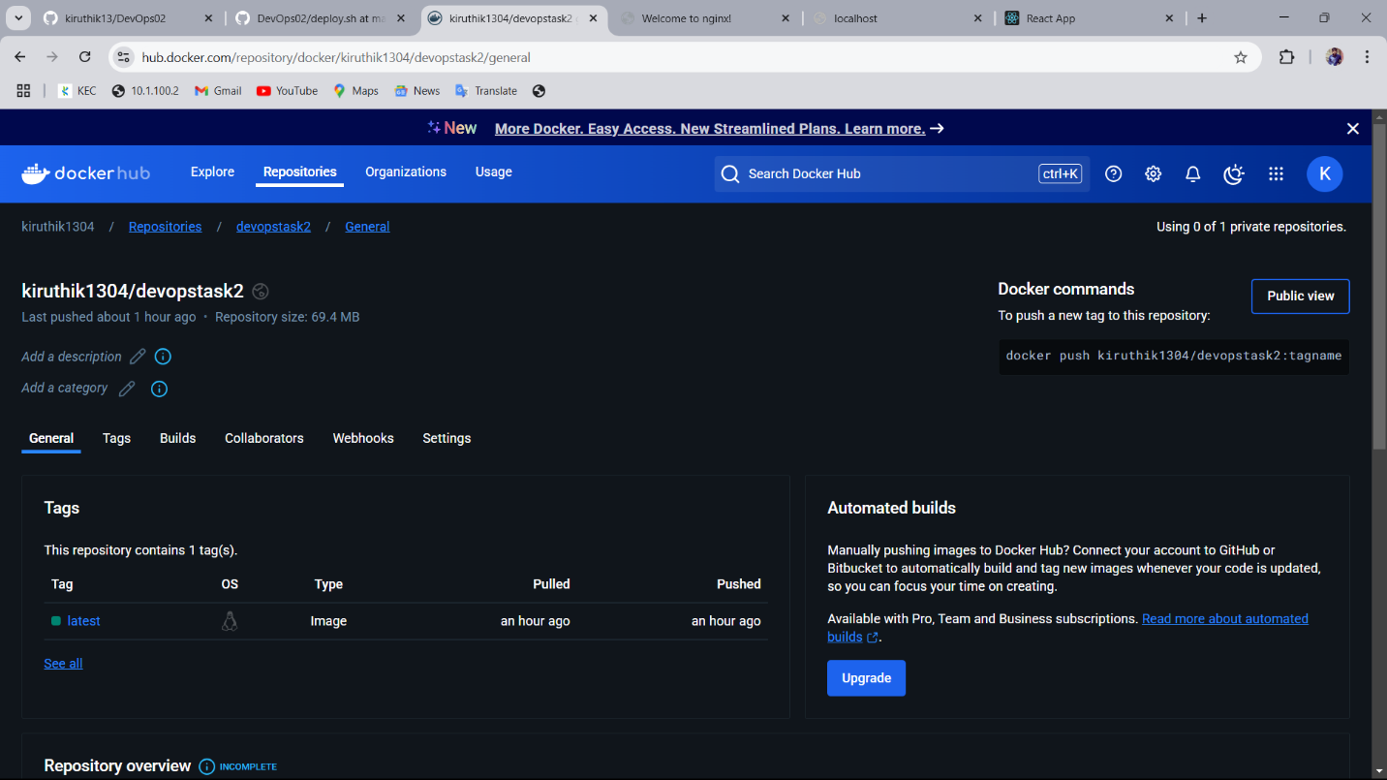

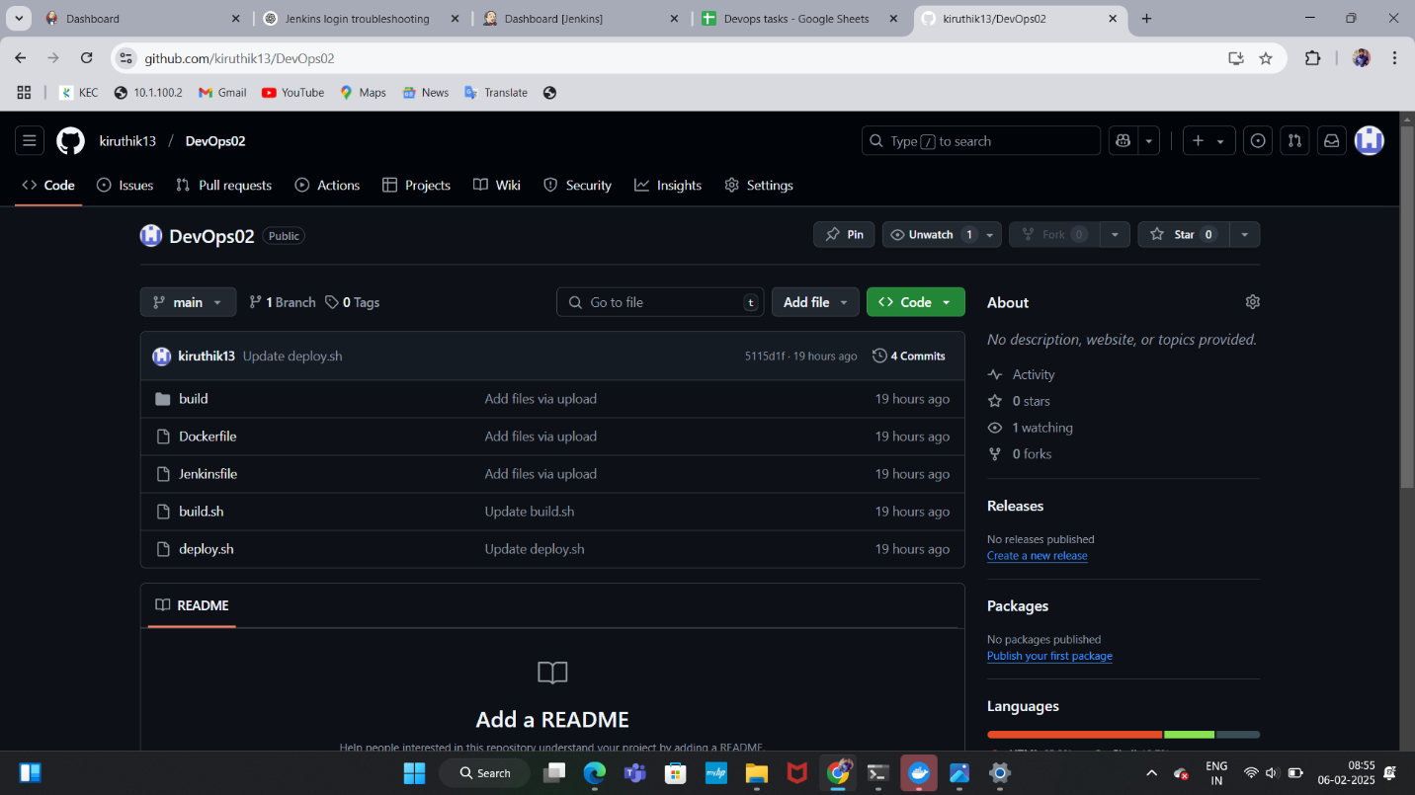

**Setting Up Minikube:**

* **Starting a Minikube cluster locally.**
* **Configuring Minikube to pull images from Docker Hub.**







**Verifying Deployment:**

* **Checking if the pods are running.**
* **Accessing the application through Minikube service.**

