***Building Maven with pipeline concept through Jenkins***

***Objective***

The objective is to deploy the GitHub repository [Ekart](https://github.com/Athik01/Ekart.git) on Minikube using Jenkins pipelines and access it locally in a browser.

***Procedure:***

1. **Setup Jenkins on Windows** 
   * Installed **Jenkins** on a Windows machine.
   * Configured Jenkins to use **Kubernetes for dynamic build agents**.
   * Installed required **Jenkins plugins** for Kubernetes integration.
2. **Installed and Configured Minikube** 
   * Installed **Minikube** on the Windows machine.
   * Initialized Minikube using:

minikube start

* + Verified Minikube was running using:

minikube status

1. **Installed and Configured kubectl** 
   * Installed kubectl and configured it to interact with Minikube.
   * Checked the Kubernetes cluster status:

kubectl cluster-info

1. **Cloned the GitHub Repository in Jenkins** 
   * Configured Jenkins to pull the Ekart repository from GitHub.

Steps 1: preparing the Repository

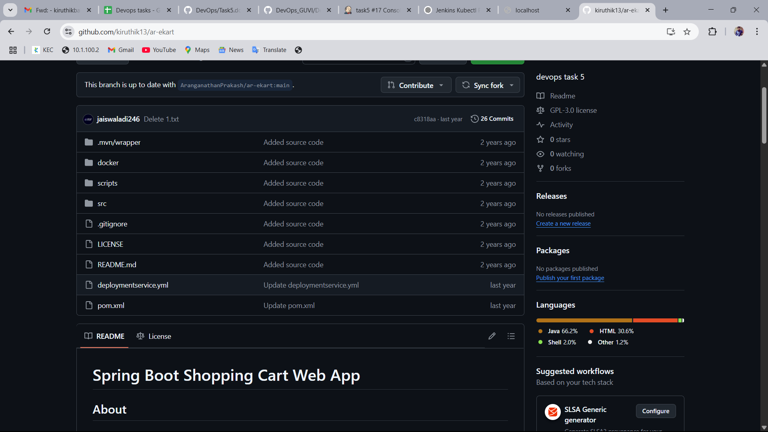

Step 2: Add JDK and Maven path to Jenkins

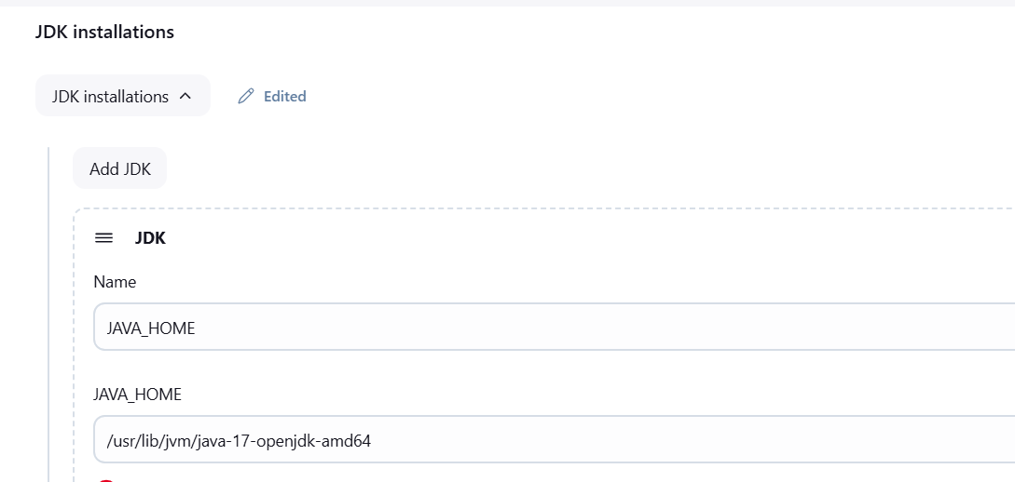

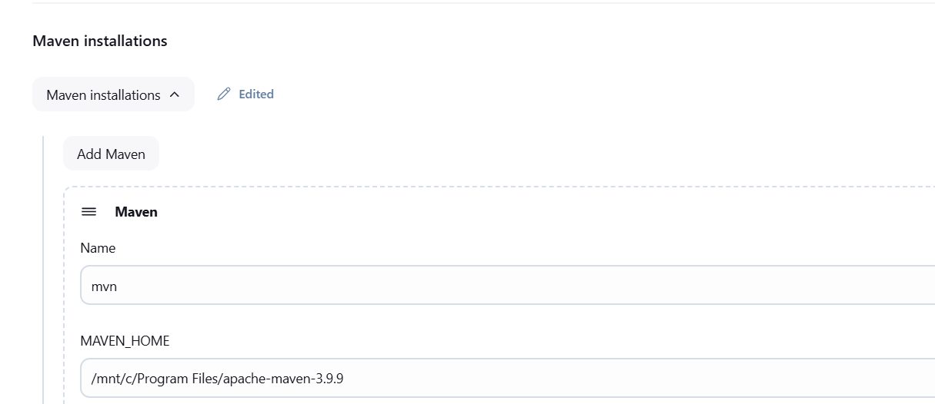

Step 3: Adding Github Repository Link

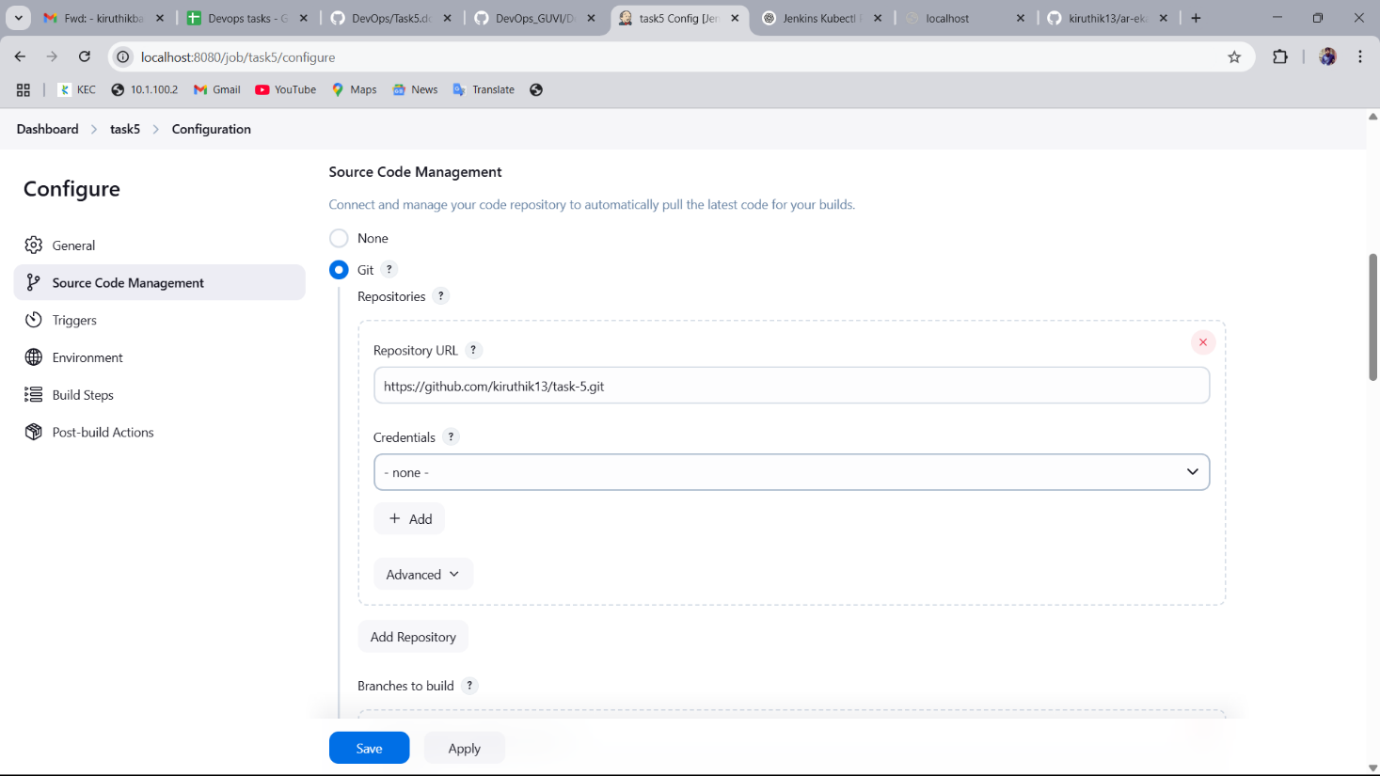

Step 4 : **Choosing Invoke top-level Maven targets** in build steps and Selecting the Maven and adding command to quickly build an artifact without executing tests.

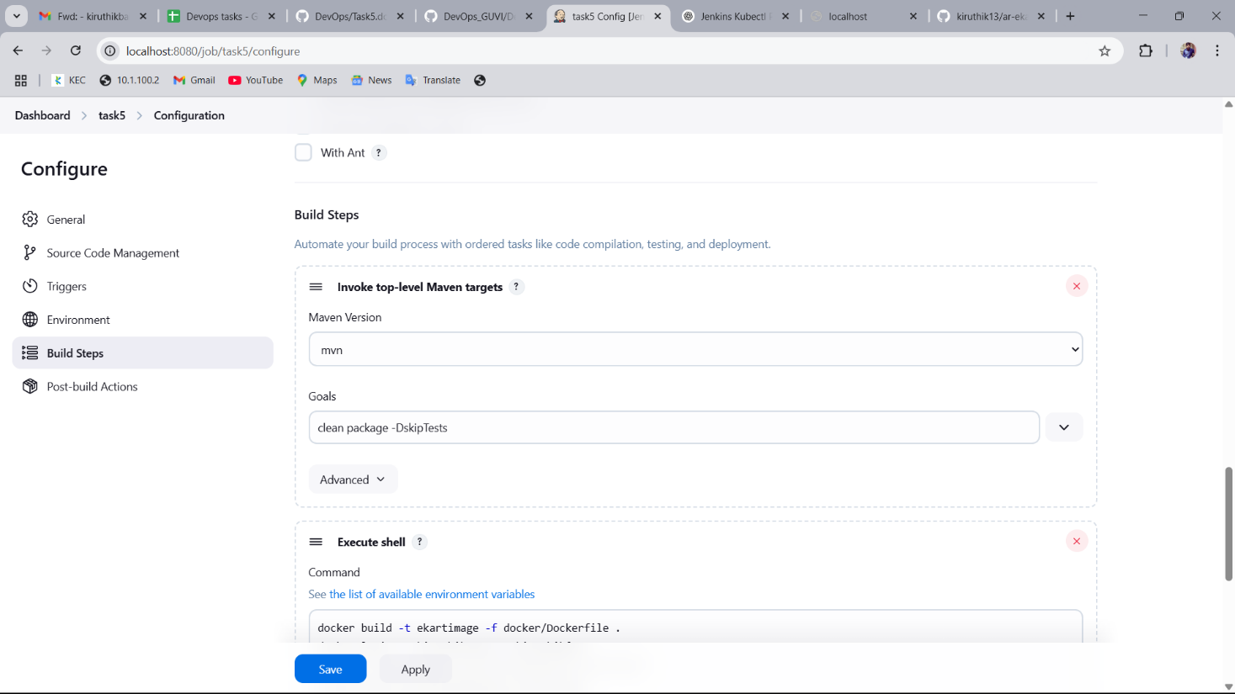

Step 5 : Executing Shell commands

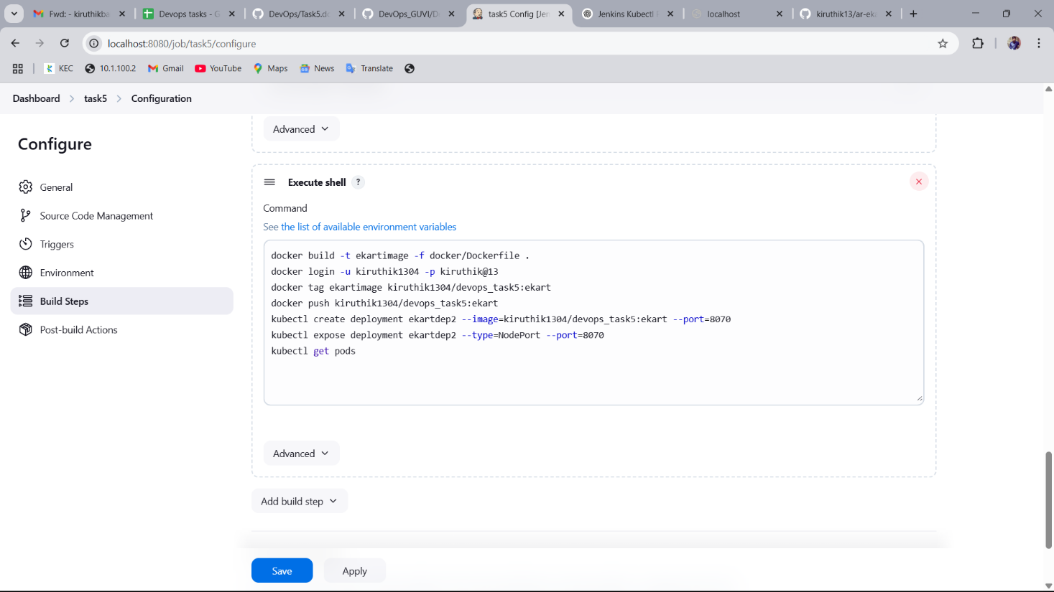

Step 6: Successful execution of the above commands and generation of war file for Tomcat deployment.

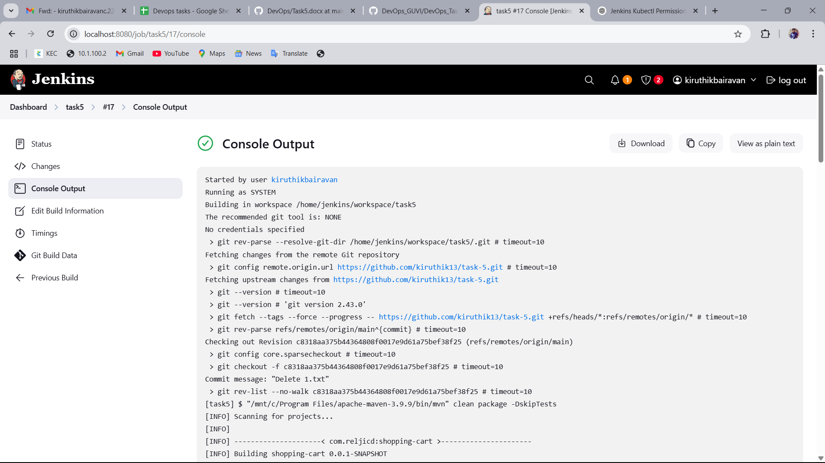

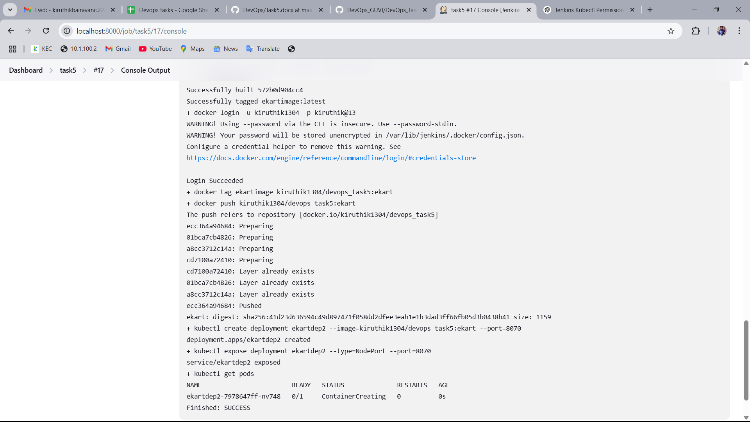

Step 7: **Managing deployment with Kubernates**

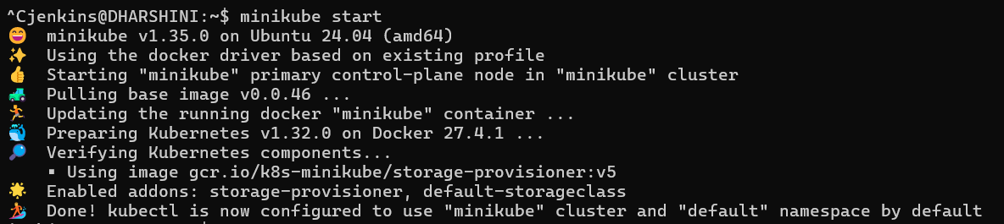

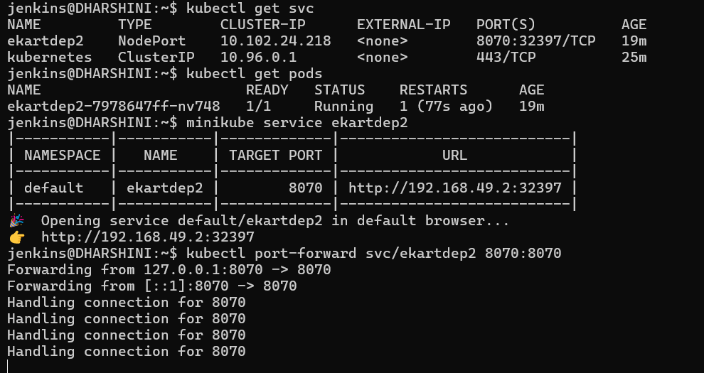

Step 8: Find the output in this URL : http://192.168.49.2:32397 Target port:8070

