SWIFTTRACKER
AI-STYLE PARCEL BOOKING & TRACKING SYSTEM
HTML, CSS & JavaScript Based Web Project
PROJECT REPORT
A frontend single-page parcel management application for booking, tracking,
agent updates, administration and parcel assistance.
Prepared in the same chapter-style organization as the supplied SwiftShip Tracker reference report,
with the content adapted to the new SwiftTracker implementation and screenshots.

1. Abstract
SwiftTracker is a web-based parcel booking and tracking application designed to bring the main stages of parcel management into a single interface. The system allows a customer to enter sender and receiver details, create a parcel booking, generate a unique tracking ID, and monitor the shipment through four delivery stages: Booked, In Transit, Out for Delivery, and Delivered.
The application also provides an Agent Console for advancing parcel status, an Admin Dashboard for operational monitoring, and a Swift AI Assistant for basic parcel-related queries. The current prototype is implemented using HTML5, CSS3 and vanilla JavaScript. Parcel records are stored in browser localStorage, allowing the different views to use the same data without a server.
The user interface uses a dark navy background, purple and blue gradients, glass-style cards, glowing controls, animated background elements and responsive layouts. This gives the project a modern logistics-dashboard appearance while keeping the implementation simple enough to run directly in a browser.

Core Features
- Parcel booking with sender, receiver, address, phone, weight and expected delivery date.
- Automatic generation of an ST-##### tracking ID.
- Four-stage parcel delivery timeline.
- Agent Console for status progression.
- Admin Dashboard with parcel counters and record table.
- Swift AI Assistant for basic status and booking queries.
- Browser localStorage persistence.
- Responsive and animated UI.

2. Introduction
Customers often need to move between different screens or support channels while booking and tracking a parcel. SwiftTracker simplifies this flow by providing booking, tracking, agent and administrative functions inside one single-page web application.
The supplied reference report follows the same general concept: a frontend prototype models the Parcel, Sender, Receiver and Delivery workflow, while localStorage acts as a lightweight persistence layer. SwiftTracker preserves this functional organization but uses a new interface, new styling and the implementation represented by the screenshots supplied for this project.

Problem Statement
A parcel-management prototype should demonstrate how a shipment is created, identified, tracked, updated and monitored. It should also show how different roles can interact with the same parcel data.

Proposed Solution
SwiftTracker uses a shared browser data store. Booking creates the record, Track reads the record, Agent Console updates the status, Admin summarizes the records, and the assistant provides a conversational view over the same data.

3. Objectives
- Design a responsive single-page interface for parcel booking and tracking.
- Generate a unique tracking reference for every new parcel booking.
- Visually represent the parcel lifecycle from booking to delivery.
- Reduce the complexity of checking delivery status across screens.
- Provide a simple assistant interface for parcel-related questions.
- Allow agents to progress a parcel through its predefined delivery stages.
- Give administrators a clear view of parcel counts and records.
- Persist parcel information locally so all modules share the same data.
- Create a professional interface using gradients, glassmorphism and animations.
- Keep the prototype easy to run without a build system or server.

4. Literature Review
The supplied SwiftShip reference report explains that courier and logistics platforms normally use full-stack systems containing a database, backend APIs and an AI or support service. It also identifies frontend technologies as useful for structuring booking, tracking and dashboard screens, styling role-appropriate interfaces, and validating interaction flows before backend investment.
- HTML is used to structure booking forms, tracking screens, navigation and dashboards.
- CSS is used to create clear role-based layouts and responsive visual design.
- JavaScript drives form handling, navigation, status updates and assistant interactions.
- Frontend-only prototypes are useful for rapidly validating end-to-end parcel workflows.
- localStorage can represent a temporary persistence layer during early prototyping.
SwiftTracker applies these principles to the parcel-management domain. The project is therefore a functional frontend prototype rather than a production logistics platform.

5. System Architecture
The application behaves as a small single-page application. Navigation switches between visible sections without a full page reload. All modules use the same parcel array stored in localStorage.
Layer | Responsibility | SwiftTracker implementation
Presentation Layer | Displays the user interface and responsive components. | HTML5 + CSS3
Interaction Layer | Handles clicks, forms, tracking and status changes. | Vanilla JavaScript
Data Layer | Persists parcel records in the browser. | localStorage key: swift_tracker_data_v2
Assistant Layer | Interprets simple parcel questions. | Rule-based JavaScript matching

Functional Flow
Customer → Book Parcel → Generate Tracking ID → Track Parcel → Agent Updates Status → Admin Monitors Records
The Assistant can query the same tracking records and return the current status and ETA.

6. Data Model
Each parcel is represented as a JSON-serializable JavaScript object. The object is stored inside an array in browser localStorage.
Field | Type | Description
id | String | Tracking ID such as ST-32880.
status | String | Booked, In Transit, Out for Delivery, or Delivered.
created | ISO DateTime | Time when the booking was created.
sender | String | Sender name.
receiver | String | Receiver name.
senderAddress | String | Sender address.
receiverAddress | String | Receiver address.
senderPhone | String | Sender contact number.
receiverPhone | String | Receiver contact number.
weight | Number/String | Parcel weight in kilograms.
eta | Date | Expected delivery date.
This model is intentionally simple for the browser prototype. A future database implementation could separate Parcel, Sender, Receiver and Delivery entities while retaining the same user-facing workflow.

7. Methodology
- Requirement Analysis — Identified parcel booking, tracking, delivery status, agent operation and administration requirements.
- Design Planning — Planned a persistent sidebar with Home, Book Parcel, Track Parcel, Agent Console, Admin Dashboard and AI Assistant views.
- Data Modelling — Defined the parcel object and four-stage status lifecycle.
- Frontend Development — Built the structure with HTML5, styling with CSS3 and behaviour with vanilla JavaScript.
- Visual Enhancement — Added purple/blue gradients, glassmorphism cards, animated background effects, glowing buttons and responsive layouts.
- Integration — Connected all modules to the same localStorage-backed parcel array.
- Testing — Checked booking, tracking, status progression, assistant responses, dashboard counts and responsive behaviour.

8. Implementation
The implemented application contains the following major capabilities:
- Home Dashboard — introduces SwiftTracker and highlights Fast Booking, Live Tracking, AI Assistant and Easy Management.
- Book Parcel — collects sender/receiver details, weight and expected delivery date, then generates a tracking ID.
- Track Parcel — searches by tracking ID and renders a four-stage timeline with shipment details.
- Agent Console — lists stored parcels and advances each parcel to the next status.
- Admin Dashboard — displays total, booked, in-transit and delivered counts and a parcel table.
- Swift AI Assistant — detects tracking IDs and provides basic status/ETA responses.
- Demo Data — provides sample records for demonstrations.
- Clear Data — removes browser-stored parcel records after confirmation.

9. Technologies Used
Technology | Purpose
HTML5 | Semantic structure for navigation, forms, cards, timelines, tables and chat.
CSS3 | Responsive layout, gradients, glassmorphism, glowing borders and animations.
JavaScript | Navigation, booking, tracking, status updates, dashboard rendering and assistant logic.
Browser localStorage | Client-side persistence of parcel data.
Google Fonts | Modern typography used by the interface.
Web Browser | Execution environment; no server is required for the prototype.

10. Modules

10.1 Home Dashboard
Provides the landing screen and introduces the main parcel-management capabilities.

10.2 Book Parcel
Captures sender and receiver information, parcel weight and expected delivery date. On submission, an ST-##### tracking ID is created and the record is stored.

10.3 Track Parcel
Accepts a tracking ID and displays the current status, sender, receiver, ETA and weight along a four-stage timeline.

10.4 Agent Console
Shows all parcel records and provides an Update button that advances the parcel through the delivery lifecycle.

10.5 Admin Dashboard
Calculates status counters and displays the complete stored parcel table.

10.6 Swift AI Assistant
Provides a chat-style interface. A tracking ID in the user message is matched against stored parcels and the current status and ETA are returned.

11. Code Walkthrough
Function / Logic | Purpose
save() | Writes the current parcels array to localStorage.
makeId() | Generates an ST-##### tracking ID and checks current records for duplication.
showView(id) | Switches the visible SPA section and active sidebar button.
Booking submit handler | Creates the parcel object, stores it and displays the generated tracking ID.
trackParcel() | Searches for a tracking ID and renders the delivery timeline and details.
nextStatus(id) | Advances the parcel to the next status.
renderAgent() | Builds the Agent Console table from stored records.
renderAdmin() | Calculates counters and renders the Admin Dashboard table.
loadDemo() | Adds predefined sample records for demonstration.
sendChat() / addMsg() | Handles assistant messages and rule-based parcel replies.
The code keeps data access and UI rendering separate enough that a future backend can replace the localStorage layer without redesigning the complete interface.

12. Code Used
The project is maintained as one self-contained HTML file. The source is divided logically into HTML structure, CSS styling and JavaScript logic.

12.1 HTML Structure
Defines the sidebar, header, six views, booking form, tracking timeline container, agent table, admin dashboard and assistant chat interface.

12.2 CSS Styling
Defines the dark navy/purple theme, gradient buttons, glass panels, animated grid, floating glow effects, status badges, timeline and responsive breakpoints.

12.3 JavaScript Logic
Implements localStorage persistence, navigation, booking, tracking, agent status updates, dashboard rendering, demo records and assistant responses.

Representative Code Fragment
const KEY = "swift_tracker_data_v2";
const statuses = [
"Booked",
"In Transit",
"Out for Delivery",
"Delivered"
];
function save() {
localStorage.setItem(KEY, JSON.stringify(parcels));
}
function makeId() {
let id;
do {
id = "ST-" + Math.floor(10000 + Math.random() * 90000);
} while (parcels.some(p => p.id === id));
return id;
}

13. Output Screens
The following screenshots are the actual SwiftTracker interface supplied with this project. The screens are included in the report in the same output-oriented style used by the reference report.
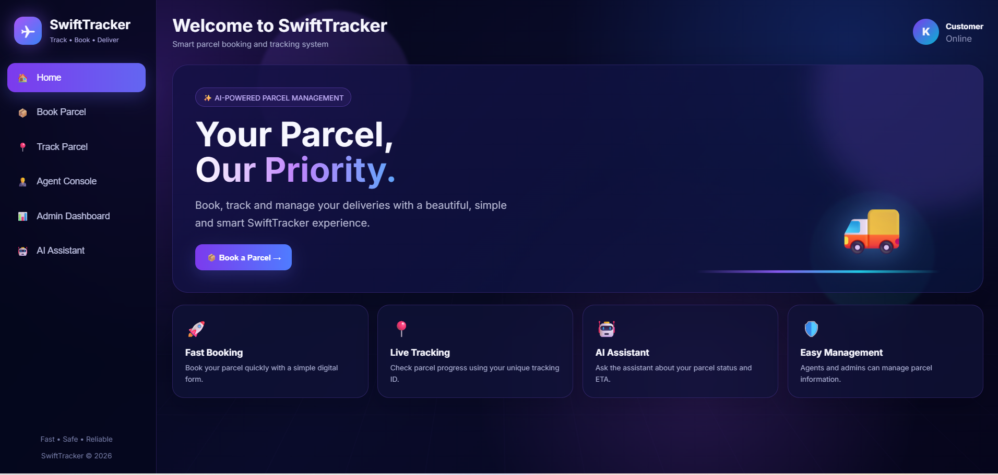
Figure 13.1 — SwiftTracker Home Dashboard

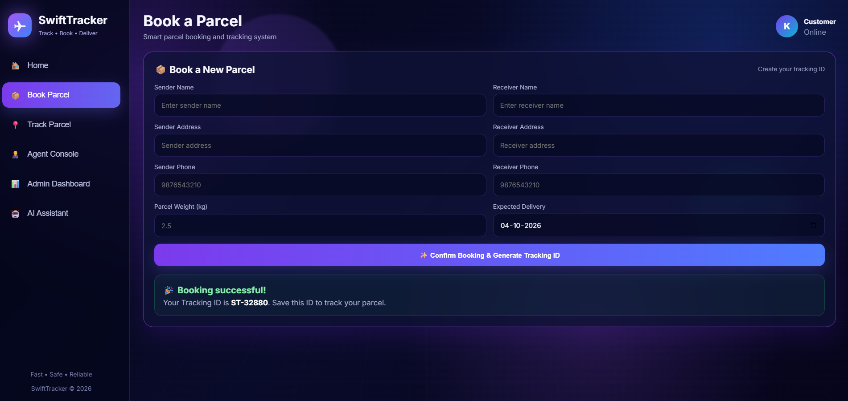
Figure 13.2 — Book a Parcel screen with successful booking confirmation

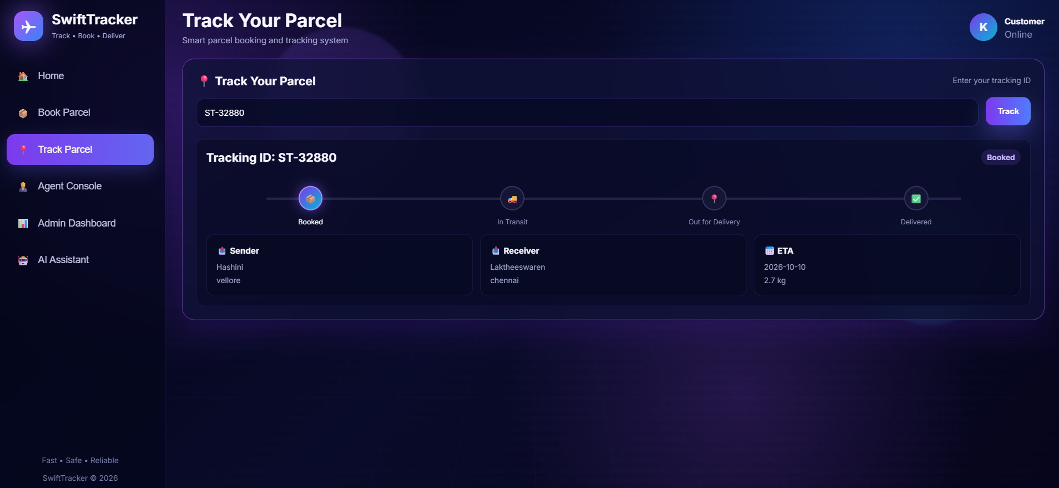
Figure 13.3 — Track Your Parcel screen with delivery timeline

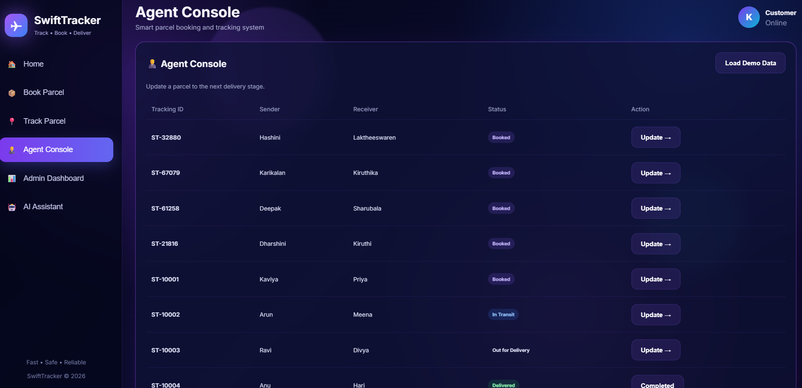
Figure 13.4 — Agent Console with parcel status controls

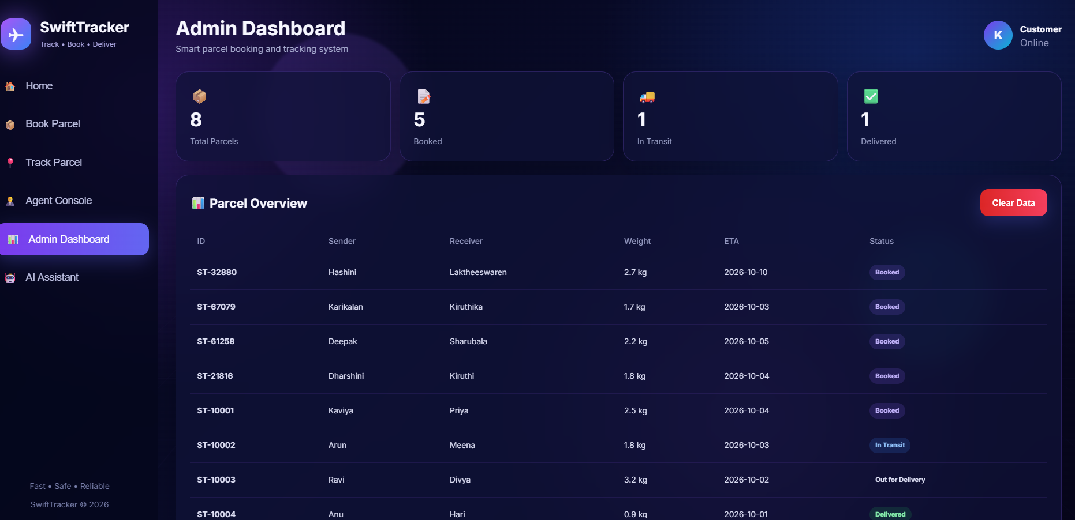
Figure 13.5 — Admin Dashboard with counters and parcel overview

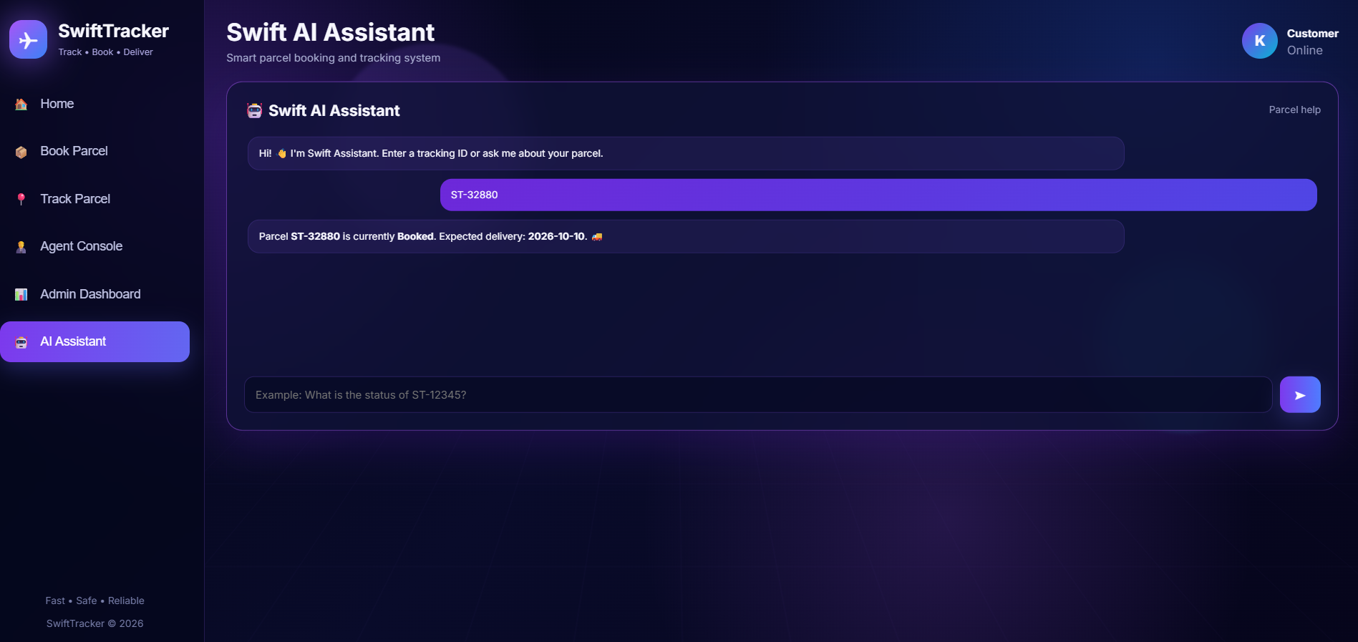
Figure 13.6 — Swift AI Assistant with tracking response

14. Testing
Testing follows the reference report's manual, end-to-end approach: booking is checked first, then the same record is used in Track, Agent and Admin views. Responsive behaviour and assistant interactions are also checked.
Test Case | Steps | Expected Result | Result
Book a parcel | Fill sender/receiver form and submit. | New ST-##### ID and confirmation appear. | Pass
Track valid ID | Enter an existing tracking ID. | Correct current stage and details appear. | Pass
Track invalid ID | Enter an unknown tracking ID. | Parcel-not-found message appears. | Pass
Agent update | Click Update for a parcel. | Status advances one stage. | Pass
Admin counters | Open Admin after creating/loading records. | Counters match stored parcel statuses. | Pass
Assistant tracking query | Enter a message containing a valid tracking ID. | Assistant returns status and ETA. | Pass
Demo data | Click Load Demo Data. | Sample records are inserted. | Pass
Clear data | Click Clear Data and confirm. | Records are removed and empty states appear. | Pass
Responsive layout | Resize the browser to a smaller viewport. | Cards, forms and tables adapt to available width. | Pass

15. Results
The project successfully demonstrates a complete frontend parcel workflow. A booking can be created, identified by a tracking ID, viewed through a delivery timeline, updated by an agent and summarized by an administrator.
- A clean interface covers booking, tracking, agent and admin flows.
- The assistant provides a believable parcel-query experience using rule-based matching.
- Status information remains consistent because the modules share the same browser data store.
- The responsive interface adapts to smaller screen sizes.
- The visual system provides a modern dark logistics dashboard with purple/blue accents and animated effects.
- The implementation provides a practical foundation for a future backend and real AI integration.
The current project does not claim to provide a real backend, live GPS tracking or a production language model. Those capabilities are identified as future extensions.

16. Advantages
- No installation or server is required for the prototype.
- Runs directly in a modern browser from one HTML file.
- Fast to demonstrate using the built-in demo-data loader.
- All modules share one stored parcel dataset.
- Easy to understand because it uses standard HTML, CSS and JavaScript.
- Modern visual design with responsive behaviour.
- Simple architecture makes future API integration practical.
- Clear separation between customer, agent and admin interactions.

17. Limitations
- Parcel data is stored per browser and is not shared between devices or users.
- The Swift AI Assistant is a rule-based matcher, not a real language model.
- There is no authentication or role-based access control.
- Email/SMS notifications are not actually sent; the interface uses visual confirmation/toast behaviour.
- Tracking is not connected to GPS or a live carrier network.
- Random tracking IDs are generated in the browser rather than by a centralized service.
- The prototype does not provide a real backend database.

18. Conclusion
SwiftTracker demonstrates how a frontend-only prototype can validate the parcel customer journey before investment in backend and AI infrastructure. Using HTML, CSS and JavaScript, the project combines parcel booking, tracking, agent status updates, administration and a conversational parcel assistant in one responsive interface.
The data model and module boundaries follow the same core Parcel/Sender/Receiver/Delivery concept used by the supplied reference report, while the new SwiftTracker implementation introduces its own dark-purple visual identity, animated interface and six-screen navigation.

19. Future Scope
- Replace the rule-based assistant with a real AI agent or LLM API.
- Connect the frontend to a backend and production database.
- Add authenticated login for customers, agents and administrators.
- Implement role-based permissions.
- Send real email/SMS/push notifications when status changes.
- Add analytics for delivery performance and regional operations.
- Add live map/GPS tracking during transit.
- Support bulk booking and multi-parcel shipments.
- Add payment and shipping-rate calculation.
- Add secure APIs and audit logs for production deployment.

20. Comparison with the Reference Salesforce-Based Design
The supplied reference report describes an original Salesforce-oriented design using custom objects, Flow Builder and AgentForce/Prompt Builder concepts. The current SwiftTracker project is a browser prototype that mirrors the interaction model rather than implementing those Salesforce services.
Concern | Reference Salesforce-Based Design | SwiftTracker Web Prototype
Data storage | Parcel/Sender/Receiver/Delivery custom objects | JavaScript parcel objects in browser localStorage
Automation | Salesforce record-triggered / auto-launched Flows | JavaScript event handlers
AI assistant | AgentForce agent with Prompt Builder topics/actions | Rule-based Swift AI Assistant
Access control | Profiles, permission sets and sharing rules | No authentication; prototype views are open
Notifications | Custom email alerts/templates | On-screen confirmation/toast behaviour
Hosting | Salesforce Experience Cloud / Lightning App | Single static HTML file
Reporting | Salesforce records and dashboards | Admin Dashboard with client-side counters/table
This comparison is included to preserve the reference report's original framing. SwiftTracker is a frontend implementation for demonstration and academic validation, not a claim of Salesforce integration.

21. File Structure & Deployment
The application is intentionally packaged as one self-contained HTML file.
File / Item | Purpose
SwiftTracker_Animated_Project.html | Complete application containing HTML, CSS and JavaScript.
Browser localStorage | Stores parcel records under swift_tracker_data_v2.
Google Fonts connection | Loads the interface font when internet access is available.
Screenshot set | Documents the Home, Book, Track, Agent, Admin and Assistant outputs.

Deployment
- Save the HTML file on a computer.
- Open it directly in a modern browser such as Chrome or Edge.
- No package manager, build step or server-side runtime is required for the current prototype.
- For production, move data and authentication to a secure backend and replace localStorage with an API/database.

22. References
- Supplied reference report: SwiftShip Tracker – AI-Powered Parcel Booking & Tracking System (HTML, CSS & JavaScript Based).
- HTML5 Documentation.
- CSS3 Documentation and responsive web design references.
- MDN Web Docs — HTML, CSS, JavaScript and Web Storage.
- W3Schools — HTML, CSS and JavaScript tutorials.
- Salesforce Trailhead — AgentForce and Prompt Builder documentation (for the reference architecture only).
Note: The report content above is adapted from the supplied reference report's chapter organization and project framing, while implementation details, UI descriptions and screenshots are based on the SwiftTracker project shown in this conversation.

