|  |
| --- |
| Exp.No:3  **Application of Jquery and Ajax**  7.03.2024 |

**Aim:**

To develop an application to demonstrate applications of Jquery and Ajax.

**Procedure:**

1. Fill out student details in form.

2. Click "Add Student" to submit.

3. JavaScript prevents default form submission.

4. Send data via AJAX to "add_student.php".

5. PHP script echoes added student details.

6. Alert shows "Student added successfully!" message.

7. AJAX request loads and updates student list.

8. Updated student list displayed on webpage.

**Code:**

<!DOCTYPE html>

<html>

<head>

<title>Student Details</title>

<script src="https://ajax.googleapis.com/ajax/libs/jquery/3.5.1/jquery.min.js"></script>

<script src="script.js"></script>

</head>

<body>

<h1>Student Details</h1>

<form id="studentForm">

<label for="name">Name:</label>

<input type="text" id="name" name="name"><br><br>

<label for="age">Age:</label>

<input type="text" id="age" name="age"><br><br>

<label for="grade">Grade:</label>

<input type="text" id="grade" name="grade"><br><br>

<input type="submit" value="Add Student">

</form>

<div id="studentList">

<!-- Student details will be displayed here -->

</div>

</body>

</html>

$('#studentForm').submit(function(event){

event.preventDefault();

var name = $('#name').val();

var age = $('#age').val();

var grade = $('#grade').val();

$.ajax({

type: "POST",

url: "add_student.php",

data: {

name: name,

age: age,

grade: grade

},

success: function(response){

// Display success message

alert("Student added successfully!");

// Refresh student list

loadStudentList();

},

error: function(xhr, status, error){

// Display error message

alert("Error adding student: " + error);

}

});

});

function loadStudentList(){

$.ajax({

type: "GET",

url: "get_students.php",

success: function(response){

$('#studentList').html(response);

},

error: function(xhr, status, error){

alert("Error loading student list: " + error);

}

});

}

loadStudentList();

});

<?php

if($_SERVER["REQUEST_METHOD"] == "POST"){

$name = $_POST["name"];

$age = $_POST["age"];

$grade = $_POST["grade"];

echo "Added Student:<br>";

echo "Name: $name<br>";

echo "Age: $age<br>";

echo "Grade: $grade<br>";

}

?>

<?php

$students = array(

array("name" => "Alice", "age" => 20, "grade" => "A"),

array("name" => "Bob", "age" => 21, "grade" => "B"),

array("name" => "Charlie", "age" => 19, "grade" => "A-")

);

foreach($students as $student){

echo "<div>";

echo "Name: " . $student["name"] . "<br>";

echo "Age: " . $student["age"] . "<br>";

echo "Grade: " . $student["grade"] . "<br>";

echo "</div>";

}

?>

**Output:**

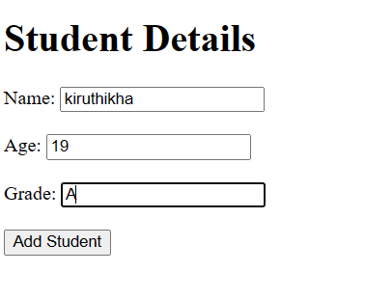

**Result:**

Thus the output of the experiment has been verified successfully.