**Cloud computing** changes business in several ways. Whether they store your data or how they protect your secure information, cloud computing benefits all companies in each sector.

Smart companies are always looking for the most innovative ways to improve and achieve their business objectives. When it comes to cloud technology, more and more companies are realizing the benefits that this technology can offer and start looking for more cloud computing options to do their business. With the multiplicity of future technological trends in cloud computing, companies in each sector benefit from the opportunities offered by cloud technology.

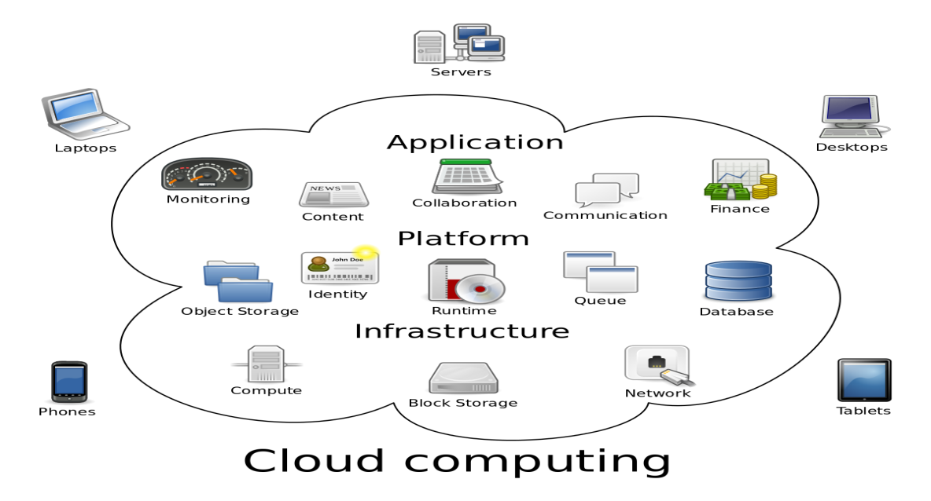

**What is the Future of** [**Cloud Computing**](http://gangboard.com/cloud-computing-training)**?**

We can’t tell, what will happen in future, but we can predict it by analyzing the current situations, trends and usage of technologies. So here are several predictions about the **Trends of Cloud Computing in Future**,

* Growth in cloud service solutions
* Introduction to the Internet of Everything (IoE)
* Increase storage capacity
* Improve cloud services
* Economic

**Growth in Cloud Service Solution**

The future growth of cloud computing began when the growth of infrastructure as a service, IaaS, and the platform as a service, PaaS, increased the number of cloud solutions available in the public and private sectors. As IaaS and PaaS continue to be used throughout the world to achieve various objectives, we will see that these solutions are the most frequent cloud services worldwide.

Cisco predicts that SaaS, software as a service, will account for more than 60% of all cloud-based workloads this year. They also expect PaaS and IaaS to increase in 2018. Any company that seeks to streamline its operations and make services easier to reach for customers will likely move to cloud services.

**Introduction to the Internet of Everything (IoE)**

The vast majority of us have heard the trendy expression, web of things, IoT. With ceaseless advancements continuously information examination and distributed computing, we will see the most up to date innovation trendy expression, the web of everything, be utilized all the more regularly as 2018 advances.



Cloud computing will assume a significant job in the manner IoE creates as it depends vigorously on a machine to machine interchanges, information, forms and the manner in which people connect with things in their condition. A significant pattern we will see this year is the critical job distributed computing will play in IoE's capacity to disentangle all collaborations.

**Increasing Storage Capacity**

Today, data is producing in a high volume and it's hard to store it with security. The vast majority of the organizations require a spot where they can safely store their data.

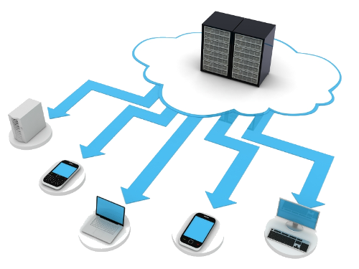

Such a significant number of organizations are receiving cloud figuring and it has been anticipated that the Cloud suppliers will give more data focuses at a lower cost as there is an enormous challenge between them.

**Improvement cloud services**

Cloud Computing includes several services as,

* Infrastructure as a Service
* Software as a Service
* Platform as a Service

With this service, we can accomplish our ideal objectives. There are numerous scientists which have demonstrated that Cloud Computing will be one of the main innovations later on as the product as a service arrangement will represent over 60% of the remaining task at hand. It likewise has been anticipated that the stage as a service and framework as a service will increment step by step as it has been utilized in the vast majority of the associations. Cloud Computing is easy to understand and is good with both new just as old associations.

**Economy**

On the off chance that cloud figuring will keep on advancing the utilization of equipment will be less as the greater part of the work will be finished with the assistance of cloud processing and virtualization. We can spare the arrangement cost of programming by separating it and this will prompt diminishing the utilization of equipment.

In the event that the development proceeds with the data put away in the cloud will get dissected with the assistance of a machine and it won't need any human support.

**Conclusion**

Organizations these days are looking for creative approaches to develop and achieve their business objectives. With the assistance of cloud registering, this business will continue developing later on. The fate of cloud figuring is brilliant and will give advantages to both the host and the client. This was about, future, patterns, and forecasts about Cloud processing.



So [Learn Cloud Computing Course](http://gangboard.com/cloud-computing-training) to enhance your career with all the upcoming trends in Cloud Computing