DAR ES SALAAM INSTITUTE OF TECHNOLOGY


DEPARTMENT OF COMPUTER ENGINEERING
DESIGN AND DEVELOPMENT OF A UNIVERSITY STUDENT ELECTION SYSTEM WEBSITE
A PROJECT REPORT

NAME : KELVIN JOSEPH KIRWAY
REG NO : 250242467587
PROGRAMME : COMPUTER ENGINEERING
MODULE : WEB DESIGN AND HOSTING
CODE : COU07201
ACADEMIC YEAR : 2026.

DECLARATION
I declare that this project report entitled “University Student Election System Website” is my own work prepared as part of my academic studies. The project demonstrates the application of skills taught at the class in designing a user-friendly website interface for a student election system and it has been a great effort to ensure that this work is a success and it can air out my understanding on this course as of practical use and application to the people
This project is a finctional website meaning it is created for the purpose of learning and it is not a complete working website as it lack a database for which it can be more realistic and practical so there are some function that can not be performed as the website real intention.
Name: Kelvin Joseph kirway

ACKNOWLEDGEMENT
I would like to express my sincere gratitude to God for giving me strength and the ability to complete this project. I also appreciate my lecturers for providing the knowledge and guidance required to understand web design and website development. I am grateful for the opportunity to apply HTML and CSS concepts in a practical project. I also thank my fellow students, friends, and everyone who provided ideas, encouragement, and support during the development of the website.

ABSTRACT
This project involved the design and development of a University Student Election System website. The purpose of the project was to create an organized and user-friendly platform for presenting student election information, including election details, candidate information, voting options, and contact information. HTML was used to create the structure of the web pages while CSS was used to design the layout, appearance, navigation, spacing, and responsiveness of the website. The project provides a front-end foundation that can later be expanded into a complete online election system through the integration of a database, user authentication, and server-side technologies. The project also provided practical experience in website planning, HTML, CSS, user interface design, and problem-solving.
.TABLE OF CONTENTS
DECLARATION 2
ACKNOWLEDGEMENT 3
ABSTRACT 3
CHAPTER ONE: INTRODUCTION 5
1.1 Background of the Project 5
1.2 Problem Statement 5
1.3 Objectives 5
1.4 Scope of the Project 5
CHAPTER TWO: BACKGROUND AND LITERATURE REVIEW 5
2.1 Website Development 5
2.2 HTML and CSS 5
2.3 Student Election Systems 6
CHAPTER THREE: SYSTEM ANALYSIS AND DESIGN 6
3.1 Target Users 6
3.2 Functional Requirements 6
3.3 Website Structure 6
3.4 System Flow 6
CHAPTER FOUR: SYSTEM IMPLEMENTATION 6
4.1 HTML Implementation 6
4.2 CSS Implementation 7
4.3 Main Website Pages 7
4.4 Tools Used 7
CHAPTER FIVE: TESTING AND EVALUATION 7
5.1 Testing 7
5.2 Challenges Encountered 7
5.3 Results 7
CONCLUSION AND RECOMMENDATIONS 8
Conclusion 8
Recommendations 8
REFERENCES 8
APPENDIX: PROJECT FILE STRUCTURE 8

APPEARANCE OF THE WEBSITE.
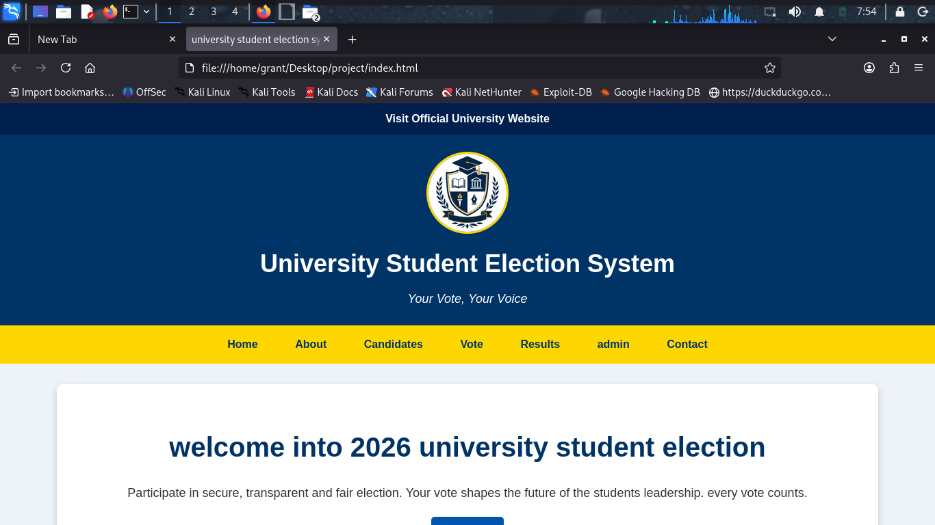
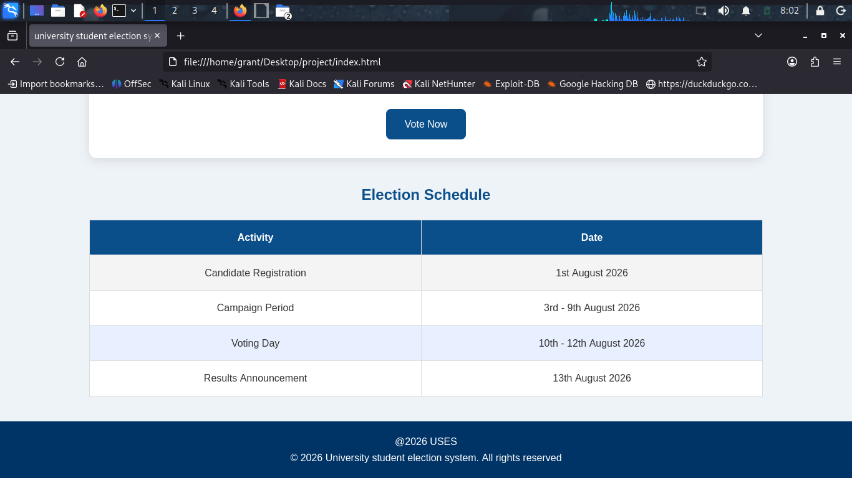

CHAPTER ONE: INTRODUCTION

1.1 Background of the Project
Student elections are an important part of university life because they give students the opportunity to choose leaders who can represent their interests and communicate their concerns. Election information is often communicated through notice boards, announcements, social media, and other channels. However, when information is spread across different platforms, students may find it difficult to access complete and organized election information.
This project therefore focused on designing a Universitty Student Election System website that provides a central platform for election information. The website was designed around the idea that every student should have access to clear information about the election process and candidates. The project motto is “Your Vote, Your Voice,” emphasizing the importance of student participation.

1.2 Problem Statement
Students may experience difficulties accessing election information when candidate details, election procedures, and announcements are not organized in one place. This can reduce awareness and make the election process less convenient. A well-designed website can provide a central and accessible platform where students can view election information and access the voting interface.

1.3 Objectives
The main objective of this project was to design and develop a user-friendly Universitty Student Election System website and other objectives as listed below:
- To design a professional home page for the student election system.
- To provide information about the election and candidates.
- To create a simple voting interface.
- To provide contact information for users.
- To apply html language concepts in a practical web development project.
- To create a foundation that can be expanded into a complete online election system.

1.4 Scope of the Project
The project focused on the front-end design and development of the website. The developed interface includes a home page, election information, candidate information, a voting page, a contact page, navigation, branding, and responsive design. The current version does not include a real database, student authentication, or actual vote storage.

CHAPTER TWO: BACKGROUND AND LITERATURE REVIEW

2.1 Website Development
A website is a collection of related web pages that can be accessed through a web browser. Websites are widely used for communication, information sharing, education, business, and service delivery. A good website should be easy to navigate, understandable, visually organized, and accessible on different devices.

2.2 HTML and CSS
HTML (HyperText Markup Language) was used to create the structure of the website. It provides elements such as headings, paragraphs, images, links, forms, buttons, and sections. CSS (Cascading Style Sheets) was used to control the visual presentation of the website, including colors, fonts, spacing, layout, borders, and responsive behavior.

2.3 Student Election Systems
A student election system supports the process of selecting student representatives. A complete electronic election system may include student registration, login, candidate management, voting, vote counting, and results publication. The system developed in this project mainly focuses on the front-end interface and provides a foundation for the development of a complete system in the future.

CHAPTER THREE: SYSTEM ANALYSIS AND DESIGN

3.1 Target Users
The primary users of the website are students who need to access election information and voting options. In a future expanded version, election administrators would manage candidates, students, election periods, and results.

3.2 Functional Requirements
- The system should display election information.
- The system should allow users to view candidate information.
- The system should provide a voting interface.
- The system should provide contact information.
- The system should allow users to navigate between different pages.

3.3 Website Structure
The website was organized into separate HTML pages and supporting folders. This structure makes the project easier to manage and maintain.
File/Folder | Purpose
index.html | Home page
about.html | Election information
candidates.html | Candidate information
vote.html | Voting interface
contact.html | Contact information
css/style.css | Website styling
images/ | Logo and other images

3.4 System Flow
The general user flow of the website is: the user opens the home page, views election information, views candidates, proceeds to the voting page, selects a candidate, and submits the voting form.
Home Page → Election Information → Candidates → Voting Page → Submit Vote

CHAPTER FOUR: SYSTEM IMPLEMENTATION

4.1 HTML Implementation
HTML was used to create the main structure of the website. Common elements included headings, paragraphs, navigation links, sections, forms, buttons, and images. The pages were linked together using the navigation bar so that users could move easily between different sections.

4.2 CSS Implementation
CSS was used to improve the appearance and organization of the website. Styling was applied to the header, navigation bar, page sections, candidate cards, buttons, forms, and footer. CSS Flexbox was used to help organize elements horizontally and vertically. Responsive design techniques were also considered to improve the appearance of the website on smaller screens.

4.3 Main Website Pages
Home Page: Introduces the Universitty Student Election System and displays the main election message and navigation options.
About Page: Provides information about the purpose of the election system and the election process.
Candidates Page: Presents candidate names, positions, and other relevant information.
Voting Page: Provides an interface where users can select candidates using form controls.
Contact Page: Provides contact information for election-related communication.

4.4 Tools Used
- HTML for creating the structure of web pages.
- CSS for styling and layout.
- A text/code editor for the website structure and design.
- A web browser for viewing and testing the website.

CHAPTER FIVE: TESTING AND EVALUATION

5.1 Testing
Testing was carried out by opening the website in a web browser and checking the main pages, links, forms, layout, and visual appearance. The purpose of testing was to identify errors and confirm that the website behaved as expected.
Test Item | Expected Result | Status
Home page | Loads successfully | Passed
Navigation links | Open the correct pages | Passed
Candidate page | Displays candidate information | Passed
Voting interface | Allows candidate selection | Passed
Contact page | Displays contact information | Passed
Responsive layout | Adjusts to smaller screens | Passed

5.2 Challenges Encountered
- Understanding how multiple HTML pages and CSS files work together.
- Correcting layout problems where content appeared compressed into a narrow section.
- Adjusting the logo size and positioning.
- Changing the navigation links from a vertical arrangement to a horizontal layout.
- Organizing the project files and folders correctly.

5.3 Results
The final result was a functional front-end website that presents student election information in an organized manner. The website successfully demonstrates navigation between pages, presentation of candidates, a voting interface, and contact information. The project also provides a foundation for future development into a fully functional online election system.

CONCLUSION AND RECOMMENDATIONS

Conclusion
The project successfully achieved its main objective of designing and developing a Universitty Student Election System website using HTML and CSS. The website provides an organized interface for presenting election information, candidate details, voting options, and contact information. The project provided practical experience in website structure, styling, navigation, responsive design, and problem-solving. Although the current version is mainly a front-end system, it provides a strong foundation for future development.

Recommendations
- Integrate the website with a database such as MySQL.
- Add student login and authentication.
- Store votes securely in a database.
- Prevent students from voting more than once.
- Develop an administrator dashboard for managing candidates and elections.
- Add automatic vote counting and election results.
- Improve security and privacy features.

REFERENCES
- Duckett, J. (2014). HTML and CSS: Design and Build Websites. Wiley.
- Mozilla Developer Network (MDN). HTML and CSS Documentation.
- World Wide Web Consortium (W3C). Web Standards and Accessibility Guidelines.
- Robbins, J. N. (2018). Learning Web Design. O'Reilly Media.
- Web Design course notes and practical materials provided during studies at the Dar es Salaam Institute of Technology.

APPENDIX: PROJECT FILE STRUCTURE
The main project files were organized as shown below:
Universitty-ELECTION-SYSTEM/
├── index.html
├── about.html
├── candidates.html
├── vote.html
├── contact.html
├── css/
│ └── style.css
└── images/
└── university-logo.png

