**Nume**: Kis

**Prenume**: Alexandra-Daria

**E-mail**: Kis.Sa.Alexandra@student.utcluj.ro

**Poza**:

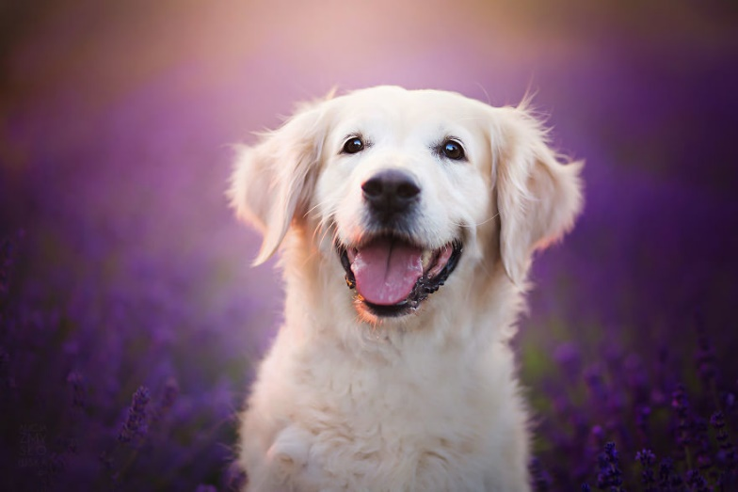

**Asteptari legate de educatie**:

* Sa invat cat mai multe lucruri noi

**Discipline**: <https://etti.utcluj.ro/planuri-de-invatamant.html>

|  |  |  |
| --- | --- | --- |
| Disciplina | An | Link |
| Informatica Aplicata | 1 | https://etti.utcluj.ro/files/Acasa/Site/FiseDisciplina/EaRo/06.pdf |
| Analiza matematica | 1 | https://etti.utcluj.ro/files/Acasa/Site/FiseDisciplina/EaRo/01b.pdf |
| Fizica | 1 | https://etti.utcluj.ro/files/Acasa/Site/FiseDisciplina/EaRo/03.pdf |
| Educatie fizica si sport | 1 | https://etti.utcluj.ro/files/Acasa/Site/FiseDisciplina/EaRo/07.pdf |
| Componente si circuite pasive | 1 | https://etti.utcluj.ro/files/Acasa/Site/FiseDisciplina/EaRo/05b.pdf |
| Algebra liniara si geometrie analitica si diferentiala | 1 | https://etti.utcluj.ro/files/Acasa/Site/FiseDisciplina/EaRo/02b.pdf |
| Programarea calculatoarelor si limbaje de programare | 1 | https://etti.utcluj.ro/files/Acasa/Site/FiseDisciplina/EaRo/04b.pdf |

**Hobby-uri**:

* unghii
* snowboarding