**Technical requirements**

**FUNCTIONS & PROCEDURES**

-- This procedure shows the average grade for the given function among students

create or replace procedure avg_grade

(v_course IN number,

v_average OUT number) as

begin

select round(avg(numeric_grade))

into v_average

from grade join section

on grade.section_id = section.section_id

join course on section.course_no = course.course_no

where course.course_no = v_course;

dbms_output.put_line('course number = ' || v_course || ', average grade = ' || v_average);

end avg_grade;

-- test it

declare

v_average number;

begin

avg_grade(25, v_average);

end;

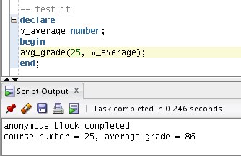

-- This procedure shows the status of specified function or procedure

create or replace procedure checkStatus (

procedureName IN varchar)as

xstatus varchar2(10);

begin

select status into xstatus

from user_objects

where object_type in ('FUNCTION','PROCEDURE')

and object_name = procedureName;

dbms_output.put_line('Procedure NAME: ' || procedureName);

if xstatus = 'VALID' then

dbms_output.put_line('The procedure is valid');

end if;

exception

when no_data_found then

dbms_output.put_line('The procedure is invalid');

when others then

dbms_output.put_line('Some error occured: ' || SQLERRM);

end checkStatus;create or replace

procedure checkStatus (

procedureName IN varchar)

as

xstatus varchar2(10);

begin

select status

into xstatus

from user_objects

where object_type in ('FUNCTION','PROCEDURE')

and object_name = procedureName;

dbms_output.put_line('Procedure NAME: ' || procedureName);

if xstatus = 'VALID' then

dbms_output.put_line('The procedure is valid');

end if;

exception

when no_data_found then

dbms_output.put_line('The procedure is invalid');

when others then

dbms_output.put_line('Some error occured: ' || SQLERRM);

end checkStatus;

-- test it

begin

checkStatus('AVG_GRADE');

end;

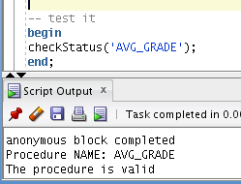

-- This function checks student GPA and if it is greater than 2

-- then a student is passed to the next year, otherwise a student has to be expelled

create or replace function CheckGPA (

xstudent IN number) RETURN VARCHAR IS

type mygrade is record(

numeric_grade grade.numeric_grade%type);

type xgrades is table of mygrade;

xfingrade xgrades := xgrades();

int number := 0;

xgpa number;

xfinalgpa float;

begin

for x in (select numeric_grade

from grade

join student

on grade.student_id=student.student_id

join section on

grade.section_id=section.section_id

join course on

course.course_no=section.course_no

where grade.student_id=xstudent and grade_type_code='FI') loop

xfingrade.extend;

int := int+1;

xfingrade(int).numeric_grade := x.numeric_grade;

end loop;

for x in 1 .. int loop

dbms_output.put_line(xfingrade(x).numeric_grade);

end loop;

xgpa := (xfingrade(1).numeric_grade + xfingrade(2).numeric_grade) / 2;

dbms_output.put_line('Average GPA: ' || xgpa);

case

when xgpa >= 90 then

xfinalgpa := 3.67;

when xgpa >= 80 and xgpa < 90 then

xfinalgpa := 3.0;

when xgpa >= 70 and xgpa < 80 then

xfinalgpa := 2.67;

when xgpa >= 60 and xgpa < 70 then

xfinalgpa := 2.33;

when xgpa >= 50 and xgpa < 60 then

xfinalgpa := 2.0;

else xfinalgpa := 0;

end case;

dbms_output.put_line('Final GPA: ' || xfinalgpa);

if xfinalgpa > 2.0 then

return 'Passed to the next year';

else

return 'Expelled from the university';

end if;

exception

when no_data_found then

return 'No data found for that student';

end CheckGPA;

-- test it

declare

v_result varchar2(30);

begin

v_result := checkGPA(102);

dbms_output.put_line(v_result);

end;

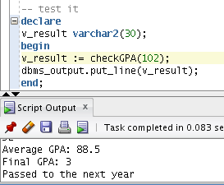

-- This function counts the number of students enrolled into course, if less than

-- 5 then a course gets discount of 5%

create or replace

function course_discount

(v_course_no IN number)

RETURN varchar2

IS

v_count_students NUMBER;

begin

SELECT count(*)

INTO v_count_students

FROM section

JOIN enrollment

ON section.section_id = enrollment.section_id

JOIN course

ON course.course_no = section.course_no

WHERE course.course_no = v_course_no;

IF v_count_students < 5 THEN

UPDATE course

SET cost = (cost * 95) / 100

WHERE course_no = v_course_no;

RETURN 'This course got discount of 5%';

ELSE

RETURN 'No discount for this course';

END IF;

end course_discount;

-- test it

declare

v_result varchar2(30);

begin

v_result := course_discount(25);

dbms_output.put_line(v_result);

end;

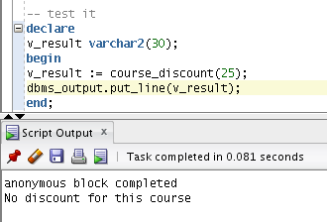

**COLLECTIONS (ARRAYS AND RECORDS)**

-- Showing any three sections with more than 5 students enrolled

declare

type mysection is record (

section_id enrollment.section_id%type,

num_rows number);

type myarray is table of mysection index by binary_integer;

v_array myarray;

int number :=0;

begin

for i in ( select * from(select section_id, count(student_id) my_count

from enrollment

group by section_id

having count(student_id) > 5) where rownum <=3 ) loop

int := int+1;

v_array(int).section_id :=i.section_id;

v_array(int).num_rows :=i.my_count;

end loop;

for i in 1 .. int loop

dbms_output.put_line('Section ID: ' || v_array(i).section_id || ', Number of Students enrolled: ' || v_array(i).num_rows);

end loop;

end;

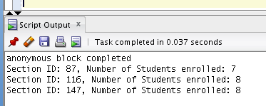

-- Create a phone book for instructors

declare

type InstrRec

is record (

myinstr instructor.instructor_id%type,

myname varchar2(50),

myzip instructor.zip%type,

myphone instructor.phone%type

);

v_instructor_one InstrRec;

v_instructor_two InstrRec;

v_instructor_three InstrRec;

begin

select instructor_id, first_name || ' ' || last_name, zip, phone

into v_instructor_one

from instructor

where salutation = 'Ms'

and rownum <=1;

select instructor_id, first_name || ' ' || last_name, zip, phone

into v_instructor_two

from instructor

where salutation = 'Ms'

and rownum <=1 and instructor_id = 105;

select instructor_id, first_name || ' ' || last_name, zip, phone

into v_instructor_three

from instructor

where salutation = 'Ms'

and rownum <=1 and instructor_id = 110;

dbms_output.put_line(v_instructor_one.myinstr || ' ' || v_instructor_one.myname ||

' ' || v_instructor_one.myzip || ' ' || v_instructor_one.myphone);

dbms_output.put_line(v_instructor_two.myinstr || ' ' || v_instructor_two.myname ||

' ' || v_instructor_two.myzip || ' ' || v_instructor_two.myphone);

dbms_output.put_line(v_instructor_three.myinstr || ' ' || v_instructor_three.myname ||

' ' || v_instructor_three.myzip || ' ' || v_instructor_three.myphone);

end;

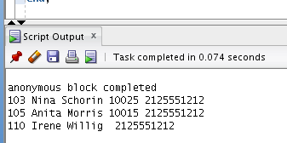

**CURSORS**

DECLARE

CURSOR c_group_discount

IS

SELECT distinct s.course_no, c.description

FROM section s, enrollment e, course c

WHERE s.section_id = e.section_id

AND c.course_no = s.course_no

GROUP BY s.course_no, c.description, e.section_id, s.section_id

HAVING COUNT(*)<=8;

BEGIN

FOR i IN c_group_discount

LOOP

UPDATE course

SET cost = cost*0.95

WHERE course_no = i.course_no;

dbms_output.put_line('A 5% discount has been given to ' ||

i.course_no || ' ' ||

i.description);

END LOOP;

END;

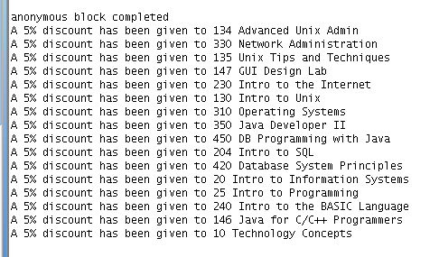

-- GET ALL MALE STUDENTS

DECLARE

CURSOR Students IS

SELECT *

FROM student

where salutation = 'Mr.';

StudRecords student%ROWTYPE;

BEGIN

OPEN Students;

LOOP

FETCH Students INTO StudRecords;

EXIT WHEN Students%NOTFOUND;

dbms_output.put_line('Student ' || StudRecords.first_name ||

' ' || StudRecords.last_name || ' has ID: ' || StudRecords.student_id);

END LOOP;

CLOSE Students;

END;

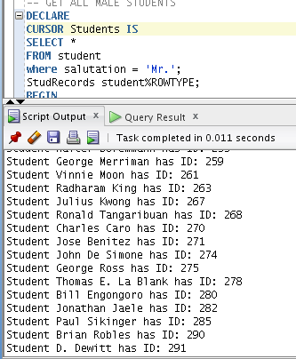

-- TOP 3 STUDENTS OF THE SPECIFIED COURSE

DECLARE

CURSOR TopStudents (SelectCourse section.course_no%type) IS

select section.course_no, description, grade.numeric_grade, grade.student_id

from course

join section

on course.course_no=section.course_no

join enrollment

on section.course_no=SelectCourse

join grade

on enrollment.student_id=grade.student_id

where grade_type_code='FI' and section.course_no = SelectCourse

order by grade.numeric_grade desc;

StudentSect section%rowtype;

StudentCourse course%rowtype;

StudentGrade grade%rowtype;

SelectCourse course.course_no%type := &enter_course_no;

invalid_exc exception;

BEGIN

IF NOT (TopStudents%ISOPEN) THEN

OPEN TopStudents(SelectCourse);

END IF;

IF SelectCourse <= 0

THEN RAISE invalid_exc;

ELSE

LOOP

FETCH TopStudents INTO StudentSect.course_no, StudentCourse.description,

StudentGrade.numeric_grade, StudentGrade.student_id;

EXIT WHEN TopStudents%ROWCOUNT = 4;

dbms_output.put_line('Course No and Name: ' || StudentSect.course_no || ' '

|| StudentCourse.description || ' Student with ID: ' || StudentGrade.student_id

|| ' has final grade of ' || StudentGrade.numeric_grade);

--dbms_output.put_line('Student ID: ' || StudentSect.section_id);

END LOOP;

COMMIT;

IF (TopStudents%ISOPEN) THEN

CLOSE TopStudents;

END IF;

END IF;

EXCEPTION

when invalid_exc then

dbms_output.put_line('Invalid course number');

when value_error then

dbms_output.put_line('Value error');

END;

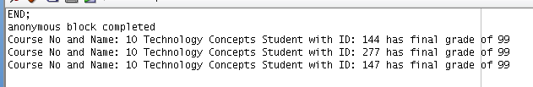

-- CONVERTING STUDENTS NUMERIC GRADE INTO LETTER GRADE

DECLARE

stud_id int(12):= &stud_id;

stud_name varchar(32);

course_description varchar(32);

g_numeric integer(3);

CURSOR Student IS

select student.first_name, course.description, grade.numeric_grade

from student

inner join grade on grade.student_id = student.student_id

inner join enrollment on grade.student_id = enrollment.student_id

inner join section on enrollment.section_id = section.section_id

inner join course on section.course_no = course.course_no

where stud_id = student.student_id and grade_type_code = 'FI'

group by student.first_name, course.description, grade.numeric_grade;

student_id_invalid EXCEPTION;

begin

if stud_id <= 0 then

raise student_id_invalid;

else

open Student;

loop

fetch Student into stud_name, course_description, g_numeric;

exit when Student%NOTFOUND;

dbms_output.put_line('Name:' || stud_name || ', course name: '||course_description);

case

when g_numeric between 85 and 100 then dbms_output.put_line('A');

when g_numeric between 75 and 85 then dbms_output.put_line('B');

when g_numeric between 60 and 75 then dbms_output.put_line('C');

when g_numeric between 50 and 60 then dbms_output.put_line('D');

when g_numeric between 0 and 50 then dbms_output.put_line('F');

end case;

end loop;

close Student;

end if;

EXCEPTION

when student_id_invalid then

dbms_output.put_line('Invalid student id');

when others then

dbms_output.put_line('Other error!');

end;

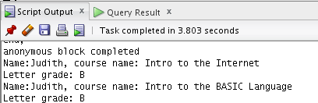

**PACKAGES**

--GETS INSTRUCTOR DATA

create or replace PACKAGE instructor_package AS

procedure DeleteInstructor (

xinstructor_id IN instructor.instructor_id%type);

procedure ListInstructors;

function totalInstructors

(xinstructor_id IN section.instructor_id%type,

xsection_id IN section.section_id%type)

RETURN VARCHAR;

END instructor_package;

create or replace

PACKAGE BODY instructor_package AS

procedure DeleteInstructor (

xinstructor_id IN instructor.instructor_id%type)

AS

invalid_id exception;

BEGIN

DELETE FROM instructor

WHERE instructor_id = xinstructor_id;

IF xinstructor_id < 0 THEN

RAISE invalid_id;

END IF;

EXCEPTION

WHEN invalid_id THEN

dbms_output.put_line('Invalid instructor ID');

END DeleteInstructor;

procedure ListInstructors AS

type myinstructors is record (

first_name instructor.first_name%type,

last_name instructor.last_name%type,

modified_date instructor.modified_date%type);

type allInstructors is table of myinstructors;

xinstructors allInstructors := allInstructors();

int number := 0;

BEGIN

for x in (select first_name, last_name, modified_date

from instructor

order by modified_date) loop

xinstructors.extend;

int := int+1;

xinstructors(int).first_name := x.first_name;

xinstructors(int).last_name := x.last_name;

xinstructors(int).modified_date := x.modified_date;

end loop;

for x in 1 .. int loop

dbms_output.put_line(xinstructors(x).first_name || ' ' || xinstructors(x).last_name || ' modified date is ' ||

xinstructors(x).modified_date);

end loop;

END ListInstructors;

function totalInstructors

(xinstructor_id IN section.instructor_id%type,

xsection_id IN section.section_id%type)

RETURN VARCHAR

IS

xcount number;

BEGIN

select count(*)

into xcount

from section

where section_id = xsection_id AND instructor_id = xinstructor_id;

if xcount > 0 then

return xcount;

else

return 'This department has no instructors';

end if;

end totalInstructors;

end instructor_package;

--CHECKS THE ENROLLMENT

CREATE OR REPLACE PACKAGE MyPackage AS

FUNCTION checkEnrollment

(xstudent_id IN enrollment.student_id%type)

RETURN varchar;

FUNCTION checkEnrollment

(xstudent_id IN enrollment.student_id%type,

xsection_id IN enrollment.section_id%type)

RETURN varchar;

END MyPackage;

create or replace

PACKAGE BODY MyPackage AS

FUNCTION checkEnrollment

(xstudent_id IN enrollment.student_id%type)

RETURN VARCHAR

IS

xcount number;

BEGIN

SELECT COUNT(*)

INTO xcount

FROM ENROLLMENT

WHERE STUDENT_ID = xstudent_id;

IF xcount > 0 then

RETURN 'Student is enrolled';

ELSE

RETURN 'Student is not enrolled';

END IF;

EXCEPTION

when no_data_found then

return 'Student with that ID is not found';

when others then

return 'Some error occured';

END checkEnrollment;

FUNCTION checkEnrollment

(xstudent_id IN enrollment.student_id%type,

xsection_id IN enrollment.section_id%type)

RETURN VARCHAR

IS

xcount number;

BEGIN

SELECT COUNT(*)

INTO xcount

FROM enrollment

WHERE student_id = xstudent_id AND section_id = xsection_id;

IF xcount > 0 then

RETURN 'Student is enrolled into specified section';

ELSE

RETURN 'Student is not enrolled into this section';

END IF;

EXCEPTION

when no_data_found then

return 'Student with that ID is not found';

when others then

return 'Some error occured';

END checkEnrollment;

END MyPackage;



create package package3 as

procedure proc1 (sect_no in out section.section_no%type,

cor_no in out section.course_no%type ,

s_id out section.section_id%type,

c_no out section.course_no%type,

counter number,

output varchar2);

function over1 (st_id in out grade.student_id%type,

sec_id out grade.section_id%type,

)

return varchar2;

function over1 (grade_code in out grade_type.grade_type_code%type,

des out grade_type.description%type)

return varchar2;

end package3;

--4th package

CREATE OR REPLACE PACKAGE StudentFind AS

PROCEDURE FIND_STUDENT(

V_STUDENT IN NUMBER,

V_FNAME OUT VARCHAR2,

V_LNAME OUT VARCHAR2);

END StudentFind;

CREATE OR REPLACE PACKAGE BODY StudentFind AS

PROCEDURE FIND_STUDENT(

V_STUDENT IN NUMBER,

V_FNAME OUT VARCHAR2,

V_LNAME OUT VARCHAR2)

AS

BEGIN

SELECT FIRST_NAME, LAST_NAME

INTO V_FNAME, V_LNAME

FROM STUDENT

WHERE STUDENT_ID = V_STUDENT;

EXCEPTION

WHEN OTHERS THEN

DBMS_OUTPUT.PUT_LINE(SQLERRM);

END FIND_STUDENT;

END StudentFind;

**TRIGGERS**

-- Trigger to display cost changes

CREATE OR REPLACE TRIGGER display_cost_changes

BEFORE DELETE OR INSERT OR UPDATE ON course

FOR EACH ROW

WHEN (NEW.course_no > 0)

DECLARE

cost_diff number;

BEGIN

cost_diff := :NEW.cost - :OLD.cost;

dbms_output.put_line('Old cost: ' || :OLD.cost);

dbms_output.put_line('New cost: ' || :NEW.cost);

dbms_output.put_line('Cost difference: ' || cost_diff);

END;



-- Trigger to change the description of the course or delete it at all

CREATE OR REPLACE TRIGGER dept_set_null

AFTER DELETE OR UPDATE OF description ON course

FOR EACH ROW

-- Before row is deleted from dept or primary key (DEPTNO) of dept is updated,

-- set all corresponding dependent foreign key values in emp to NULL:

BEGIN

IF UPDATING AND :OLD.description != :NEW.description OR DELETING THEN

UPDATE course SET course.description = NULL

WHERE course.description = :OLD.description;

END IF;

END;

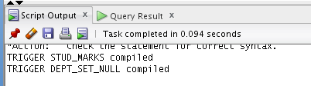

**DYNAMIC SQL**

-- first define a procedure

CREATE OR REPLACE PROCEDURE calc_stats (

w NUMBER,x NUMBER,y NUMBER,z NUMBER)

IS

BEGIN

DBMS_OUTPUT.PUT_LINE(w + x + y + z);

END;

-- Test it, using dynamic SQL

DECLARE

a NUMBER := 5;

b NUMBER := 6;

plsql_block VARCHAR2(100);

BEGIN

plsql_block := 'BEGIN calc_stats(:x, :x, :y, :x); END;';

EXECUTE IMMEDIATE plsql_block USING a, b;

END;

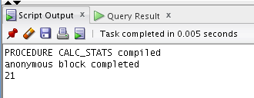

-- this script finds the difference between course costs

-- first define a procedure

CREATE OR REPLACE PROCEDURE cost_diff (

x1 NUMBER,x2 NUMBER)

IS

BEGIN

DBMS_OUTPUT.PUT_LINE(x2-x1);

END;

-- Test it, using dynamic SQL

DECLARE

a number;

b number;

plsql_block VARCHAR2(100);

BEGIN

select cost

into a

from course

where course_no = 25;

select cost

into b

from course

where course_no = 80;

plsql_block := 'BEGIN cost_diff(:x, :y); END;';

EXECUTE IMMEDIATE plsql_block USING a, b;

END;

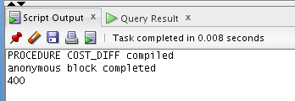

-- this script gets course information including ID and description

-- first define a procedure

CREATE OR REPLACE PROCEDURE course_info (

x1 number,x2 varchar2)

IS

BEGIN

DBMS_OUTPUT.PUT_LINE(x1 || ' ' || x2);

END;

-- Test it, using dynamic SQL

DECLARE

a number;

b varchar2(30);

plsql_block VARCHAR2(100);

BEGIN

select course_no, description

into a, b

from course

where course_no = 25;

plsql_block := 'BEGIN course_info(:x, :y); END;';

EXECUTE IMMEDIATE plsql_block USING a, b;

END;

