# Executive Summary

We are launching a very trendy software called Food Delivery App. Food Delivery Software has become an important role for people in today’s society to survive on food. This software will have a feature that will make a user browse their craves on food easily and fast. This venture will provide easy and fast transactions, example of this is Domino’s Pizza, where they come with a 30-minute guarantee from the time an order is placed. If the time taken to deliver the pizza is more than 30 minutes, the pie comes free if it costs under Rs 300/ $4.

Also ordering online has become a trend since pandemic-related lockdowns start in March 2020, the growing food-delivery business has spiked to new heights in the most mature markets.

Before the pandemic put thousands of establishments out of business, the US restaurant industry was growing 3 to 4 percent per year. Delivery sales were increasing at roughly twice that pace (7 to 8 percent). While population growth was a factor, the bulk of the increase came at the expense of the grocery sector, with millennials and Gen Zers preferring the convenience of prepared meals. This trend toward convenience has grown more pronounced during the pandemic. Between March and May 2020, when lockdowns in Europe and the United States were the most severe, the food-delivery market spiked. Significantly, it has maintained that trajectory, continuing to grow throughout 2020 and into 2022.

References:

<https://economictimes.indiatimes.com/corporate-industry/8-mantras-dominos-adopts-to-deliver-your-pizza-in-30-minutes/slideshow/19123621.cms>

<https://www.mckinsey.com/industries/technology-media-and-telecommunications/our-insights/ordering-in-the-rapid-evolution-of-food-delivery>

# Business Idea

We decided to create a venture called JM Express, because we have experienced the feeling of being extremely hungry and needing something to eat right away. Ordering food online has become significant and convenient for us, especially during this pandemic. We have also seen the impact and the idea of ordering online assists the restaurant or any eatery business in preventing overcrowding and serving everyone at the same time. We discovered Domino's Pizza's idea of delivering its food as quickly as possible to attract more customers. We also have seen many Food delivery apps available out there that still have room to improve or make better. So, the main purpose of our idea is to serve people fast and conveniently so they can experience and prevent overcrowding and remove the hassle they feel when it comes to ordering their favorite foods online.

# Business Form

Partnership is our business form. We decided that partnership is the business form we are going to use because based on our study about our venture, we are going to do a lot of partnerships with other companies. Having a partnership with other companies available within the Dagupan Area will make our business more open to dealing with new partnerships in the future. More partnership leads to more food-available options for our users that we think will also lead to more customers. Also having a partnership as a business form will make our firm able to raise more funds easily and not subject to double taxation at the same time.

# Business Models

**Advertising** is the first business model we decided on. Nowadays, advertising has many different ways to introduce new products. Television advertisements, street advertisements, radio, websites, newspapers, etc. We help people become aware of our product or service through the use of commercial methods. This kind of publicity helps to endorse a specific interest of a person for product sale.

**Concierge/Customization** is the second business model we decided. We already know that customizing their order allows customers to feel more personalized in the production side of the product, making their order feel more personalized and unique. Increasingly, customers expect delivery of high-quality, customized products and services at affordable prices.

**Marketplace** is the business model we decided. We will put our product on the marketplace so that customers can see our prices, have more options, and feel confident when selecting the type of food they want, whether or not it is configurable. The marketplace will also assist our business promote our services and insurance so that customers may buy with confidence.

**Access to Excess** is the last model we decided to use. In today's new normal it's hard to reach some customers but we have access to excess to help us to connect with the customers easily. It is compatible with our JM express food delivery to use it as a tool for an excess supply of a service with each buyer.

# Industry and Competitor Analysis

| What industry does your venture belong to? | Explain how your venture is involved in the industry that you have selected. | Identify and apply the five (5) forced model to your venture |
| --- | --- | --- |
| IT Industry | JM Express is a Food Delivery software that can be accessed via our mobile phones, computers, laptops, tablets, or any other technology capable of running an app or website. | **Threat of Substitutes** - Our venture is a great substitute compared to today's existing food delivery app available right now.  **Threat of New Entrants** - We will surely ensure that our customers will always be satisfied in terms of delivering their order as fast we can. So, if there is a new competitor they will still choose and trust us.  **Rivalry among Existing Forms** - As we searched for most and common problems that food delivery services encounter, one of them is late deliveries that will lead to affecting the food quality itself. We will make sure the 30-minute guarantee from the time an order is placed to make sure customers always trust our service.  **Bargaining Power of Suppliers** –  We will make sure that our partnered companies orders will always be delivered fast while the quality of products is maintained at best.  **Bargaining Power of Buyers** – We will make sure that our users will find our service to be user friendly or easy to use, and we are going to serve them fast and they can get their orders as soon as possible compared to the other food delivery services available out there. |

| List at least 5 of your venture’s competitors | Are they direct or indirect? | Explain how they become your competitors | How do you plan to win against your competitors? |
| --- | --- | --- | --- |
| **Food Panda** | **Direct** | Because they also collect the best variety of foods on their platform, users have more options when it comes to selecting their foods. | We will become the top food delivery service to people by delivering their orders in such a short period of time that they can enjoy eating their food at the highest quality possible. |
| **GrabFood** | **Direct** |
| **Lalafood** | **Direct** |
| **Domino’s Pizza** | **Indirect** | They also sell foods through their platform, but only to their customers. |
| **McDonald's Delivery** | **Indirect** |

# SWOT Analysis

| **Strengths:**  - Experience with similar apps  - Well-established and efficient operational plan using technology  -Fast delivery service  -Increasing store and restaurant sales while also empowering drivers  -Simple-to-use, fast, transparent, reliable, and secure platform | **Weaknesses:**  -Limited Areas  -Low brand recognition: We will leverage aggressive marketing in the first few years of operations to build brand awareness and gain the loyalty of users  -Limited funds to start up |
| --- | --- |
| **Opportunities:**  -The growing mobile app market and increasing internet penetration  - The increasing rate of dining out and online ordering.  -Technological advancement offering improvements to mobile apps | **Threats:**  -Existing apps compete fiercely.  as well as platforms  -Uncertainty about the economic  outlook, particularly with the COVID-19 outbreak of a pandemic  -Susceptibility of the platform to cyberattacks |

# The Four Ps of Marketing a New Venture

**Product**

We have been forced to stay at home for the last two years since the pandemic's outbreak and cannot even imagine the changes we are facing. Luckily, this app we made can help people to order food just by staying at home. We are developing a product called JM Express that can be used during this period, an application for food delivery that can be used via mobile phones and can also be downloaded from the Google Playstore.

**Price**

When we buy a product instead of adding it to the shopping cart, the first thing that comes to mind is the price. Buyers are primarily shopping for low-cost items.

And this application (JM Express) assists users in understanding what they are purchasing, identifying particular pricing, and comparing them of the products, which can also reduce shipping costs in a manageable way, and through your partnership agreement with the other company.

**Promotion**

Million users of Facebook, Instagram, Twitter, Messenger, YouTube; etc. It is a platform where we can promote our app. Those platforms can connect millions of users to gain reviews about the app. To follow, watch, and read.

**Place**

Go to your Google Play store and search for JM Express. After installing the app, You may now access it and select the foods you wish to purchase. JM Express assists you in obtaining the most convenient method of delivering your meals on schedule.

# Writing a Summary Business Plan

**NAME OF THE COMPANY: JM Express**

**COMPANY DESCRIPTION**

JM EXPRESS's purpose is to provide excellent service to customers while reducing the amount of time they spend waiting in line for food in a restaurant or shop. Customers are not required to relocate or leave their homes in this situation, making it more convenient and secure for them.

**MANAGEMENT TEAM:**

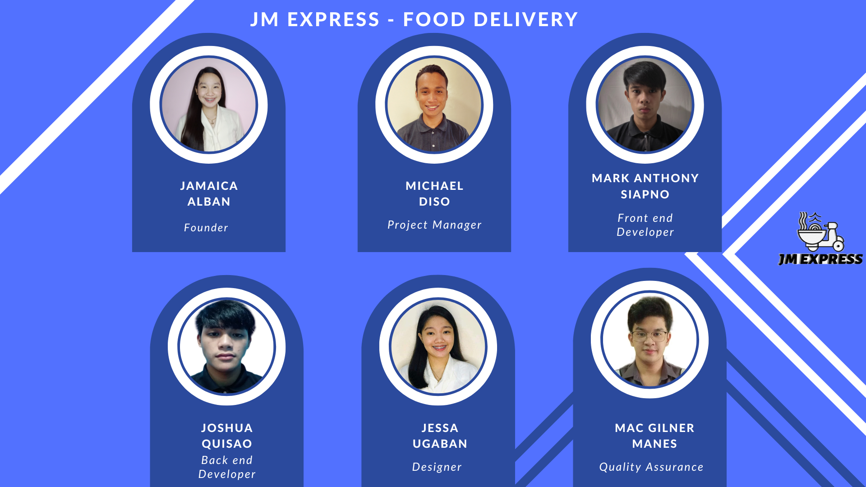

**OVERALL TENTATIVE SCHEDULE:**

| **Year when you plan to open your business:** | **Date:** | **Target output or milestone.** |
| --- | --- | --- |
| When do you plan to incorporate your IT venture? | **August 25, 2022** | **August 31, 2022** |
| Target completion date of prototypes? | **September 15, 2022** | **September 30, 2022** |
| When do you plan to work on the rental or acquisition of facilities/equipment needed? | **September 29, 2022** | **January 21, 2023** |
| When do you plan to obtain your critical financing? | **December 10, 2022** | **January 5, 2023** |
| Date when you plan to meet with your business partners | **December 22, 2022** | **January 11, 2023** |
| Date to operationalize the production/testing | **March 6, 2023** | **May 3, 2023** |
| Date when you plan to launch the soft opening of your business | **May 7, 2023** | **May 23, 2023** |

**OPERATIONS PLAN: Transactional flow of your business. This is your schematic diagram and a brief explanation about the transactional flow.**

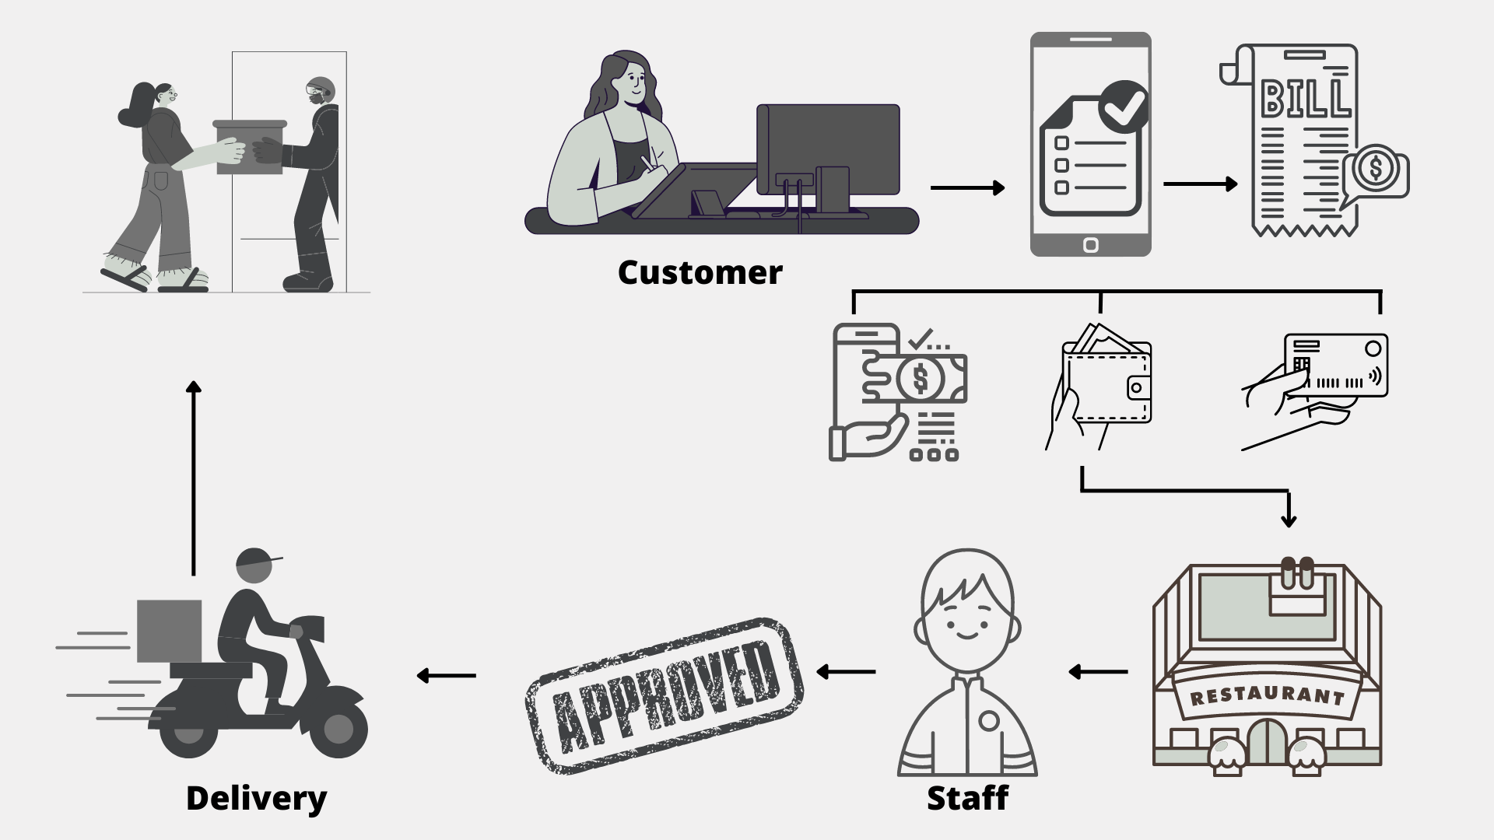

**TRANSACTIONAL FLOW:**

After downloading the app (JM Express), customers are already signing in and ready to purchase items or to order food through this app. They can pay through Cash on Delivery (COD), E wallet; credit card while it's still processing from the chosen restos/cafe/fast food and assisted by the staff and it will be ready to shipped out to the customers home and the customers received their order.

# **RAISING** **CAPITAL:**

| **LIST DOWN ATLEAST 2 PLANS TO RAISE A CAPITAL FOR YOUR VENTURE** | **HOW DO YOU PLAN TO EXECUTE IT?** |
| --- | --- |
| **Personal Saving** | **Personal savings gained from work or other business you have to support on your new venture.** |
| **Bank Loan** | **You can obtain a personal loan from your current bank or you can search around for good deals** |

**IDENTIFY NEW AGE WAYS OF GAINING CAPITAL.**

**GoFundMe**

**CONS:**

**· Limited services available in GoFundMe.**

**· Poor customer support.**

**·**

**GoFundMe campaigners have issues withdrawing funds.**

**PROS:**

**· You can collect funds without meeting your funding.**

**· No platform fees.**

**· No time limit or deadline for campaigns.**

**X- The New Venture Team and Business Ethics**



**FOUNDER/S: JAMAICA ALBAN**

| **NAME OF EMPLOYEE** | **ROLE** | **JOB DESCRIPTION** |
| --- | --- | --- |
| **JAMAICA ALBAN** | **Founder** | **A Founder takes a business from an idea to an entity and also the founder is typically responsible for setting the mission and vision of a company.** |
| **MICHAEL DISO** | **Project Manager** | **He will be incharge to manage the team and predict as many dangers and problems as possible.** |
| **MARK ANTHONY SIAPNO** | **Front-End Developer** | **A Front-End Developer goal is to combine technology and design to create inviting and easy-to-use system for consumers.** |
| **JOSHUA QUISAO** | **Back-End Developer** | **A Back-End Developer is to develop the server-side logic and the maintenance of the central database.** |
| **JESSA UGABAN** | **Designer** | **A Designer creates interfaces which users find easy to use and pleasurable** |
| **MAC GILNER MANES** | **Quality Assurance** | **A quality assurance specialist ensures that the final product observes the company's quality standards.** |

**XI- NEW AGE SOURCE OF SUSTAINABLE INCOME**

| **New age source Income** | **How do you plan to use it** | **What will be its impact to your business?** |
| --- | --- | --- |
| **Advertisements/Sponsors** | * **To improve the profitability by attracting more users and customers.** * **It is an outstanding chance to advertise our business.** * **To promote our business and to encourage more users.** | * **Our brand’s exposure to our target audience is greatly increased via advertising.** * **It could boost the growth of our business.** |
| **Donations** | * **Upgrading equipment** * **Buying new model car/motor for fast delivery** * **Endorsing our company.** | * **It helps the development of the community, customer attraction, and revenue growth.** * **It can fund events to increase awareness of our brand.** |

**XII- Feasibility Analysis Template**

| **Parts** | **Score**  **(-5 to +5)** | **Overall Potential of the Businesses Idea Based on Each Part (High, Moderate, Low)** | **Suggestions for Improving the Potential** |
| --- | --- | --- | --- |
| **Part 1: Strength of Business Idea** | **+1** | **Moderate** | **Every idea has potential but it needs more things to execute it well.** |
| **Part 2: Industry-Related Issues** | **+2** | **Moderate** | **Make your business the best so people will choose your business over competitors.** |
| **Part 3: Target Market and Customer Related Issues** | **+3** | **Moderate** | **Create digital advertisement** |
| **Part 4: Founder’s (or Founders’) Related Issues** | **+4** | **High** | **Doing more research of what business or product we have.** |
| **Part 5: Financial Issues** | **-1** | **Low** | **Need a big investment.** |
| **Overall Assessment** | **+3** | **Moderate** | **With good advertisement and good service to our users it will make our business grow faster and quickly overcome the breakeven.** |

**XIII. Conclusion**

Online Food Delivery gave enormous impacts in the Philippines during covid-19 outbreak. It has been proven that online food delivery has been advantageous for customers. Application like this helps the customer to make life easier, looking at a wider perspective Online Food Delivery serves as a good idea for customer, you don't have to stand in line, go to restaurants, cafe, fast foods to buy your food.

Based on the conclusion of this project venture, here are the recommendations to be considered:

1. JM Express - Food Delivery can help people to order food just by staying at home.

2. JM Express purpose is to provide excellent service to customers while reducing the amount of time they spend waiting in line for food in a restaurant or shop.

3. Through this app and internet connection, the customer may place their order to buy food easily and conveniently.