CS1083

Ms. Leah Bidlake

October 14, 2020

Kisenge Mbaga/3680552

1.

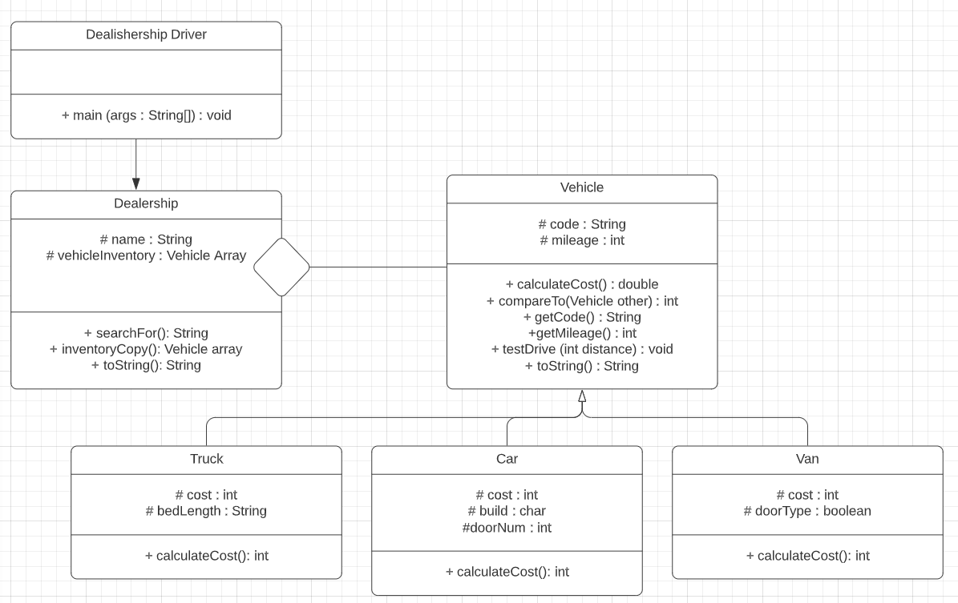

2.

Vehicle.java

/\*\*

This class represents a Vehicle.

@author Kisenge Mbaga

\*/

import java.util.Scanner;

import java.text.NumberFormat;

abstract class Vehicle{

/\*\*

The vehicle code.

\*/

private String code;

/\*\*

The mileage of the vehicle

\*/

private int mileage;

NumberFormat costFormat = NumberFormat.getCurrencyInstance();

/\*\*

Constructs a Vehicle object with a vehicle code and mileage.

@param codeIn The vehicle code

@param mileageIn The vehicles mileage.

\*/

public Vehicle( String codeIn, int mileageIn){

code=codeIn;

mileage=mileageIn;

}

public abstract double calculateCost();

/\*public int compareTo(Vehicle other){

if(this.code.compareTo(other.getCode())==0){

}

}\*/

/\*\*

Returns the vehicle code

@return The vehicle code.

\*/

public String getCode(){

return code;

}

/\*\*

Returns the vehicle mileage

@return The vehicle mileage.

\*/

public int getMileage(){

return mileage;

}

/\*\*

Returns whether the car was found.

@param distance The distance the vehicle has driven.

\*/

public void testDrive(int distance){

mileage+=distance;

}

/\*\*

Returns the vehicle code, mileage and cost in a string

@return A string of the vehicle code, mileage and cost.

\*/

public String toString(){

String output="";

output+=("\n"+code+"\tMileage: "+mileage+"km\n");

output+=("\t\tCost: "+costFormat.format(this.calculateCost()));

return output;

}

}

Car.java

/\*\*

This class represents a Car.

@author Kisenge Mbaga

\*/

public class Car extends Vehicle{

/\*\*

Base cost of the car.

\*/

private double cost= 10000;

/\*\*

Number of doors.

\*/

private int doorNum=2;

/\*\*

The type indiciating whether hatchback or trunk.

\*/

private char build;

/\*\*

Constructs a Vehicle object with a vehicle code and mileage.

@param codeIn The vehicle code

@param mileageIn The vehicles mileage.

@param doorNumIn The number of doors.

@param buildIn The type of build. Hatchback or trunk.

\*/

public Car( String codeIn, int mileageIn, int doorNumIn, char buildIn){

super(codeIn, mileageIn);

doorNum= doorNumIn;

build= buildIn;

}

/\*\*

Returns the cost of the vehicle based on the number of doors

and the type.

@return The cost of the vehicle.

\*/

public double calculateCost(){

if (doorNum==4){

cost+= 0.05\*(cost);

}

if (build=='H'){

cost+= 1000;

}

return cost;

}

}

Truck.java

/\*\*

This class represents a Truck.

@author Kisenge Mbaga

\*/

public class Truck extends Vehicle{

/\*\*

The type indiciating whether hatchback or trunk.

\*/

private String bedLength;

/\*\*

The base cost of a truck.

\*/

private double cost= 50000;

/\*\*

Constructs a Vehicle object with a vehicle code and mileage.

@param codeIn The vehicle code

@param mileageIn The vehicles mileage.

@param bedLenthIn The type of truck length

\*/

public Truck( String codeIn, int mileageIn, String bedLengthIn){

super(codeIn, mileageIn);

bedLength= bedLengthIn;

}

/\*\*

Returns the cost of the vehicle based on type of truck bed.

@return The cost of the vehicle.

\*/

public double calculateCost(){

if (bedLength.equals("short")){

cost-= 0.1\*(cost);

}

if (bedLength.equals("long")){

cost+= 0.1\*(cost);

}

return cost;

}

}

Van.java

/\*\*

This class represents a Van.

@author Kisenge Mbaga

\*/

public class Van extends Vehicle{

/\*\*

Base cost of the truck.

\*/

private double cost= 25000;

/\*\*

Boolean indicating whether door is electric or not.

\*/

private boolean doorType= false;

/\*\*

Constructs a Vehicle object with a vehicle code and mileage.

@param codeIn The vehicle code

@param mileageIn The vehicles mileage.

@param doorTypeIn The type of door. Manual or electric.

\*/

public Van( String codeIn, int mileageIn, boolean doorTypeIn){

super(codeIn, mileageIn);

doorType= doorTypeIn;

}

/\*\*

Returns the cost of the vehicle based on the door type.

@return The cost of the vehicle.

\*/

public double calculateCost(){

if (doorType==true){

cost+= 0.15\*(cost);

}

return cost;

}

}

Dealership.java

/\*\*

This class represents a Dealership.

@author Kisenge Mbaga

\*/

import java.util.Scanner;

public class Dealership{

/\*\*

Name of dealership.

\*/

private String name;

/\*\*

Array of vehicles

\*/

private Vehicle [] vehicleInventory;

/\*\*

Number of vehicles dealership.

\*/

private int vehicleNum;

Scanner sc= new Scanner(System.in);

private String extraInfo;

private String vCode;

private String in;

/\*\*

Constructs a Dealership object by reading the name of the dealership, and

reading in a String array of vehicle information. It creates vehicles and puts them

into its Vehicle array.

@param nameIn The dealership name

@param vehicleInventoryIn An array with all vehicle information.

\*/

public Dealership(String nameIn, String[] vehicleInventoryIn){

name= nameIn;

for(int i=0; i<vehicleNum; i++){ //convert String Array to Vehicle Array

String in= vehicleInventoryIn[i];

Scanner sc2= new Scanner(in);

String vCode= sc2.next();

int mileage= Integer.parseInt(sc2.next());

Scanner sc3= new Scanner(vCode);

char vType= vCode.charAt(0);

if(vType=='C'){

String extraInfo= sc2.next() + sc2.next();

Scanner sc4= new Scanner(extraInfo);

int doorNum= sc4.nextInt();

char build= sc4.next().charAt(0);

Car car1= new Car(vCode, mileage, doorNum, build);

vehicleInventory[i] = car1;

}

if(vType=='T'){

String extraInfo= sc2.next();

String bedLength= extraInfo;

Truck truck1= new Truck(vCode, mileage, bedLength);

vehicleInventory[i] = truck1;

}

if(vType=='V'){

String extraInfo= sc2.next();

boolean doorType= Boolean.parseBoolean(extraInfo);

Van van1= new Van(vCode, mileage, doorType);

vehicleInventory[i] = van1;

}

}

}

/\*\*

Returns whether the car was found.

@param codeIn The code being searched for

@return A string indicating whether the vehicle was found or not.

\*/

public String searchFor(String codeIn){

String result="";

for(int i=0; i<vehicleInventory.length; i++){

Vehicle ref= vehicleInventory[i];

if(ref.getCode().equals(codeIn)){

result="Vehicle found at dealership.";

}

else{

result="Vehicle not found at dealership.";

}

}

return result;

}

/\*\*

Returns a copy of the array of vehicles.

@return A vehicle Array with the dealership vehicles

\*/

public Vehicle[] inventoryCopy(){

return vehicleInventory;

}

/\*\*

Returns a string with the dealership name and vehicle information.

@return A string

\*/

public String toString(){

String output="";

output+=(name+"\n");

for(int i=0; i>vehicleInventory.length; i++){

Vehicle vehicleIn= vehicleInventory[i];

output+= vehicleIn.toString();

}

return output;

}

}

dealershipDriver.java

import java.util.Scanner;

public class DealershipDriver{

public static void main(String[] args){

Scanner sc = new Scanner(System.in);

String name= sc.nextLine();

int vehicleNum= sc.nextInt();

int counter=0;

//scan each vehicle record into a String array

String [] vehicleInventory= new String[vehicleNum];

for (int i=0; i<vehicleInventory.length; i++){

vehicleInventory[i]=sc.nextLine();

}

//scan the Vcodes to search for into an array

boolean check= true;

while(check=true){

if (sc.hasNextLine()){

counter++;

}

else{

check=false;

}

}

String [] testVCode= new String[counter];

for(int i=0; i<testVCode.length; i++){

testVCode[i]=sc.nextLine();

}

//create a dealership object

Dealership honda= new Dealership(name,vehicleInventory);

System.out.print(honda.toString());

// System.out.print(selectionSort((honda.inventoryCopy())));

//search for the vehicle

for(int i=0; i<vehicleInventory.length; i++){

String vCode;

vCode=vehicleInventory[i];

honda.searchFor(vCode);

}

}

}

3. Output

Was unable to fix problem to test. The driver and all other classes compiled but the driver couldn’t run.

Aswell, I commented out the compareTo() method as I was unable to get it.

