Robert Kiser

07/27/25

CSD325

Module 9.2 Assignment – Module 12 Redo

Astronaut API

Random Joke API (NOTE: every time this API is run will produce a different outcome based on which joke is being supplied).

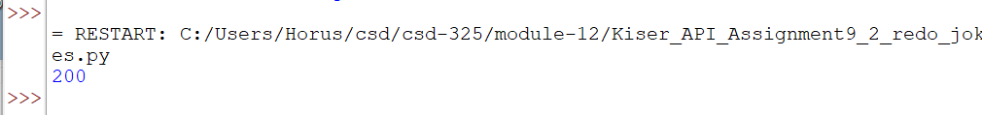

I added this last one to show the joke in the correct order since “punchline” comes alphabetically before “setup”.