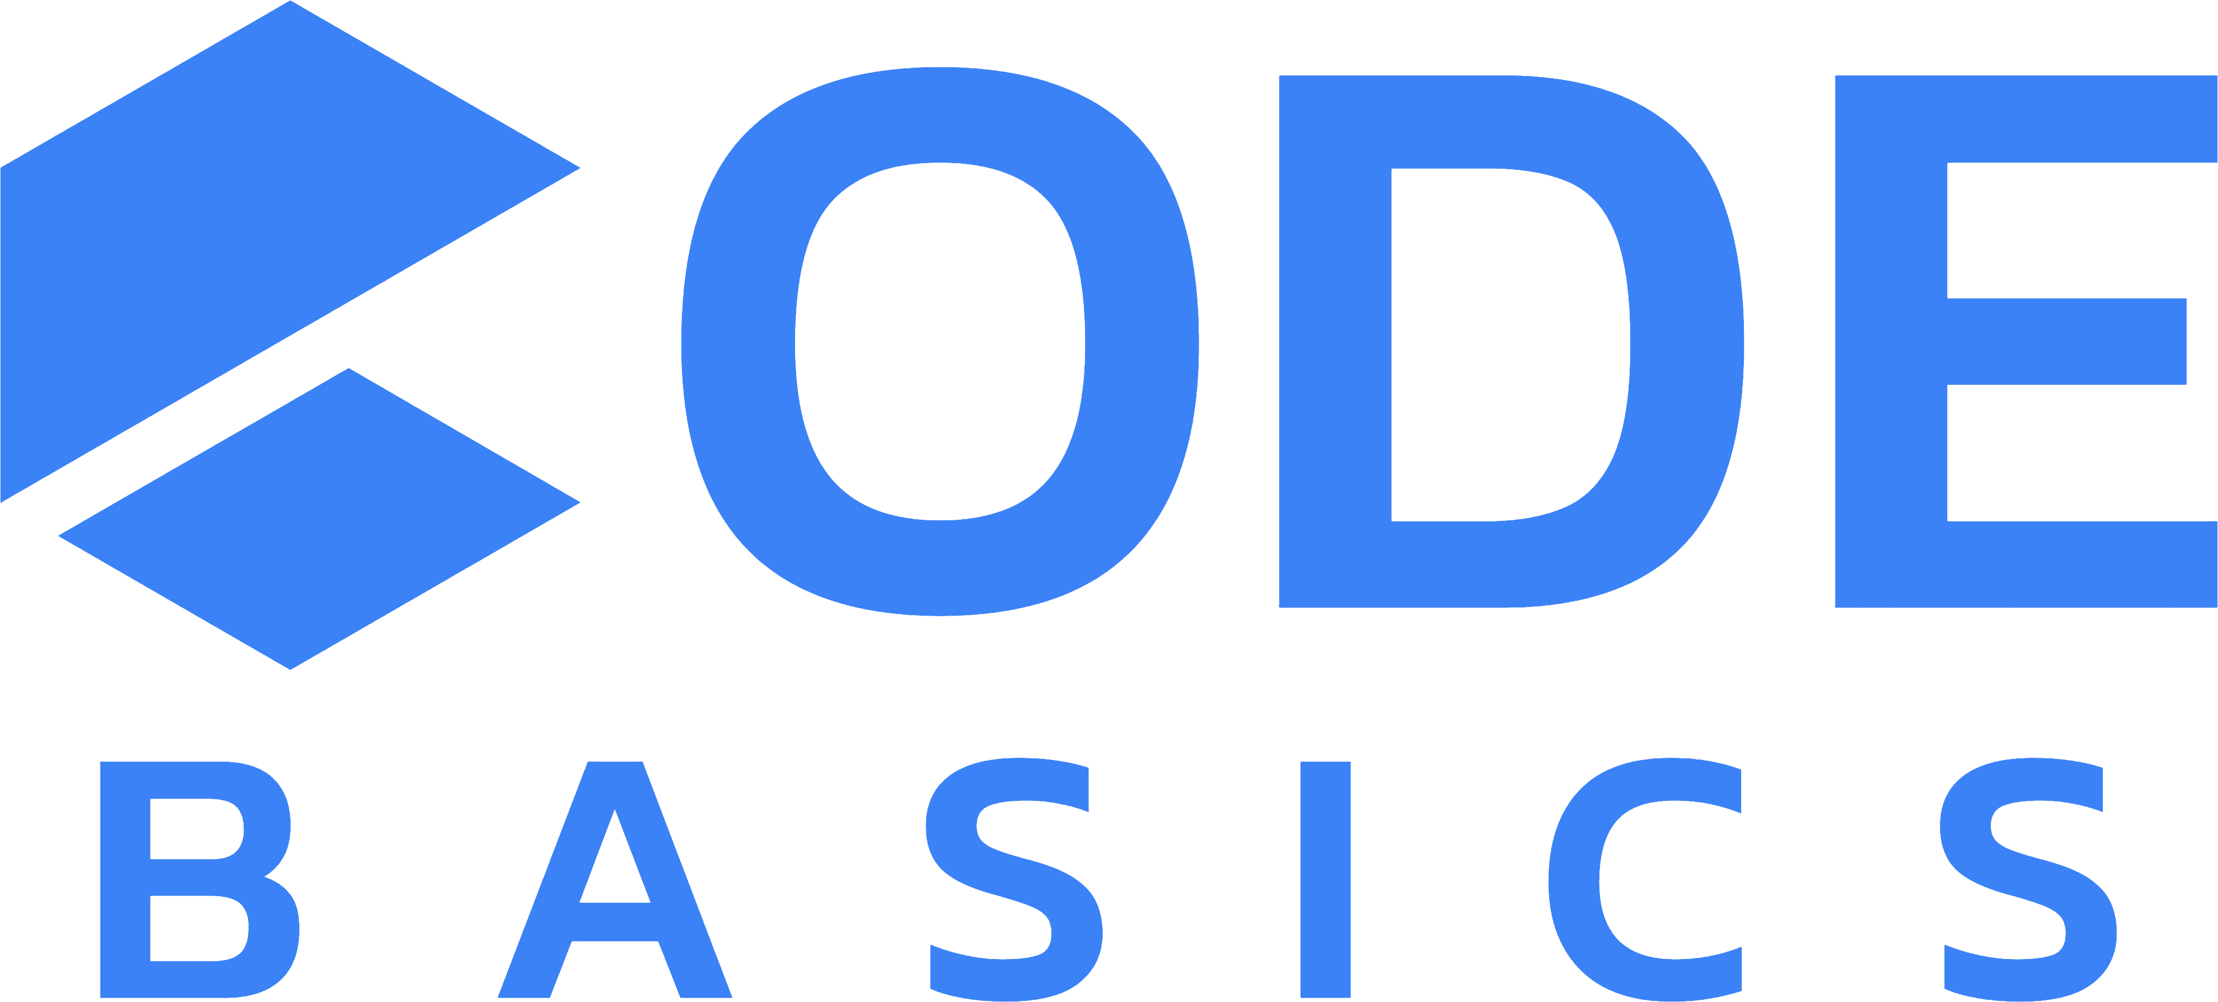
AtliQ Commerce — Phase 2: Real-Time Lane
Kafka · Databricks Structured Streaming · Airflow — build the speed lane beside your batch pipeline

1. The Story: Why a Second Lane
In Phase 1 you built AtliQ's batch lane: the OLTP database syncs to the analytics warehouse every night, and leadership sees yesterday's numbers each morning. That is exactly right for most reporting.
But the operations team has questions the nightly batch cannot answer: How many orders are coming in right now? Did revenue suddenly drop in the last ten minutes? Waiting until tomorrow morning is not an option.
Your job in Phase 2 is to build the speed lane: order events stream through Kafka the moment they happen, Databricks Structured Streaming processes them continuously into the medallion pattern you already know, and Airflow runs the scheduled work a stream still needs — quality checks, maintenance, and the daily rollup.
Same company, same lakehouse conventions — but this project is standalone: it does not touch your Phase 1 deployment. The two lanes run side by side, the way batch and streaming coexist in real companies.
Phase 1 (batch lane) nightly OLTP -> ADF -> medallion -> Fabric
Phase 2 (speed lane) continuous events -> Kafka -> Streaming
+ Airflow for the scheduled work around the stream
2. What You Are Given (Starter Package)
File | What it is
producer/order_event_producer.py | Producer starter — event shapes given, Kafka parts are TODOs
producer/.env.example | Template for your Confluent Cloud credentials
databricks/01_kafka_stream_processing.py | Notebook starter — setup given, the three streams are your tasks
airflow/dags/atliq_streaming_ops_dag.py | DAG starter — shell given, the three operators are your tasks
requirements.txt | Local Python dependencies

The events use the same business vocabulary as Phase 1 (order_id, customer_id, product_id, order_amount, the same cities and payment methods) — familiar data, new delivery mechanism. Every event carries a unique `event_id`: that is your de-duplication key, playing the role updated_at played in batch.
3. Tech Stack
Layer | Tool
Event transport | Apache Kafka on Confluent Cloud (free trial)
Stream processing | Databricks Structured Streaming (Free Edition, serverless)
Storage | Delta tables in Unity Catalog (atliq.streaming)
Orchestration | Apache Airflow (Docker, local)

Note On Databricks Free Edition (serverless) there is no DBFS /tmp. Streaming checkpoints go in a Unity Catalog Volume, and streams write to managed tables. The starter notebook creates the Volume for you — do not point checkpoints at DBFS paths.

4. Task 1 — Kafka Up and Events Flowing
Build: a Confluent Cloud topic receiving live AtliQ order events from your laptop.
- Sign up at https://confluent.cloud (free trial), create a Basic cluster near you.
- Create the topic `atliq.orders.events` and a cluster-scoped API key. Note the bootstrap server (Cluster settings → Endpoints).
- Complete the three TODOs in order_event_producer.py: the producer config (SASL_SSL + PLAIN), publishing each event (key = order_id, value = JSON, with a delivery callback), and guaranteeing delivery before exit.
- Copy .env.example to .env, fill your values, then:
pip install -r requirements.txt
python order_event_producer.py --rate 2 --duration 300
Checkpoint: delivery lines print in your terminal, and in the Confluent console (Topics → Messages) you watch JSON events arriving live.
Tip Why key by order_id? Kafka guarantees ordering within a partition, and equal keys always land in the same partition — so one order's lifecycle events stay in order. Say this in your write-up.

5. Task 2 — Stream into Bronze and Silver
Build: two always-on streams in the Databricks notebook.
Bronze — read the topic with spark.readStream.format("kafka") and append the raw records (key/value cast to string, plus topic/partition/offset/timestamp) to atliq.streaming.bronze_order_events. No parsing — Bronze keeps everything, exactly like Phase 1.
Silver — stream from the Bronze table: parse the JSON with an explicit schema, convert event_ts to a timestamp, add a 10-minute watermark, and `dropDuplicates(["event_id"])` into atliq.streaming.silver_order_events.
Checkpoint: with the producer running, this query's counts grow on every re-run:
SELECT event_type, COUNT(*) FROM atliq.streaming.silver_order_events GROUP BY event_type;
Warning Every stream must have its own checkpoint folder inside the Volume (.../checkpoints/bronze, /silver, /gold). Sharing one checkpoint between streams — or deleting one mid-experiment — causes duplicates or a stream that will not start. This is graded.

6. Task 3 — Gold: the Live Revenue Ticker
Build: from the Silver stream, keep only payment_received events and aggregate into 5-minute tumbling windows — orders_paid (count) and revenue (sum of order_amount) — appended to atliq.streaming.gold_revenue_5min.
Checkpoint: after ~10 minutes of producing, windows appear:
SELECT * FROM atliq.streaming.gold_revenue_5min ORDER BY window_start DESC;
Note Windows only appear after they close — the watermark must pass the window's end first. So rows show up 10–15 minutes behind real time. That is correctness (waiting for late events), not a bug. Explaining why is part of your write-up.

7. Task 4 — Airflow Runs the Scheduled Work
Build: complete the four TODOs in the DAG starter so an hourly DAG guards and maintains the streaming tables:
Task you build | Requirement
check_fresh_events | Fails when no events landed in the last 2 hours (hint: Databricks SQL assert_true)
optimize_tables | OPTIMIZE on the Silver and Gold tables (streaming creates many small files)
refresh_daily_summary | Rebuilds gold_daily_summary: per date — orders placed / paid / cancelled, revenue
chaining | The three run in sequence, hourly

Setup steps (provider package, databricks_default connection, SQL warehouse HTTP path) are in the DAG's docstring.
Checkpoint: Graph view all green — then stop the producer, wait, trigger the DAG, and watch check_fresh_events fail. A quality gate you cannot make fail is not a quality gate.
8. What You Submit
A Git repository containing:
- Your completed producer (commit .env.example, never the real .env).
- The streaming notebook with all three streams and separate checkpoints.
- The completed Airflow DAG, plus two screenshots: a green run, and the DQ task failing while the producer is stopped.
- A half-page write-up: how the speed lane relates to Phase 1's batch lane — when does a business need each? Include why Gold windows appear late and why events are keyed by order_id.

