

|  |
| --- |
| Image processing  2018 |
|  |
| OCTOBER 4  PANIMALAR ENG CLG  Authored by: KISHAL.T( JAYAPRAKASH( |

 Python image processing

Abstract:

In this project, an image is enhanced in multiple steps. Mainly three stages are implemented - Denoising, Edge Detection and Contrast Enhancement. First stage is noise reduction of image. Noise of the image has been reduced whether the given image contains noise or it is de-noised. Next stage is edge detection. To perform better enhancement, we need to detect certain edges to differentiate darker and lighter part of image. Aim of this operation is to find boundaries of distinct objects in the image and to obtain discontinuities in brightness. Blurred image has been subtracted from the original image. This process will sharpen the image. Further stage is contrast enhancement which produces more clearer image. Contrast enhancement is implemented here by Histogram equalization. Thus, Image has been enhanced after passing through multiple stages and what we get as a final output is a clearer and better-quality image

1. Introduction:

1.1) Problem Statement -- Since a normal image is not clear and it may not show some useful information or its brightness level seems inappropriate, then to get rid of such problems, we perform image enhancement to get a better and clearer image. 1.2) Why this topic was chosen -- 1.2.1) To gain deeper knowledge of contrast enhancement. 1.2.2) To implement & understand the concepts of signals & system in the context of image

2.1 Image Denoising, Edge Detection:

First step is to reduce noise in image. Noise in an image hide the details. To obtain denoised image, Fourier spectrum of original image is passed through low pass filter which removes signals of high frequencies. Next stage is Edge Detection. To get the clearer edges of the image, the original image is subtracted from its blurred version. The blurred version of the image would be given by applying an Unsharp Mask Filter on the Fourier transform of original image. EE213 Signals and Systems | Term Project 2019-20 Semester III | Page 2 Now we take the outputs of the above mentioned two steps and merge them both. This is achieved by taking the interpolated sum of each of the pixels of denoised & edge detected images.

2.2 Contrast Enhancement using Histogram Equalization:

Image histogram is a graphical representation of the intensity distribution of an image. The graph contains specific number of pixels for each intensity value. In any image, usually the pixels seem to be clustered around the middle range intensities. Histogram equalization is a technique for adjusting image intensities to enhance contrast. Its basic fundamental is to stretch out intensity range and get clearer image. What it does is employ a monotonic, non-linear mapping which re-assigns the intensity values of pixels in the input image such that the output image contains a uniform distribution of intensities. First, we take the image histogram and its cumulative distribution. Then new value of each pixel is calculated using the general histogram formula:



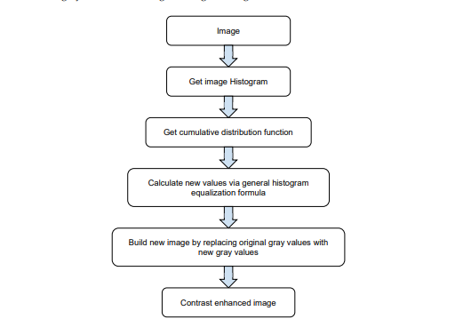

where cdfmin is the minimum value of the cumulative distribution function, M x N are the image’s number of columns and rows, L is the number of gray levels used

CONTRAST ENHANCEMENT:

Contrast enhancement techniques expand the range of brightness values in an image so that the image can be efficiently displayed in a manner desired by the analyst. The density values in a scene are literally pulled farther apart, that is, expanded over a greater range. The effect is to increase the visual contrast between two areas of different uniform densities. This enables the analyst to discriminate easily between areas initially having a small difference in density. Contrast enhancement can be effected by a linear or non linear transformation. Linear Contrast Stretch: This is the simplest contrast stretch algorithm. The grey values in the original image and the modified image follow a linear relation in this algorithm. A density number in the low range of the original histogram is assigned to extremely black, and a value at the high end is assigned to extremely white. The remaining pixel values are distributed linearly between these extremes. The features or details that were obscure on the original image will be clear in the contrast stretched image. In exchange for the greatly enhanced contrast of most original brightness values, there is a trade off in the loss of contrast at the extreme high and low density number values. However, when compared to the overall contrast improvement, the contrast losses at the brightness extremes are acceptable trade off, unless one were specifically interested in these elements of the scene. The equation Y = ax+b performs the linear transformation in a linear contrast stretch method. The values of ‘a’ and ‘b’ are computed from the equations.



4.Limitations and Results:

Edges of the images have been successfully detected by subtracting its blurred image by using unsharp mask filter. Graphical representation has been obtained which contains stretched range of intensities of pixels. And enhanced image has been obtained through contrast enhancement using histogram equalization technique. The used algorithm for denoising image is not optimized. Advanced, more efficient and optimized algorithms like Gaussian filtering, an improved Non-Local Means of denoising algorithm, etc. are available. Algorithm for appending could also be optimized using advanced concepts. Histogram equalization algorithm could be improved by replacing it with more advanced technique known as Adaptive Histogram Equalization technique.

Results:

Normal:

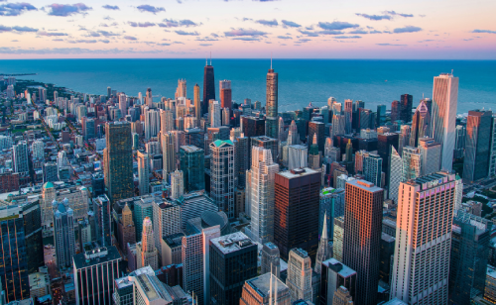



Edge detection:

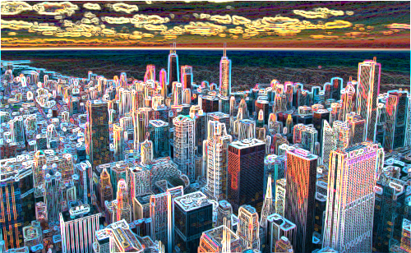

Contrast enchanced :

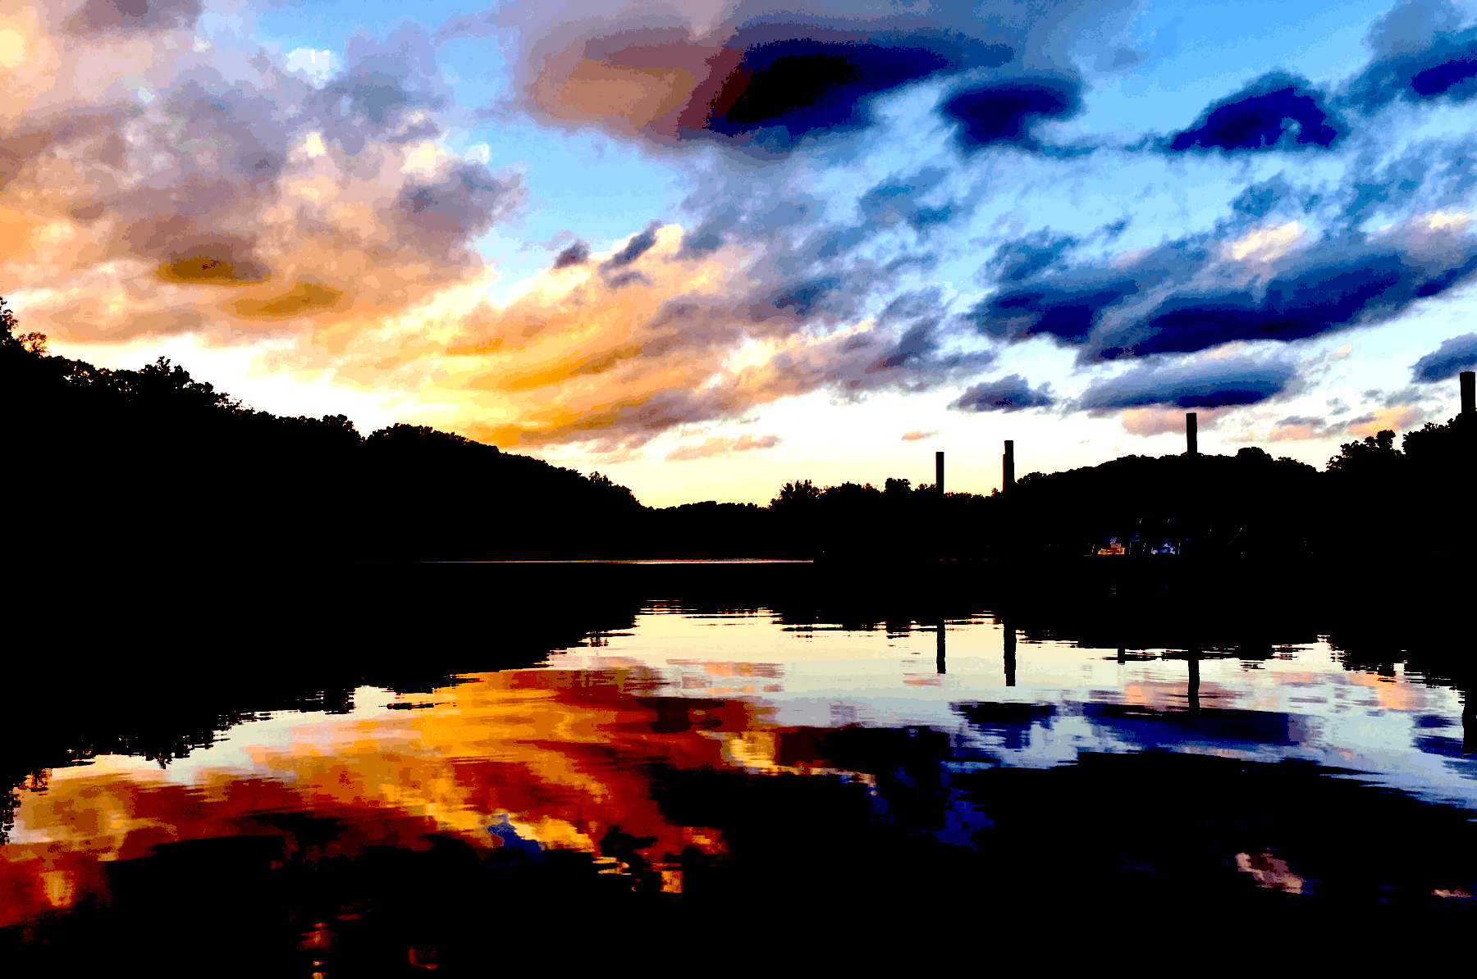

9. CONCLUSION

Image enhancement techniques change images to

provide a better representation of the information

encapsulated in the image. In this paper is presented a

review for various fields of image enhancement. For every

purpose like underwater imaging or medical images, there

are different algorithms and techniques suitable for image

enhancement. As we can see from this review paper, and

also from other review papers, there is no universal image

enhancement technique, the most important reason for that

is the fact that there are a lot of different factors, for

example, fogg in images and videos, or the fact that

medical images are mostly grayscale images

9. CONCLUSION

Image enhancement techniques change images to

provide a better representation of the information

encapsulated in the image. In this paper is presented a

review for various fields of image enhancement. For every

purpose like underwater imaging or medical images, there

are different algorithms and techniques suitable for image

enhancement. As we can see from this review paper, and

also from other review papers, there is no universal image

enhancement technique, the most important reason for that

is the fact that there are a lot of different factors, for

example, fogg in images and videos, or the fact that

medical images are mostly grayscale images

9. CONCLUSION

Image enhancement techniques change images to

provide a better representation of the information

encapsulated in the image. In this paper is presented a

review for various fields of image enhancement. For every

purpose like underwater imaging or medical images, there

are different algorithms and techniques suitable for image

enhancement. As we can see from this review paper, and

also from other review papers, there is no universal image

enhancement technique, the most important reason for that

is the fact that there are a lot of different factors, for

example, fogg in images and videos, or the fact that

medical images are mostly grayscale images

5. CONCLUSION:

Image enhancement techniques change images to provide a better representation of the information encapsulated in the image. In this paper is presented a review for various fields of image enhancement. For every purpose like underwater imaging or medical images, there are different algorithms and techniques suitable for image enhancement. As we can see from this review paper, and also from other review papers, there is no universal image enhancement technique, the most important reason for that is the fact that there are a lot of different factors, for example, fogg in images and videos, or the fact that medical images are mostly grayscale images.