VISVESVARAYA TECHNOLOGICAL UNIVERSITY BELAGAVI - 590018


FSD Mini Project Report on

“News App”

Submitted in partial fulfillment of the requirement for the award of the degree of

Bachelor of Engineering in
Computer Science and Engineering

Submitted By

Kishan H S 1DT21CS071
Rakshith Hegde 1DT21CS119

Under the Guidance of

Prof. Sushmitha S
Assistant Professor, Department of CSE


DAYANANDA SAGAR ACADEMY OF TECHNOLOGY AND MANAGEMENT
Udayapura, Kanakapura Road, Bangalore-560082
(Affiliated to VTU, Belagavi and Approved by AICTE, New Delhi), CE, CSE, ECE, EEE, ISE, ME Courses Accredited by NBA, New Delhi, NAAC A+

Department of Computer Science and Engineering
Academic Year: 2023-24

CERTIFICATE

Certified that the Mini Project titled “News App” carried out by KISHAN H S, bearing USN 1DT21CS071, RAKSHITH HEGDE, bearing USN 1DT21CS119, bonafide students of Dayananda Sagar Academy 0f Technology and Management, is in partial fulfillment for the award of the BACHELOR OF ENGINEERING in Computer Science and Engineering from Visvesvaraya Technological University, Belagavi during the year 2023-2024. It is certified that all the corrections/suggestions indicated for Internal Assessment have been incorporated in the report submitted to the department. The Project report has been approved as it satisfies the academic requirements in respect of the Mini Project Work prescribed for the said Degree.

Prof. Sushmitha S Assistant Professor Department of CSE DSATM, Bengaluru.

Examiner 1: Name…………………….…….....
Signature………………………..………
Examiner 2:
Name…………………………….
Signature………………………….

Dr. Kavitha C Professor & HOD Department of CSE DSATM, Bengaluru.

Dr. M. Ravishankar Principal
DSATM, Bengaluru.

DECLARATION
We, KISHAN H S , bearing USN 1DT21CS071, RAKSHITH HEGDE, bearing USN 1DT20CS119, students of Sixth Semester B.E, Department of Computer Science and Engineering, Dayananda Sagar Academy 0f Technology and Management, Bengaluru, declare that the Mini Project Work titled “News App” has been carried out by us and submitted in partial fulfilment of the course requirements for the award of degree in Bachelor of Engineering in Computer Science and Engineering from Visvesvaraya Technological University, Belagavi during the academic year 2023- 2024.

1. KISHAN H S | 1DT21CS071
2. RAKSHITH HEGDE | 1DT21CS119

Place: Bengaluru
Date:
ABSTRACT
The NewsApp is a web-based application developed using the Django framework, designed to provide users with categorized news articles and allow user interaction through comments. This project aims to deliver a dynamic, responsive, and user-friendly interface by leveraging the power of Django for backend operations and Bootstrap for front-end design.
The primary objective of NewsApp is to create an organized platform where users can easily navigate through news articles sorted by different categories such as technology, sports, entertainment, and more. Each news article can be commented on, fostering user engagement and discussion.
The application features a well-structured database design that efficiently handles relationships between categories, news articles, and comments. The project adheres to the Model-View-Controller (MVC) architecture, ensuring a clean separation of concerns and maintainability.
The development process involved setting up the Django environment, designing models to represent data entities, creating views to manage user interactions, and utilizing templates to render the user interface. Bootstrap was integrated to enhance the visual appeal and responsiveness of the site.
Testing was conducted to ensure the robustness and reliability of the application, covering various functionalities such as adding, editing, and viewing news articles, as well as posting comments.
In conclusion, NewsApp serves as a comprehensive platform for accessing and interacting with news content. Future enhancements could include user authentication, advanced search capabilities, and personalized news feeds to further improve user experience.

ACKNOWLEDGEMENT

The satisfaction and the euphoria that accompany the successful completion of any task would be incomplete without the mention of the people who made it possible. The constant guidance of these people and encouragement provided, crowned us with success and glory. We take this opportunity to express our gratitude to one and all.

It gives us immense pleasure to present before you our project titled “NEWS APP”. The joy and satisfaction that accompanies the successful completion of any task would be incomplete without the mention of those who made it possible. We are glad to express our gratitude towards our prestigious institution DAYANANDA SAGAR ACADEMY OF TECHNOLOGY AND MANAGEMENT for providing us with utmost knowledge, encouragement and the maximum facilities in undertaking this project.

We wish to express a sincere thanks to our respected Principal Dr. M Ravi Shankar, Principal, DSATM for all his support.
We express our deepest gratitude and special thanks to Dr. Kavitha C, H.O.D, Dept. of Computer Science Engineering, for all her guidance and encouragement.

We sincerely acknowledge the guidance and constant encouragement of our mini-project guide,
Prof. Sushmitha S, Assistant Professor, Dept. of Computer Science & Engineering.

Kishan H S  Rakshith Hegde | 1DT21CS071  1DT21CS119

TABLE OF CONTENTS

Chapter No. | Chapter Name | Page No.
1 | INTRODUCTION | 8
1.1 | Purpose | 8
1.2 | Scope | 8
2 | REQUIREMENT SPECIFICATION | 9
2.1 | Hardware configuration | 9
2.2 | Software configuration | 9
3 | SYSTEM ANALYSIS AND DESIGN | 10
3.1 | Analysis | 10
3.2 | Design Introduction | 11
3.2.1 | Control flow diagram | 11
4 | IMPLEMENTATION | 12
4.1 | Modules | 12
4.2 | Source code | 14
5 | TESTING | 28
5.1 | System testing. | 28
5.2 | Module Testing | 28
5.3 | Integration Testing | 28
6 | RESULT ANALYSIS & SCREENSHOTS | 29
7 | CONCLUSION | 31

LIST OF FIGURES

SL NO. | FIGURE NO. | FIGURE NAME | PAGE NO.
1 | Figure 6.1 | Home | 29
2 | Figure 6.2 | All News | 29
3 | Figure 6.3 | Category | 30
4 | Figure 6.4 | Admin news | 30
5 | Figure 6.5 | Admin news data | 30

CHAPTER 1

INTRODUCTION

1.1 PURPOSE
The purpose of the NewsApp project is to develop a web-based platform that efficiently organizes and presents news articles categorized by various topics. This application aims to enhance the user experience by providing an intuitive and responsive interface, allowing users to easily navigate through news content, read articles of interest, and engage with the content through comments.
Key objectives of the project include:
- Categorized News Organization:
  - To create a structured system where news articles are organized into distinct categories, making it easier for users to find content related to their interests.
- User Interaction:
  - To implement a commenting system that allows users to share their thoughts and opinions on individual news articles, fostering engagement and discussion.
- Responsive Design:
  - To utilize Bootstrap for front-end development to ensure the application is visually appealing and accessible across various devices and screen sizes.
- Scalability and Maintainability:
  - To employ the Django framework's Model-View-Controller (MVC) architecture to ensure the application is scalable and maintainable, allowing for future enhancements and feature additions.
- Efficient Data Management:
  - To design a robust database schema that effectively manages the relationships between categories, news articles, and comments, ensuring data integrity and efficient retrieval.
- User-Friendly Experience:

To create an intuitive and easy-to-navigate interface that enhances the overall user experience, making it simple for users to browse and interact with news content.

1.2 SCOPE
The scope of the NewsApp project encompasses the following aspects:
Core Functionalities:
Categorized News Display: The application will feature a categorized display of news articles, allowing users to browse content by specific topics such as technology, sports, entertainment, etc.
News Article Management: Administrators will have the ability to add, edit, and delete news articles through a user-friendly interface.
Comment System: Users can post comments on individual news articles, fostering interaction and discussion. Comments will be displayed below each article, with features for adding and deleting comments.
User Interface:
Responsive Design: The application will utilize Bootstrap to ensure a responsive and visually appealing design that works seamlessly across various devices and screen sizes.
Navigation and Layout: A clean and intuitive navigation system will be implemented, allowing users to easily switch between different categories and access news articles.
Database Management:
Models and Relationships: The project will involve designing and implementing Django models to represent categories, news articles, and comments, with appropriate relationships and constraints.
Data Integrity: Ensuring data integrity and consistency through proper validation and error handling mechanisms.
Backend Development:
Django Framework: Utilizing Django's robust framework for backend development, ensuring a secure and scalable application.
Views and Templates: Implementing Django views to handle user requests and responses, and using templates to render the user interface dynamically.
Testing and Validation:
Unit Testing: Writing unit tests to verify the correctness of individual components such as models, views, and forms.
Integration Testing: Conducting integration tests to ensure the different parts of the application work together seamlessly.
Documentation:
Project Documentation: Providing comprehensive documentation for the project, including setup instructions, code explanations, and usage guidelines.
User Guide: Creating a user guide to help end-users navigate and utilize the application effectively.

REQUIREMENT SPECIFICATION

Hardware Configuration
Processor: Dual-core processor or higher
• Memory: 4 GB RAM or more (8 GB recommended for smoother performance)
• Storage: 10 GB of available disk space (SSD recommended for faster read/write operations)
• Operating System: Windows 10/11, macOS, or a Linux distribution (e.g., Ubuntu)
• Display: Monitor with a resolution of 1920x1080 or higher

Software Configuration
Web Server:
Processor: Quad-core processor or higher
Memory: 8 GB RAM or more (16 GB recommended for handling higher traffic)
Storage: 20 GB of available disk space (SSD recommended for faster read/write operations)
Operating System: Linux distribution (e.g., Ubuntu Server, CentOS)
Network: Reliable network connectivity with sufficient bandwidth to handle user traffic

SYSTEM ANALYSIS AND DESIGN

3.1 ANALYSIS

The NewsApp project is designed to provide a web-based platform for users to access and interact with categorized news articles. This system analysis delves into the functional and non-functional requirements, system components, data flow, architecture, and security measures of the application.

Functional Requirements
The core functionalities of the NewsApp include user and news management. Users should be able to register, log in, and log out, although user authentication features might be added in future enhancements. Administrators can perform CRUD (Create, Read, Update, Delete) operations on news articles, ensuring that the content remains up-to-date and relevant. News articles are categorized, and users can browse through these categories to find articles of interest. Each news article can be viewed in detail, and users can post comments on articles, encouraging interaction and discussion.

Non-Functional Requirements
The non-functional requirements focus on the quality attributes and constraints of the system. Performance is a key consideration, with the application expected to handle concurrent users efficiently and provide quick loading times. Scalability is also crucial, ensuring the system can grow to accommodate increasing numbers of users and news articles. Security measures must be in place to protect user data and prevent unauthorized access. Usability is a priority, with a user-friendly interface that is easy to navigate. Maintainability ensures that the codebase is modular and well-documented, facilitating future updates and enhancements.

DESIGN INTRODUCTION

The design of the NewsApp project is centered around creating a structured, scalable, and user-friendly web application that effectively organizes and displays news articles by category. Leveraging the Django framework, the project follows the Model-View-Controller (MVC) architecture to ensure a clean separation of concerns, making the application modular and easy to maintain. The user interface is designed with responsiveness and usability in mind, using Bootstrap to ensure a consistent and
appealing visual experience across different devices
CHAPTER 4

IMPLEMENTATION

4.1 MODULES

Models (news/models.py):
- Define the data structure using Django models.
- Includes models for Category, News, and Comment.
- Handles database interactions and relationships between entities.
• Views (news/views.py):
- Implement view functions that handle user requests and responses.
- Includes views for listing categories, listing news articles by category, and displaying detailed news articles with comments.
- Utilizes Django's querysets to fetch data from the database and render templates.
• Templates:
- Located in the news/templates/news/ directory.
- HTML files that define the user interface using Django's template language.
- Includes templates for displaying category lists (category_list.html), news lists (news_list.html), and news details with comments (news_detail.html).
- Uses Bootstrap for front-end styling and responsiveness.
• Forms (news/forms.py):
- Define Django forms for handling user input.
- Includes forms for adding comments (CommentForm) associated with news articles.
- Validates user input and processes form submissions.
• URLs (news/urls.py):
- Define URL patterns for routing user requests to appropriate view functions.
- Maps URLs such as /categories/, /categories/<category_id>/, and /news/<news_id>/ to corresponding views.
- Integrates with the main project's URL configuration (urls.py).
• Static Files (news/static/news/):
- Includes Bootstrap CSS (bootstrap.min.css) for styling the application.
• Admin Panel:
- Django provides an automatic admin interface (admin.py) for managing application data.
- Registers models (Category, News, Comment) to allow administrators to add, edit, and delete records directly.
• Settings (newsapp/settings.py):
- Configure Django settings for the NewsApp.
- Includes database settings, static files configuration, middleware, and installed apps.
- Specifies templates directory, static files directories, and other project-specific settings.
• Database (SQLite):
- Default database engine used by Django for development.
- Stores data for categories, news articles, and comments.
- Tables and relationships defined by Django models (manage.py migrate to create database schema).
• Middleware and Middleware Hooks:
- Middleware components defined in news/middleware.py.
- Hooks like process_request, process_view, and process_response defined to manipulate request and response objects.

4.2 SOURCE CODE

Urls.py

from django.contrib import admin
from django.urls import path,include

urlpatterns = [
path('admin/', admin.site.urls),
path('',include('main.urls')),
]

all-news.html

{% extends 'base.html' %} {% block content%}
<main class="container mt-3 mb-5">
<h3 class="border-bottom pb-1 my-4">{{news.catgeory.title }}</h3>
<!-- News Box -->
{% for news in all_news %}
<div class="card mb-4 shadow">
<div class="row no-gutters">
<div class="col-md-3">
<img
src="/media/{{news.image}}"
class="card-img"
alt="{{news.title}}"
/>
</div>
<div class="col-md-8">
<div class="card-body">
<h5 class="card-title">{{news.title}}</h5>
<p class="card-text">{{news.detail}}</p>
<p class="card-text">
<a href="/detail/{{news.id}}" class="btn btn-sm btn-dark"
>Read Full</a
>
</p>
</div>
</div>
</div>
</div>
{% endfor %}
</main>
{% endblock%

Base.html
{% load static %}
<!DOCTYPE html>
<html>
<head>
<title>{% block title %}homepage {% endblock%}</title>
<!-- Bootstrap 4 CSS -->
<link
rel="stylesheet"
type="text/css"
href="{% static 'vendor/bs4/bootstrap.min.css ' %}"
/>
<!-- Main Jquery -->
<script
type="text/javascript"
src="{% static 'vendor/jquery.min.js' %} "
></script>
<!-- Bootstrap Js -->
<script
type="text/javascript"
src="{% static '/vendor/bs4/bootstrap.min.js' %}"
></script>
</head>
<body>
<nav class="navbar navbar-expand-lg bg-body-tertiary bg-dark">
<div class="container-fluid">
<a class="navbar-brand" href="/">Newsapp</a>
<button
class="navbar-toggler"
type="button"
data-bs-toggle="collapse"
data-bs-target="#navbarNav"
aria-controls="navbarNav"
aria-expanded="false"
aria-label="Toggle navigation"
>
<span class="navbar-toggler-icon"></span>
</button>
<div class="collapse navbar-collapse m-2" id="navbarNav">
<ul class="navbar-nav">
<li class="nav-item">
<a class="nav-link active" aria-current="page" href="/">Home</a>
</li>
<li class="nav-item">
<a class="nav-link" href="{% url 'all-news' %}">All News</a>
</li>
<li class="nav-item">
<a class="nav-link" href="{% url 'all-category' %}"
>All Categories</a
>
</li>
</ul>
</div>
</div>
</nav>

<!-- Top News -->

{% block content %} {% endblock%}
<footer class="bg-dark" style="color: white">
<div class="container">
<p class="float-right">
<a href="#">Back to top</a>
</p>
<p>This is a newsapp built for fun</p>
<p>Designed and Developed by Rakshith Hegde and Kishan HS</p>
</div>
</footer>
</body>
</html>

Categories.html

{% extends 'base.html' %} {% block content%}
<main class="container mt-3 mb-5">
<h3 class="border-bottom pb-1 my-4">All Categories</h3>
<div class="row">
<!-- Category Box -->
{% for cat in cats%}
<div class="col-md-4">
<div class="card mb-3 shadow">
<img
src="/media/{{cat.category_image}}"
class="card-img-top"
alt="{{cat.title}}"
/>

<div class="card-body">
<h5 class="card-title">{{cat.title }}</h5>
<hr />
<p class="card-text">
<a href="category/{{cat.id}}" class="btn btn-sm btn-dark"
>All News</a
>
</p>
</div>
</div>
</div>
{% endfor%}
</div>
</main>
{% endblock%}

Category-news.html

{% extends 'base.html' %} {% block content%}
<main class="container mt-3 mb-5">
<h3 class="border-bottom pb-1 my-4">{{category.title}}</h3>
<!-- News Box -->
{% for news in all_news %}
<div class="card mb-4 shadow">
<div class="row no-gutters">
<div class="col-md-3">
<img
src="/media/{{news.image}}"
class="card-img"
alt="{{news.title}}"
/>
</div>
<div class="col-md-8">
<div class="card-body">
<h5 class="card-title">{{news.title}}</h5>
<p class="card-text">{{news.detail}}</p>
<p class="card-text">
<a href="/detail/{{news.id}}" class="btn btn-sm btn-dark"
>Read Full</a
>
</p>
</div>
</div>
</div>
</div>
{% endfor %}
</main>
{% endblock%}

Detail.html

{% extends 'base.html' %} {% block content%}
<main class="container mt-3 mb-5">
<!-- featured news -->
<div class="row my-3">
<!-- Left -->
<div class="col-md-8">
<div class="card mb-3">
<img
src="/media/{{news.image}}"
class="card-img-top"
alt="{{news.title}}"
/>
<div class="card-body">
<h5 class="card-title">{{news.title}}</h5>
<hr />
<p class="card-text">{{news.detail}}</p>
</div>
<div class="card-footer">
In
<a href="/category/{{news.category.id}}">{{news.category.title}}</a>
</div>
</div>

<!-- Comments -->
<div class="card my-4">
<h6 class="card-header">Add Comment</h6>
<div class="card-body">
{% for message in messages%}
<p class="text-success">{{message}}</p>
{% endfor %}
<form method="post" action="/detail/{{news.id}}">
{% csrf_token %}
<div class="form-group row">
<label class="col-md-2"
>Name<span class="text-danger">*</span></label
>
<div class="col-md-10">
<input type="text" name="name" required class="form-control" />
</div>
</div>
<div class="form-group row">
<label class="col-md-2"
>Email<span class="text-danger">*</span></label
>
<div class="col-md-10">
<input
type="temailext"
name="email"
required
class="form-control"
/>
</div>
</div>
<div class="form-group row">
<label class="col-md-2"
>Comment<span class="text-danger">*</span></label
>
<div class="col-md-10">
<textarea
class="form-control"
name="message"
required
></textarea>
</div>
</div>
<input type="submit" class="btn btn-dark" />
</form>
</div>
</div>
<!-- Previous Comments -->
<div class="card my-4">
<h6 class="card-header">Comments</h6>
<div class="card-body">
{% for comment in comments %}
<blockquote class="blockquote text-right">
<p class="mb-0">{{comment.comment}}</p>
<footer class="blockquote-footer">
{{comment.name}}
<cite title="Source Title"> {{comment.email}}</cite>
</footer>
</blockquote>
<hr />
{% endfor %}
</div>
</div>
</div>
<!-- Related News -->
<div class="col-md-4">
<h3 class="mb-3 border-bottom pb-1">From this Category</h3>
<!-- Category Box -->
{% for news in related_news %}
<div class="card mb-3 shadow">
<img
src="/media/{{news.image}}"
class="card-img-top"
alt="{{news.title}}"
/>
<div class="card-body">
<h5 class="card-title">{{news.title}}</h5>
<hr />
<p class="card-text">
<a href="/detail/{{news.id}}" class="btn btn-sm btn-dark"
>Read Full</a
>
</p>
</div>
</div>
{% endfor %}
</div>
</div>
</main>
{% endblock%}

Home.html

{% extends 'base.html' %} {% block content%}
<main class="container mt-3 mb-5">
<!-- featured news -->
<div class="row my-3">
<!-- Left -->
<div class="col-md-7">
<div class="card mb-3">
<img
src="/media/{{first_news.image}}"
class="card-img-top"
alt="{{first_news.title}}"
/>
<div class="card-body">
<h5 class="card-title">{{first_news.title}}</h5>
<hr />
<p class="card-text">
<a href="/detail/{{first_news.id}}" class="btn btn-sm btn-dark"
>Read Full</a
>
</p>
</div>
</div>
</div>
<!-- Right -->
<div class="col-md-5" style="max-height: 450px; overflow: auto">
{% for news in three_news %}
<!-- News Box -->
<div class="card">
<div class="row no-gutters">
<div class="col-md-4">
<img
src="/media/{{news.image}}"
class="card-img-top"
alt="{{news.title}}"
/>
</div>
<div class="col-md-8">
<div class="card-body">
<h5 class="card-title">{{news.title}}</h5>
<p class="card-text">
<a href="/detail/{{news.id}}" class="btn btn-sm btn-dark"
>Read Full</a
>
</p>
</div>
</div>
</div>
</div>
<hr />
{% endfor%}
</div>
</div>
<!-- Category Wise News -->
{% for category in three_categories %}
<h3 class="border-bottom pb-1">
{{category.title}}
<a href="/category/{{category.id}}" class="float-right btn btn-sm btn-dark"
>In this Category</a
>
</h3>
<div class="row my-4">
{% for news in category.news_set.all %} {% if forloop.counter < 5 %}
<!-- News box -->
<div class="col-md-3">
<div class="card mb-3 shadow">
<img
src="/media/{{news.image}}"
class="card-img-top"
alt="{{news.title}}"
/>
<div class="card-body">
<h5 class="card-title">{{news.title}}</h5>
<hr />
<p class="card-text">
<a href="/detail/{{news.id}}" class="btn btn-sm btn-dark"
>Read Full</a
>
</p>
</div>
</div>
</div>
{% endif %} {% endfor %}
</div>
{% endfor %}
<!-- End Single Category -->
</main>
{% endblock%}

Models.py

from django.db import models

# category model
class Category(models.Model):
title=models.CharField(max_length=200)
category_image=models.ImageField(upload_to='imgs/')

class Meta:
verbose_name_plural ='Categories'

def __str__(self):
return self.title

class News(models.Model):
category=models.ForeignKey(Category,on_delete=models.CASCADE)
title=models.CharField(max_length=300)
image=models.ImageField(upload_to='Imgs')
detail=models.TextField()
add_time=models.DateTimeField(auto_now_add=True)

class Meta:
verbose_name_plural ='News'

def __str__(self):
return self.title

# comments Model

class Comment(models.Model):
news=models.ForeignKey(News,on_delete=models.CASCADE)
name=models.CharField(max_length=100)
email=models.CharField(max_length=200)
comment=models.TextField()
status=models.BooleanField(default=False)

def __str__(self):
return self.comment

Admin.py

from django.contrib import admin
from .models import Category,News,Comment

# Register your models here.
admin.site.register(Category,)

class AdminNews(admin.ModelAdmin):
list_display=('title','category','add_time')
admin.site.register(News,AdminNews)

class AdminComment(admin.ModelAdmin):
list_display=('news','email','comment','status')
admin.site.register(Comment,AdminComment)

mainapp/urls.py

from django.urls import path

from django.conf import settings
from django.conf.urls.static import static

from . import views

urlpatterns = [
path('',views.home,name='home'),
path('all-news',views.all_news,name='all-news'),
path('detail/<int:id>',views.detail,name="detail"),
path('all-category',views.all_category,name='all-category'),
path('category/<int:id>',views.category,name='category'),

] + static(settings.MEDIA_URL, document_root=settings.MEDIA_ROO

Views.py
from django.shortcuts import render,redirect
from django.contrib import messages
from .models import News,Category,Comment
import requests

# Home Page
def home(request):
first_news=News.objects.first()
three_news=News.objects.all()[1:4]
three_categories=Category.objects.all()[0:3]

return render(request, 'home.html',{
'first_news':first_news,
'three_news':three_news,
'three_categories':three_categories

})

# All News Page
def all_news(request):
all_news=News.objects.all()
return render(request, 'all-news.html',{
'all_news':all_news
})

# Deatil Page
def detail(request,id):
news=News.objects.get(pk=id)
if request.method=='POST':
name=request.POST['name']
email=request.POST['email']
comment=request.POST['message']
Comment.objects.create(
news=news,
name=name,
email=email,
comment=comment,
status=True,
)

# messages.success(request,'comment submitted but in moderation mode.')
category=Category.objects.get(id=news.category.id)
rel_news=News.objects.filter(category=category).exclude(id=id)
comments=Comment.objects.filter(news=news,status=True).order_by('-id')
return render(request, 'detail.html',{
'news':news,
'related_news':rel_news,
'comments':comments
})

#fetch all category
def all_category(request):
cats=Category.objects.all()
return render(request,'category.html',{
'cats':cats
})

#fetch news in category
def category(request,id):
category=Category.objects.get(id=id)
news=News.objects.filter(category=category)
return render(request,'category-news.html',{
'all_news':news,
'category':category
})
Settings.py

"""
Django settings for newsapp project.

Generated by 'django-admin startproject' using Django 3.2.6.

For more information on this file, see
https://docs.djangoproject.com/en/3.2/topics/settings/

For the full list of settings and their values, see
https://docs.djangoproject.com/en/3.2/ref/settings/
"""

import os
from pathlib import Path

# Build paths inside the project like this: BASE_DIR / 'subdir'.
BASE_DIR = Path(__file__).resolve().parent.parent

# Quick-start development settings - unsuitable for production
# See https://docs.djangoproject.com/en/3.2/howto/deployment/checklist/

# SECURITY WARNING: keep the secret key used in production secret!
SECRET_KEY = 'django-insecure-wx#(kuy3iwvu+j%b!^=vwe!$%91*%8d53u1ol&e8a%em3dy472'

# SECURITY WARNING: don't run with debug turned on in production!
DEBUG = True

ALLOWED_HOSTS = []

# Application definition

INSTALLED_APPS = [
'django.contrib.admin',
'django.contrib.auth',
'django.contrib.contenttypes',
'django.contrib.sessions',
'django.contrib.messages',
'django.contrib.staticfiles',
'main'
]

MIDDLEWARE = [
'django.middleware.security.SecurityMiddleware',
'django.contrib.sessions.middleware.SessionMiddleware',
'django.middleware.common.CommonMiddleware',
'django.middleware.csrf.CsrfViewMiddleware',
'django.contrib.auth.middleware.AuthenticationMiddleware',
'django.contrib.messages.middleware.MessageMiddleware',
'django.middleware.clickjacking.XFrameOptionsMiddleware',
]

ROOT_URLCONF = 'newsapp.urls'

TEMPLATES = [
{
'BACKEND': 'django.template.backends.django.DjangoTemplates',
'DIRS': [],
'APP_DIRS': True,
'OPTIONS': {
'context_processors': [
'django.template.context_processors.debug',
'django.template.context_processors.request',
'django.contrib.auth.context_processors.auth',
'django.contrib.messages.context_processors.messages',
],
},
},
]

WSGI_APPLICATION = 'newsapp.wsgi.application'

# Database
# https://docs.djangoproject.com/en/3.2/ref/settings/#databases

DATABASES = {
'default': {
'ENGINE': 'django.db.backends.sqlite3',
'NAME': BASE_DIR / 'db.sqlite3',
}
}

# Password validation
# https://docs.djangoproject.com/en/3.2/ref/settings/#auth-password-validators

AUTH_PASSWORD_VALIDATORS = [
{
'NAME': 'django.contrib.auth.password_validation.UserAttributeSimilarityValidator',
},
{
'NAME': 'django.contrib.auth.password_validation.MinimumLengthValidator',
},
{
'NAME': 'django.contrib.auth.password_validation.CommonPasswordValidator',
},
{
'NAME': 'django.contrib.auth.password_validation.NumericPasswordValidator',
},
]

# Internationalization
# https://docs.djangoproject.com/en/3.2/topics/i18n/

LANGUAGE_CODE = 'en-us'

TIME_ZONE = 'UTC'

USE_I18N = True

USE_L10N = True

USE_TZ = True

# Static files (CSS, JavaScript, Images)
# https://docs.djangoproject.com/en/3.2/howto/static-files/

STATIC_URL = '/static/'

MEDIA_ROOT = os.path.join(BASE_DIR, 'media')
MEDIA_URL = '/media/'

# Default primary key field type
# https://docs.djangoproject.com/en/3.2/ref/settings/#default-auto-field
DEFAULT_AUTO_FIELD = 'django.db.models.BigAutoField'
CHAPTER 5
TESTING
5.1 SYSTEM TESTING
System Testing assesses the behavior and functionality of the complete NewsApp system as a whole. This testing approach focuses on validating the application against its requirements and user expectations. It involves testing user workflows, interactions with external systems (if any), and overall system performance. System tests ensure that the application meets its functional and non-functional requirements, including usability, security, and performance, thereby verifying its readiness for deployment and use.

5.2 MODULE TESTING

Module Testing involves verifying the functionality and behavior of individual modules within the NewsApp project. Each module, typically encapsulating related functionality or a specific feature set, is tested independently to ensure it operates correctly according to its design and specifications.
Module testing focuses on assessing the internal workings of each module, including its functions, classes, and interfaces. By isolating modules from the rest of the system, developers can detect and resolve issues early in the development process. This approach helps maintain code quality, supports modular design principles, and facilitates easier debugging and troubleshooting. Module testing also ensures that each component of the NewsApp functions as intended before integration into the larger system, contributing to overall system reliability and maintainability.

5.3 INTEGRATION TESTING

Testing is a systematic technique or construction the program structure while atthe same time conducting tests to uncover error associated with the interfacing.Scope of testing summarizes the specific functional, performance and internal design characteristics that are to be tested.

CHAPTER 6

RESULT ANALYSIS AND SCREENSHOTS

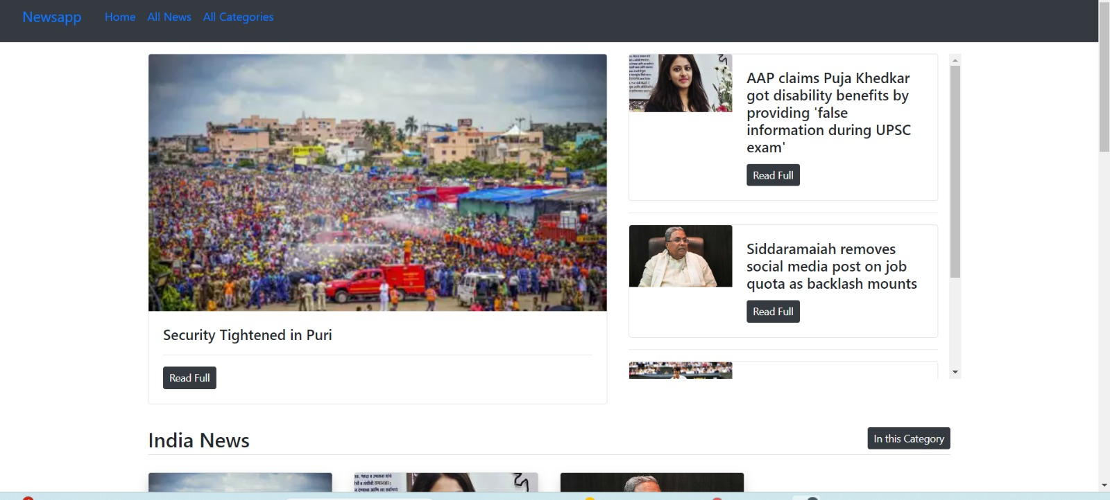

Fig 6.1 Home Page
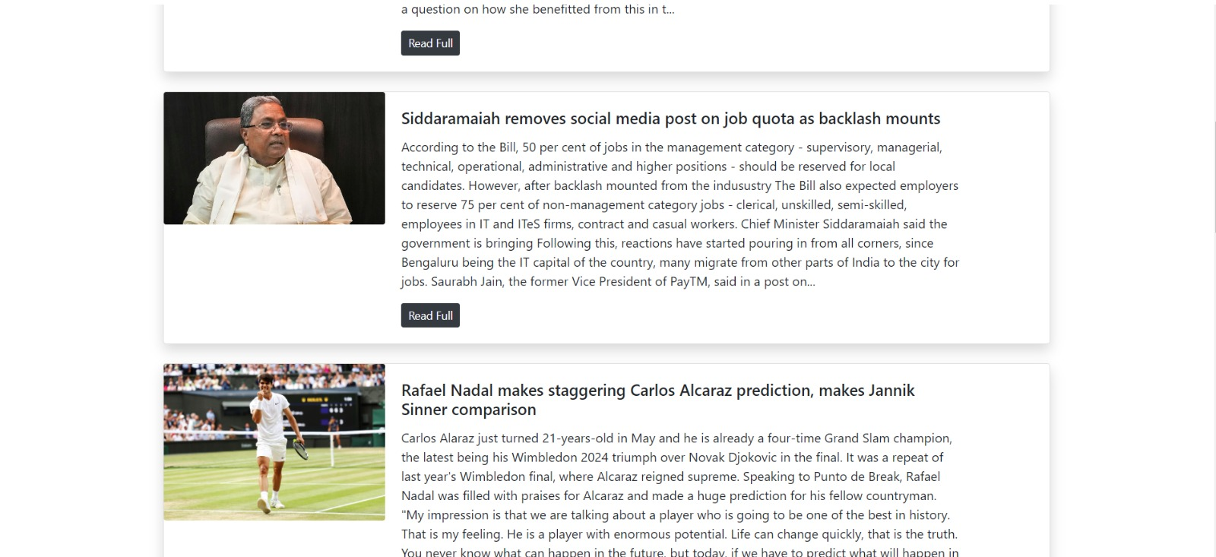
Fig 6.2 All News

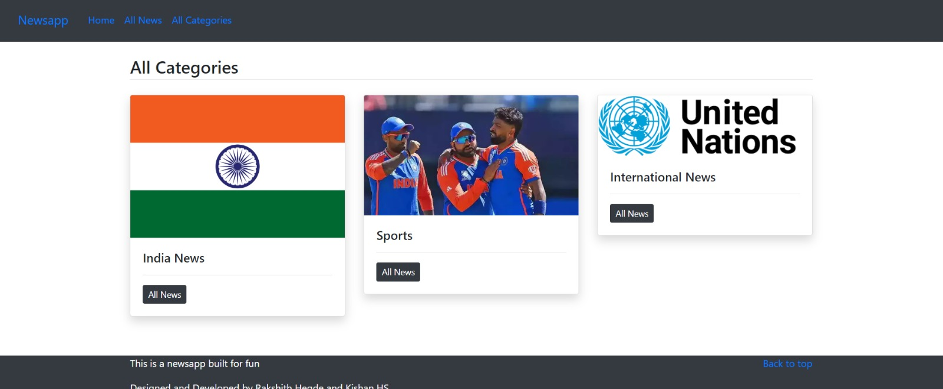

Fig 6.3 Category news

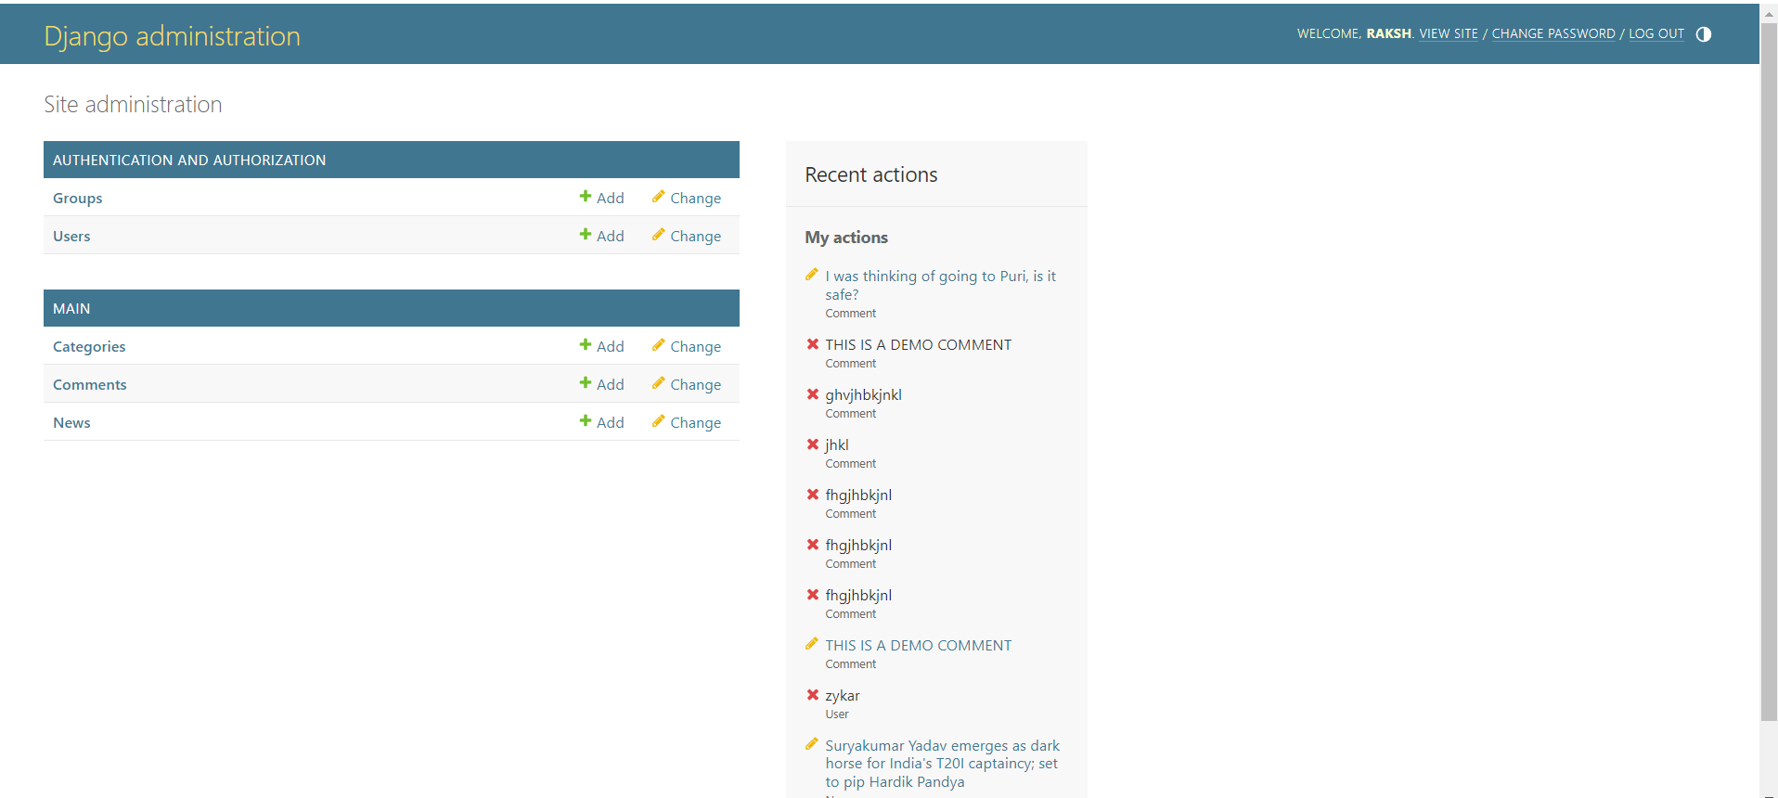

Fig 6.4 Admin news

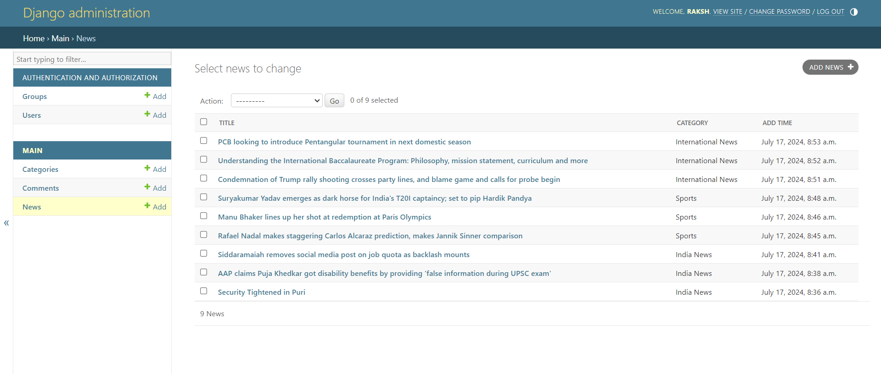

Fig 6.5 Admin panel news data

CHAPTER 7

CONCLUSION AND FUTURE ENHANCEMENTS

The development and testing of the NewsApp project highlight the importance of a structured and comprehensive approach to software development. By implementing unit, module, integration, and system testing, the project ensures that each component functions correctly, integrates seamlessly with others, and meets user expectations and requirements. Unit testing helps in verifying individual components, module testing focuses on the internal workings of each module, integration testing checks the interactions between different modules, and system testing validates the complete system's functionality and performance.

MERITS

• Modular Design: The NewsApp follows a modular design approach, making the codebase more manageable and maintainable. Each module or component can be developed, tested, and debugged independently, reducing complexity and improving development efficiency.
• Scalability: With the use of Django’s robust framework and the modular approach, the application is easily scalable. New features and functionalities can be added without significant changes to the existing codebase, ensuring that the app can grow with user needs.
• User-Friendly Interface: Leveraging Bootstrap for the front-end design ensures a responsive and visually appealing user interface. This enhances user experience by providing easy navigation and interaction across different devices and screen sizes.
• Comprehensive Testing: The project employs unit testing, module testing, integration testing, and system testing, ensuring high reliability and robustness. Thorough testing at each level guarantees that individual components and the entire system function as intended, reducing the likelihood of bugs and errors.
• Security: Implementing best practices in data validation, user authentication, and secure communication (HTTPS) enhances the security of the NewsApp, protecting user data and preventing unauthorized access.

FUTURE ENHANCEMENTS
• User Authentication and Authorization: Implementing a comprehensive user authentication and authorization system will allow for more personalized experiences. Users can register, log in, and access features based on their roles and permissions, such as adding or editing news articles and comments.
• Search Functionality: Adding a search feature will enable users to quickly find specific news articles or categories. This will enhance the usability of the application by providing an efficient way to access relevant information.
• Advanced Commenting System: Introducing features like threaded comments, comment likes/dislikes, and reporting inappropriate comments can foster a more interactive and moderated discussion environment.
• Enhanced Analytics and Reporting: Implementing analytics to track user engagement, popular articles, and category trends can provide valuable insights. Administrators can use this data to improve content strategy and user experience.

BIBLIOGRAPHY
Django
https://www.djangoproject.com/start/

Bootstrap
https://getbootstrap.com/

Personal Details:
- NAME: KISHAN H S
- USN: 1DT21CS071
SEMESTER: 6TH SEM, ‘B’ SECTION

COLLEGE: DAYANANDA SAGAR ACADEMY OF TECHNOLOGY AND MANAGEMENT

- NAME: RAKSHITH HEGDE
- USN:1DT21CS119
SEMESTER: 6TH SEM, ‘B’ SECTION
COLLEGE: DAYANANDA SAGAR ACADEMY OF TECHNOLOGY AND MANAGEMENT

