Date : 05-08-2021

Session : Basic HTML Website

Task given : Create Basic HTML Website Create Home Page , Contact Page , About page …

My Task : Today , I have create Basic HTML Website and Create Home Page , Contact Page and About Page

Index.html

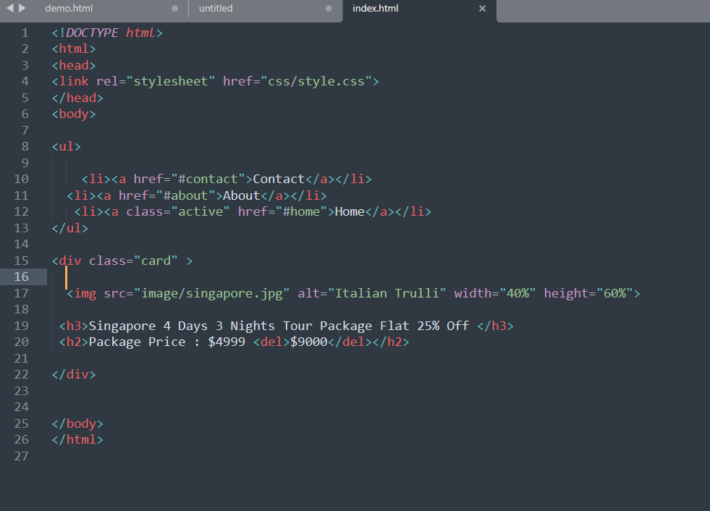

OUTPUT Will Be….

