Date : 18-08-2021

Session : JavaScript LocalStorage Session Cookies

Task given : Counter in js – TODO perform – LocalStorage

My Task :

|  |  |  |  |
| --- | --- | --- | --- |
| **No.** | **Task Details** | **Start Time** | **End Time** |
| 1 | Session | 10.00 AM | 11.15 AM |
| 2 | PPT Revision | 11.15 PM | 1.00 PM |
| 3 | break | 1.00 PM | 1.30 PM |
| 4 | Practicals Preform | 1.30 PM | 4.15. PM |
| 5 | Apply CSS | 4.15 PM | 5.15 PM |
| 6 | Leraning About CRUD Opration and Also Gitup Update | 5.15 PM | 6.30 PM |

.

OUTPUT :

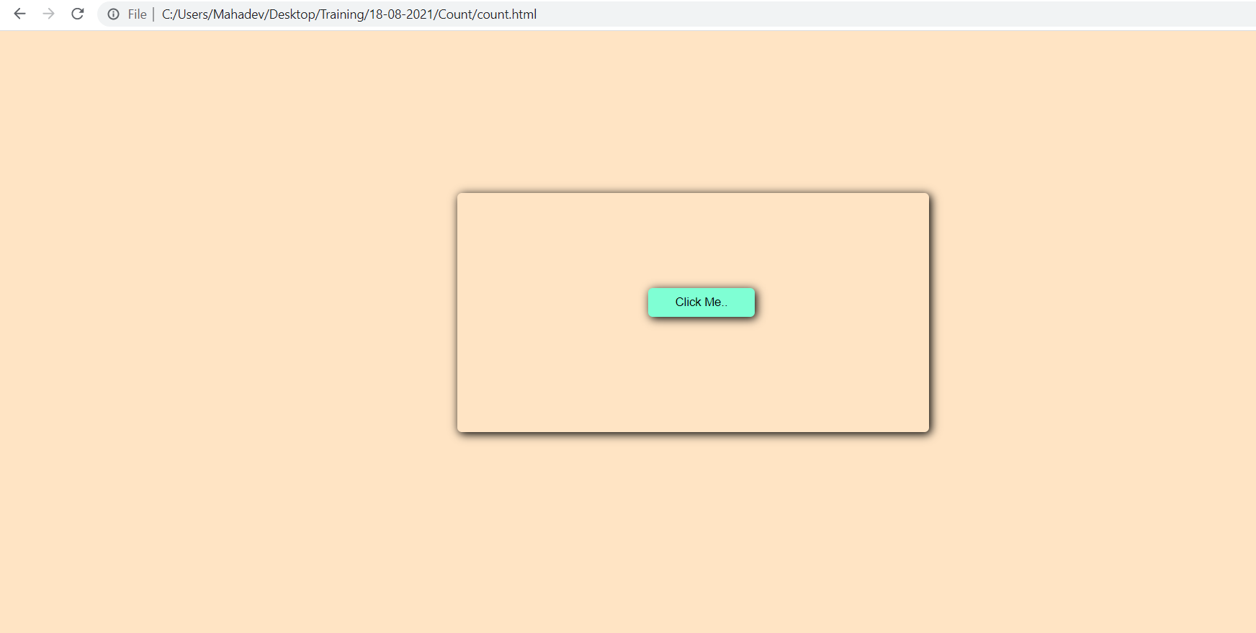

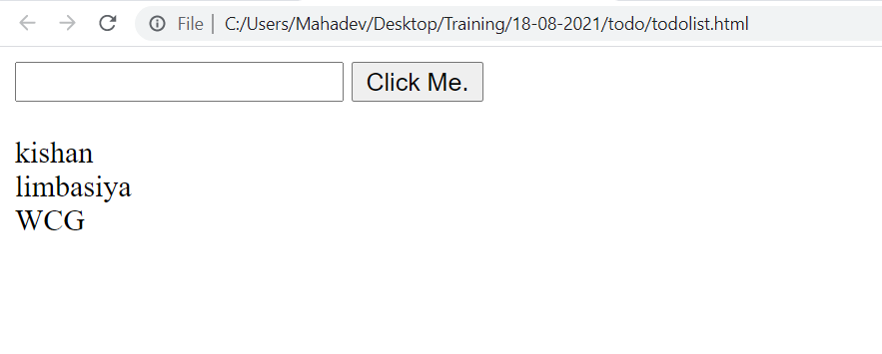

**LocalStorage TODO**

