**1. Class:**

* A class is a user-defined data type.
* It consists of data members and member functions, which can be accessed and used by creating an instance of that class.

**2. Object:**

* An Object is an instance of a Class.
* When a class is defined, no memory is allocated but when it is instantiated (i.e. an object is created) memory is allocated.
* An object has an identity, state, and behavior.

**3. Data Abstraction:**

* Providing only essential information about the data to the outside world, hiding the background details or implementation.

**4. Encapsulation:**

* Encapsulation is defined as the wrapping up of data under a single unit.
* In Encapsulation, the variables or data of a class are hidden from any other class and can be accessed only through any member function of their class in which they are declared.
* Example of encapsulation, in a company, there are different sections like the accounts section, finance section, sales section, etc.Data of the sales section and the employees that can manipulate them are wrapped under a single name “sales section”.

**5. Inheritance:**

* The capability of a class to derive properties and characteristics from another class is called Inheritance.

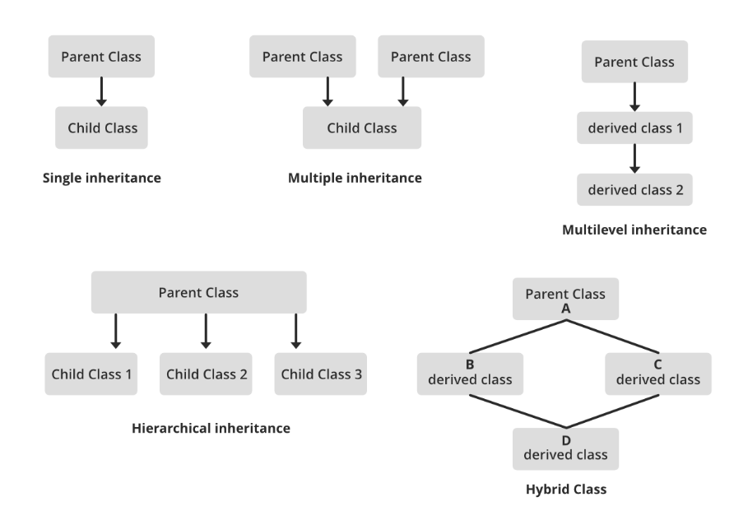



**6. Polymorphism:**

* Having many forms,different behavior in different situations.

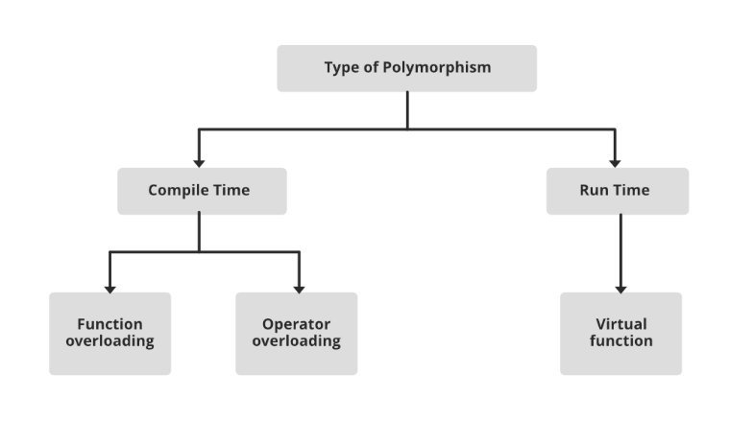

**7. Dynamic Binding:**

* Code associated with a given procedure call is not known until the time of the call at run time.

**8. Message Passing:**

* It is a form of communication used in object-oriented programming as well as parallel programming