Question 1)

- open the terminal and type the following comands:
#Add the Cloud SDK distribution URI as a package source
echo "deb [signed-by=/usr/share/keyrings/cloud.google.gpg] http://packages.cloud.google.com/apt cloud-sdk main" | sudo tee -a /etc/apt/sources.list.d/google-cloud-sdk.list
# Import the Google Cloud Platform public key
curl https://packages.cloud.google.com/apt/doc/apt-key.gpg | sudo apt-key -- keyring /usr/share/keyrings/cloud.google.gpg add -
# Update the package list and install the Cloud SDK
sudo apt-get update && sudo apt-get install google-cloud-sdk
- To initialise SDK type the command “gloud init” and pick your project and add the default regions and zones .

To see all the componets intalled, type: gcloud componenrs list

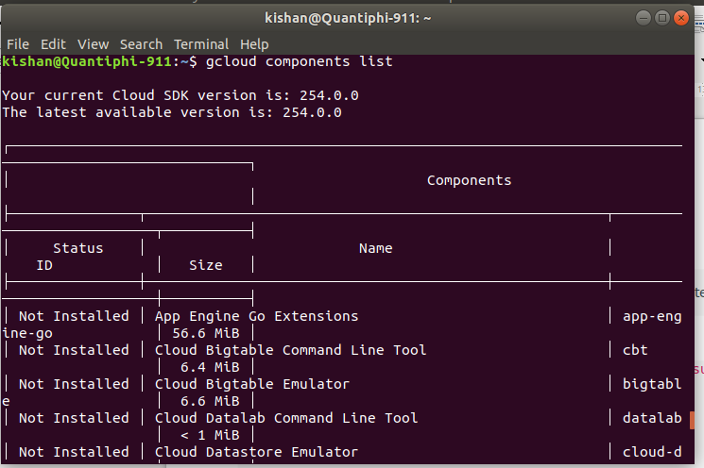

gsutil,kubectl, bq, gcloud Alpha commands, gcloud beta commands are intalled directly from above process.

