1)
Just made a github repo and added a file to it

2)
git pull

git add .

git status

git commit -m 'add singh'

git push

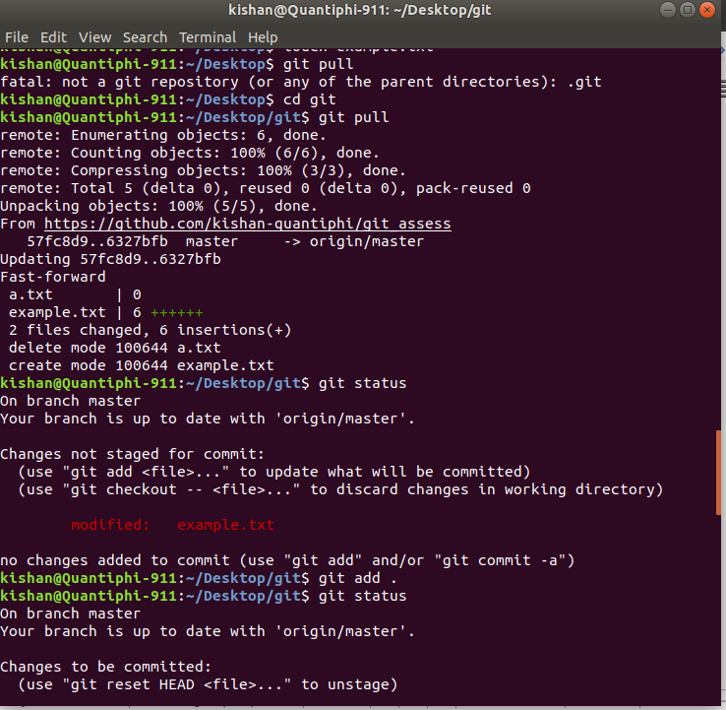
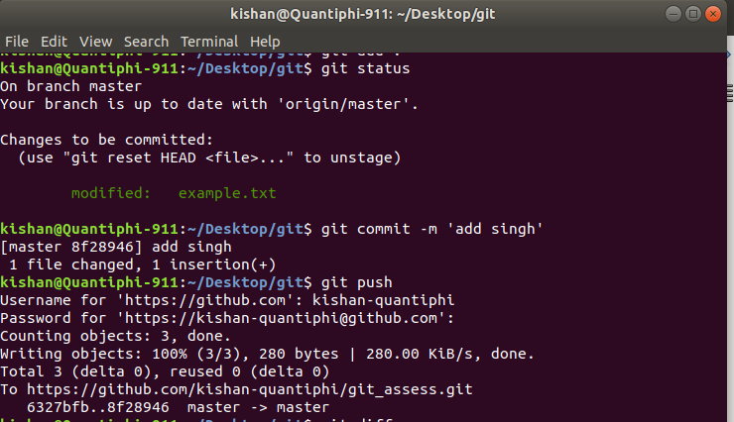

3)

git show 8f28946d72f193dafe679e9693fb5539fb64b433 --name-only

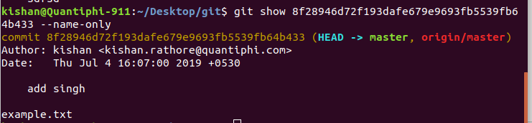

4)

git rm --cached a.txt

git commit -m 'remove from repo'

git push

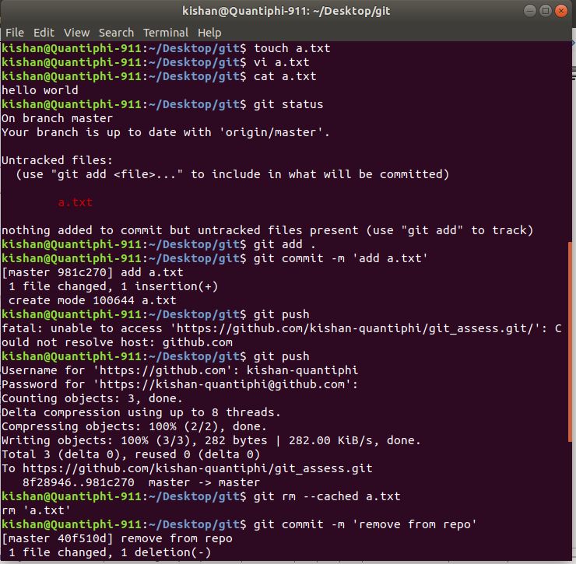

5)

git reset --hard 40f510d2b29ca519545b0eec2c232449976dd9dd

git reset --soft HEAD@{1}

git commit -m 'revert to previous commit'

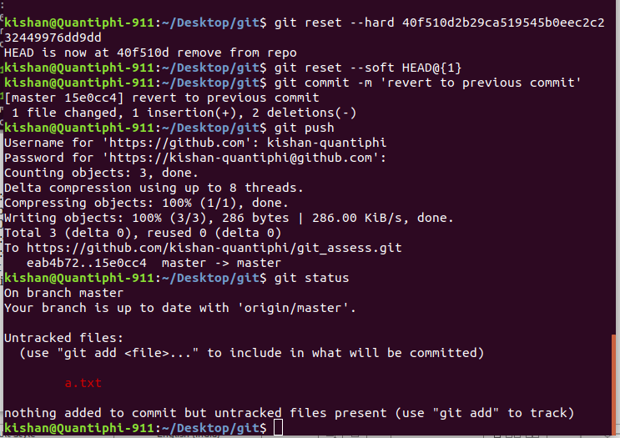

6)
git checkout -b branch2

git status

git add .

git commit -m "add playing football"

git push --set-upstream origin branch2

git checkout master

git status

git add .

git commit -m "play basketball"

git push origin master

git checkout

git merge branch2

git add .

git commit -m "merge master and branch2"

git push

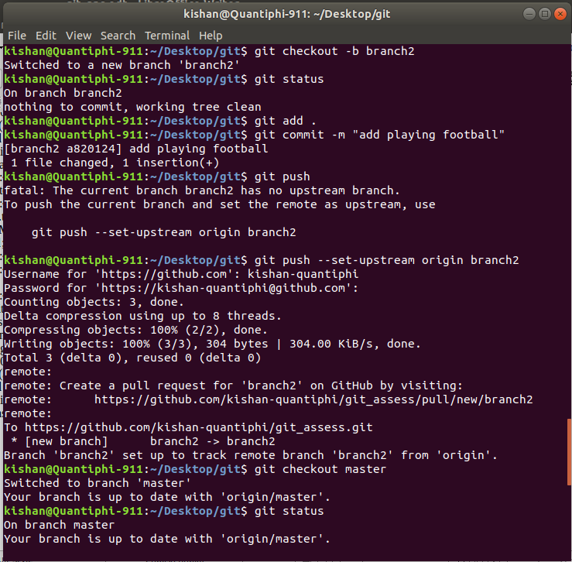

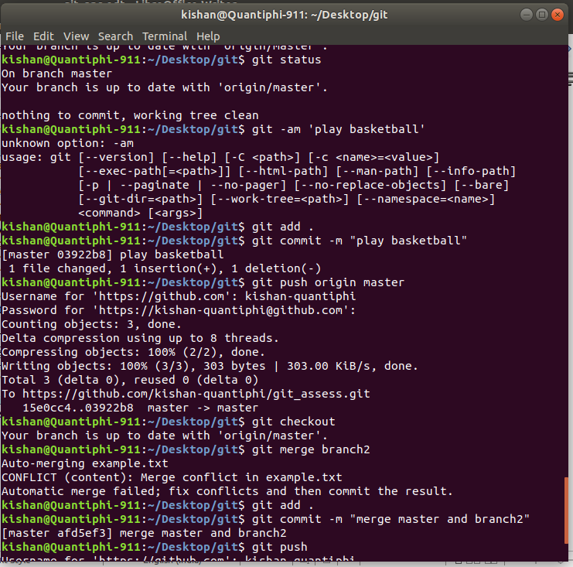

7) used cherry-pick command to select particular commit from master branch to add it into prod branch

git cherry-pick 4b2a1fb5e3d9caed9bc54884660b914d74016abf

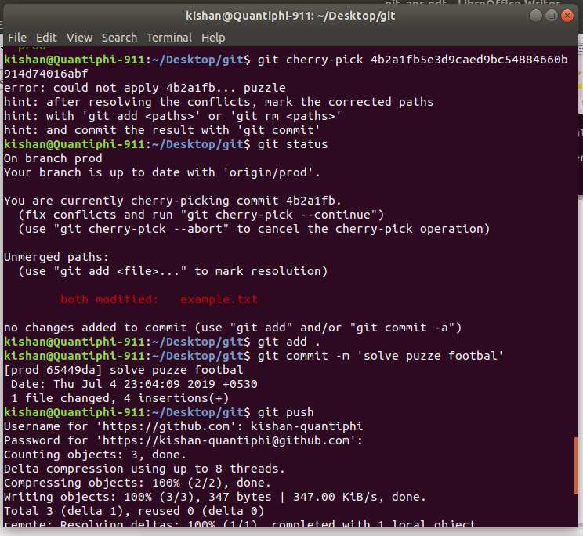

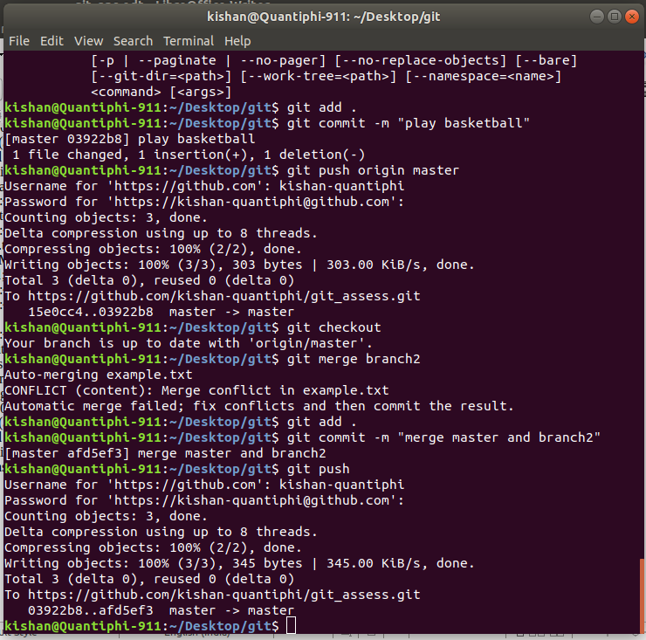
Final Network------>
