Question 1)
cat multi_txt.txt

egrep 'love' multi_txt.txt

egrep -c 'love' multi_txt.txt

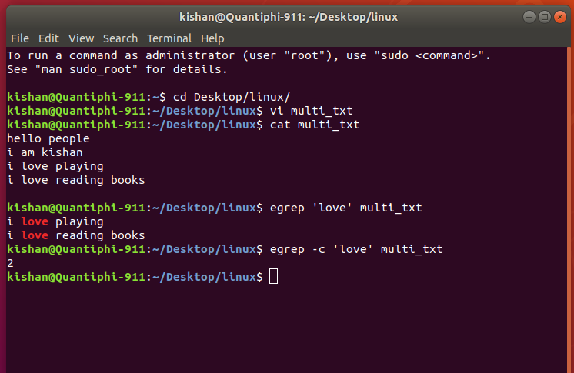

Question 2)
ls *.txt

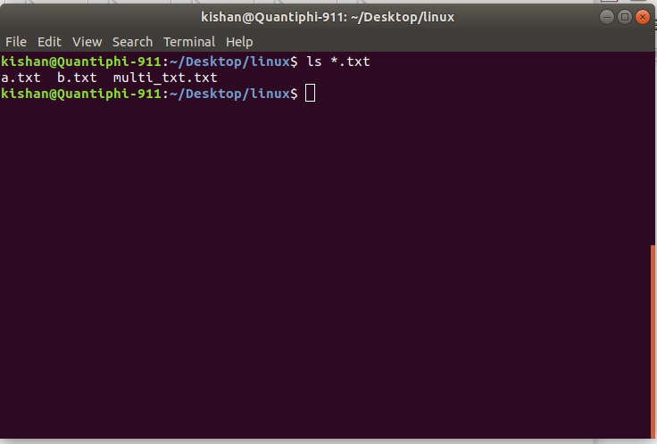

Question 3)

for d in ./parent/aws*/ ; do ( ls $d ); done
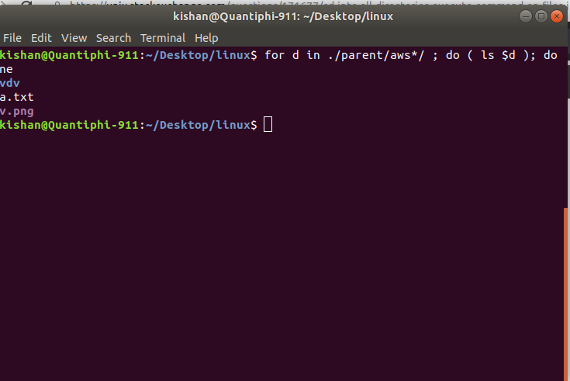

Question 4)
sed ‘s/love/like/g’ multi_txt.txt
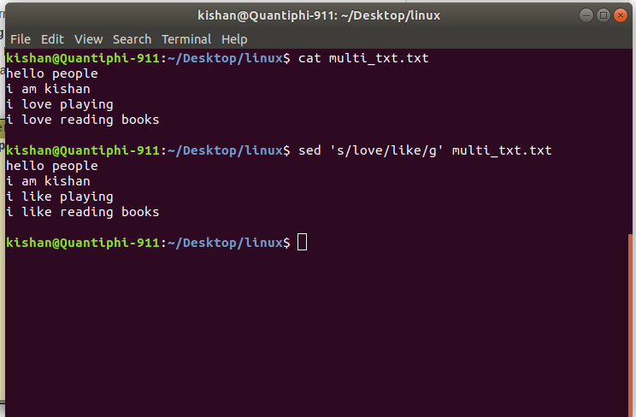

Question 5)
cat s3_info.txt | jq ‘.Record[0].s3.bucket.arn’
