**Detailed description related to how I perform a task:_**

**Task :- 1**

I have created a webpage similar to the mockup as mention in the task And an attached file named: style.css

**Task :- 2**

I have checked the issue and it can be solved by using below steps:

Step:1 Open Forminator > click on Forms

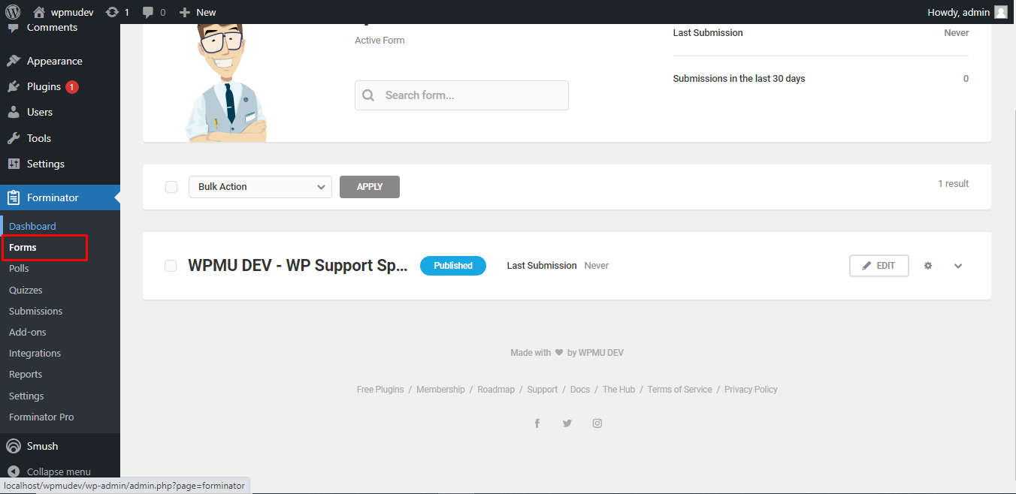

Step:2 Click on the edit button in form

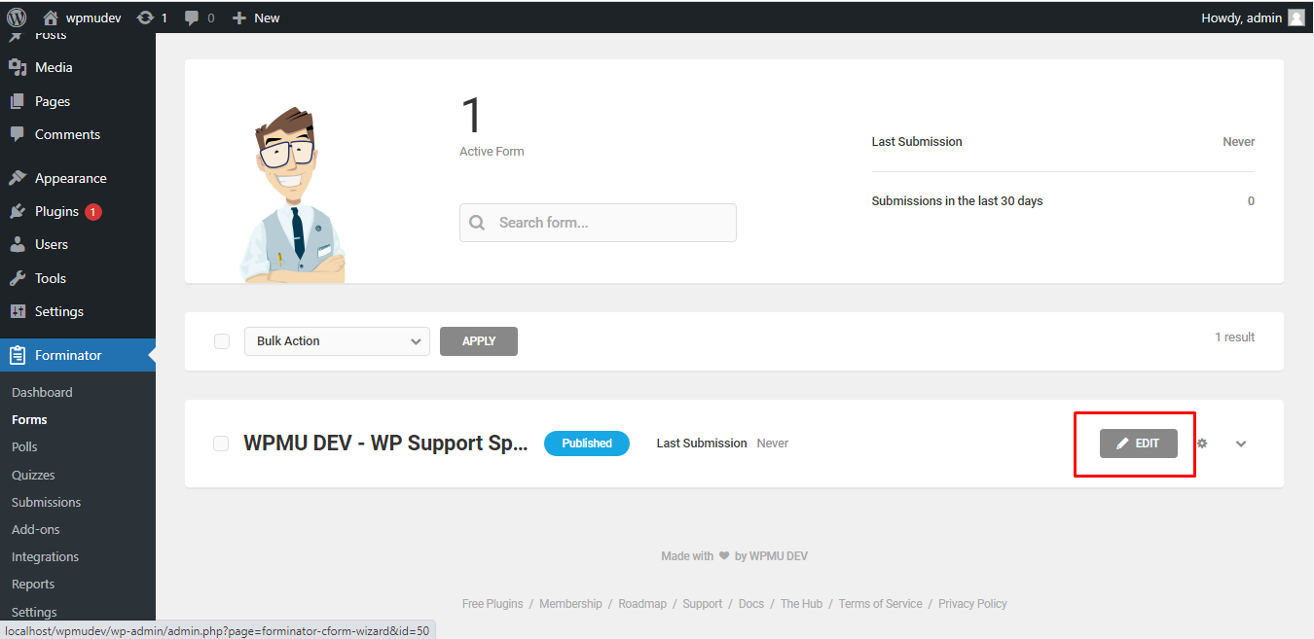

Step:3 Scroll down and click on Send message

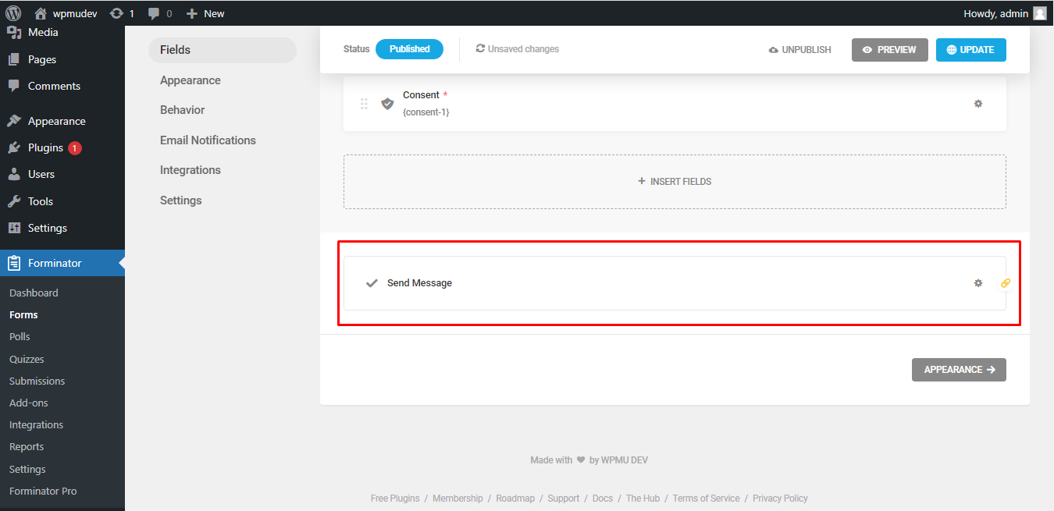

Step:4 Open the visibility tab in the popup

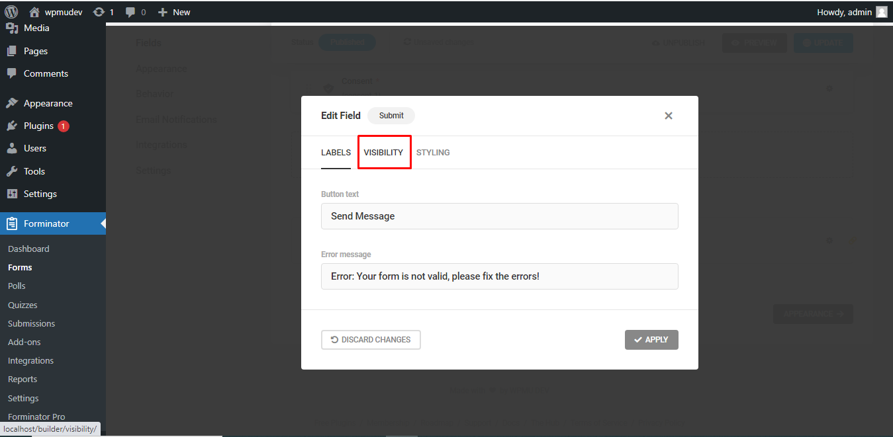

Step:5 Click on Show/Hide to add or remove the submit button and click on Apply.

The Submit button should now display.

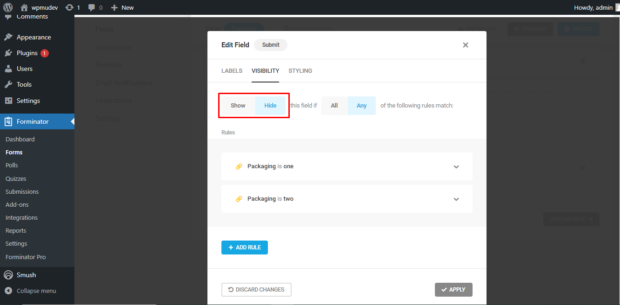

**Task :- 3**

We need to change the theme to Twenty Twenty-Three then we can solve the issue By following the below step:

Step:1 Open Smush > Click on settings

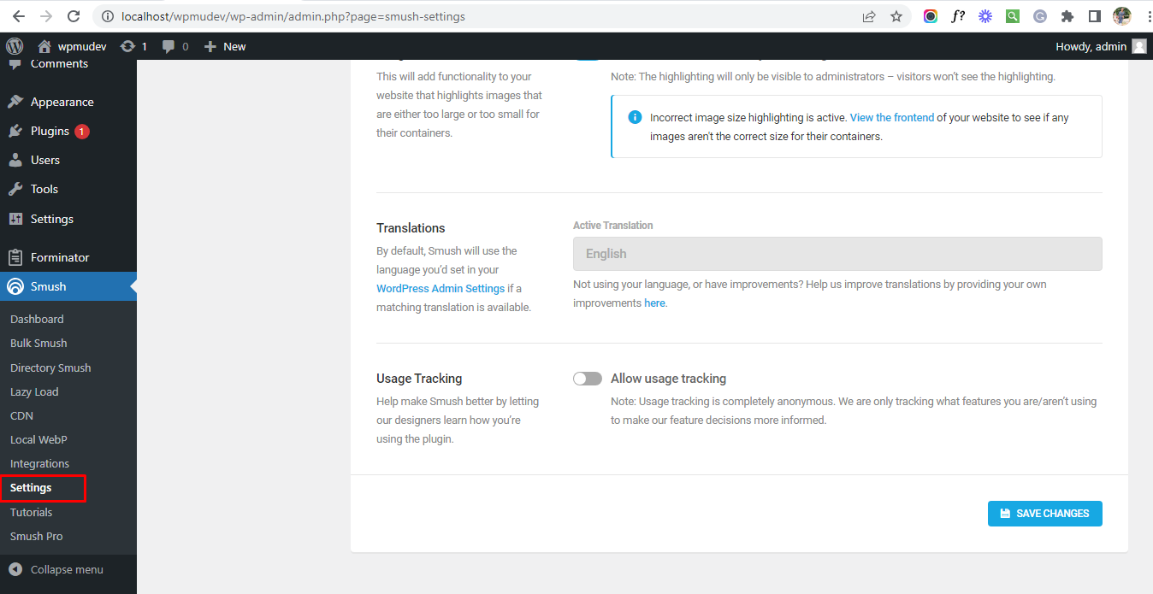

Step:2 We can add or remove the yellow border by turning the marked toggle button on/off

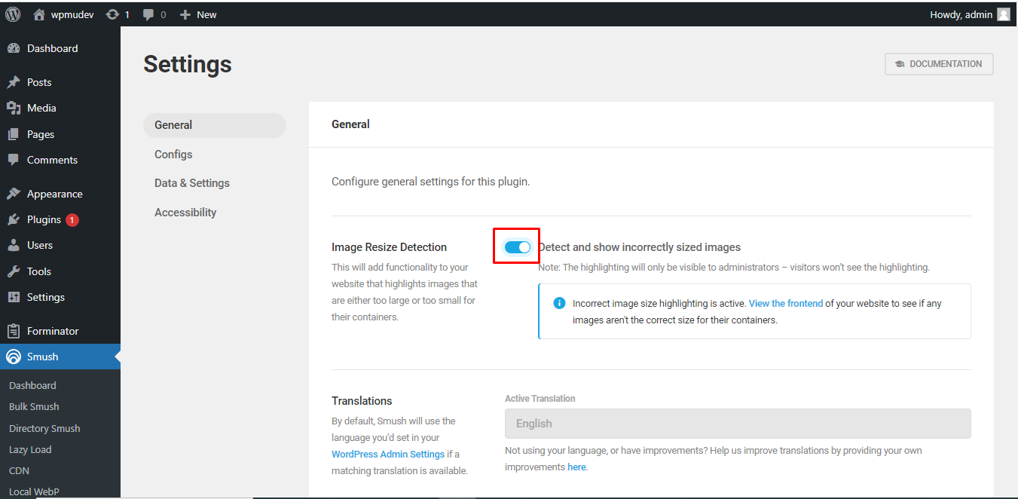

**Task :- 4**

You can increase the performance by solving the below errors

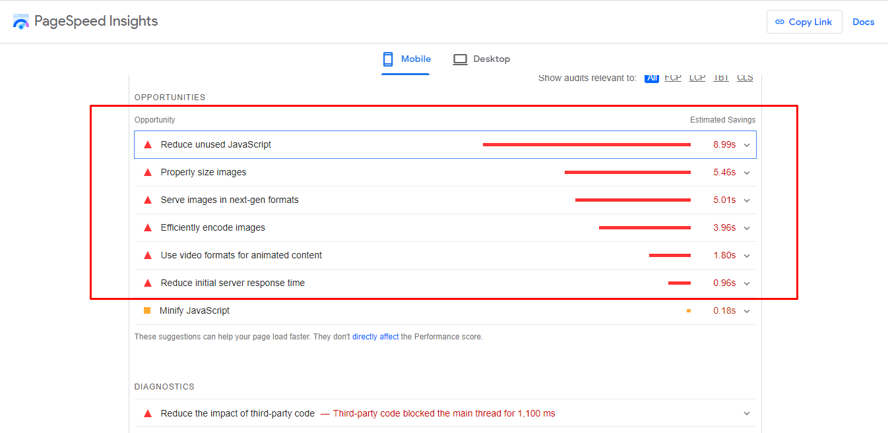

**Task :- 5**

I have updated the code and now the user name is visible And an attached file is named: function.php

