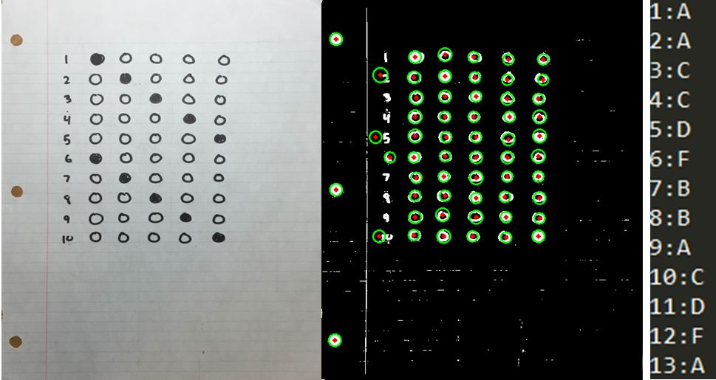

Recognizes holes in paper as dots in their own rows

Fixed by deleting rows of circles which have 2 circles or less

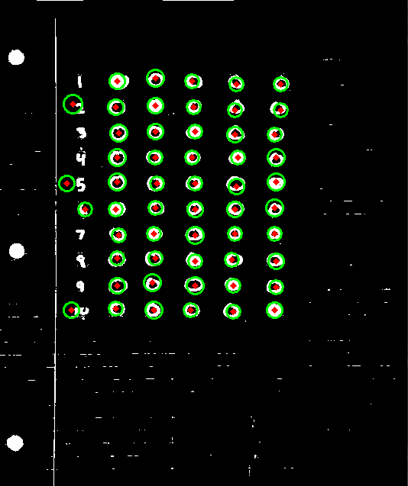

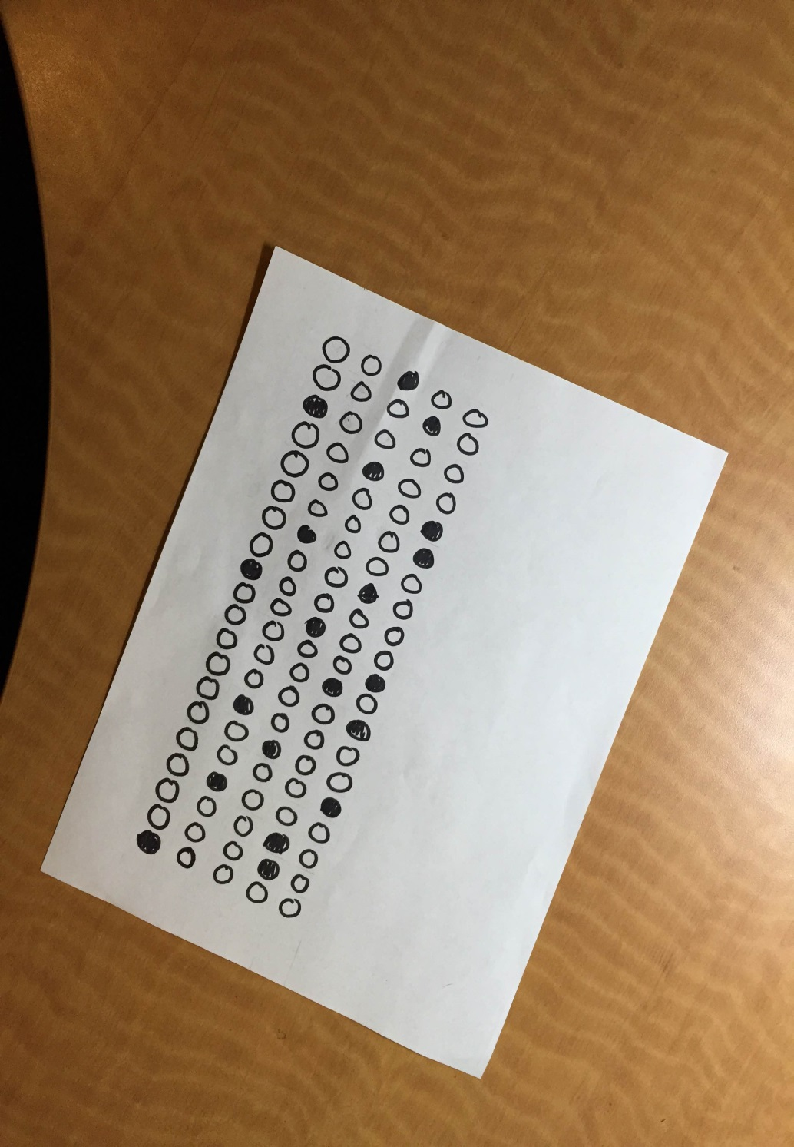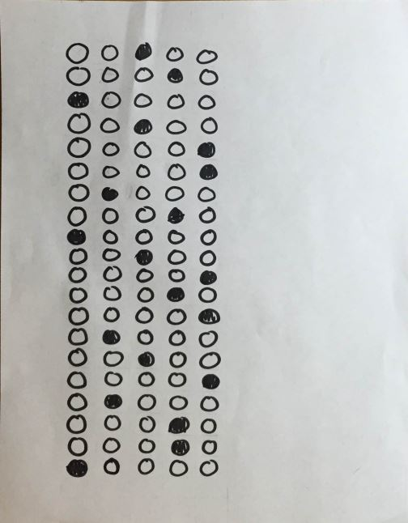

**hand21.jpg**

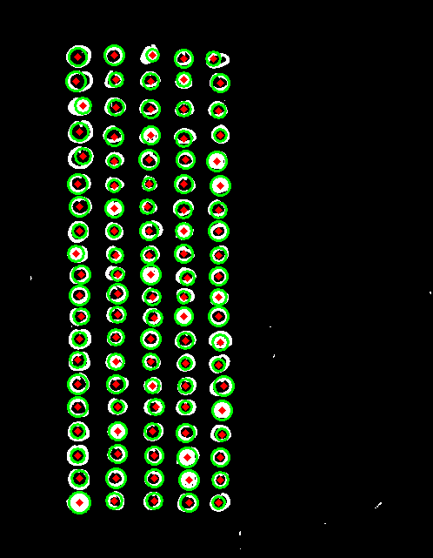

**Perfect**

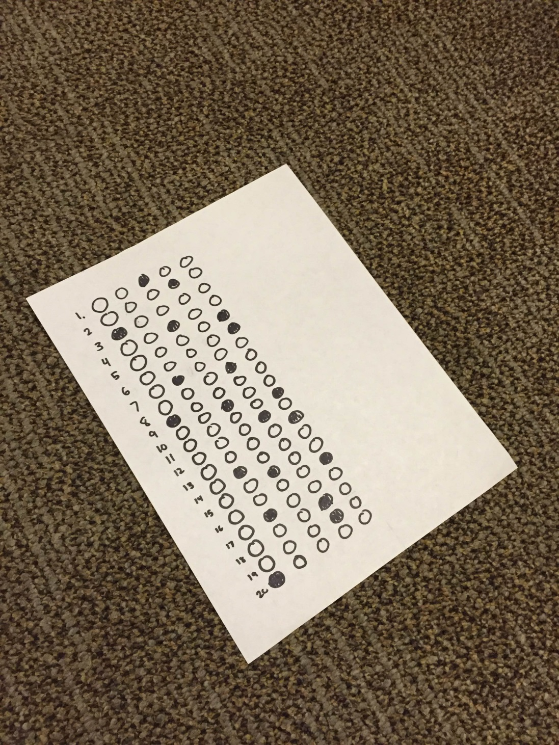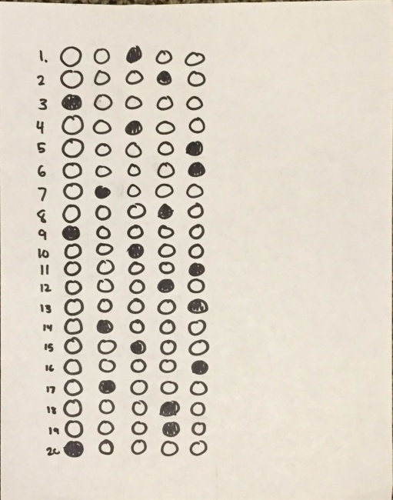

**Hand31.jpg**

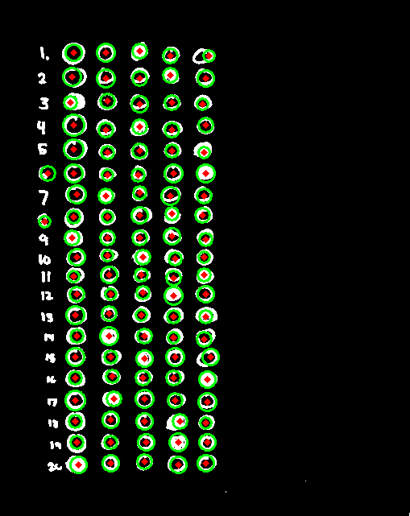

**Extra circles on 6 & 8: (accounted for)**



**Hand11.jpg**

* **Recognizes holes in paper as dots**
* **Extra dots recognized near numbers ruin index counting**

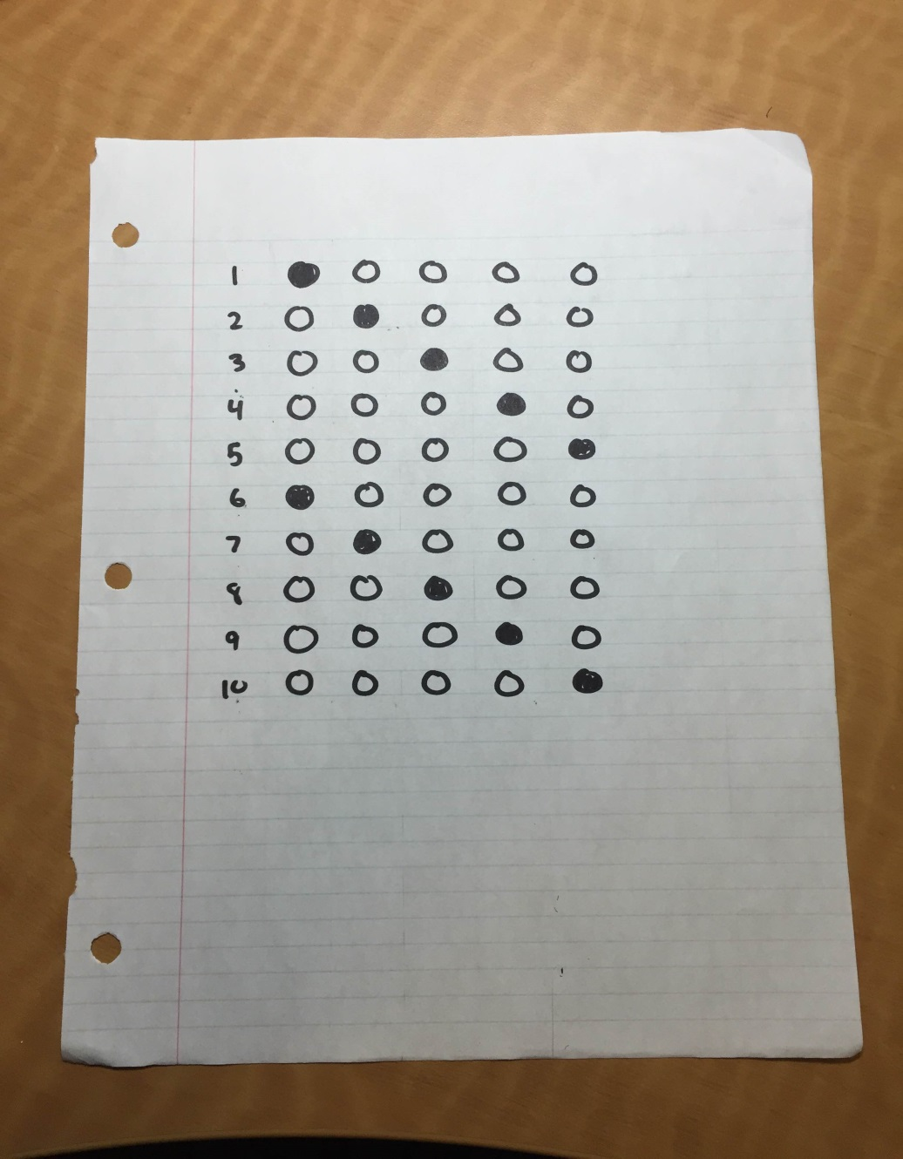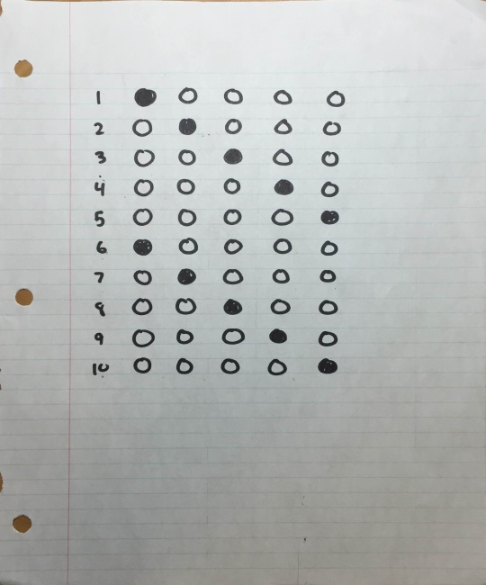

**Hand11.jpg**

**minDist = 30, param1=50,param2=10,minRadius=7,maxRadius=14**

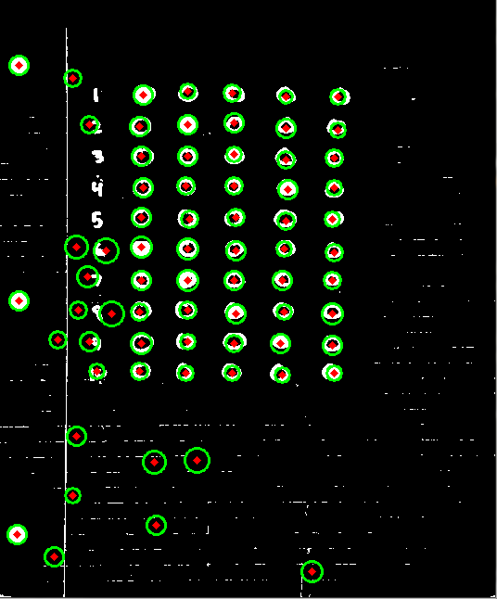

**Finds many extra bubbles**

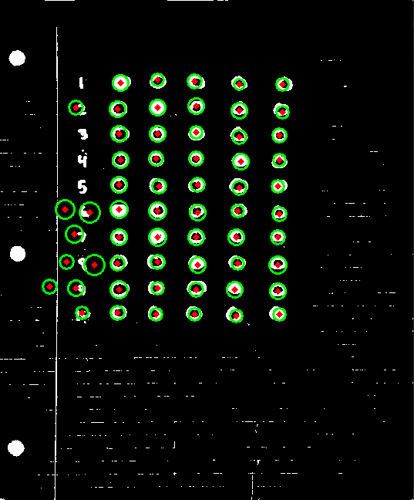

**Eliminated random bubbles. Other bubbles in row accounted for**



**Hand11.jpg**

**minDist = 30, param1=100,param2=10,minRadius=7,maxRadius=14**

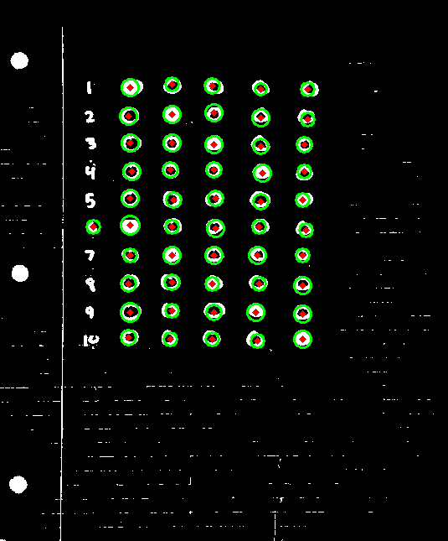 \

**Much more accurate. Extra bubble on number 6 accounted for**