A

Project Report For

**“ARDUINO DAY 2021”**

|  |  |
| --- | --- |
| **Problem Statement:** | IoT Based Digital Notice Board using Node MCU (ESP 8266) |
| **Probable Discipline:** | Electronics & Communication |
| **College Name:** | Sal Institute of Technology and Engineering Research |
| **College Code:** | 067 |
| **Team Leader Name:** | Rajput Kishan |
| **Faculty Guide:** | Prof. Kuldeep Shukla |

Prepared By:

Rajput Kishan Raghuvirsinh

Sankle Akshay Prabhakar

Jha Durganand Rajesh

Mrigankshi Singh Chauhan

Tripathi Neha Devisahai

(Electronics & Communication Engineering)

Under the guidance of

**Prof. Kuldeep Shukla**

(Electronics & Communication Engineering)



SAL Institute of Technology and Engineering Research, Ahmedabad

**TABLE OF CONTENTS**

|  |  |  |
| --- | --- | --- |
| **Chapter No.** | **Description** | **Page No.** |
| 1 | Synopsis Abstract | 1 |
| 2 | Block Diagram | 2 |
| 3 | Flow Diagram | 3 |
| 4 | Component List and Description | 4 |
| 5 | Results/Output | 6 |
| 6 | Advantages & Disadvantages / limitations of Project | 7 |
| 7 | Future scope | 8 |
| Datasheets | | 9 |

**CHAPTER 1. SYNOPSIS ABSTRACT**

Node MCU is an open-source IoT platform, it includes firmware which runs on the ESP8266 Wi-Fi soc which makes the Node MCU a good choice for the IoT Application. As most of the digital notice board prefer LED technology for display. We decided to use An LED Matrix, it is formed by Arrangement of LEDs in rows and columns to form a Matrix which is driven by 74HC595 shift register daisy chain and 4017-decade counter. Column scanning is done by 74HC595 Shift Registers, Shift Register has 8 bits serial-in, serial or parallel-out shift register with output latches. Row scanning is done by the 4017-decade counter. A decade counter is a circuit in which each of the chip outputs is turned on, one at a time, sequentially or in succession. The User will open the IP address using the Wi-Fi on his mobile or computer which will show An HTML website opens with an input text box, The LED Matrix will show the result as inserted into the text box.

**CHAPTER 2. BLOCK DIAGRAM**

For Column using 74HC595 Shift Register.

For Row using the 4017 Decade Counter.

3.3/5 V Power Supply.

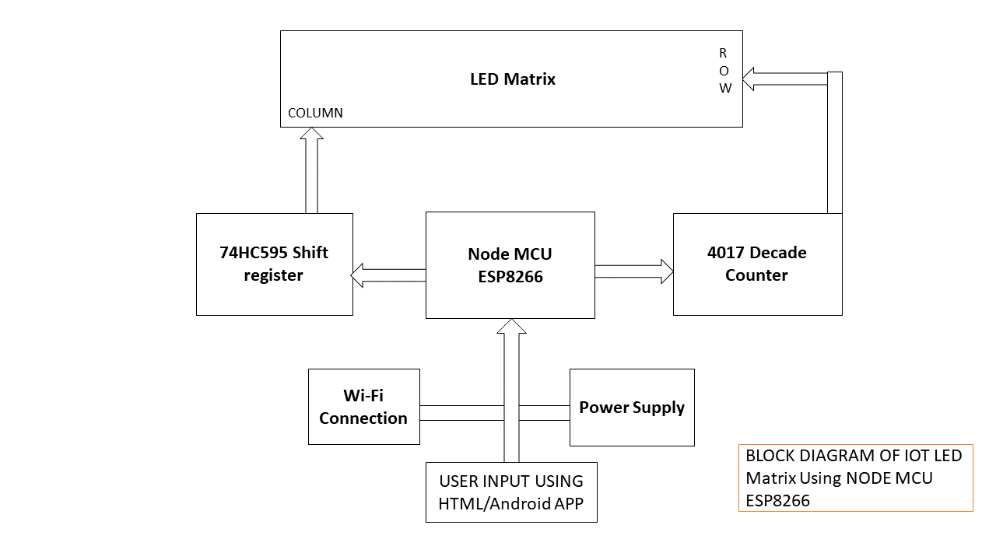

**CHAPTER 3. FLOW DIAGRAM**

 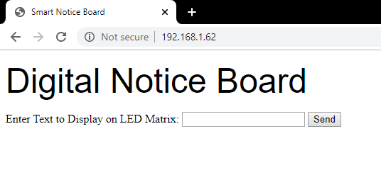

**HTML WEBPAGE**

**COMPUTER/MOBILE APPLICATION**



**Wireless Communication (Wi-Fi)**

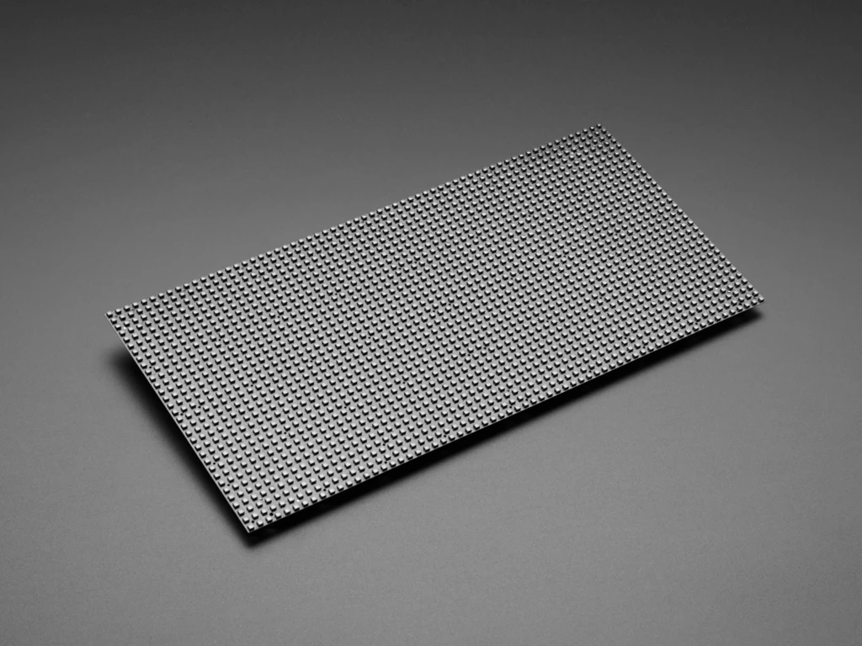 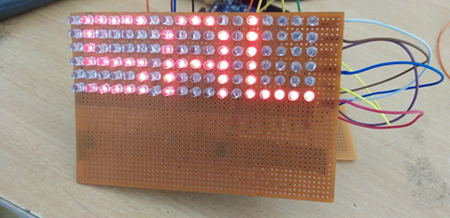

**Message Display**

**LED Matrix**

**CHAPTER 4. COMPONENTS LIST & DESCRIPTION**

1. LEDs

* A light-emitting diode (LED) is a semiconductor light source that emits light when current flows through it.

1. 4017 Decade Counter

* A decade counter is a circuit in which each of the chip outputs is turned on, one at a time, sequentially or in succession.

1. 74HC595 Shift Register

* 74HC595 is an "8-bit serial-in, serial or parallel-out shift register with output latches; 3-state." we can use it to control 8 outputs at a time while only taking up a few pins on the microcontroller.

1. 2N3904 Transistors

* The 2N3904 is a common NPN bipolar junction transistor used for general-purpose low-power amplifying or switching applications It is designed for low current and power, medium voltage, and can operate at moderately high speeds.

1. Node MCU (8266)

* Node MCU is an open-source firmware and development kit that helps you to prototype or build IoT products. It includes firmware, which runs on the ESP8266 Wi-Fi SoC from Espressif Systems, and hardware, which is based on the ESP-12 module.

1. General Purpose Board

* General-purpose PCB's are widely used to embed circuits randomly for running of hardware. Its layer is coated with copper and allows proper soldering without any short circuit.

1. Resistors

* resistors are used to reduce current flow, adjust signal levels, to divide voltages, bias active elements, and terminate transmission lines, among other uses

1. Female and Male Headers

* A pin header is a form of electrical connector.

1. A Wi-Fi Connection

**CHAPTER 5. RESULTS**

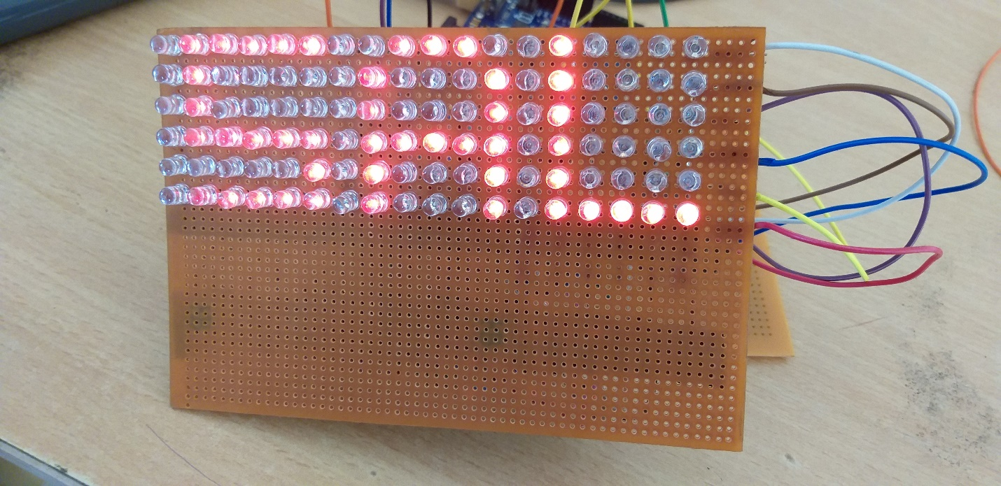

**(SAL)**

**Front View**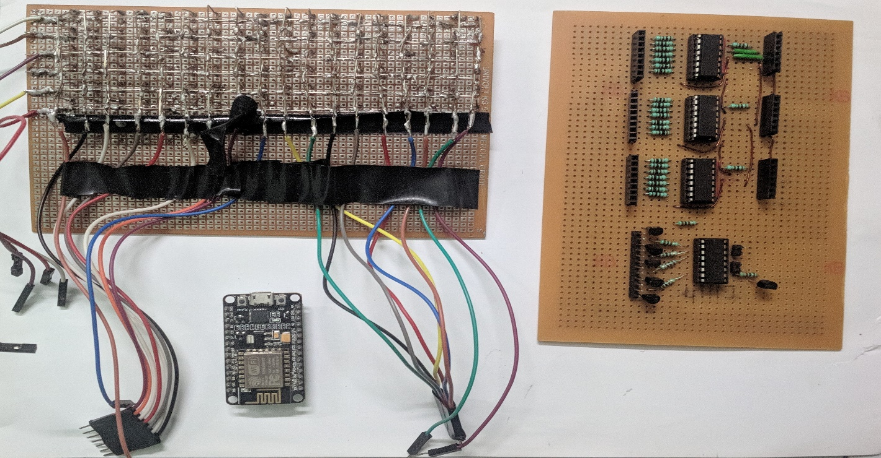

**Back View**

**CHAPTER 6. ADVANTAGES & DISADVANTAGES**

* Advantages

1. We can update our signboard with the use of programming
2. Quick Updates or a Fix can be possible.
3. Economical Efficient for the larger Matrix.
4. Power Efficient.
5. Easy to Operate.
6. The number LED in the matrix can be expanded with the simple addition of Shift register & Decade Counter IC.
7. All Components are easily available.
8. Does not require any special components.
9. Easy to install & Does not require more space.
10. Updates can be made wirelessly.
11. Brightness can be adjusted.
12. Special Characters or Symbols can be coded manually.

* Disadvantages

1. Requires PC at the time of debugging.

**CHAPTER 7. FUTURE SCOPE**

* The LED matrix can be increased with Demands using 74HC595 Shift registers and 4017 Decade Counter.
* External Power Supply Can be used up to 12V.
* The RGB or Color Matrix can be made with the help of an RGB LED.
* The Brightness can be adjusted by the use of the PWM method or by the use of resistors.
* For More Robust Approach PCB layout can be made.
* Use of Sound or Vocal with the scrolling of text.

**APPENDIX (COMPONENT’S DATA SHEETS)**

5 mm Round White LED

**Absolute Maximum Ratings (Ta=25℃)**

|  |  |  |  |
| --- | --- | --- | --- |
| **Parameter** | **Symbol** | **Rating** | **Unit** |
| Continuous Forward Current | IF | 30 | mA |
| Peak Forward Current (Duty /10 @ 1KHZ) | IFP | 100 | mA |
| Reverse Voltage | VR | 5 | V |
| Operating Temperature | Topr | -40 ~ +85 | ℃ |
| Storage Temperature | Tstg | -40 ~ +100 | ℃ |
| Soldering Temperature (T=5 sec) | Tsol | 260 ± 5 | ℃ |
| Power Dissipation | Pd | 100 | mW |
| Zener Reverse Current | Iz | 100 | mA |
| Electrostatic Discharge | ESD | 4K | V |

# Pin Information

## 



**74+&4017**

**74+&74017**

45

41

40

42

46

47

43

*1'

9&&

05

&30 &31 45-9

49

44

48

*001DDK238*

**Fig 6. Pin configuration SO16 and (T)SSOP16**

**74+&4017**

**74+&74017**

WHUPLQDO 1 LQGH[ DUHD

7UDQVSDUHQW WRS YLHZ

(1) This is not a supply pin. The substrate is attached to this pad using conductive die attach material. There is no electrical or mechanical requirement to solder this pad. However, if it is soldered, the solder land should remain floating or be connected to GND.

**Fig 7. Pin configuration DHVQFN16**

1 45

16

9&&

|  |  |  |
| --- | --- | --- |
|  |  |  |
| 1 | 16 |
| 2 | 15 |
| 3 | 14 |
| 4 | 13 |
| 5 | 12 |
| 6 | 11 |
| 7 | 10 |
| 8 | 9 |
|  |  |

|  |  |  |  |  |
| --- | --- | --- | --- | --- |
| 41 | 2 |  | 15 | 05 |
| 40 | 3 |  | 14 | &30 |
| 42 | 4 |  | 13 | &31 |
| 46 | 5 |  | 12 | 45-9 |
| 47 | 6 | *1'(1) | 11 | 49 |
| 43 | 7 |  | 10 | 44 |
|  |  |  |  | *001DDK241* |

##### Pin description

|  |  |  |
| --- | --- | --- |
| **Symbol** | **Pin** | **Description** |
| Q[0:9] | 3, 2, 4, 7, 10, 1, 5, 6, 9, 11 | Decoded output |
| GND | 8 | Ground (0 V) |
| Q5-9 | 12 | Carry output (active LOW) |
| CP1 | 13 | Clock input (HIGH-to-LOW edge-triggered) |
| CP0 | 14 | Clock input (LOW-to-HIGH edge-triggered) |
| MR | 15 | Master reset input (active HIGH) |
| VCC | 16 | Supply voltage |

**74HC595 Shift Register**

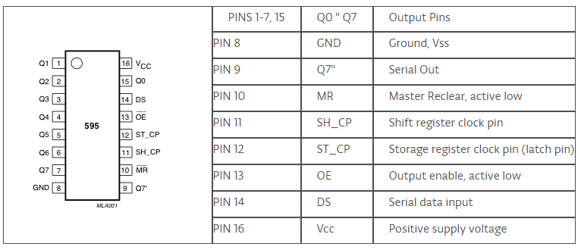

|  |  |  |  |  |  |  |
| --- | --- | --- | --- | --- | --- | --- |
|  | | | **MIN** | **NOM** | **MAX** | **UNIT** |
| VCC | Supply voltage |  | 2 | 5 | 6 | V |
| VIH | High-level input voltage | VCC = 2 V | 1.5 | | | V |
| VCC = 4.5 V | 3.15 | | |
| VCC = 6 V | 4.2 | | |
| VIL | Low-level input voltage | VCC = 2 V | 0.5 | | | V |
| VCC = 4.5 V | 1.35 | | |
| VCC = 6 V | 1.8 | | |
| VI | Input voltage |  | 0 |  | VCC | V |
| VO | Output voltage |  | 0 |  | VCC | V |
| t/v‡ | Input transition rise/fall time | VCC = 2 V | 1000 | | | ns |
| VCC = 4.5 V | 500 | | |
| VCC = 6 V | 400 | | |
| TA | Operating free-air temperature |  | −55 |  | 125 | C |

**2N3904 Transistors**



**TO-92**

**Bulk**

**TO-92**

**Ammopack**



**INTERNAL SCHEMATIC DIAGRAM**

**ABSOLUTE MAXIMUM RATINGS**

|  |  |  |  |
| --- | --- | --- | --- |
| **Symbol** | **Parameter** | **Value** | **Unit** |
| VCBO | Collector-Base Voltage (IE = 0) | 60 | V |
| VCEO | Collector-Emitter Voltage (IB = 0) | 40 | V |
| VEBO | Emitter-Base Voltage (IC = 0) | 6 | V |
| IC | Collector Current | 200 | mA |
| Ptot | Total Dissipation at TC = 25 oC | 625 | mW |
| Tstg | Storage Temperature | -65 to 150 | oC |
| Tj | Max. Operating Junction Temperature | 150 | oC |

**Node MCU ESP8266**

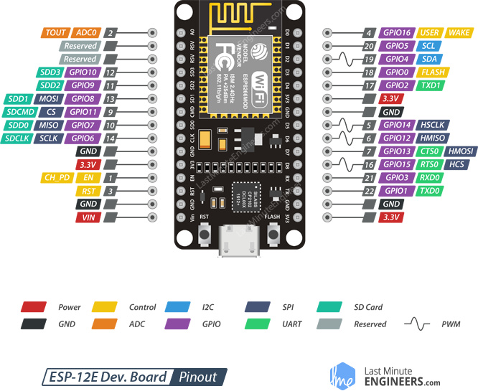

* Microcontroller: Tensilica 32-bit RISC CPU Xtensa LX106
* Operating Voltage: 3.3V
* Input Voltage: 7-12V
* Digital I/O Pins (DIO): 16
* Analog Input Pins (ADC): 1
* UARTs: 1
* SPIs: 1
* I2Cs: 1
* Flash Memory: 4 MB
* SRAM: 64 KB
* Clock Speed: 80 Mhz
* Wi-Fi: IEEE 802.11 b/g/n:
* Integrated TR switch, balun, LNA, power amplifier and matching network WEP or WPA/WPA2 authentication, or open networks