**READ ME: Data Fields for Mini-Challenge 2**

Id: Identification number for the record (only for bookkeeping)

Value: Measured value for the chemical or property in this record

Location: Name of the location sample was taken from. See the map for geo-location of the sampling site.

Sample Date: Date sample was taken from the location

Measure: Chemicals (e.g., Sodium) or water properties (e.g., Water temperature) measured in the record

Sample Data:

id,value,location,sample date,measure

2221,2,Boonsri,11-Jan-98,Water temperature

2223,9.1,Boonsri,11-Jan-98,Dissolved oxygen

2227,0.33,Boonsri,11-Jan-98,Ammonium

2228,0.01,Boonsri,11-Jan-98,Nitrites

2229,1.47,Boonsri,11-Jan-98,Nitrates

2230,0.06,Boonsri,11-Jan-98,Orthophosphate-phosphorus

2231,0.09,Boonsri,11-Jan-98,Total phosphorus

2232,13.9,Boonsri,11-Jan-98,Sodium

Notation on the map: This note indicates the location of the potential contamination site identified in last year's VAST Challenge. After on-site inspection, Mistford College investigators have most recently found no indication of contamination at that site.

**Evidences:**

* Kasios is not taking the accusations lying down, and they deny any accusation of industrial waste dumping.
* Kasios’ spokespersons state that there isn’t any ground contamination near the remote ranger station that was suggested by last year’s mini-challenge 1 and 3 participants, and they have inspected that area and found it as pristine as the rest of the preserve
* The Mistford College Hydrology Department have come forward with several years of water sensor readings from rivers and streams in the preserve. These samples were taken from different locations scattered throughout the area and contain measurements of several chemicals of possible interest, but they have never been analyzed due to lack of funding. Could visual analytics help reveal something in this data that could make up for the soil evidence that was destroyed?

**Questions**

1. **Characterize the past and most recent situation with respect to chemical contamination in the Boonsong Lekagul waterways. Do you see any trends of possible interest in this investigation? Your submission for this questions should contain no more than 10 images and 1000 words.**

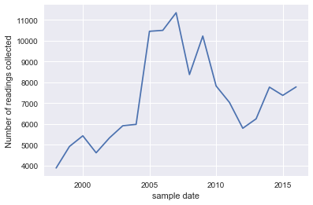

Samples collected year-wise. Peak in 2007.

Plot the % of chemicals collected as a total of whole for each year.

Brainstorming possible approaches:

1. **What anomalies do you find in the waterway samples dataset? How do these affect your analysis of potential problems to the environment? Is the Hydrology Department collecting sufficient data to understand the comprehensive situation across the Preserve? What changes would you propose to make in the sampling approach to best understand the situation? Your submission for this question should contain no more than 6 images and 500 words.**

Get a sense of the number of measurements which have been taken in a particular year across different locations. So, this is independent of the individual chemical. We wish to see the number of chemicals which they have measured, across time, as a ratio to the overall numbers.

For e.g. in year 1, they measured 40 out of 106 chemicals, then 45 of 106 chemicals, and so on….

At each location it should be easy to see how their sampling strategy has been.

There is no information on what is a safe benchmark of contaminants, etc.

1. **After reviewing the data, do any of your findings cause particular concern for the Pipit or other wildlife? Would you suggest any changes in the sampling strategy to better understand the waterways situation in the Preserve? Your submission for this question should contain no more than 6 images and 500 words.**