# HERO DOG

Dogs are often regarded as man's best friend - loyal pets and affectionate companions. It is true that dogs are nothing more than sunshine in our lives; they are the light of our lives. Some have compared dogs to angels but with fur instead of wings. When a dog saves a life, it goes above and beyond. Their playful and adorable traits were matched by their bravery and heroic actions. These are some of the most astounding and incredible stories of dogs saving lives.

A 7-year-old boy discovered a stray dog beneath a 3-meter pit across the street during a snowstorm. The dog's owner slipped and fell into the hole as he tried to reach and pull under to save it. A missing person report was filed for the boy. The dog was repeatedly barking and howling when the boy was found inside the pit three days later.

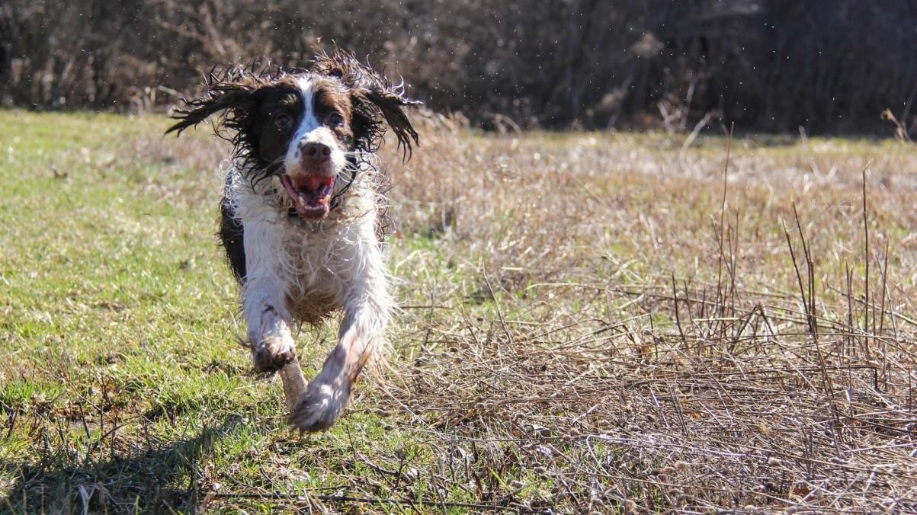

Dogs protected a boy from freezing weather by covering him. Rescuers captured the dogs. A young boy was believed to have been saved from hypothermia by the dog at the time.

# Balto: The Hero of the Great Race of Mercy

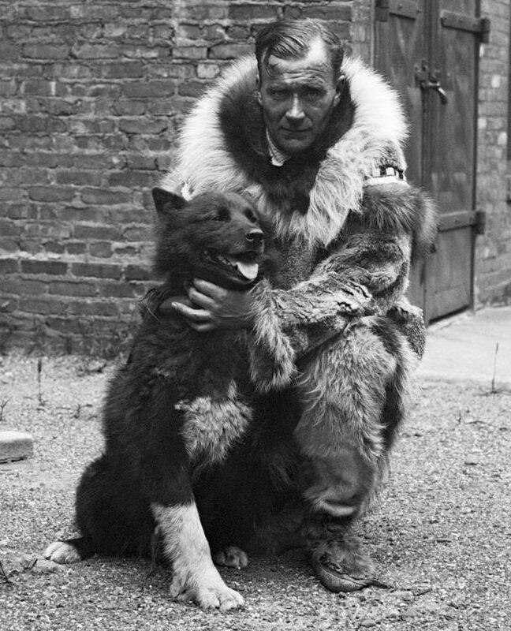

Balto, a Siberian Husky, played a vital role in delivering life-saving medicine during the 1925 diphtheria epidemic in Nome, Alaska. Despite harsh weather conditions and treacherous terrain, Balto led a sled dog team through a grueling journey to transport the

antitoxin serum to the town, saving countless lives. Balto's courage and determination made him a true hero in the eyes of the community (Anglis, 2021).

# WORKING DOG

In many parts of the world, these dogs continue to be used today for working purposes.

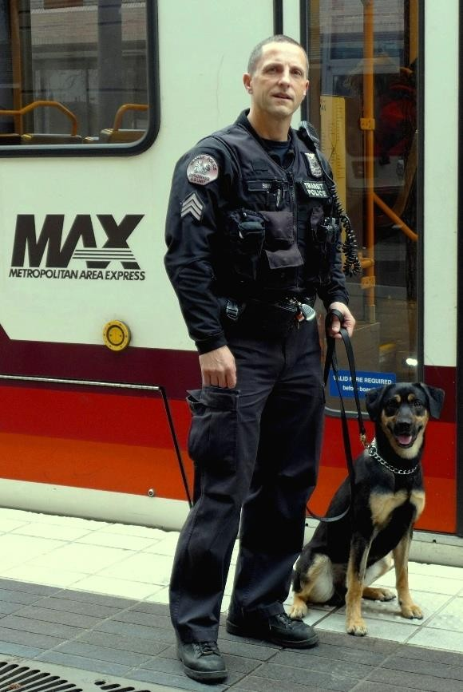

# K9 officer Max:

K9 Officer Max, a German Shepherd, is a shining example of a working dog dedicated to protecting people. Max is a highly trained police service dog who assists law enforcement in various tasks, including tracking suspects, apprehending criminals, and detecting narcotics. With his keen sense of smell, intelligence, and unwavering loyalty, Max has been instrumental in ensuring public safety and supporting his human counterparts (Torres, 2022). Working dogs play a vital role in guarding and protecting livestock, helping to minimize predation and ensure the well-being of herds. Their natural instincts, intelligence, and loyalty make them indispensable partners for farmers and ranchers (Torres, 2022).

As an example, a Great Pyrenees or husky can often be seen guarding sheep or pulling sleds. Today, most of these dogs are companion animals. Although they are generally laid back and easy to care for, they are bred to work, which means they aren't as easy to train as other breeds.

Breeds that perform working duties, ranging from sled pulling to guarding, all fall into this group of broadly similar breeds. At present, 31 breeds are recognized by the AKC as part of the working group, including huskies, mastiffs, Great Danes, and other popular breeds.

There are several breeds in the working group that would make good family pets, but others are quite large and assertive, and so are not suitable for people who have little experience with pets.

# COMPANION DOG

The presence of a companion dog is especially beneficial to those suffering from anxiety and depression. Patients with anxiety disorders who have difficulty navigating their daily lives often ask doctors for companion dogs and are prescribed them by them. As a result of their ability to give their owners back some independence, companion dogs can help improve their quality of life and reduce their anxiety.

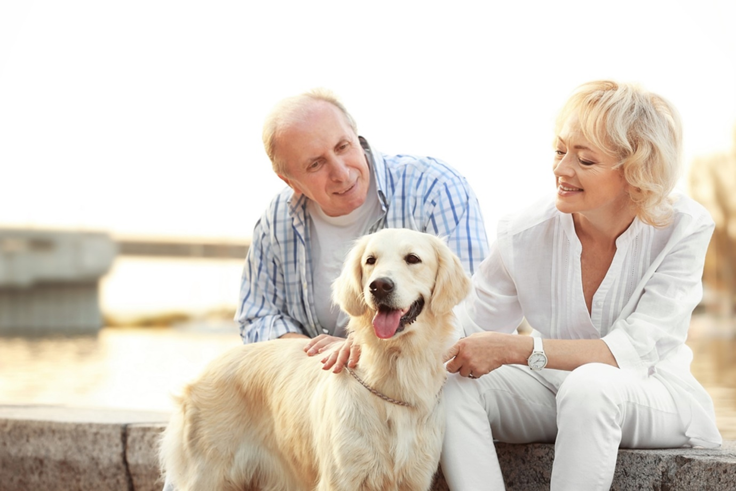

# George

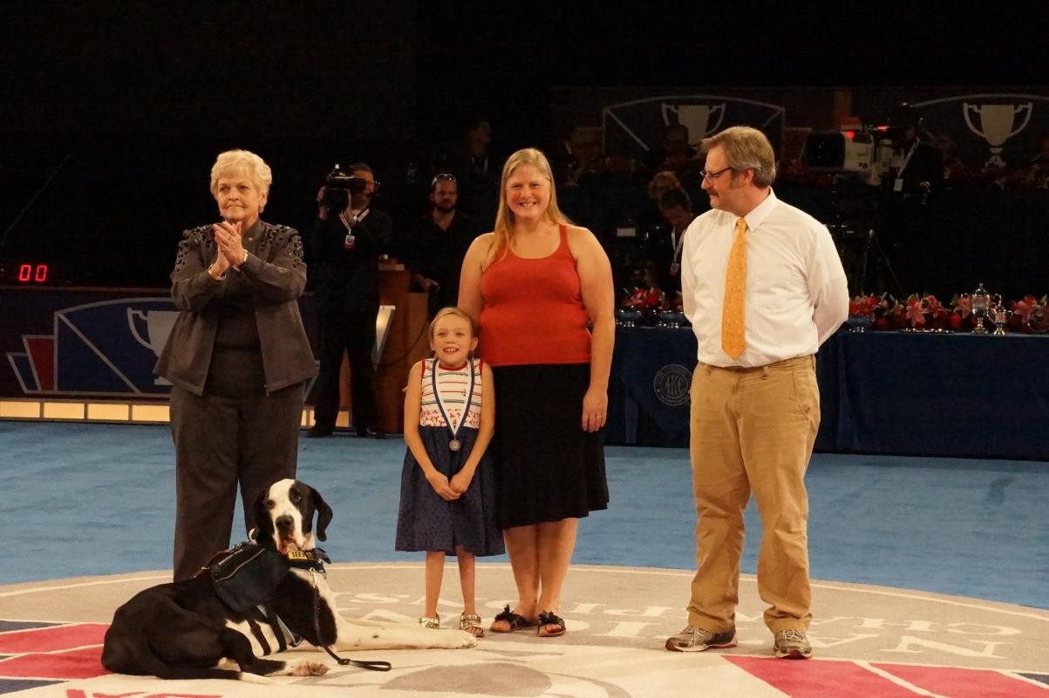

George, a Great Dane service dog, helped a little girl named Bella walk again. The 11-year-old girl suffers from Morquio Syndrome and thought she’d spent her life on crutches or in a wheelchair. But all of that changed when she met George (Michaels, 2022). Until Bella got George 20 months ago, she had to rely on crutches and a wheelchair to get around. Then Bella learned to lean on George, a fun activity that also strengthened her legs. “We

never thought she would be off crutches. And now she will go in the yard and play, even without George,” Rachel says. “To see how much stronger, she’s gotten is awesome” (Michaels, 2022). Bella and George’s love for each other and their adventures are followed by more than 20,000 fans on their Facebook page. After Bella began receiving a weekly infusion of enzyme replacement therapy at Boston Children’s Hospital in June 2014, George was at her side. George has also accompanied Bella for two recent short overnight hospital stays, and as dogs are apt to do, climbed into bed with her. On October 14, Bella returns to the hospital for reconstructive surgery on her right foot. George will be with her.

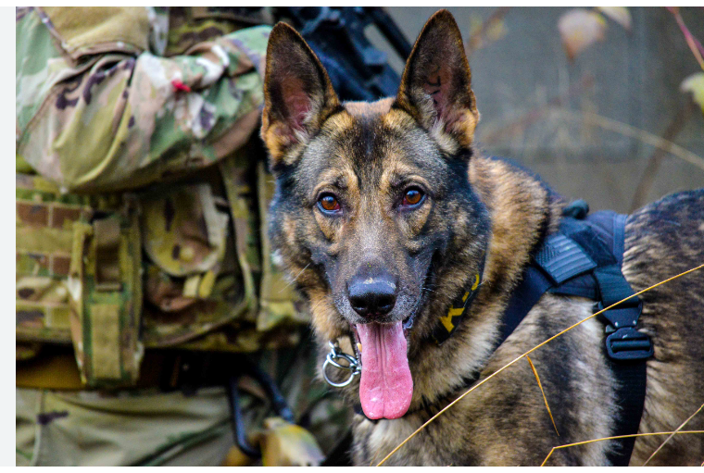

A life form's behavior may make someone feel stressed, or it may provide an outlet for someone to express their feelings towards that life form. There is no right or wrong answer to whether a companion dog would improve your quality of life or negatively impact it. A companion dog could become one of the best decisions you ever make in your life if you decide to adopt one.

# References

Anglis, J. (Sep 26, 2021). The True Story Of Balto, The Husky That Helped Save An Entire

Alaskan Town From Certain Death. Retrieved from, https://allthatsinteresting.com/balto/

Torres, L. (Aug 08, 2022). Memorial Service to be held for Lake Wales K-9 officer killed on

duty. [https://www.abcactionnews.com/news/region-polk/memorial-service-to-be-](https://www.abcactionnews.com/news/region-polk/memorial-service-to-be-held-for-lake-wales-k9-officer-killed-on-duty)

[held-for-lake-wales-k9-officer-killed-on-duty](https://www.abcactionnews.com/news/region-polk/memorial-service-to-be-held-for-lake-wales-k9-officer-killed-on-duty)

Michaels, D. (Nov 25, 2022). Dog gives his all for little girl, so family decides to return the favor. Retrieved from, https://stories.iheartdogs.com/2022/11/25/george-and-bella/