**Docker**

**Virtualization**

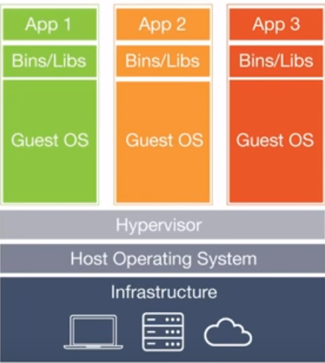

**Docker**

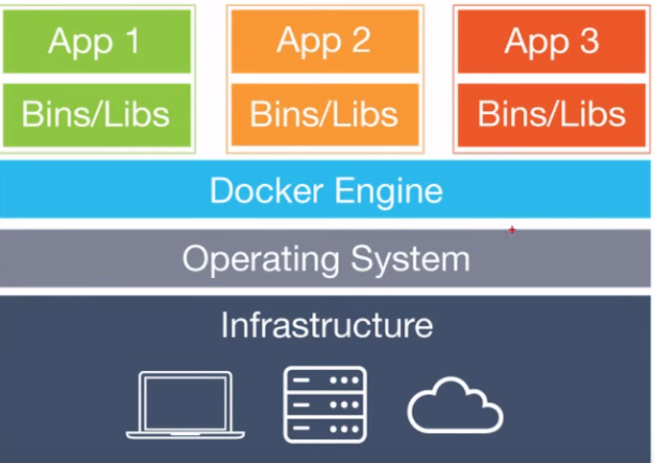

**Docker image**

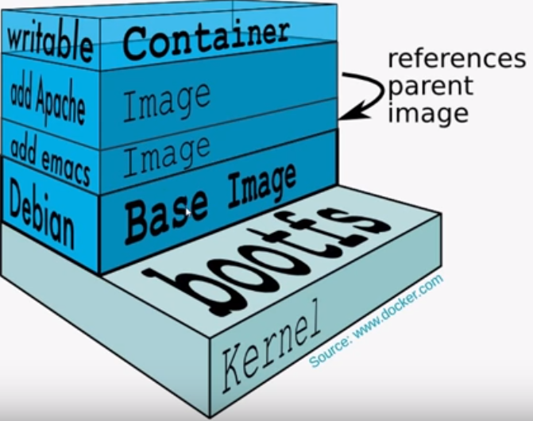

**Docker Architecture**

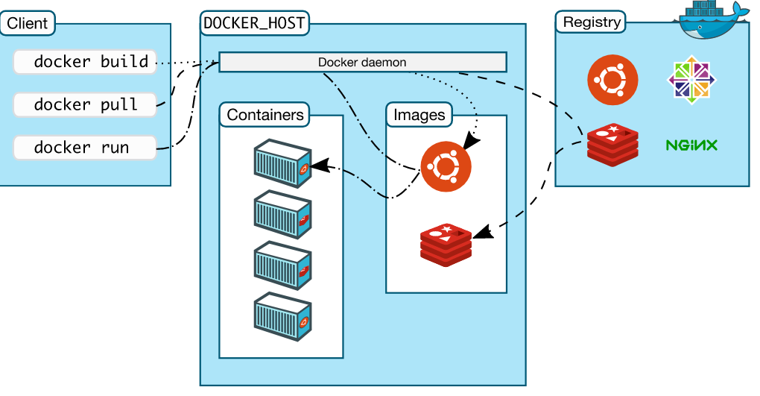

**Installation**

The Docker Comunity package is now called “docker-ce“. Let’s add the CE repository for docker installation.

# yum -y install  wget

# wget https://download.docker.com/linux/centos/docker-ce.repo -O /etc/yum.repos.d/docker-ce.repo

Install the latest version of Docker CE using the following command.

# yum -y install docker-ce

**Start and stop Docker**

#service docker start

#service docker stop

Docker commands

#sudo docker version

#sudo docker info

**Docker Hub**

*https://hub.docker.com/*

**Docker Images**

Running a docker image (or) downloading images

#sudo docker run hello-world

Running a ubuntu image

#Docker run –it Ubuntu bash

Here you are telling Docker to run the command in the interactive mode via the **–it** option.

Displaying docker images

#docker images

Removing a docker image

#docker rmi *ImageID*

Inspect an images

#docker inspect *imagename*

**Containers**

Running a container

#sudo docker run –it centos /bin/bash

Listing containers

#docker ps

Listing all containers

#sudo docker ps -a

Docker history

#docker history *ImageID*

Top container

docker top *ContainerID*

stop a container

#docker stop *conainerID*

Remove a container

docker rm *ContainerID*

Container Stats

docker stats *ContainerID*

Attach a container

docker attach *ContainerID*

Pause a container

docker pause ContainerID

UnPause a container

docker unpause ContainerID

Kill a container

docker kill ContainerID

docker inspect

#docker inspect <container ID>

Running container in “interactive mode”

--- first start container

#docker start <container id>

---then ‘exec’

#docker exec -it <container id> bash

Docker – Container Lifecycle

The following illustration explains the entire lifecycle of a Docker container.

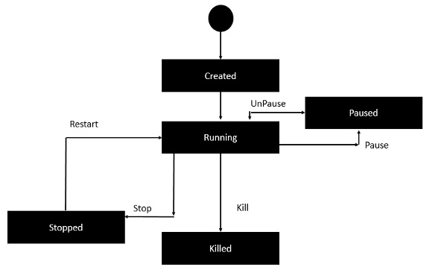

Linking containers

Source containers:

#docker pull Jenkins

#dokcer run –-name=jenkinsa –d Jenkins

Destination container:

#docker run - -name=reca - -link=jenkinsa:alias-src –it ubuntu /bin/bash

#env

#docker ps

Mongo DB image

#docker pull mongo

#docker run –it –d mongo

#docker run –it –link=client_sys:mongo mongo /bin/bash

#docker inspect *continerid*

#mongo 178.13.0.10:27017

#use demo

nginix image

#docker pull nginix

#docker run –p 8080:80 –d nginix 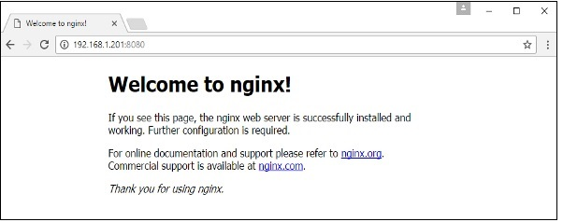

Nagios

Install

docker pull jasonrivers/nagios:latest

Running

Run with the example configuration with the following:

docker run --name nagios4 -p 0.0.0.0:8080:80 jasonrivers/nagios:latest

alternatively you can use external Nagios configuration & log data with the following:

**browser: http://localhost:8080**

#### Credentials

The default credentials for the web interface is nagiosadmin / nagios

Docker file...

1.create docker file

2.docker build -t myimage .

3.docker run -it myimage /bin/bash

push...

docker login

docker tag imageid tkprasanna/image:1.0

docker push tkprasanna/image:1.0