Customer Drop-Out Analysis
Understanding Purchase Funnel Leakage in an E-Commerce Marketplace
Prepared by: Kishan Yadav
Tools Used: PostgreSQL (SQL) · Python (pandas, matplotlib, plotly)
Dataset: Multi-table E-Commerce Dataset (Olist-style)

1. Executive Summary
This project investigates why customers drop out before completing a product purchase on an e-commerce marketplace. Using a multi-table dataset covering customers, orders, order items, products, product categories, sellers, reviews and geolocation, the analysis traces every order through its lifecycle — from purchase to delivery — to identify where and why orders fail to complete.
The overall drop-out rate is small (about 3% of all orders), but it is heavily concentrated at one specific stage of the funnel: between payment approval and shipment. Further investigation shows this is not a category-driven problem — failure rates are fairly uniform across product categories — but a seller-driven problem, with a small group of sellers showing failure rates up to 20 times the platform baseline.

2. Project Objective
To analyze the customer purchase journey and identify the stage(s), patterns, and contributing factors behind orders that fail to convert into completed, delivered purchases — and to translate those findings into actionable business recommendations.

3. Dataset Overview
The analysis used 8 relational tables loaded into a PostgreSQL database (“company”):
Table | Rows | Purpose
customers | 99,441 | Customer identity & location
orders | 99,441 | Order lifecycle timestamps & status
order_items | 112,650 | Line-item level product, seller, price
order_reviews | 99,224 | Post-purchase review scores
products | 32,951 | Product attributes
product_category | 71 | Category name translation
sellers | 3,095 | Seller identity & location
geolocation | 738,327 | Zip code coordinate mapping

4. Methodology
- Loaded all datasets into PostgreSQL and validated row counts and schema integrity.
- Defined the purchase funnel using order timestamp columns: Purchased → Approved → Shipped → Delivered.
- Classified “drop-out” orders as those with status canceled or unavailable.
- Measured drop-out as both raw counts and failure rate (%) to avoid volume bias.
- Cross-examined drop-out by funnel stage, product category, and seller.
- Used Python (pandas + SQLAlchemy) to pull query results and build visualizations.

5. Findings

5.1 Order Status Distribution
Of 99,441 total orders, 97.02% were successfully delivered. The remaining ~3% is split across cancellations, unavailable stock, and orders stuck mid-process.
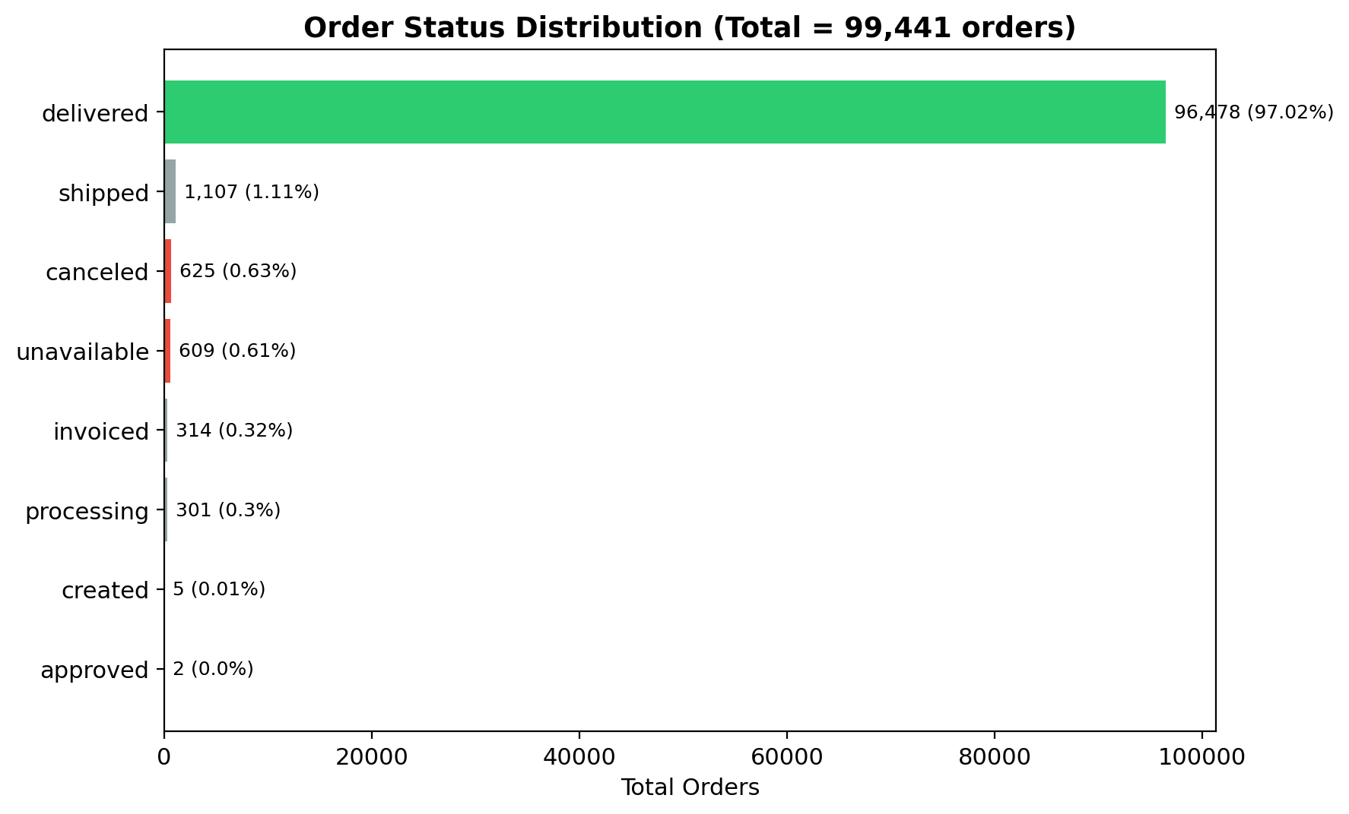
Figure 1: Distribution of orders by final status

5.2 Funnel Analysis — Where Orders Are Lost
Tracking orders through purchase, approval, shipping and delivery stages reveals exactly where the largest drop-offs occur.
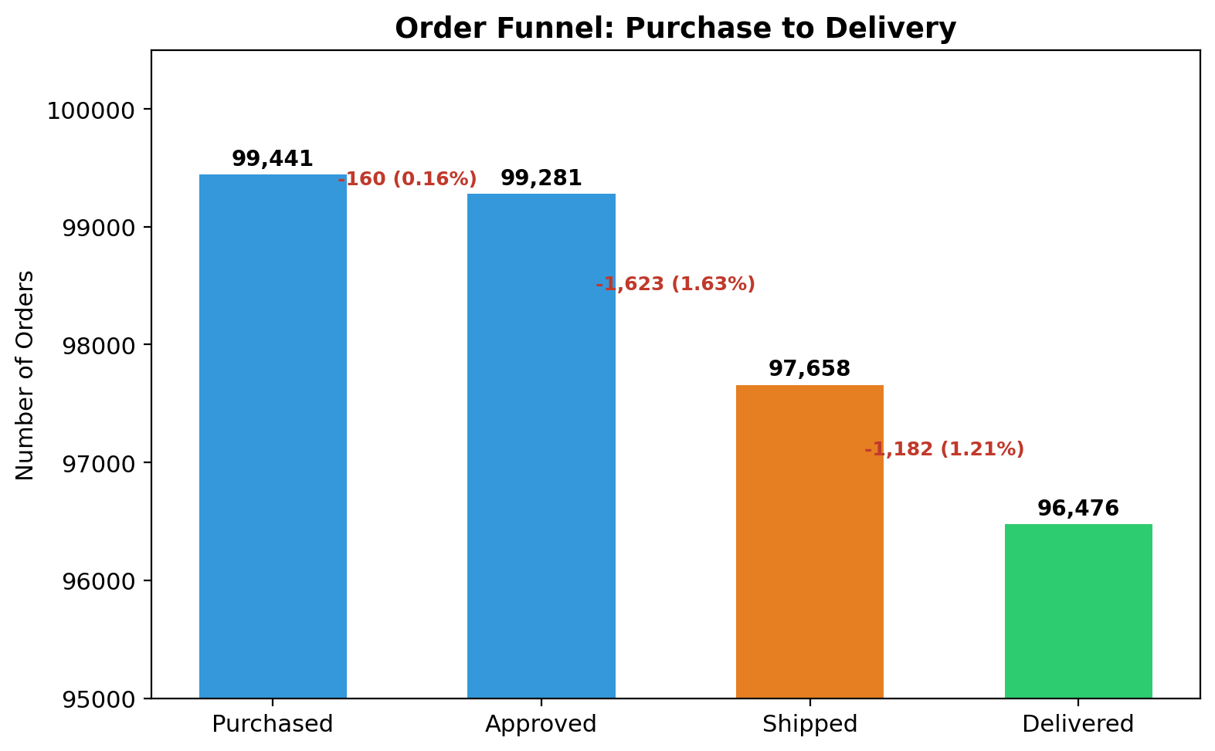
Figure 2: Order funnel from purchase to delivery
The Approved → Shipped transition is the single largest leak in the funnel, losing 1,623 orders (1.63%) — more than any other stage. The Shipped → Delivered stage loses a further 1,182 orders (1.21%), pointing to secondary logistics/delivery issues. Purchase → Approved is comparatively healthy, losing only 160 orders (0.16%).

5.3 Cancellation Timing Breakdown
Breaking down all 625 canceled orders by the stage at which cancellation occurred shows the majority happen after payment was approved:
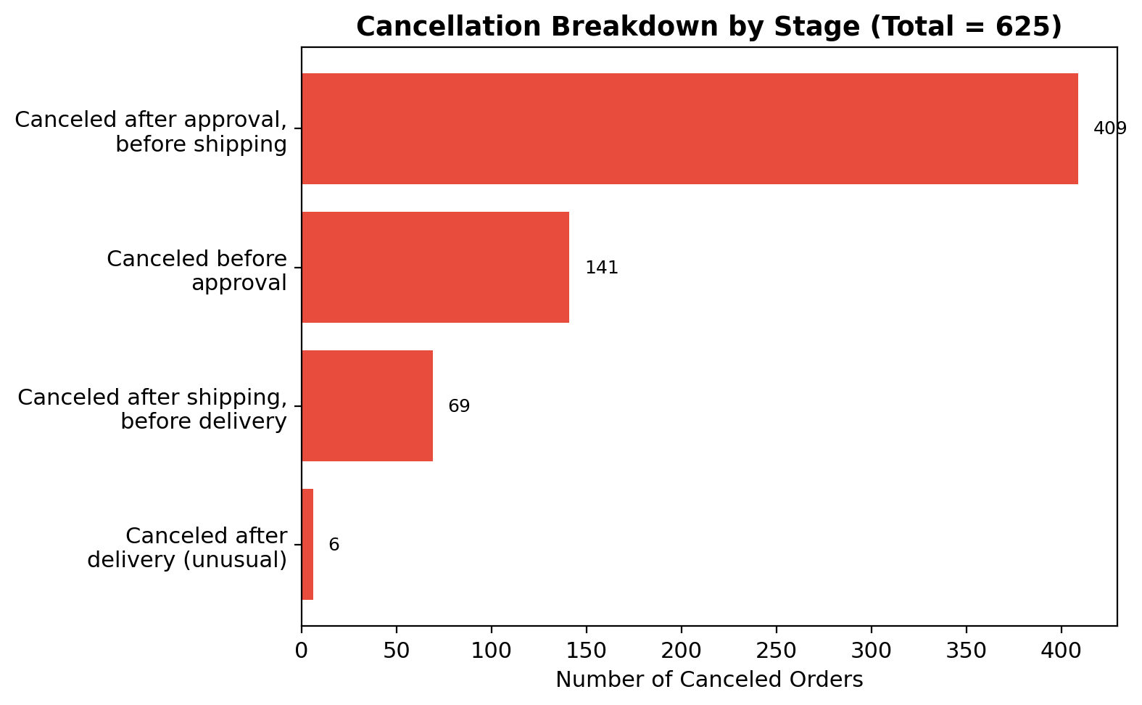
Figure 3: Cancellation stage breakdown
Cancellation Stage | Orders | % of Cancellations
Canceled after approval, before shipping | 409 | 65.4%
Canceled before approval | 141 | 22.6%
Canceled after shipping, before delivery | 69 | 11.0%
Canceled after delivery (unusual) | 6 | 1.0%

65.4% of cancellations occur after the customer has already paid — strongly suggesting the failure originates on the seller/fulfillment side rather than customer intent.

5.4 Category-Wise Failure Rate
Failure rate (% of orders in a category that were canceled-after-approval or marked unavailable) was calculated for all categories with at least 30 orders, to avoid small-sample noise.
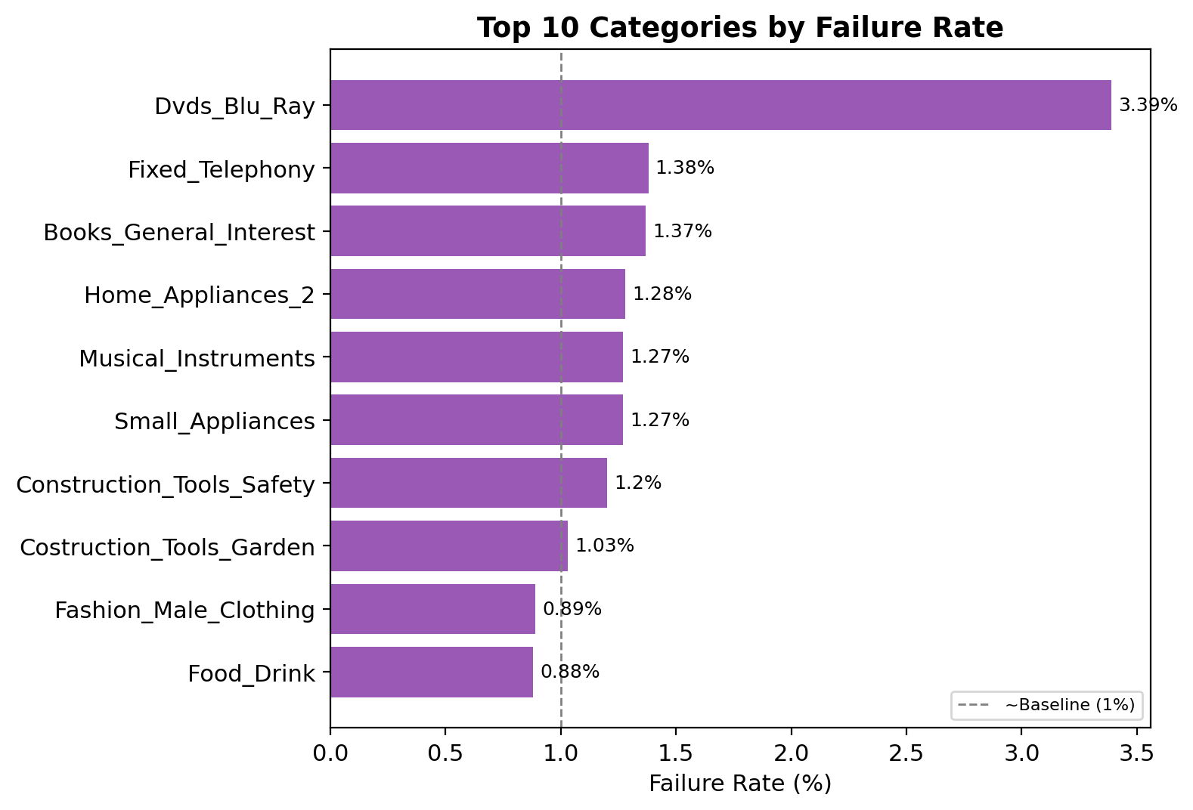
Figure 4: Top 10 categories by failure rate
Failure rates across categories are fairly uniform, mostly in the 1–3% range, with Dvds_Blu_Ray showing the highest rate (3.39%) on a small sample of 59 orders. No category stands out as a systemic outlier, indicating that drop-out is not primarily a category-specific problem.

5.5 Seller-Wise Failure Rate
The same rate calculation was applied at the seller level, for sellers with at least 20 orders.
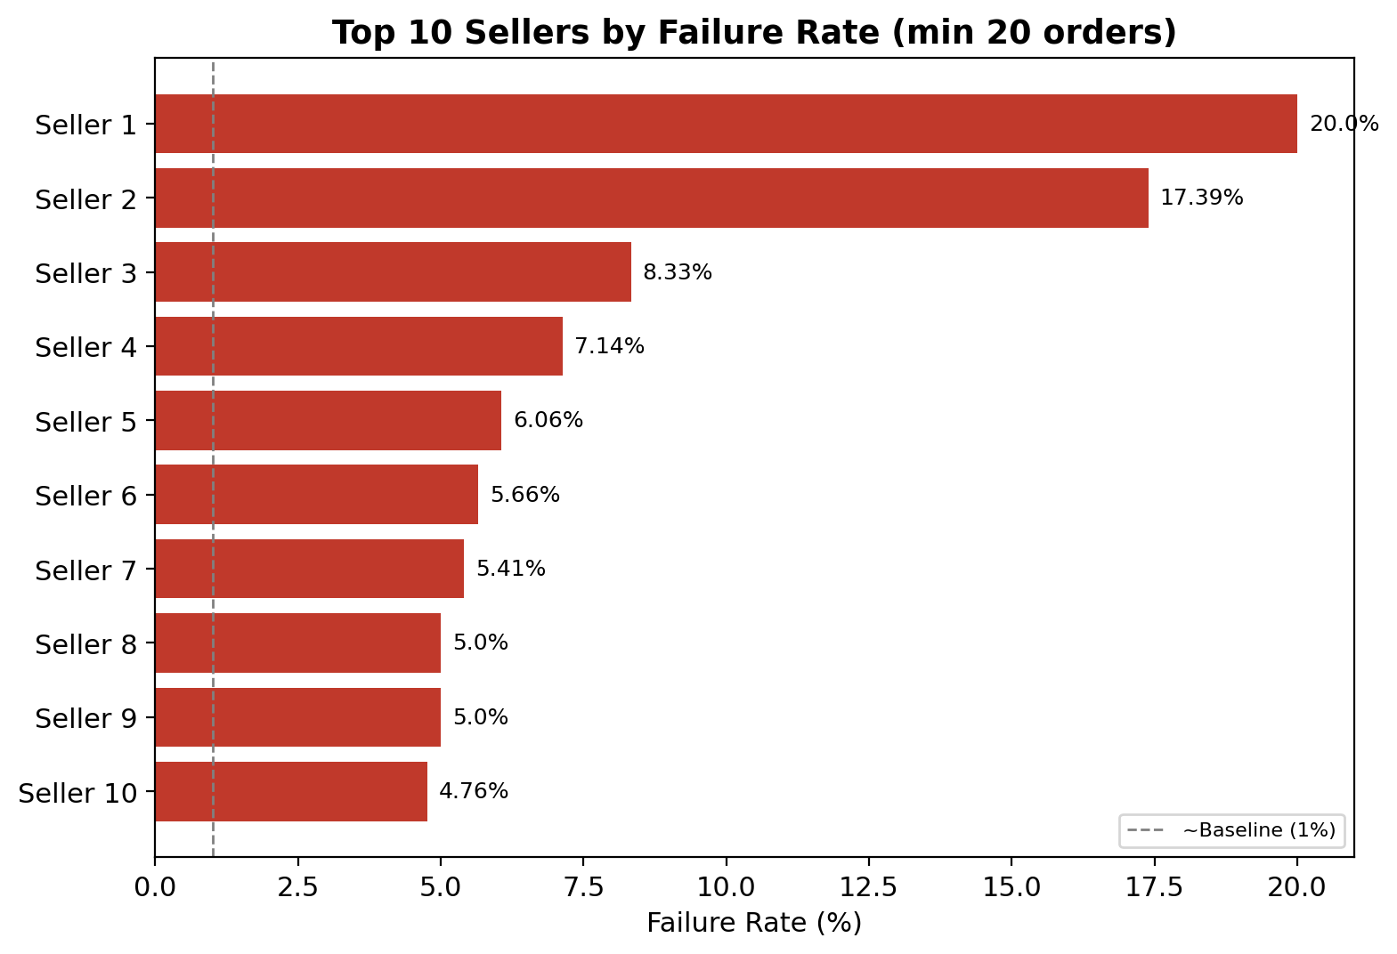
Figure 5: Top 10 sellers by failure rate
This is the most significant finding of the analysis: failure rates vary dramatically by seller, with the top sellers showing failure rates of 17–20% — up to 20 times the platform baseline (~1%). Unlike the category analysis, this points to a genuine, actionable, seller-specific performance problem.

6. Key Insights
- Overall platform health is strong — 97% of orders complete successfully.
- Drop-out is small in volume (~3%) but concentrated, not random.
- The single biggest leak is the Approved → Shipped transition (1,623 orders).
- 65% of cancellations happen post-payment, indicating seller-side fulfillment failure rather than customer-driven cancellation.
- Product category is NOT a meaningful driver of drop-out — rates are broadly uniform (~1–3%).
- Seller performance IS a meaningful driver — a small subset of sellers show failure rates up to 20x the baseline.

7. Recommendations
- Implement seller performance monitoring with an automated failure-rate flag (e.g., >5% over a rolling 20+ order window).
- Introduce stricter inventory/stock verification requirements before allowing a listing to accept orders, to reduce “unavailable” cancellations.
- Audit and support (or deprioritize) sellers with consistently high post-approval cancellation rates.
- Investigate logistics/courier performance for the Shipped → Delivered leak as a secondary workstream.
- Extend this analysis with review-score and repeat-purchase data to quantify the downstream impact of failed orders on customer retention.

8. Tools & Technical Stack
- Database: PostgreSQL (pgAdmin)
- Query Language: SQL (CTEs, conditional aggregation, window functions)
- Analysis & Visualization: Python — pandas, SQLAlchemy, matplotlib, seaborn, plotly
- Environment: Jupyter Notebook

