**Minimize Unplanned Machine Downtime**

Pre-processing Code (SQL) By KISHAN SINGH

Software: MS-SQL Server

1. create database Project; -- creating the database
2. use Project; -- Set the current database to “Project”
3. Importing the table in CSV format into MS SQL Server

→ Right click on database(project) -> tasks -> Import flat file ->browse to select the CSV file “Data”

1. select * from Machine; ----Display the “Machine” table

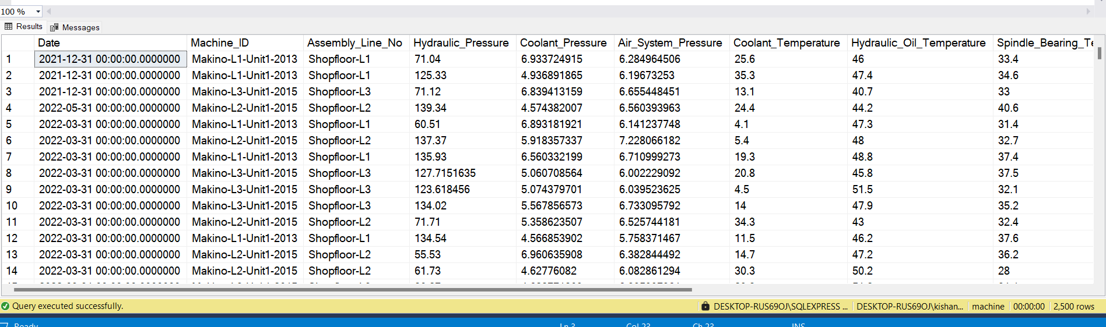

1. EXEC sp_rename 'Machine', 'MachineDowntime'; --Changing the name of the table
2. To find mean

SELECT

AVG(Hydraulic_Pressure) AS Mean_Hydraulic_Pressure,

AVG(Coolant_Pressure) AS Mean_Coolant_Pressure,

AVG(Air_System_Pressure) AS Mean_Air_System_Pressure,

AVG(Coolant_Temperature) AS Mean_Coolant_Temperature,

AVG(Hydraulic_Oil_Temperature) AS Mean_Hydraulic_Oil_Temperature,

AVG(Spindle_Bearing_Temperature) AS Mean_Spindle_Bearing_Temperature,

AVG(Spindle_Vibration) AS Mean_Spindle_Vibration,

AVG(Tool_Vibration) AS Mean_Tool_Vibration,

AVG(Spindle_Speed) AS Mean_Spindle_Speed,

AVG(Voltage) AS Mean_Voltage,

AVG(Torque) AS Mean_Torque,

AVG(Cutting) AS Mean_Cutting

FROM MachineDowntime;

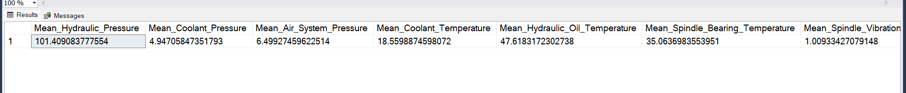

1. To find Median

WITH CTE AS (

SELECT

Hydraulic_Pressure,

Coolant_Pressure,

Air_System_Pressure,

Coolant_Temperature,

Hydraulic_Oil_Temperature,

Spindle_Bearing_Temperature,

Spindle_Vibration,

Tool_Vibration,

Spindle_Speed,

Voltage,

Torque,

Cutting,

ROW_NUMBER() OVER (ORDER BY Hydraulic_Pressure) AS RowNum,

COUNT(*) OVER () AS TotalCount

FROM MachineDowntime

)

SELECT

AVG(Hydraulic_Pressure) AS Median_Hydraulic_Pressure,

AVG(Coolant_Pressure) AS Median_Coolant_Pressure,

AVG(Air_System_Pressure) AS Median_Air_System_Pressure,

AVG(Coolant_Temperature) AS Median_Coolant_Temperature,

AVG(Hydraulic_Oil_Temperature) AS Median_Hydraulic_Oil_Temperature,

AVG(Spindle_Bearing_Temperature) AS Median_Spindle_Bearing_Temperature,

AVG(Spindle_Vibration) AS Median_Spindle_Vibration,

AVG(Tool_Vibration) AS Median_Tool_Vibration,

AVG(Spindle_Speed) AS Median_Spindle_Speed,

AVG(Voltage) AS Median_Voltage,

AVG(Torque) AS Median_Torque,

AVG(Cutting) AS Median_Cutting

FROM CTE

WHERE RowNum IN ((TotalCount + 1) / 2, (TotalCount + 2) / 2);

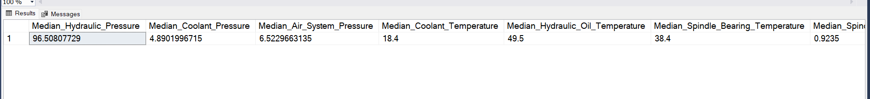

1. To Find Mode

SELECT TOP 1

(SELECT TOP 1 Hydraulic_Pressure

FROM MachineDowntime

GROUP BY Hydraulic_Pressure

ORDER BY COUNT(*) DESC) AS Mode_Hydraulic_Pressure,

(SELECT TOP 1 Coolant_Pressure

FROM MachineDowntime

GROUP BY Coolant_Pressure

ORDER BY COUNT(*) DESC) AS Mode_Coolant_Pressure,

(SELECT TOP 1 Air_System_Pressure

FROM MachineDowntime

GROUP BY Air_System_Pressure

ORDER BY COUNT(*) DESC) AS Mode_Air_System_Pressure,

(SELECT TOP 1 Coolant_Temperature

FROM MachineDowntime

GROUP BY Coolant_Temperature

ORDER BY COUNT(*) DESC) AS Mode_Coolant_Temperature,

(SELECT TOP 1 Hydraulic_Oil_Temperature

FROM MachineDowntime

GROUP BY Hydraulic_Oil_Temperature

ORDER BY COUNT(*) DESC) AS Mode_Hydraulic_Oil_Temperature,

(SELECT TOP 1 Spindle_Bearing_Temperature

FROM MachineDowntime

GROUP BY Spindle_Bearing_Temperature

ORDER BY COUNT(*) DESC) AS Mode_Spindle_Bearing_Temperature,

(SELECT TOP 1 Spindle_Vibration

FROM MachineDowntime

GROUP BY Spindle_Vibration

ORDER BY COUNT(*) DESC) AS Mode_Spindle_Vibration,

(SELECT TOP 1 Tool_Vibration

FROM MachineDowntime

GROUP BY Tool_Vibration

ORDER BY COUNT(*) DESC) AS Mode_Tool_Vibration,

(SELECT TOP 1 Spindle_Speed

FROM MachineDowntime

GROUP BY Spindle_Speed

ORDER BY COUNT(*) DESC) AS Mode_Spindle_Speed,

(SELECT TOP 1 Voltage

FROM MachineDowntime

GROUP BY Voltage

ORDER BY COUNT(*) DESC) AS Mode_Voltage,

(SELECT TOP 1 Torque

FROM MachineDowntime

GROUP BY Torque

ORDER BY COUNT(*) DESC) AS Mode_Torque,

(SELECT TOP 1 Cutting

FROM MachineDowntime

GROUP BY Cutting

ORDER BY COUNT(*) DESC) AS Mode_Cutting,

(SELECT TOP 1 Downtime

FROM MachineDowntime

GROUP BY Downtime

ORDER BY COUNT(*) DESC) AS Mode_Downtime

FROM MachineDowntime;

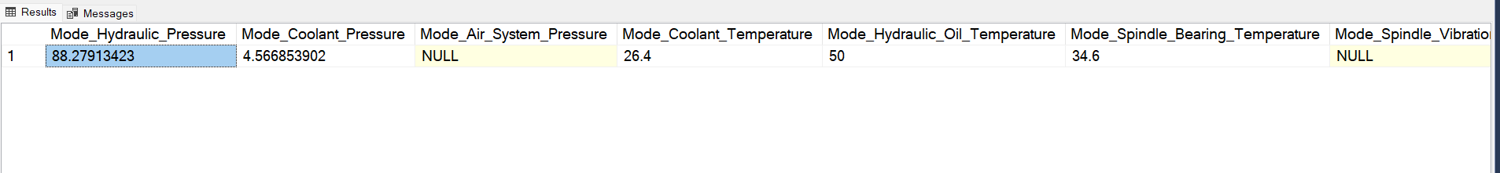

1. To Find Variance

SELECT

ROUND(VAR(Hydraulic_Pressure),2) AS Hydraulic_Pressure_var,

ROUND(VAR(Coolant_Pressure),2) AS Coolant_Pressure_var,

ROUND(VAR(Air_System_Pressure),2) AS Air_System_Pressure_var,

ROUND(VAR(Coolant_Temperature),2) AS Coolant_Temperature_var,

ROUND(VAR(Hydraulic_Oil_Temperature),2) AS Hydraulic_Oil_Temperature_var,

ROUND(VAR(Spindle_Bearing_Temperature),2) AS Spindle_Bearing_Temperature_var,

ROUND(VAR(Spindle_Vibration),2) AS Spindle_Vibration_var,

ROUND(VAR(Tool_Vibration),2) AS Tool_Vibration_var,

ROUND(VAR(Spindle_Speed),2) AS Spindle_Speed_var,

ROUND(VAR(Voltage),2) AS Voltage_var,

ROUND(VAR(Torque),2) AS Torque_var,

ROUND(VAR(Cutting),2) AS Cutting_var

from MachineDowntime;

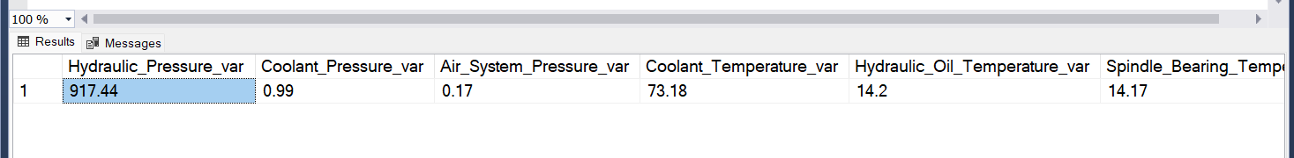

1. To find STANDARD DEVIATION

SELECT

ROUND(STDEV(Hydraulic_Pressure),2) AS Hydraulic_Pressure_STDEV,

ROUND(STDEV(Coolant_Pressure),2) AS Coolant_Pressure_STDEV,

ROUND(STDEV(Air_System_Pressure),2) AS Air_System_Pressure_STDEV,

ROUND(STDEV(Coolant_Temperature),2) AS Coolant_Temperature_STDEV,

ROUND(STDEV(Hydraulic_Oil_Temperature),2) AS Hydraulic_Oil_Temperature_STDEV,

ROUND(STDEV(Spindle_Bearing_Temperature),2) AS Spindle_Bearing_Temperature_STDEV,

ROUND(STDEV(Spindle_Vibration),2) AS Spindle_Vibration_STDEV,

ROUND(STDEV(Tool_Vibration),2) AS Tool_Vibration_STDEV,

ROUND(STDEV(Spindle_Speed),2) AS Spindle_Speed_STDEV,

ROUND(STDEV(Voltage),2) AS Voltage_STDEV,

ROUND(STDEV(Torque),2) AS Torque_STDEV,

ROUND(STDEV(Cutting),2) AS Cutting_STDEV

from MachineDowntime;

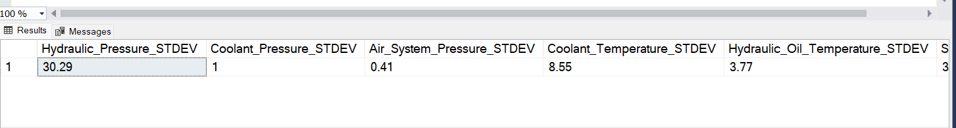

1. To find Skewness of Hydraulic_Pressure, Cutting and Torque

-- Calculate the mean

DECLARE @Mean FLOAT;

SELECT @Mean = AVG(Hydraulic_Pressure) FROM MachineDowntime;

-- Calculate the standard deviation

DECLARE @StdDev FLOAT;

SELECT @StdDev = STDEV(Hydraulic_Pressure) FROM MachineDowntime;

-- Calculate the count

DECLARE @Count INT;

SELECT @Count = COUNT(Hydraulic_Pressure) FROM MachineDowntime;

-- Calculate skewness

DECLARE @Skewness FLOAT;

SELECT @Skewness = SUM(POWER(Hydraulic_Pressure - @Mean, 3)) / @Count / POWER(@StdDev, 3) FROM MachineDowntime;

-- Output the skewness

SELECT @Skewness AS Skewness_Hydraulic_Pressure;

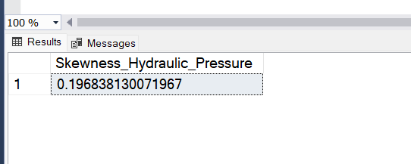

-- Calculate the mean

DECLARE @Mean FLOAT;

SELECT @Mean = AVG(Cutting) FROM MachineDowntime;

-- Calculate the standard deviation

DECLARE @StdDev FLOAT;

SELECT @StdDev = STDEV(Cutting) FROM MachineDowntime;

-- Calculate the count

DECLARE @Count INT;

SELECT @Count = COUNT(Cutting) FROM MachineDowntime;

-- Calculate skewness

DECLARE @Skewness FLOAT;

SELECT @Skewness = SUM(POWER(Cutting - @Mean, 3)) / @Count / POWER(@StdDev, 3) FROM MachineDowntime;

-- Output the skewness

SELECT @Skewness AS Skewness_Cutting;

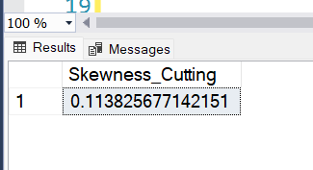

-- Calculate the mean

DECLARE @Mean FLOAT;

SELECT @Mean = AVG(Torque) FROM MachineDowntime;

-- Calculate the standard deviation

DECLARE @StdDev FLOAT;

SELECT @StdDev = STDEV(Torque) FROM MachineDowntime;

-- Calculate the count

DECLARE @Count INT;

SELECT @Count = COUNT(Torque) FROM MachineDowntime;

-- Calculate skewness

DECLARE @Skewness FLOAT;

SELECT @Skewness = SUM(POWER(Torque - @Mean, 3)) / @Count / POWER(@StdDev, 3) FROM MachineDowntime;

-- Output the skewness

SELECT @Skewness AS Skewness_Torque;

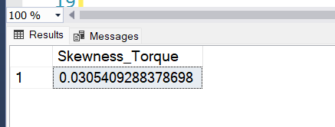

1. To find Kurtosis of Hydraulic_Pressure, Cutting and Torque

WITH Stats AS (

SELECT

AVG(Hydraulic_Pressure) AS mean,

STDEV(Hydraulic_Pressure) AS stddev,

COUNT(Hydraulic_Pressure) AS n

FROM

MachineDowntime

),

Moments AS (

SELECT

POWER(Hydraulic_Pressure - Stats.mean, 2) AS squared_diff,

POWER(Hydraulic_Pressure - Stats.mean, 4) AS fourth_diff

FROM

MachineDowntime, Stats

),

AggregatedMoments AS (

SELECT

SUM(squared_diff) AS sum_squared_diff,

SUM(fourth_diff) AS sum_fourth_diff,

COUNT(Hydraulic_Pressure) AS n

FROM

Moments, Stats,MachineDowntime

)

SELECT

(n * sum_fourth_diff) / (sum_squared_diff * sum_squared_diff) - 3 AS kurtosis_Hydraulic_Pressure

FROM

AggregatedMoments;

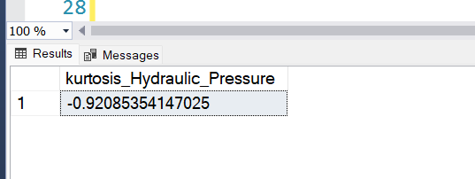

WITH Stats AS (

SELECT

AVG(Cutting) AS mean,

STDEV(Cutting) AS stddev,

COUNT(Cutting) AS n

FROM

MachineDowntime

),

Moments AS (

SELECT

POWER(Cutting - Stats.mean, 2) AS squared_diff,

POWER(Cutting - Stats.mean, 4) AS fourth_diff

FROM

MachineDowntime, Stats

),

AggregatedMoments AS (

SELECT

SUM(squared_diff) AS sum_squared_diff,

SUM(fourth_diff) AS sum_fourth_diff,

COUNT(Cutting) AS n

FROM

Moments, Stats,MachineDowntime

)

SELECT

(n * sum_fourth_diff) / (sum_squared_diff * sum_squared_diff) - 3 AS kurtosis_Cutting

FROM

AggregatedMoments;

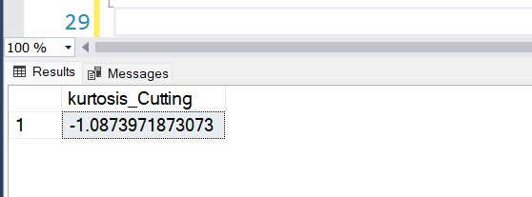

WITH Stats AS (

SELECT

AVG(Torque) AS mean,

STDEV(Torque) AS stddev,

COUNT(Torque) AS n

FROM

MachineDowntime

),

Moments AS (

SELECT

POWER(Torque - Stats.mean, 2) AS squared_diff,

POWER(Torque - Stats.mean, 4) AS fourth_diff

FROM

MachineDowntime, Stats

),

AggregatedMoments AS (

SELECT

SUM(squared_diff) AS sum_squared_diff,

SUM(fourth_diff) AS sum_fourth_diff,

COUNT(Torque) AS n

FROM

Moments, Stats,MachineDowntime

)

SELECT

(n * sum_fourth_diff) / (sum_squared_diff * sum_squared_diff) - 3 AS kurtosis_Torque

FROM

AggregatedMoments;

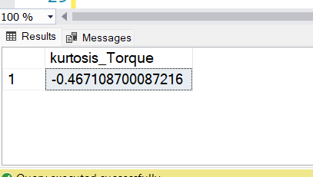

1. Find Null Values

SELECT

SUM(CASE WHEN Date IS NULL THEN 1 ELSE 0 END) AS Null_Date,

SUM(CASE WHEN Machine_ID IS NULL THEN 1 ELSE 0 END) AS Null_Machine_ID,

SUM(CASE WHEN Assembly_Line_No IS NULL THEN 1 ELSE 0 END) AS Null_Assembly_Line_No,

SUM(CASE WHEN Hydraulic_Pressure IS NULL THEN 1 ELSE 0 END) AS Null_Hydraulic_Pressure,

SUM(CASE WHEN Coolant_Pressure IS NULL THEN 1 ELSE 0 END) AS Null_Coolant_Pressure,

SUM(CASE WHEN Air_System_Pressure IS NULL THEN 1 ELSE 0 END) AS Null_Air_System_Pressure,

SUM(CASE WHEN Coolant_Temperature IS NULL THEN 1 ELSE 0 END) AS Null_Coolant_Temperature,

SUM(CASE WHEN Hydraulic_Oil_Temperature IS NULL THEN 1 ELSE 0 END) AS Null_Hydraulic_Oil_Temperature,

SUM(CASE WHEN Spindle_Bearing_Temperature IS NULL THEN 1 ELSE 0 END) AS Null_Spindle_Bearing_Temperature,

SUM(CASE WHEN Spindle_Vibration IS NULL THEN 1 ELSE 0 END) AS Null_Spindle_Vibration,

SUM(CASE WHEN Tool_Vibration IS NULL THEN 1 ELSE 0 END) AS Null_Tool_Vibration,

SUM(CASE WHEN Spindle_Speed IS NULL THEN 1 ELSE 0 END) AS Null_Spindle_Speed,

SUM(CASE WHEN Voltage IS NULL THEN 1 ELSE 0 END) AS Null_Voltage,

SUM(CASE WHEN Torque IS NULL THEN 1 ELSE 0 END) AS Null_Torque,

SUM(CASE WHEN Cutting IS NULL THEN 1 ELSE 0 END) AS Null_Cutting,

SUM(CASE WHEN Downtime IS NULL THEN 1 ELSE 0 END) AS Null_Downtime

FROM MachineDowntime;



1. Remove Null Values

DELETE FROM MachineDowntime

WHERE

Date IS NULL OR

Machine_ID IS NULL OR

Assembly_Line_No IS NULL OR

Hydraulic_Pressure IS NULL OR

Coolant_Pressure IS NULL OR

Air_System_Pressure IS NULL OR

Coolant_Temperature IS NULL OR

Hydraulic_Oil_Temperature IS NULL OR

Spindle_Bearing_Temperature IS NULL OR

Spindle_Vibration IS NULL OR

Tool_Vibration IS NULL OR

Spindle_Speed IS NULL OR

Voltage IS NULL OR

Torque IS NULL OR

Cutting IS NULL OR

Downtime IS NULL;

1. Remove Outliers

WITH Q_Hydraulic_Pressure AS (

SELECT

PERCENTILE_CONT(0.25) WITHIN GROUP (ORDER BY Hydraulic_Pressure) OVER () AS Q1,

PERCENTILE_CONT(0.75) WITHIN GROUP (ORDER BY Hydraulic_Pressure) OVER () AS Q3

FROM MachineDowntime

),

IQR_Hydraulic_Pressure AS (

SELECT

MAX(Q1) AS Q1,

MAX(Q3) AS Q3,

(MAX(Q3) - MAX(Q1)) * 1.5 AS IQR

FROM Q_Hydraulic_Pressure

),

Q_Coolant_Pressure AS (

SELECT

PERCENTILE_CONT(0.25) WITHIN GROUP (ORDER BY Coolant_Pressure) OVER () AS Q1,

PERCENTILE_CONT(0.75) WITHIN GROUP (ORDER BY Coolant_Pressure) OVER () AS Q3

FROM MachineDowntime

),

IQR_Coolant_Pressure AS (

SELECT

MAX(Q1) AS Q1,

MAX(Q3) AS Q3,

(MAX(Q3) - MAX(Q1)) * 1.5 AS IQR

FROM Q_Coolant_Pressure

),

Q_Air_System_Pressure AS (

SELECT

PERCENTILE_CONT(0.25) WITHIN GROUP (ORDER BY Air_System_Pressure) OVER () AS Q1,

PERCENTILE_CONT(0.75) WITHIN GROUP (ORDER BY Air_System_Pressure) OVER () AS Q3

FROM MachineDowntime

),

IQR_Air_System_Pressure AS (

SELECT

MAX(Q1) AS Q1,

MAX(Q3) AS Q3,

(MAX(Q3) - MAX(Q1)) * 1.5 AS IQR

FROM Q_Air_System_Pressure

),

Q_Coolant_Temperature AS (

SELECT

PERCENTILE_CONT(0.25) WITHIN GROUP (ORDER BY Coolant_Temperature) OVER () AS Q1,

PERCENTILE_CONT(0.75) WITHIN GROUP (ORDER BY Coolant_Temperature) OVER () AS Q3

FROM MachineDowntime

),

IQR_Coolant_Temperature AS (

SELECT

MAX(Q1) AS Q1,

MAX(Q3) AS Q3,

(MAX(Q3) - MAX(Q1)) * 1.5 AS IQR

FROM Q_Coolant_Temperature

),

Q_Hydraulic_Oil_Temperature AS (

SELECT

PERCENTILE_CONT(0.25) WITHIN GROUP (ORDER BY Hydraulic_Oil_Temperature) OVER () AS Q1,

PERCENTILE_CONT(0.75) WITHIN GROUP (ORDER BY Hydraulic_Oil_Temperature) OVER () AS Q3

FROM MachineDowntime

),

IQR_Hydraulic_Oil_Temperature AS (

SELECT

MAX(Q1) AS Q1,

MAX(Q3) AS Q3,

(MAX(Q3) - MAX(Q1)) * 1.5 AS IQR

FROM Q_Hydraulic_Oil_Temperature

),

Q_Spindle_Bearing_Temperature AS (

SELECT

PERCENTILE_CONT(0.25) WITHIN GROUP (ORDER BY Spindle_Bearing_Temperature) OVER () AS Q1,

PERCENTILE_CONT(0.75) WITHIN GROUP (ORDER BY Spindle_Bearing_Temperature) OVER () AS Q3

FROM MachineDowntime

),

IQR_Spindle_Bearing_Temperature AS (

SELECT

MAX(Q1) AS Q1,

MAX(Q3) AS Q3,

(MAX(Q3) - MAX(Q1)) * 1.5 AS IQR

FROM Q_Spindle_Bearing_Temperature

),

Q_Spindle_Vibration AS (

SELECT

PERCENTILE_CONT(0.25) WITHIN GROUP (ORDER BY Spindle_Vibration) OVER () AS Q1,

PERCENTILE_CONT(0.75) WITHIN GROUP (ORDER BY Spindle_Vibration) OVER () AS Q3

FROM MachineDowntime

),

IQR_Spindle_Vibration AS (

SELECT

MAX(Q1) AS Q1,

MAX(Q3) AS Q3,

(MAX(Q3) - MAX(Q1)) * 1.5 AS IQR

FROM Q_Spindle_Vibration

),

Q_Tool_Vibration AS (

SELECT

PERCENTILE_CONT(0.25) WITHIN GROUP (ORDER BY Tool_Vibration) OVER () AS Q1,

PERCENTILE_CONT(0.75) WITHIN GROUP (ORDER BY Tool_Vibration) OVER () AS Q3

FROM MachineDowntime

),

IQR_Tool_Vibration AS (

SELECT

MAX(Q1) AS Q1,

MAX(Q3) AS Q3,

(MAX(Q3) - MAX(Q1)) * 1.5 AS IQR

FROM Q_Tool_Vibration

),

Q_Spindle_Speed AS (

SELECT

PERCENTILE_CONT(0.25) WITHIN GROUP (ORDER BY Spindle_Speed) OVER () AS Q1,

PERCENTILE_CONT(0.75) WITHIN GROUP (ORDER BY Spindle_Speed) OVER () AS Q3

FROM MachineDowntime

),

IQR_Spindle_Speed AS (

SELECT

MAX(Q1) AS Q1,

MAX(Q3) AS Q3,

(MAX(Q3) - MAX(Q1)) * 1.5 AS IQR

FROM Q_Spindle_Speed

),

Q_Voltage AS (

SELECT

PERCENTILE_CONT(0.25) WITHIN GROUP (ORDER BY Voltage) OVER () AS Q1,

PERCENTILE_CONT(0.75) WITHIN GROUP (ORDER BY Voltage) OVER () AS Q3

FROM MachineDowntime

),

IQR_Voltage AS (

SELECT

MAX(Q1) AS Q1,

MAX(Q3) AS Q3,

(MAX(Q3) - MAX(Q1)) * 1.5 AS IQR

FROM Q_Voltage

),

Q_Torque AS (

SELECT

PERCENTILE_CONT(0.25) WITHIN GROUP (ORDER BY Torque) OVER () AS Q1,

PERCENTILE_CONT(0.75) WITHIN GROUP (ORDER BY Torque) OVER () AS Q3

FROM MachineDowntime

),

IQR_Torque AS (

SELECT

MAX(Q1) AS Q1,

MAX(Q3) AS Q3,

(MAX(Q3) - MAX(Q1)) * 1.5 AS IQR

FROM Q_Torque

),

Q_Cutting AS (

SELECT

PERCENTILE_CONT(0.25) WITHIN GROUP (ORDER BY Cutting) OVER () AS Q1,

PERCENTILE_CONT(0.75) WITHIN GROUP (ORDER BY Cutting) OVER () AS Q3

FROM MachineDowntime

),

IQR_Cutting AS (

SELECT

MAX(Q1) AS Q1,

MAX(Q3) AS Q3,

(MAX(Q3) - MAX(Q1)) * 1.5 AS IQR

FROM Q_Cutting

)

SELECT * INTO data_cleaned

FROM MachineDowntime

WHERE

Hydraulic_Pressure BETWEEN

(SELECT Q1 - IQR FROM IQR_Hydraulic_Pressure) AND

(SELECT Q3 + IQR FROM IQR_Hydraulic_Pressure) AND

Coolant_Pressure BETWEEN

(SELECT Q1 - IQR FROM IQR_Coolant_Pressure) AND

(SELECT Q3 + IQR FROM IQR_Coolant_Pressure) AND

Air_System_Pressure BETWEEN

(SELECT Q1 - IQR FROM IQR_Air_System_Pressure) AND

(SELECT Q3 + IQR FROM IQR_Air_System_Pressure) AND

Coolant_Temperature BETWEEN

(SELECT Q1 - IQR FROM IQR_Coolant_Temperature) AND

(SELECT Q3 + IQR FROM IQR_Coolant_Temperature) AND

Hydraulic_Oil_Temperature BETWEEN

(SELECT Q1 - IQR FROM IQR_Hydraulic_Oil_Temperature) AND

(SELECT Q3 + IQR FROM IQR_Hydraulic_Oil_Temperature) AND

Spindle_Bearing_Temperature BETWEEN

(SELECT Q1 - IQR FROM IQR_Spindle_Bearing_Temperature) AND

(SELECT Q3 + IQR FROM IQR_Spindle_Bearing_Temperature) AND

Spindle_Vibration BETWEEN

(SELECT Q1 - IQR FROM IQR_Spindle_Vibration) AND

(SELECT Q3 + IQR FROM IQR_Spindle_Vibration) AND

Tool_Vibration BETWEEN

(SELECT Q1 - IQR FROM IQR_Tool_Vibration) AND

(SELECT Q3 + IQR FROM IQR_Tool_Vibration) AND

Spindle_Speed BETWEEN

(SELECT Q1 - IQR FROM IQR_Spindle_Speed) AND

(SELECT Q3 + IQR FROM IQR_Spindle_Speed) AND

Voltage BETWEEN

(SELECT Q1 - IQR FROM IQR_Voltage) AND

(SELECT Q3 + IQR FROM IQR_Voltage) AND

Torque BETWEEN

(SELECT Q1 - IQR FROM IQR_Torque) AND

(SELECT Q3 + IQR FROM IQR_Torque) AND

Cutting BETWEEN

(SELECT Q1 - IQR FROM IQR_Cutting) AND

(SELECT Q3 + IQR FROM IQR_Cutting);

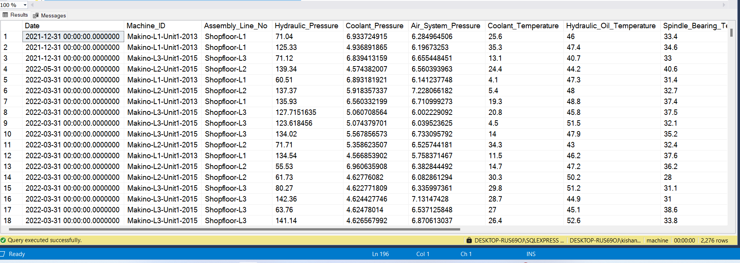

**EDA FROM CLEANED DATASET**

1. Proportion of machine downtime occurrences

select Downtime, count(*) AS total, (COUNT(*) * 100.0 / (SELECT COUNT(*) FROM data_cleaned)) AS percentages from data_cleaned group by Downtime;

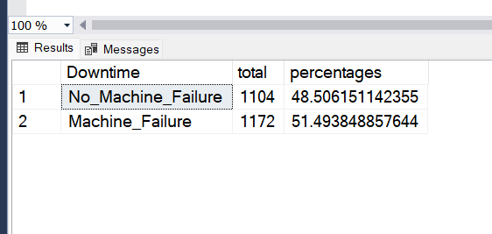

1. Downtime Occurrences by Machine ID

SELECT Machine_ID, COUNT(*) AS count,(COUNT(*) * 100.0 / (SELECT COUNT(*) FROM data_cleaned where Downtime='Machine_Failure')) AS percentages

FROM data_cleaned

WHERE Downtime='Machine_Failure'

GROUP BY Machine_ID;

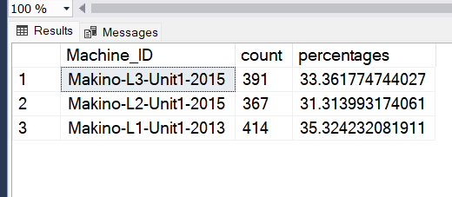

SELECT Machine_ID, COUNT(*) AS count,(COUNT(*) * 100.0 / (SELECT COUNT(*) FROM data_cleaned where Downtime='No_Machine_Failure')) AS percentages

FROM data_cleaned

WHERE Downtime='No_Machine_Failure'

GROUP BY Machine_ID;

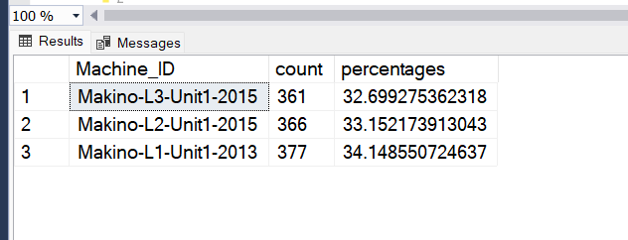

1. Downtime Occurrences by Assembly_Line_No

SELECT Assembly_Line_No, COUNT(*) AS count,(COUNT(*) * 100.0 / (SELECT COUNT(*) FROM data_cleaned where Downtime='No_Machine_Failure')) AS percentages

FROM data_cleaned

WHERE Downtime='No_Machine_Failure'

GROUP BY Assembly_Line_No;

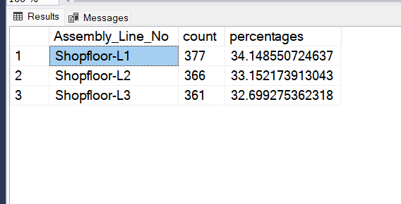

SELECT Assembly_Line_No, COUNT(*) AS count,(COUNT(*) * 100.0 / (SELECT COUNT(*) FROM data_cleaned where Downtime='Machine_Failure')) AS percentages

FROM data_cleaned

WHERE Downtime='Machine_Failure'

GROUP BY Assembly_Line_No;

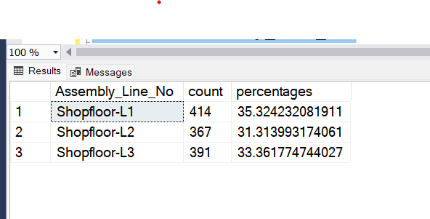

1. Hydraulic_Pressure histogram Plot

select cast (Hydraulic_Pressure/10 as int) AS Range,count(*) AS Counts FROM data_cleaned where Downtime='Machine_Failure' GROUP BY cast (Hydraulic_Pressure/10 as int) order by cast (Hydraulic_Pressure/10 as int) ASC;

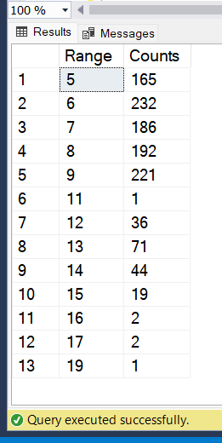

* Insights for Machine Downtime

1. Data Cleaning slightly decreased the mean in some columns like Hydraulic Pressure (bar), Coolant Temperature (°C) etc indicating that some high outliers were removed. Minimal difference, suggesting stable and accurate measurements.
2. There are some columns like Coolant pressure, Air system pressure, Torque etc. are very stable output, suggesting reliable data without significant outliers. Consistent readings, indicating good data quality.
3. There are 3 columns namely Hydraulic Pressure, Torque and Cutting are highly correlated with Downtime. Here Hydraulic Pressure(-0.553) and Torque (Nm) ( -0.411 ) are very strongly Negative correlated with Downtime. Cutting (kN) (0.454) is Very strongly Positive Correlated with Downtime.
4. There is one parameter Spindle_Speed (0.2730) which is mediately correlated with downtime.
5. Proportion of Downtime Occurrence for machine_ downtime failure is 51.49% and for no machine_downtime failure is 48.51%.
6. Almost all data is for year 2022 (99.03%) and remaining for year 2021 (0.97%).
7. If Hydraulic Pressure is approximately below 100 then there is chance of machine_failure and Ensure optimal hydraulic pressure to reduce downtime.
8. If Cutting Force is approximately between 1kN to 2.2kN or between 2.6kN to 3.3kN then there is lesser chance of machine_failure Also Monitor and control cutting force to prevent increased downtime.
9. If torque is approximately between 30Nm to 35Nm then there is minimal chance of machine_failure and Maintain adequate torque levels to minimize downtime.
10. If Hydraulic pressure above 75 and less than 175 and cutting force is 1kN to 2.2kN or 2.9kN to 3.4kN then there is chance of no machine_failure.