Company: BookBiz Distribution Inc. 7122 18th Montreal, Quebec H2A2M8 Tel: (514) 721-8662 Fax: (514) 777-8665
BookBiz Distribution Inc. is supplying computer science books to nearly all the colleges and universities in Quebec.

Project Description
The Company Has Asked To Design And Develop A Windows Based Application Called BookBiz Management System Using Visual Studio Enterprise, 2015, C#. Here the Company Needs the Four Main Users and The Operations They Are Going to perform.

Interface Design
1 – Design of Entry Page of the system.

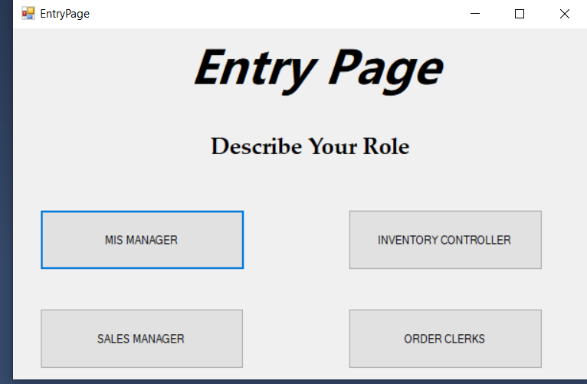

2 – Design of what a MIS Manager can do in the system.
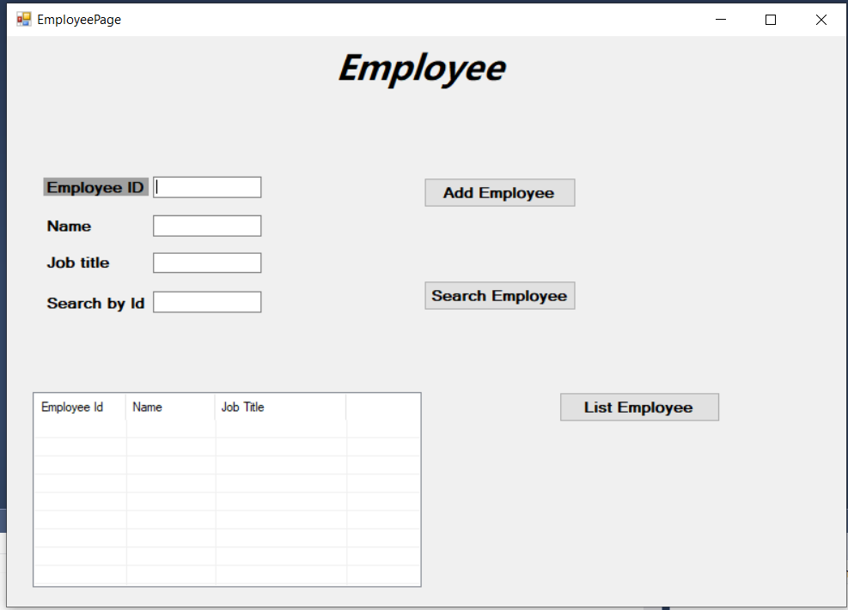
3 – Design of what a Sales Manager can do in the system.
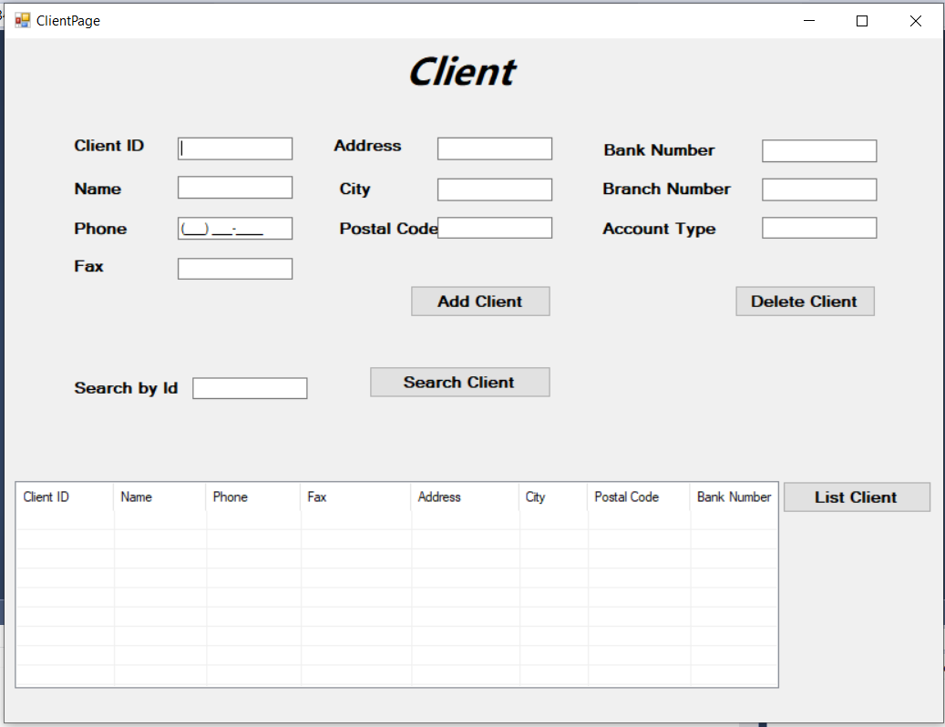

4 – Design of what an Inventory Controller can do in the system.
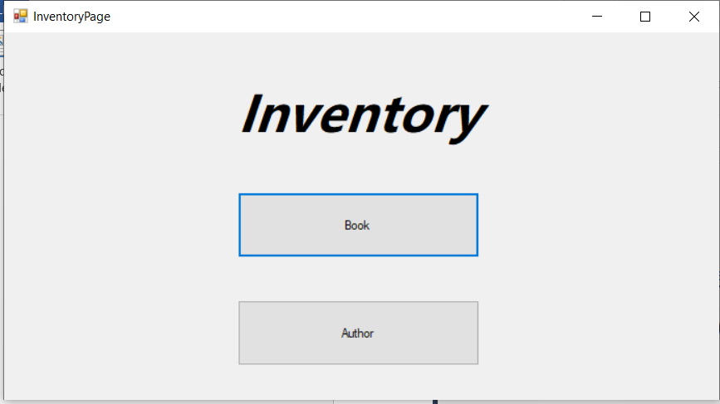
4.1 – Design of what an Inventory Controller can do in the system.
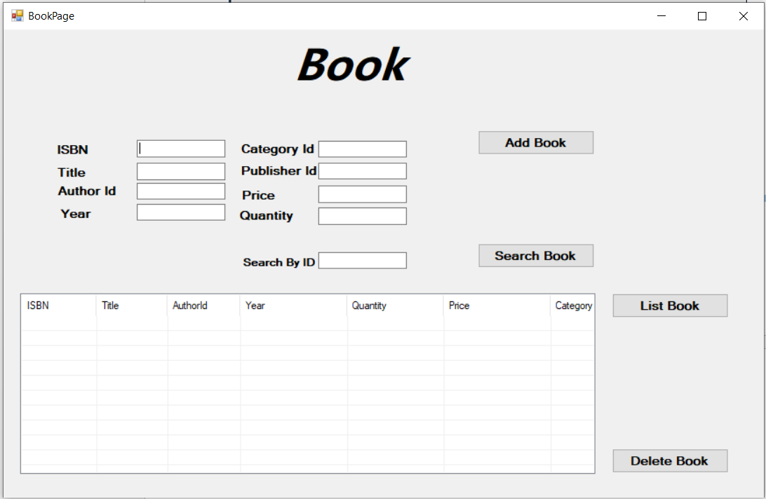
4.2 – Design of what an Inventory Controller can do in the system.
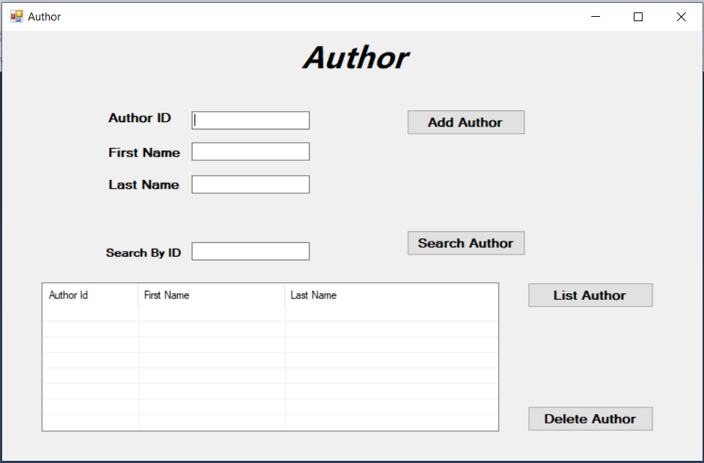
5 – Design of what an Order Clerks can do in the system.
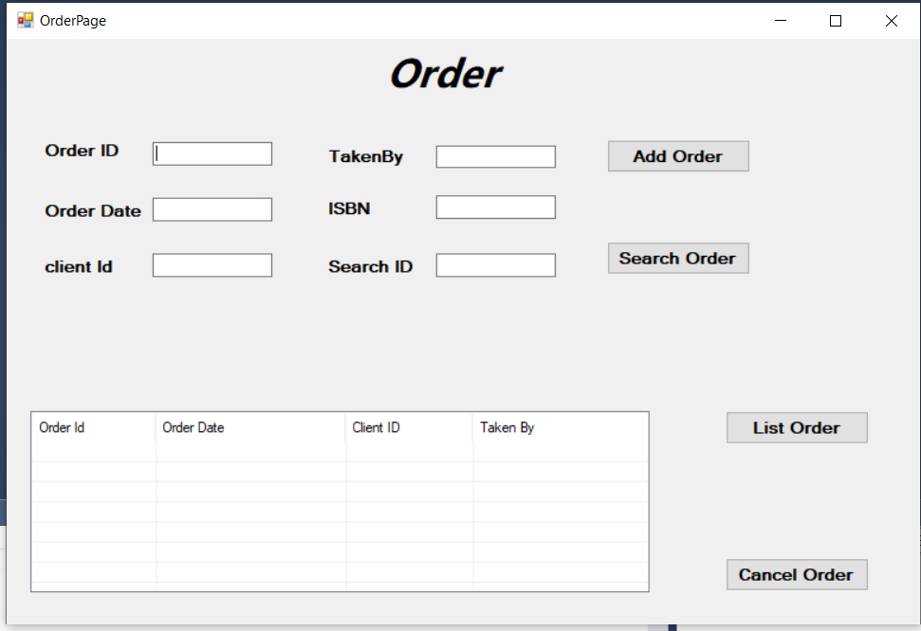
Code Design and Implementation
There are 4 layers (BLL, DAL, GUI, and VALIDATOR). I have designed and implemented code into that Layers from which some are:-

BLL (Business Layer)
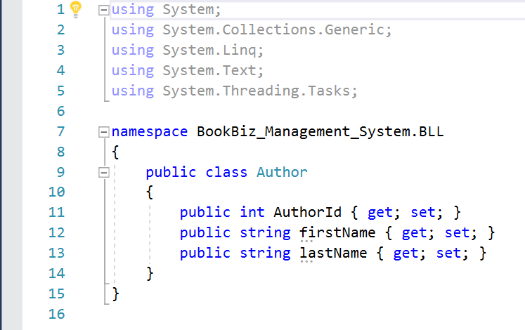

DAL (Data access layer)
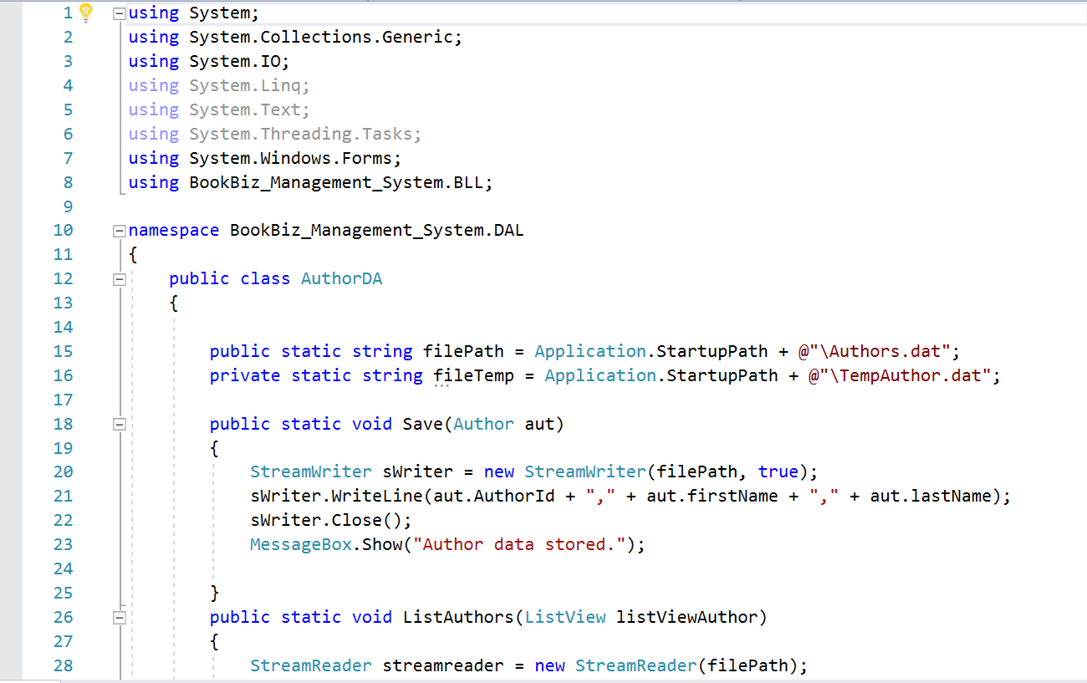
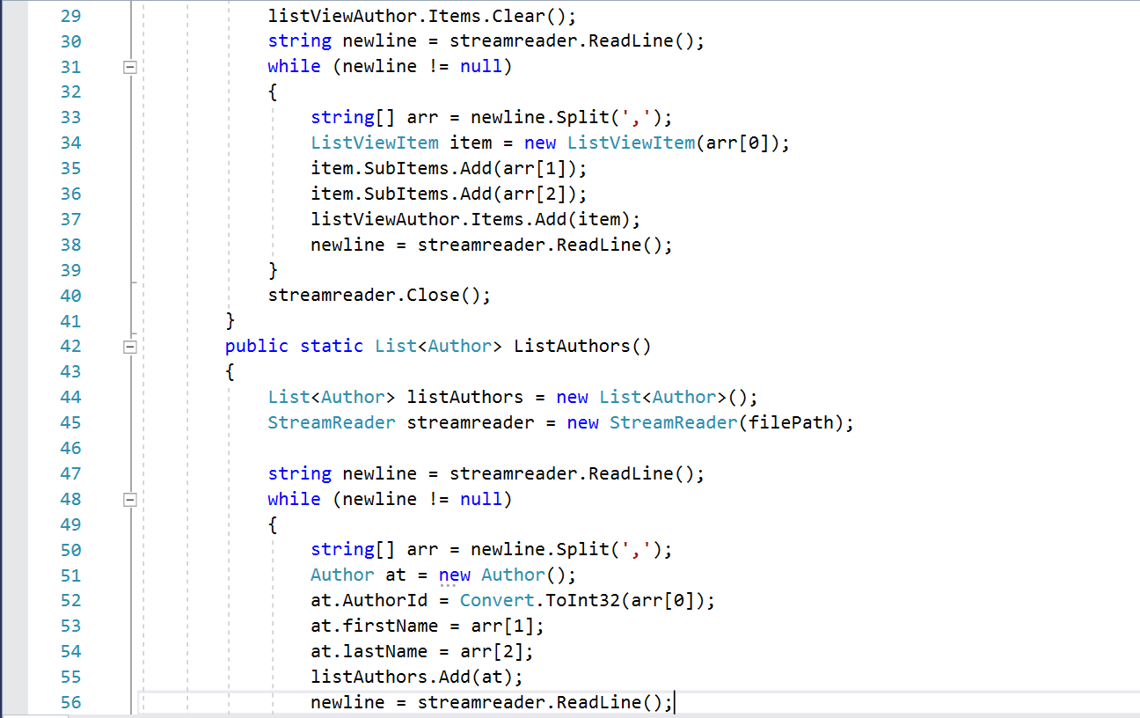
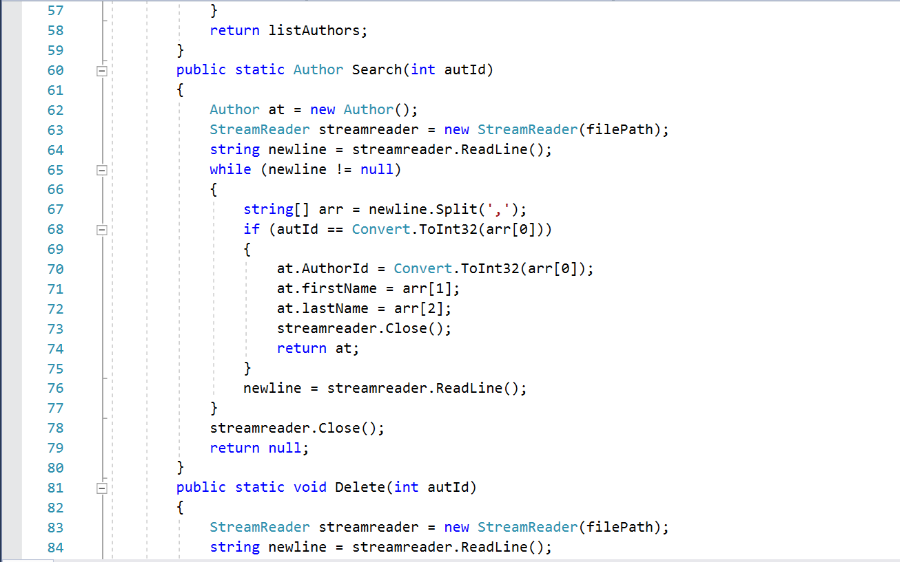
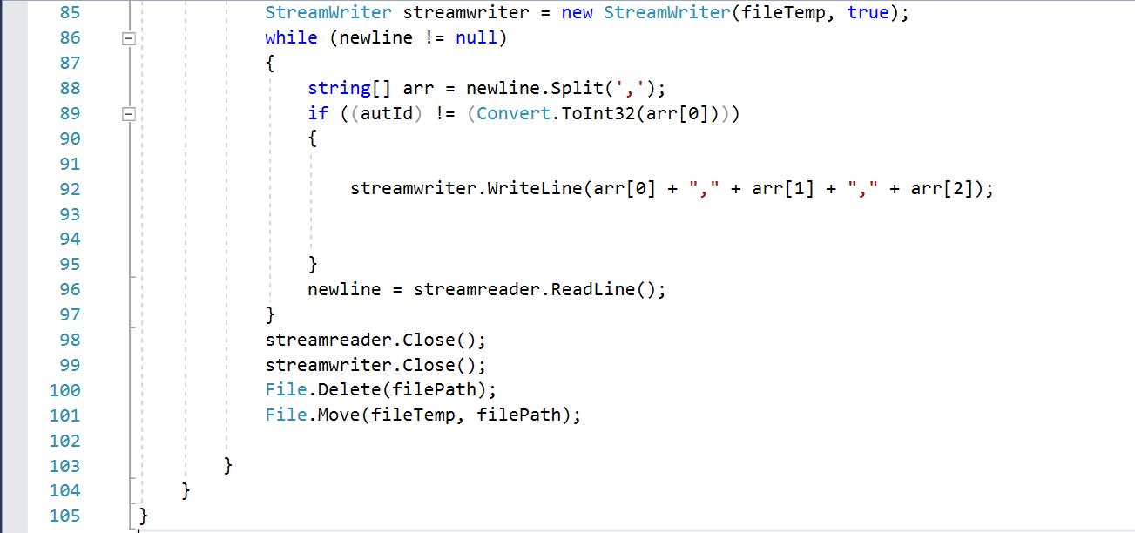

Validation ( )
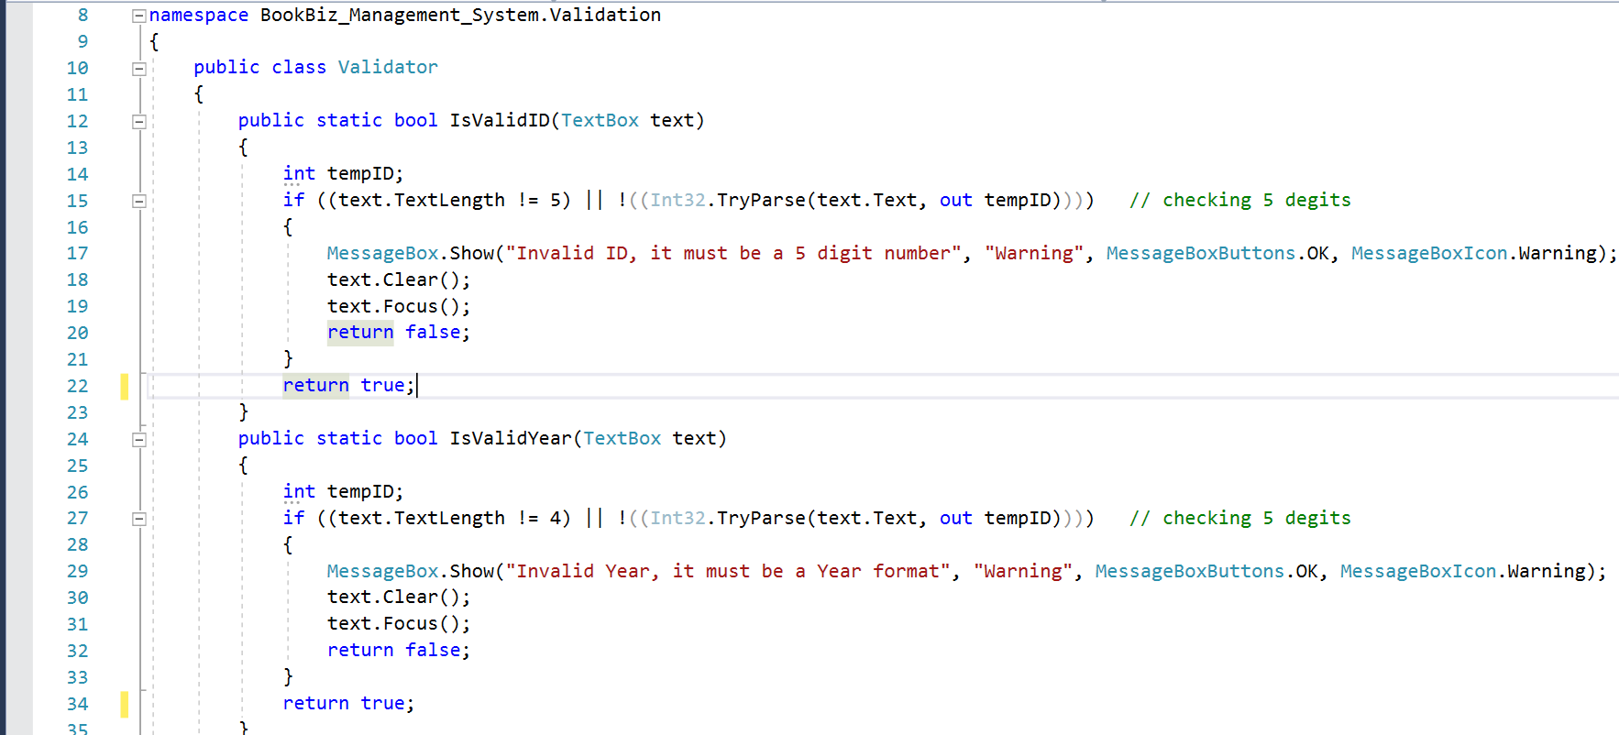

Code Design and Implementation
Through this project I have learned so many new things like how to add validation in system and different type of layers like (BLL, GUI and DAL). And also how to store the data in .DAT file. It also made me learn how to link one form on a button so that after clicking the button I am able to see the desired form.

Thank you so much Alex for being my sir in this semester and hope to see you soon in the college to meet you personally and have some conversation about the field.

Regards,
Kishan Thakkar (2013644).

