CI / CD Explained

CI / CD stands for continuous integration and continuous delivery as it says continuous integration is the key role in CI / CD.

1) Developers need to merge the code at least once a day.

2) On each merge, we need to trigger an automated code build and start the test sequence like unit tests, security tests etc..

3a) once it is success, we can push the code to master branch and deploy the build to production automatically which gives continuous deployment.

3b) if we don't want to merge the code with master branch, we can deploy the build to staging server where we can verify the functionality and if it works as expected then merge the code which holds continuous delivery.

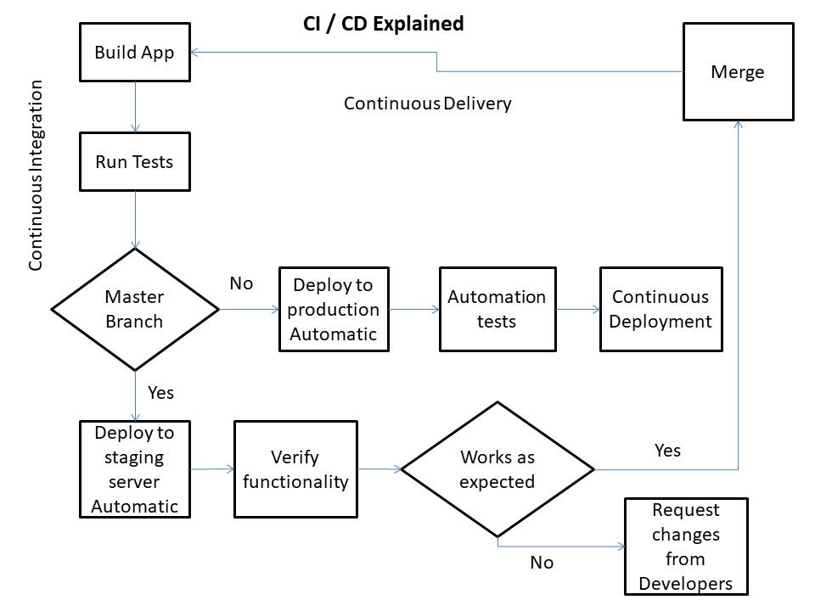

Performance Tuning Explained

1. Tune the Business Rules:
   1. Design the entire system with proper configuration which suits needs of the customer / product.
2. Tune the Data Design:
   1. In Design phase, we need to make sure what data is needed by our application.
   2. The database design process generally undergoes a normalization stage when data is analysed to eliminate data redundancy.
   3. We need to consider the data size and data store size.
3. Tune the Application Design:
   1. Main goal is to application developers should translate the business goals into an effective system design.
   2. We need to handle the exception throughout the system to avoid application crash.
4. Tune Database / Storage Queries:
   1. Queries must be optimized. Ex: while using select statement, only fetch whatever information is required and avoid fetching all data.
   2. Database maintenance which includes automatic backups.
5. Tune Memory Allocation:
   1. Proper allocation of memory resources improves cache performance, reducing parsing of SQL statements and reduce slow performance.