PREDICTIVE FORECASTING OF CARE LOAD & PLACEMENT DEMAND

Data Analytics & Machine Learning Project

Executive Summary

Objective

Forecast future HHS care occupancy and identify patterns that can support capacity planning, resource allocation, and operational decision-making.

Prepared by: Kishan Masura

Technologies

Python • Pandas • NumPy • Matplotlib • Seaborn • Scikit-learn

Project Type

Predictive Analytics / Time-Series Forecasting

EXECUTIVE OVERVIEW

This project focuses on predicting future care-load requirements using historical data from the HHS Unaccompanied Alien Children Program. The objective is to understand historical care occupancy patterns, identify important predictive factors, compare multiple machine learning models, and generate future occupancy forecasts.

The project follows a complete analytical workflow including data preparation, exploratory data analysis, feature engineering, machine learning model development, model evaluation, and future forecasting.

The final solution provides both historical insights and predictive estimates that can support capacity planning, resource allocation, and operational decision-making.

1. BUSINESS PROBLEM

Managing care capacity requires an understanding of how the number of children in HHS care changes over time. Significant fluctuations in care occupancy can create challenges related to staffing, facility capacity, resource allocation, and operational planning.

The purpose of this project is to develop a predictive analytics solution capable of learning patterns from historical care-load data and forecasting future HHS care occupancy.

Key Business Questions

• How has HHS care occupancy changed over time?

• What historical variables are associated with care occupancy?

• Which machine learning model provides the most reliable predictions?

• Which features contribute most to the prediction?

• What does the future forecast indicate about potential care-load requirements?

2. DATASET

Dataset:
HHS_Unaccompanied_Alien_Children_Program.csv

The dataset contains historical records related to the Unaccompanied Alien Children Program, including measures associated with children apprehended, children in CBP custody, children transferred from CBP custody, children in HHS care, and children discharged from HHS care.

The primary prediction target used in this project is:

Children in HHS Care

The data contains a time dimension, allowing historical trends and temporal patterns to be analyzed for forecasting purposes.

3. METHODOLOGY

The project follows an end-to-end predictive analytics workflow:

Raw Dataset
↓
Data Cleaning
↓
Exploratory Data Analysis
↓
Feature Engineering
↓
Train / Test Split
↓
Model Training
↓
Model Evaluation
↓
Best Model Selection
↓
Future Forecasting
↓
Business Insights

Machine Learning Models Evaluated

1. Linear Regression
2. Random Forest
3. Gradient Boosting

4. EXPLORATORY DATA ANALYSIS

Historical Care Occupancy Trend

The historical analysis shows substantial variation in the number of children in HHS care over time. Care occupancy reached significantly higher levels during parts of 2023 and 2024, followed by a pronounced decline during 2025.

The analysis demonstrates that HHS care occupancy is not constant and contains substantial temporal variation.

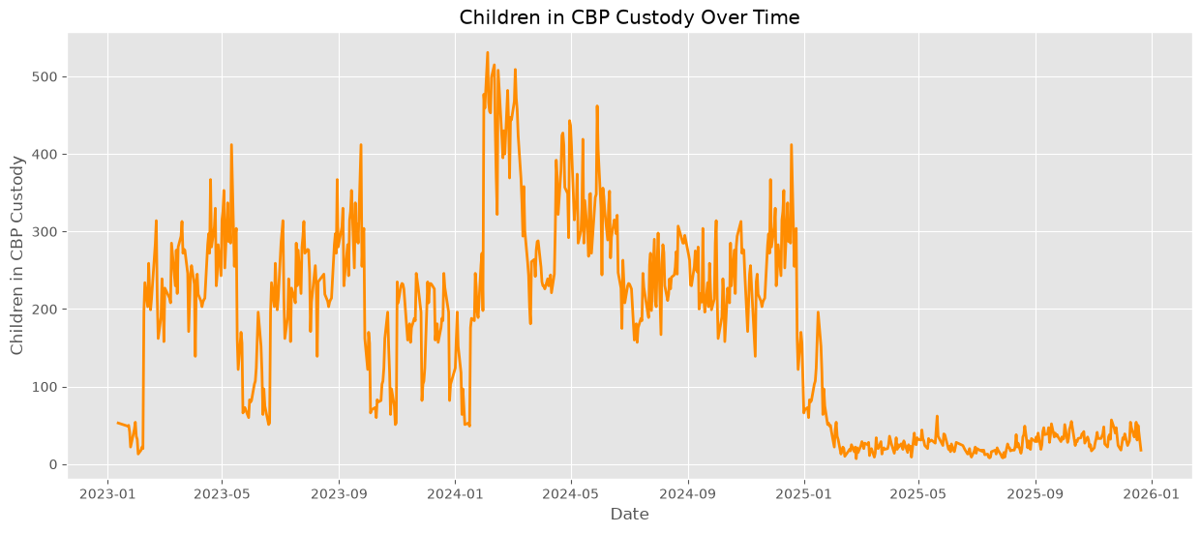

Monthly Care Occupancy

The monthly analysis further demonstrates changes in average HHS care occupancy over time. Higher average occupancy levels were observed during earlier periods, while substantially lower levels were observed during 2025.

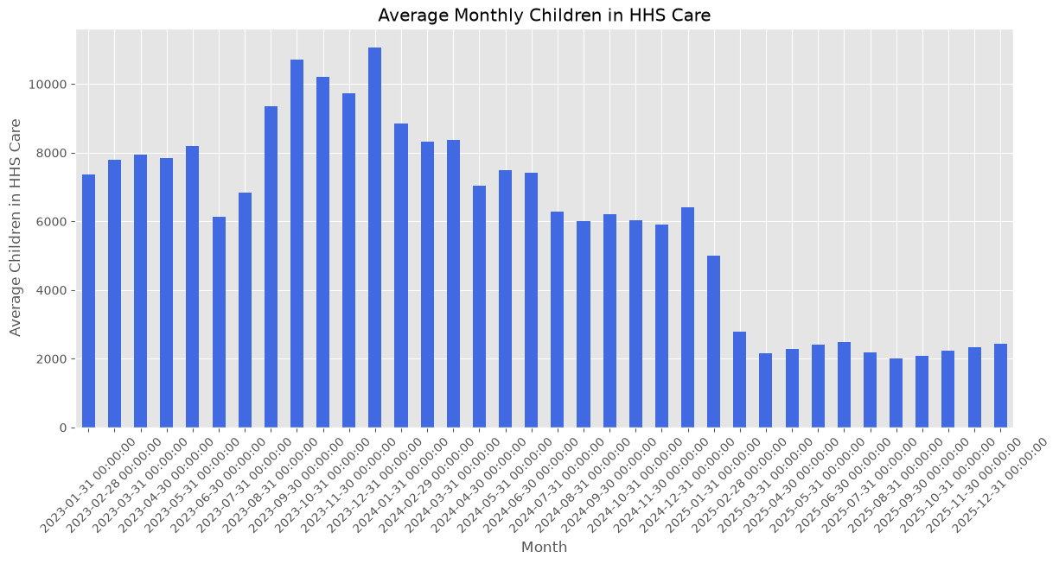

5. CORRELATION ANALYSIS

Correlation analysis was performed to understand the relationships between major custody and care-related variables.

The correlation matrix indicates strong positive relationships among several operational variables. In particular, Children in HHS Care has a strong positive relationship with Children discharged from HHS Care, while custody-related measures also demonstrate substantial associations with one another.

These relationships indicate that historical operational indicators can provide useful information for predicting HHS care occupancy.
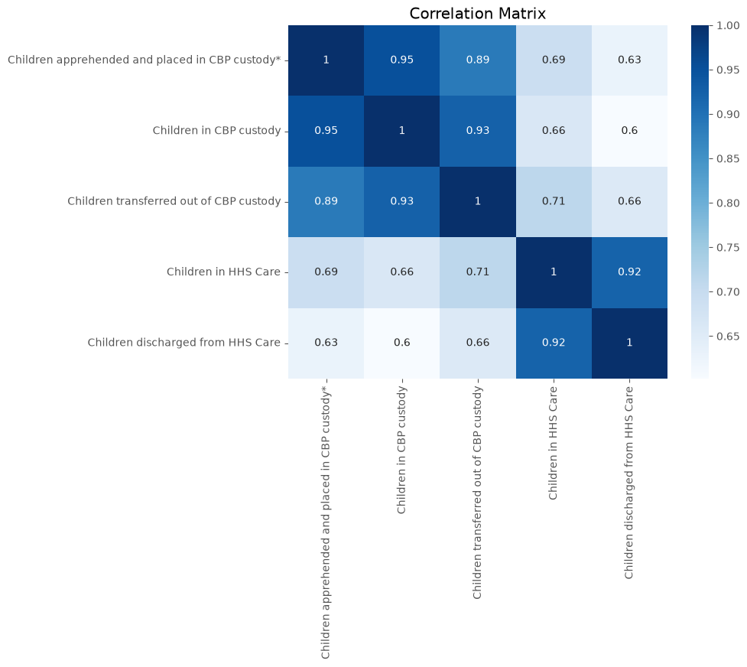

6. MODEL PERFORMANCE COMPARISON

Three machine learning models were evaluated using Mean Absolute Error (MAE), Root Mean Squared Error (RMSE), and R² Score.

Model Performance

Linear Regression
MAE: 74.55
RMSE: 98.89
R² Score: 0.998823

Random Forest
MAE: 72.21
RMSE: 114.45
R² Score: 0.998424

Gradient Boosting
MAE: 67.37
RMSE: 100.21
R² Score: 0.998791

Model Selection

Gradient Boosting achieved the lowest MAE of 67.37, indicating the smallest average absolute prediction error among the evaluated models.

Its RMSE of 100.21 was slightly higher than Linear Regression, while its R² score of 0.998791 remained extremely high.

Based on the forecasting objective and the lowest MAE, Gradient Boosting was selected as the final model.
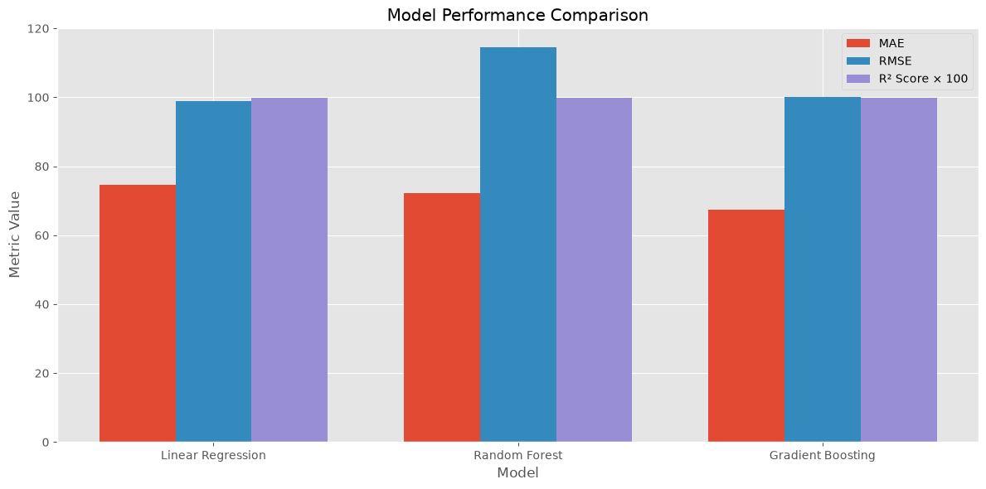

7. FEATURE IMPORTANCE

The feature-importance analysis shows that current HHS care occupancy is the strongest predictive feature, followed by the one-period lag of HHS care occupancy and the 7-day rolling average.

This indicates that recent care-load history and short-term temporal patterns play an important role in forecasting future occupancy.

The most important features include:

Children in HHS Care: 0.468840
HHS_Lag_1: 0.334926
Rolling7: 0.172212
Rolling14: 0.013689

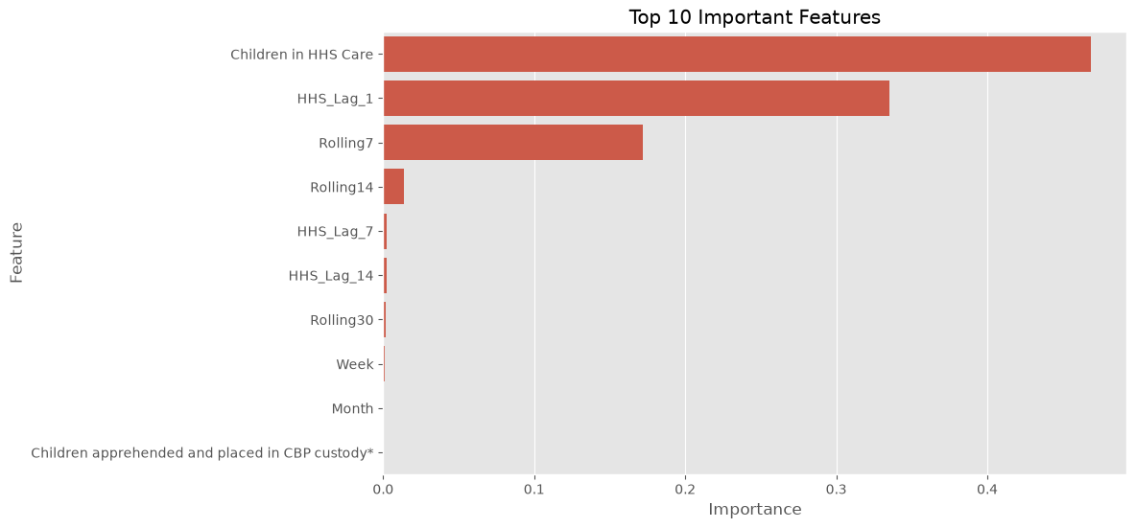

8. ACTUAL VS PREDICTED

The actual-versus-predicted visualization shows that the model predictions closely follow the observed HHS care values across the test observations.

The close alignment between the two series supports the strong predictive performance indicated by the evaluation metrics.

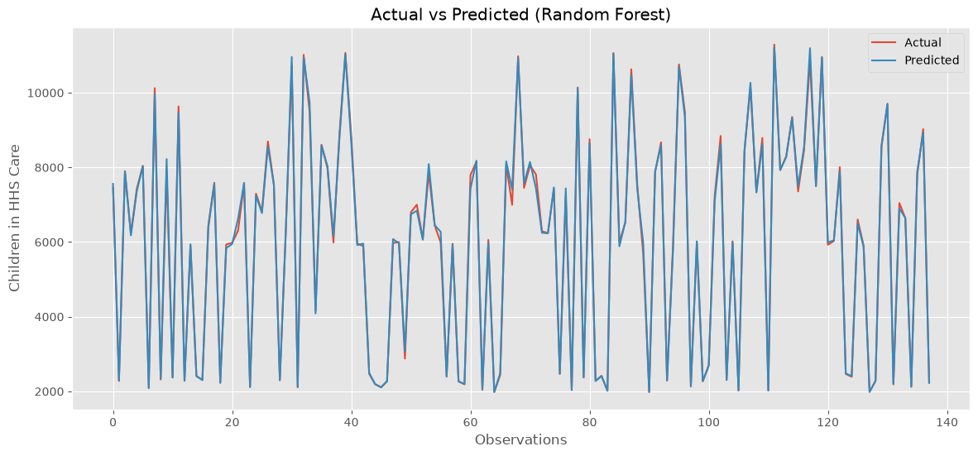
9. FUTURE FORECAST

The future forecast indicates a substantial reduction in predicted HHS care occupancy compared with the elevated levels observed during earlier periods.

Following the sharp decline, the forecast stabilizes at a substantially lower level with moderate fluctuations.

The forecast should be interpreted as a model-based estimate rather than a guaranteed future outcome.

10. KEY FINDINGS

• HHS care occupancy shows substantial variation over the historical period.

• Historical custody and care variables have strong relationships with HHS care occupancy.

• Recent HHS care occupancy and lagged values are the most influential predictive features.

• Gradient Boosting achieved the lowest MAE among the evaluated models.

• The future forecast indicates substantially lower care occupancy compared with earlier historical peaks.

11. BUSINESS RECOMMENDATIONS

1. Capacity Planning

Forecast outputs can be incorporated into capacity planning to anticipate changes in care requirements.

2. Resource Allocation

Predicted occupancy levels can help inform staffing, facilities, and operational resource allocation.

3. Monitoring Recent Trends

Since recent occupancy and lagged values are highly influential, operational teams should continuously monitor short-term changes in care load.

4. Forecast-Based Planning

Forecasts should be reviewed periodically and incorporated into planning workflows rather than relying exclusively on historical averages.

5. Model Monitoring

Model performance should be periodically evaluated as new data becomes available to ensure that prediction accuracy remains reliable.

12. CONCLUSION

This project demonstrates an end-to-end predictive analytics workflow for forecasting HHS care occupancy. Through exploratory analysis, feature engineering, model comparison, and forecasting, the project identifies important historical patterns and provides a data-driven approach to future care-load planning.

Gradient Boosting was selected as the final forecasting model based primarily on its lowest MAE, while maintaining a very high R² score.

The resulting forecasting framework can serve as a foundation for future operational dashboards, automated forecasting pipelines, and capacity-planning applications.

