'Linear_sort'

import time

import matplotlib.pyplot as plt

start=time.time()

pos=-1

def Linear_search(list,a):

i=0

while i< len(list):

if list[i]==a:

globals()['pos']=i

return True

i=i+1

return False

list=[5,3,4,2,8,9]

a=int(input("Enter key to be search:"))

if Linear_search(list,a):

print("number found at:",pos+1,"position")

else:

print("number not found")

end=time.time()

print("Run time of program:",end-start)

x=list[0:1000]

plt.plot(x,[y for y in x])

plt.title("Liner search time complexity is O(n)")

plt.xlabel("Input")

plt.ylabel("Time")

plt.show()

********************************output***********************************

Enter key to be search:6

number not found

Run time of program: 5.402985811

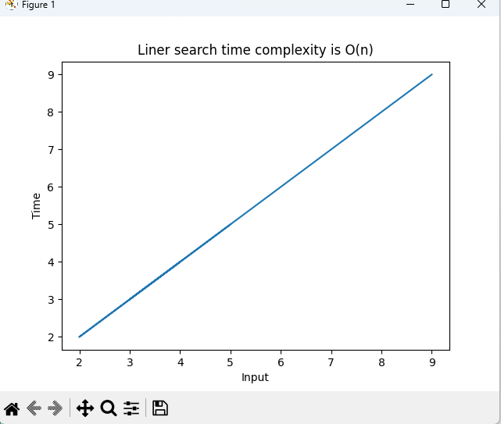335205