12 – Server Management
Domain Name Service (DNS)
- DNS is an Internet service that maps IP addresses and fully qualified domain names (FQDN) to one another.
- Computers that run DNS are called name servers.
- BIND(Berkley Internet Naming Daemon) is the most common program used for maintaining a name server on Linux.
Installation
Prerequisites: Install the following packages.
- sudo apt-get update

sudo apt-get install bind9
- sudo apt-get update

sudo apt-get install dnsutils
- sudo apt-get update

DNS commands

1.dig

dig command stands for Domain Information Groper. It is used for retrieving information about DNS name servers. It is basically used by network administrators. It is used for verifying and troubleshooting DNS problems and to perform DNS lookups.
cbkpc@Ububtu22:~$ dig www.google.com
;; communications error to 127.0.0.53#53: timed out
; <<>> DiG 9.18.18-0ubuntu0.22.04.2-Ubuntu <<>> www.google.com
;; global options: +cmd
;; Got answer:
;; ->>HEADER<<- opcode: QUERY, status: NOERROR, id: 19284
;; flags: qr rd ra; QUERY: 1, ANSWER: 1, AUTHORITY: 0, ADDITIONAL: 1
;; OPT PSEUDOSECTION:
; EDNS: version: 0, flags:; udp: 65494
;; QUESTION SECTION:
;www.google.com. IN A
;; ANSWER SECTION:
www.google.com. 232 IN A 142.250.193.164
;; Query time: 60 msec
;; SERVER: 127.0.0.53#53(127.0.0.53) (UDP)
;; WHEN: Fri Apr 19 10:51:34 IST 2024
;; MSG SIZE rcvd: 59

2.nslookup
The nslookup command in Linux is used to query DNS servers and get information about domain names and their corresponding IP addresses.

cbkpc@Ububtu22:~$ nslookup www.google.com
Server: 127.0.0.53
Address: 127.0.0.53#53
Non-authoritative answer:
Name: www.google.com
Address: 142.250.193.164
Name: www.google.com
Address: 2404:6800:4007:821::2004
cbkpc@Ububtu22:~$ nslookup 142.250.193.164
164.193.250.142.in-addr.arpa name = maa05s26-in-f4.1e100.net.
Authoritative answers can be found from:

3.host
The host command is a command-line tool that performs DNS (Domain Name System) lookups. The tool can find a hostname when provided with an IP address. However, the command returns an IP address when given a hostname.
cbkpc@Ububtu22:~$ host www.google.com
www.google.com has address 142.250.193.164
www.google.com has IPv6 address 2404:6800:4007:821::2004
FTP server on LINUX and transfer files to demonstrate its working.

ftp
ftp is the user interface to the Internet standard File Transfer Protocol. The program allows a user to transfer files to and from a remote network site.
Installation of FTP server and client in Ubuntu 22.04
step1:cbkpc@Ububtu22:~$ sudo apt update
step2:cbkpc@Ububtu22:~$ sudo apt install vsftpd
step3:cbkpc@Ububtu22:~$ sudo service vsftpd status
step4:cbkpc@Ububtu22:~$ sudo nano /etc/vsftpd.conf
step5:cbkpc@Ububtu22:~$ sudo ufw allow from any to any port 20,21,10000:10100 proto tcp
step6:sudo cbkpc@Ububtu22:~$ sudo adduser skt
step7:sudo cbkpc@Ububtu22:~$ sudo mkdir /home/skt/ftp
step8:sudo cbkpc@Ububtu22:~$ sudo chown nobody:nogroup /home/skt/ftp
step9:cbkpc@Ububtu22:~$ sudo chmod a-w /home/skt/ftp
step10:cbkpc@Ububtu22:~$ sudo mkdir /home/skt/ftp/upload
step11:cbkpc@Ububtu22:~$ sudo chown skt:skt /home/skt/ftp/upload
step12:cbkpc@Ububtu22:~$ echo "My FTP Server" | sudo tee /home/skt/ftp/upload/demo.txt
My FTP Server
step13:cbkpc@Ububtu22:~$ sudo apt install filezilla
step14:cbkpc@Ububtu22:~$ filezilla ver --
Examples below are to upload and download files using ftp service.

Example 1: Get the connection to ftp

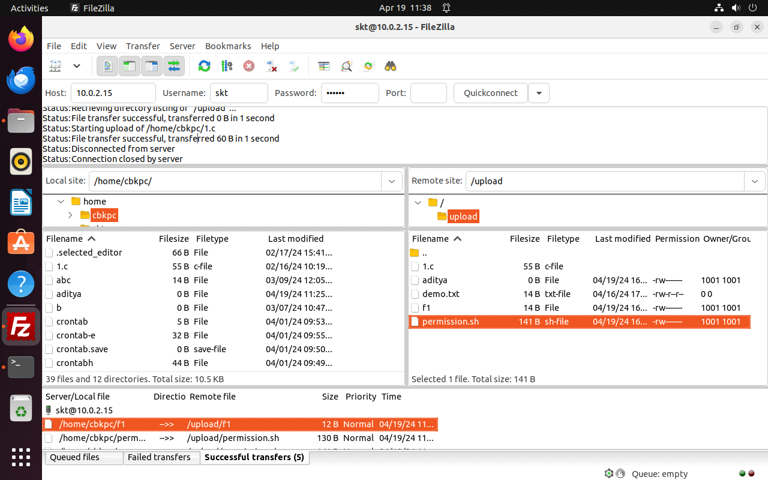

Example 2: Download the file from ftp server
- get a.txt /home/admincs/Desktop/test.txt
o will download the file a.txt from ftp server to current user Desktop with file name test.txt

Example 3: Upload the file from server
- put /home/admincs/index.html test.html
o will upload the file index.html from current (local /home/admincs) user to remote ftp server with name test.html
Example 4: User can issue commands like mkdir, cd, rmdir etc linux basic commands to control the remote server machine. (For more commands go to ? Command and man ftp command)
=== * ===

