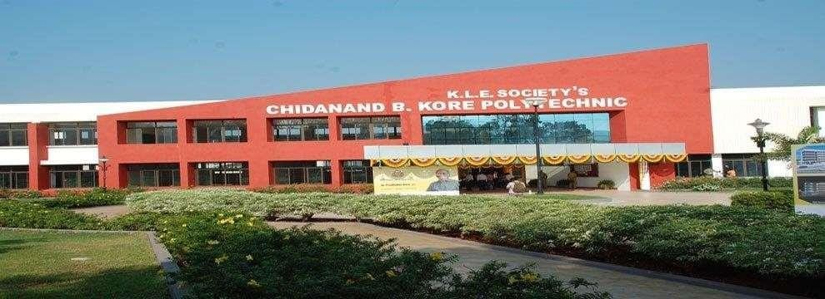

**K.L.E. Society' s**

**C.B. KORE POLYTECHNIC CHIKODI-591201**

**DEPARTMENT OF COMPUTER SCIENCE AND ENGNEERING**

**DAILY REPORT**

**SUBMITTED BY**

**KISHAN NINGANAGAUDA MANGASULE 339CS22024**

COHORT OWNER H.O.D PRINCIPAL



**K.L.E. Society' s**

**C.B. KORE POLYTECHNIC CHIKODI-591201**

**DEPARTMENT OF COMPUTER SCIENCE AND ENGNEERING**

**DAILY REPORT**

**SUBMITTED BY**

**DINESH ASHOK JADAGE 339CS22016**

COHORT OWNER H.O.D PRINCIPAL



**K.L.E. Society' s**

**C.B. KORE POLYTECHNIC CHIKODI-591201**

**DEPARTMENT OF COMPUTER SCIENCE AND ENGNEERING**

**DAILY REPORT**

**SUBMITTED BY**

**ISHWAR RAJENDRA GANDH 339CS22020**

COHORT OWNER H.O.D PRINCIPAL



**K.L.E. Society' s**

**C.B. KORE POLYTECHNIC CHIKODI-591201**

**DEPARTMENT OF COMPUTER SCIENCE AND ENGNEERING**

**DAILY REPORT**

**SUBMITTED BY**

**ABHISHEK SHINTRE 339CS23701**

COHORT OWNER H.O.D PRINCIPAL

### INDEX

|  |  |  |
| --- | --- | --- |
| **Sl No** | **Particulars** | **Page No** |
| 1 | Overview of the Organization | 1 |
| 2 | Vision, Mission | 2 |
| 3 | Company Approach | 3 |
| 4 | Roles and Responsibility | 6 |
| 5 | Product Performance | 7 |
| 6 | Market Performance | 8 |
| 7 | Organization Structure | 9 |
| 8 | Services | 10 |
| 9 | Features | 11 |
| 10 | Advantages | 12 |
| 11 | Full Stack Development Overview | 14 |
| 12 | Conclusion | 17 |

K.L.E C.B.KORE POLYTECHNIC CHIKODI

.

K.L.E’S C.B.KORE POLYTECHNIC, CHIKODI

**OVERVIEW OF THE ORGANIZATION**

K.L.E’S C.B.KORE POLYTECHNIC, CHIKODI

#### VISION

To be a trusted leader in delivering top-level quality in technology, digital marketing, and academic training. We aim to bridge the gap between academia and the corporate world, fostering a future where our expertise drives excellence and innovation. By empowering individuals and organizations with cutting-edge skills and knowledge, we strive to set the standard for success in an ever-evolving landscape.

**MISSION**

Our mission is to provide exceptional services in technology, digital marketing, and academic training that connect academic learning with corporate success. We are dedicated to delivering top-quality solutions and training, enabling our clients to achieve their goals and stay competitive. Through our expertise, we aim to empower individuals with the skills needed for excellence and innovation in today’s dynamic world.

K.L.E’S C.B.KORE POLYTECHNIC, CHIKODI

**COMPANY APPROACH**

#### Legal Judgment Prediction: Machine Learning and NLP Applications

Legal judgment prediction has gained significant attention in recent years, with many studies focusing on the use of **machine learning** and **natural language processing (NLP)** to predict the outcomes of court cases. Several key studies have examined how these methods can be applied to legal data, with a particular focus on analyzing the text of legal documents, such as judgments, contracts, and case law.

* + - * **Zhang et al. (2017)** in their study **"Predicting Legal Judgments with Machine Learning"** explored the use of **machine learning models** to predict the outcomes of civil lawsuits. Their approach used data from legal rulings to build predictive models, focusing on extracting features from case summaries and using **decision trees** and **support vector machines (SVMs)** for prediction. They demonstrated that these models could predict the outcome of cases with considerable accuracy, though they also highlighted that **bias** in training data could impact results, especially when historical case outcomes reflected social or legal biases.
      * **Cohen et al. (2019)** developed a framework for **legal text mining** using **NLP** techniques, specifically using **word embeddings** to understand legal terminology in depth. Their work showed that **deep learning models** like **convolutional neural networks (CNNs)** and **long short-term memory networks (LSTMs)** could be trained to process large volumes of legal text and predict the probability of a judgment outcome, such as whether a plaintiff is likely to win or lose.
      * **Chalkidis et al. (2020)** focused on applying **transformer-based models** such as **BERT** for legal text analysis. Their research demonstrated how **BERT** could be used to predict court rulings by analyzing the language and context in legal cases, emphasizing the importance of **contextual understanding** in legal judgment prediction. This study is relevant for the hospitality industry, as it highlights how these advanced models can be applied to predict outcomes for legal disputes involving hotels.

#### Predictive Analytics in Hospitality and Hotel Management

While legal judgment prediction in the hospitality industry is a growing area, predictive analytics has already seen broad application in **hotel management**. Studies in this area focus on using data-driven models to improve operational efficiencies, optimize pricing, and predict customer behaviors, but the application to legal risk prediction has not been widely explored.

* **Ivanov and Webster (2017)** explored the role of **big data analytics** in hospitality management. Their research emphasized how predictive analytics could be applied to forecasting demand, optimizing pricing strategies, and improving customer service. Though legal judgment prediction wasn’t directly addressed, the study demonstrated the power of predictive models in operational decision-making, which is similar to how predictive analytics could be employed for legal judgment outcomes.
* **McDonald and O’Toole (2020)** investigated the use of **AI-based technologies** for predicting hotel revenues and customer satisfaction, incorporating sentiment analysis and review mining. Their work showed that NLP and sentiment analysis could be used to understand guest feedback, which could also be applicable in predicting legal outcomes based on guest complaints or disputes that escalate to legal action.

#### Challenges in Legal Judgment Prediction for Hotel Management

Several challenges have been identified in the literature regarding the use of predictive models for legal judgment in hotel management, with scholars pointing out issues related to data quality, model accuracy, and interpretability.

* **Data Scarcity and Bias**: A key challenge in using predictive models for legal judgment is the availability and quality of relevant data. **Hedegaard et al. (2019)** highlighted that legal data often contains biases that reflect societal inequalities or judicial tendencies, which could affect the fairness of predictions. This issue is particularly relevant in hotel management, where disputes often arise from customer complaints, employee issues, or liability claims that could be influenced by biased judgments in historical data.
* **Legal Complexity and Variability**: Legal cases involving hotels can be highly variable, as they span different jurisdictions with varying laws, regulations, and standards. **Radev et al. (2020)** discussed how legal prediction models face challenges in dealing with the complexities of the law, particularly when cases involve nuanced issues such as contract interpretation or liability questions. Hotel managers need to understand how these complexities could affect the outcomes of specific legal disputes, especially when predicting outcomes in international contexts where laws differ.

# CHAPTER-3

**PROBLEM STATEMENT AND OBJECTIVES**

#### Problem Statement

The hotel industry, like many others, faces various legal challenges ranging from customer complaints, contract disputes, labor issues, to liability claims. These legal issues can result in costly lawsuits, regulatory penalties, and damage to a hotel’s reputation.

As the volume and complexity of legal cases grow, hotel managers and legal teams need tools to predict the outcomes of potential legal disputes. Currently, the absence of advanced predictive tools makes it difficult to manage legal risks efficiently. The problem lies in the lack of predictive models specifically designed for the hospitality industry that can accurately forecast the outcomes of legal disputes.

Traditional methods of managing legal risks, such as relying on historical case studies or manual legal assessments, are time-consuming and may not fully account for the nuances and specificities of individual hotel-related legal cases.

The need for a legal judgment prediction system tailored to the hotel industry has become critical to assist hotel managers in minimizing legal risks, making informed decisions, and resolving disputes effectively. Without such a system, hotels are left vulnerable to unpredictable legal outcomes, leading to increased costs, damage to reputation, and legal non-compliance.

#### Objectives

The primary goal of this research is to develop a **legal judgment prediction model** tailored specifically to the hotel industry, leveraging machine learning and natural language processing techniques to forecast the outcomes of potential legal cases. The specific objectives are:

#### To Analyze Legal Data:

* + Collect and analyze data related to legal disputes in the hotel industry, such as guest complaints, liability claims, employment issues, and contract disputes. This data will form the basis for the model’s training.

#### To Develop a Predictive Model:

* + Develop a machine learning model that can predict the likely outcomes of legal disputes in the hotel industry, such as determining whether a hotel is likely to win or lose a case based on historical case data. Models will incorporate algorithms like **random forests**, **SVM**, **logistic regression**, and **deep learning techniques** (e.g., **BERT** and **LSTMs**).

K.L.E’S C.B.KORE POLYTECHNIC, CHIKODI

# CHAPTER-4 REQUIREMENTS

### Hardware Requirements

* + - **Processor:** Intel Core i5 or equivalent
    - **RAM:** 8 GB
    - **Storage:** 100 GB HDD or SSD
    - **Internet:** Reliable internet connection for API access and updates

### Software Requirements

* + - **Operating System:** Windows 10 or higher, macOS, or Linux
    - **Programming Language:**CSS,JavaScript,PHP,SHELL
    - **Database: Mysql Database**

### Functional Requirements

The **functional requirements** define the specific capabilities and features that the **legal judgment prediction system** for hotel management must possess. These requirements will ensure that the system can handle real-world tasks, provide actionable insights, and offer support for hotel managers and legal teams in decision-making. Below are the key functional requirements for the system:

#### Non-Functional Requirements

Non-functional requirements define the system’s **quality attributes**, such a its **performance**, **scalability**, **reliability**, and **security**. These requirements ensure that the **legal judgment prediction system** for hotel management not only functions correctly but also meets specific standards for efficiency, security, and user experience. Below are the key **non-functional requirements**:

K.L.E’S C.B.KORE POLYTECHNIC, CHIKODI

### Technical Requirements

#### Machine Learning Framework:

* + The prediction model will require machine learning libraries or frameworks for model development, training, and evaluation. Key libraries and tools include:

#### Computational Resources:

* + Cloud computing infrastructure (e.g., AWS, Google Cloud, or Azure) or high- performance local servers will be required for model training, especially for large datasets or deep learning models.
  + GPU support may be needed for deep learning models to speed up training.

#### Model Development and Training:

* + Supervised learning will be the main approach, requiring labeled datasets for training.
  + Hyperparameter tuning to optimize model performance.
  + Cross-validation techniques to assess model robustness and avoid overfitting.
  + Model interpretability tools (e.g., SHAP values) to ensure the model's predictions are understandable and explainable to legal teams.

#### Legal Text Processing:

* + Advanced NLP techniques will be necessary to process the complex legal language in case data. This includes:
    - Text classification (e.g., identifying case types such as personal injury, breach of contract).
    - Sentiment analysis (to gauge the tone and context of legal documents).
    - Text summarization (to distill key information from lengthy legal texts).

#### Integration with Hotel Management Systems:

* + The prediction model should be able to integrate with existing hotel management systems (e.g., Property Management Systems (PMS), Point of Sale (POS), and customer relationship management (CRM) systems) to fetch relevant data on customer complaints, bookings, employee issues, etc.
  + Integration should allow real-time updates and predictions based on incoming data, providing actionable insights for managers.

K.L.E’S C.B.KORE POLYTECHNIC, CHIKODI

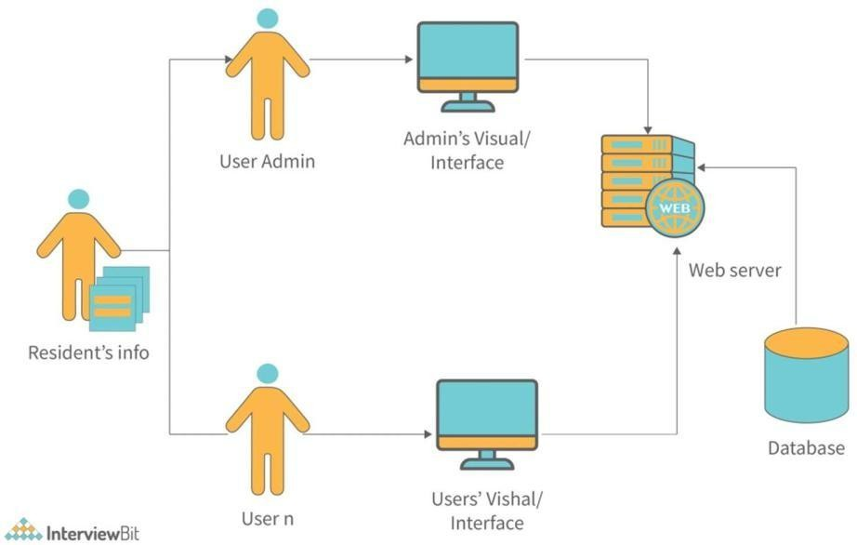

**CHAPTER-5**

# SYSTEM DESIGN AND METHODOLOGY

#### Methodology

In the context of hotel management, **methodology** refers to the systematic approach used to manage the various operational, financial, customer service, and legal aspects of a hotel. It includes processes, strategies, and tools that guide managers in achieving goals such as operational efficiency, guest satisfaction, profitability, and regulatory compliance.

#### Software Architecture

In the context of hotel management, **software architecture** refers to the structure and design of the software systems that manage the core operations of a hotel.

These systems encompass everything from guest reservations, room management, and billing to service requests, employee management, and even legal or regulatory compliance.

A well-designed software architecture ensures that the system is **scalable**, **efficient**, **secure**, and easy to maintain, providing a smooth user experience for both hotel staff and guests.

The **hotel management software architecture** can be broken down into several **layers** and components

K.L.E’S C.B.KORE POLYTECHNIC, CHIKODI

#### Database Design

The database design for AdvocAI will include the following key tables: **Entity**: An object or concept in the real world that is relevant to the system (e.g., "Guest", "Room", "Reservation").

**Attribute**: Characteristics or properties of an entity (e.g., "Guest Name", "Room Type").

**Relationship**: How entities are related to each other (e.g., a "Guest" makes a "Reservation" for a "Room").

**Primary Key**: A unique identifier for each record in a table. **Foreign Key**: A reference to a primary key in another table, creating relationships between tables.

**Normalization**: The process of organizing the database to reduce redundancy and dependency.

#### UI Design

* + - **Clarity**: Information and actions should be presented clearly. Avoid overwhelming users with too much information at once.
    - **Consistency**: The design must maintain a consistent layout, color scheme, and behavior across different screens and actions.
    - **Simplicity**: Keep the interface simple, ensuring that the essential features are easily accessible without unnecessary complexity.
    - **User-Focused Design**: The interface should be designed around the needs and workflow of the specific user (guest, front desk, manager).
    - **Feedback**: Provide immediate, clear feedback to users after actions (e.g., successful reservation, error message, payment confirmation).

K.L.E’S C.B.KORE POLYTECHNIC, CHIKODI

#### Prototyping and User Testing

Once the initial designs are created, it’s important to prototype the UI and conduct user testing. This allows real users (staff or guests) to interact with the interface and provide feedback on usability.

* Prototyping Tools: Tools like Figma, Sketch, or Adobe XD can be used to create interactive prototypes of the UI design.
* User Testing: Conduct usability testing sessions to ensure the interface is intuitive, identifies areas for improvement, and validates that the design meets the needs of hotel staff and guests.

#### Key Features:

* **Financial Overview**: A dashboard for viewing the hotel's revenue, occupancy rates, and profit margins. Integration of reports for payments, services, and sales.
* **Employee Management**: Access to employee schedules, payroll, and staff performance tracking.
* **Analytics and Reports**: Detailed analytics of booking patterns, guest demographics, and financial performance.

K.L.E’S C.B.KORE POLYTECHNIC, CHIKODI

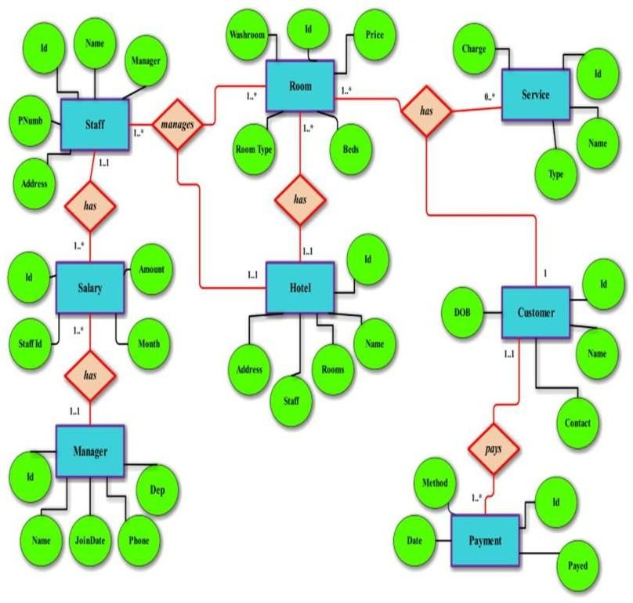

#### 5.1 ERD Diagram

K.L.E’S C.B.KORE POLYTECHNIC, CHIKODI

# CHAPTER-6 PSUEDOCODE

START

Initialize hotel_rooms[] // List of available rooms with status (available, reserved, etc.) Initialize reservations[] // Store reservations made by guests

Initialize guest_profiles[] // Store guest information

Initialize payment_records[] // Track payments made by guests Initialize staff[] // Staff member details

Load current_date_time // Set today's date and time END

FUNCTION registerGuest(guest_name, guest_email, guest_phone): guest_id = generate_unique_id()

guest_profile = { Guest_ID: guest_id, Name: guest_name, Email: guest_email, Phone: guest_phone

}

guest_profiles.append(guest_profile) RETURN guest_id

END

FUNCTION searchAvailableRooms(check_in_date, check_out_date): available_rooms = []

FOR each room IN hotel_rooms:

IF room.status == "available" AND isRoomAvailableDuringDates(room, check_in_date, check_out_date):

available_rooms.append(room) IF available_rooms.isEmpty():

DISPLAY "No rooms available for the selected dates." ELSE

DISPLAY available_rooms END

FUNCTION makeReservation(guest_id, room_id, check_in_date, check_out_date): room = findRoomById(room_id)

IF room.status == "available": reservation_id = generate_unique_id() reservation = {

Reservation_ID: reservation_id, Guest_ID: guest_id,

Room_ID: room_id, Check_In_Date: check_in_date, Check_Out_Date: check_out_date, Status: "confirmed"

}

K.L.E’S C.B.KORE POLYTECHNIC, CHIKODI

reservations.append(reservation) room.status = "reserved"

DISPLAY "Reservation successful!" RETURN reservation_id

ELSE

DISPLAY "Selected room is not available." END

FUNCTION checkInGuest(guest_id, reservation_id):

reservation = findReservationById(reservation_id)

IF reservation is NOT NULL AND reservation.Guest_ID == guest_id: room = findRoomById(reservation.Room_ID)

room.status = "occupied" reservation.Status = "checked-in"

DISPLAY "Check-in successful! Welcome to the hotel." ELSE

DISPLAY "Reservation not found or mismatch." END

FUNCTION checkOutGuest(guest_id, reservation_id): reservation = findReservationById(reservation_id)

IF reservation is NOT NULL AND reservation.Guest_ID == guest_id AND reservation.Status == "checked-in":

room = findRoomById(reservation.Room_ID) room.status = "available"

reservation.Status = "checked-out"

final_bill = calculateBill(reservation.Room_ID, reservation.Check_In_Date, reservation.Check_Out_Date)

DISPLAY "Checkout successful. Your final bill is: " + final_bill ELSE

DISPLAY "No active check-in found for this reservation." END

FUNCTION calculateBill(room_id, check_in_date, check_out_date): room = findRoomById(room_id)

nights_stayed = calculateNumberOfNights(check_in_date, check_out_date) total_cost = nights_stayed * room.price_per_night

ADD additional_services_cost TO total_cost RETURN total_cost

END

FUNCTION makePayment(guest_id, reservation_id, amount): payment_id = generate_unique_id()

payment = {

K.L.E’S C.B.KORE POLYTECHNIC, CHIKODI

Payment_ID: payment_id, Reservation_ID: reservation_id, Amount: amount,

Payment_Date: current_date_time, Status: "completed"

}

payment_records.append(payment)

DISPLAY "Payment received. Thank you!" END

FUNCTION requestRoomMaintenance(room_id):

room = findRoomById(room_id) IF room.status == "occupied":

DISPLAY "Maintenance request pending; please wait for room to be vacated." ELSE

room.status = "under maintenance"

DISPLAY "Room under maintenance. Please allow time for repairs or cleaning." END

FUNCTION viewReservationHistory(guest_id): guest_reservations = []

FOR each reservation IN reservations:

IF reservation.Guest_ID == guest_id: guest_reservations.append(reservation)

IF guest_reservations.isEmpty():

DISPLAY "No past reservations found." ELSE

DISPLAY guest_reservations END

FUNCTION updateRoomStatus(room_id, status): room = findRoomById(room_id)

room.status = status

DISPLAY "Room status updated to " + status END

FUNCTION generateOccupancyReport(): occupied_rooms = 0

total_rooms = length(hotel_rooms) FOR each room IN hotel_rooms:

IF room.status == "occupied": occupied_rooms += 1

occupancy_rate = (occupied_rooms / total_rooms) * 100 DISPLAY "Occupancy Rate: " + occupancy_rate + "%" END

K.L.E’S C.B.KORE POLYTECHNIC, CHIKODI

FUNCTION

generateFinancialReport():

total_income = 0

FOR each payment IN payment_records: total_income += payment.Amount DISPLAY "Total Income: " + total_income END

FUNCTION exitSystem():

Save all unsaved data (reservations, payments, room statuses) DISPLAY "System shut down successfully."

END

K.L.E’S C.B.KORE POLYTECHNIC, CHIKODI

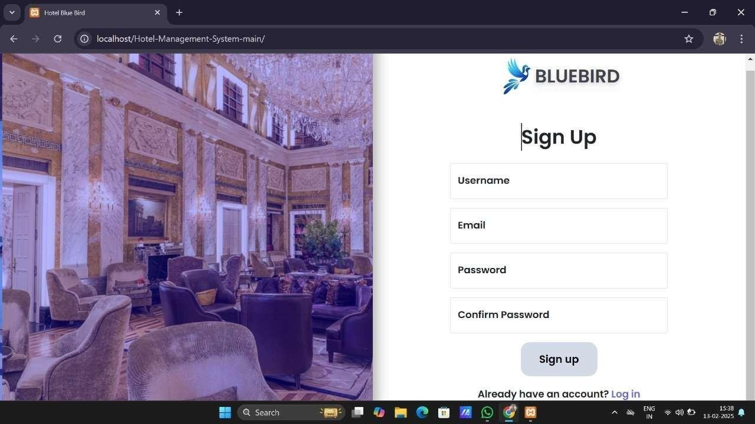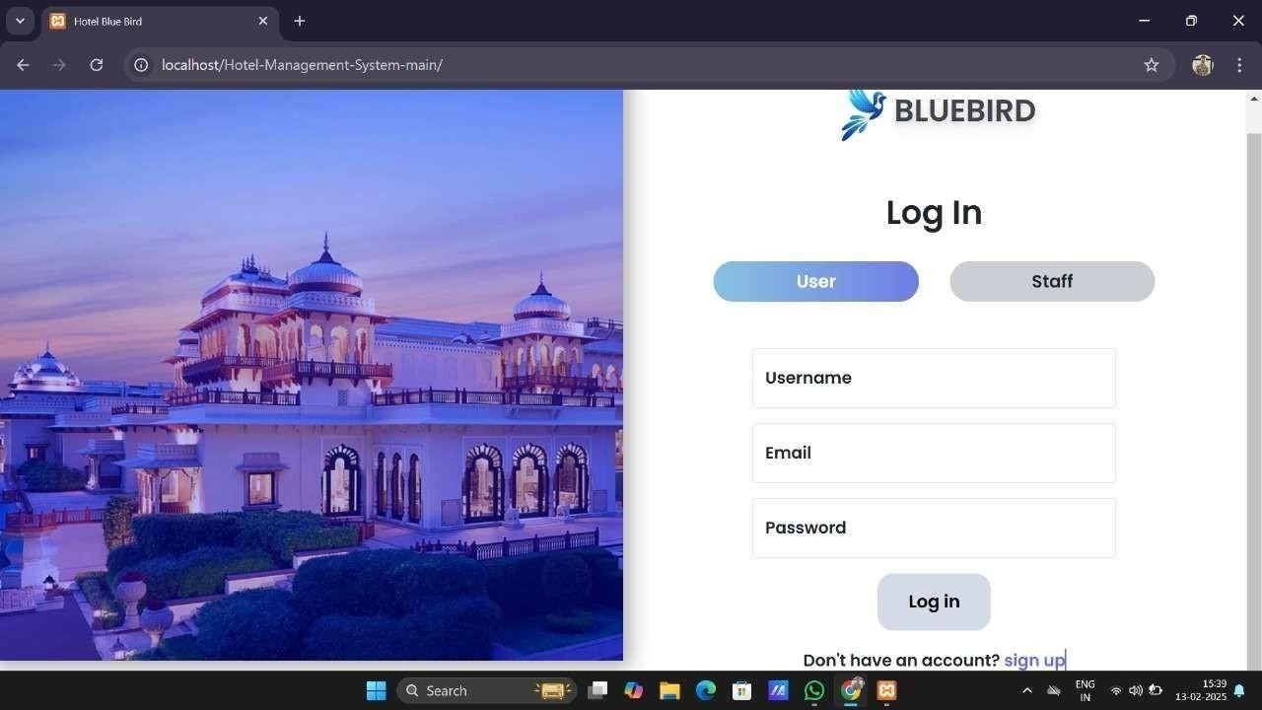

# CHAPTER-7 EXPERIMENTS AND RESULTS

**SIGN UP:**

**LOGIN PAGE AND STAFF LOGIN:-**

K.L.E’S C.B.KORE POLYTECHNIC, CHIKODI

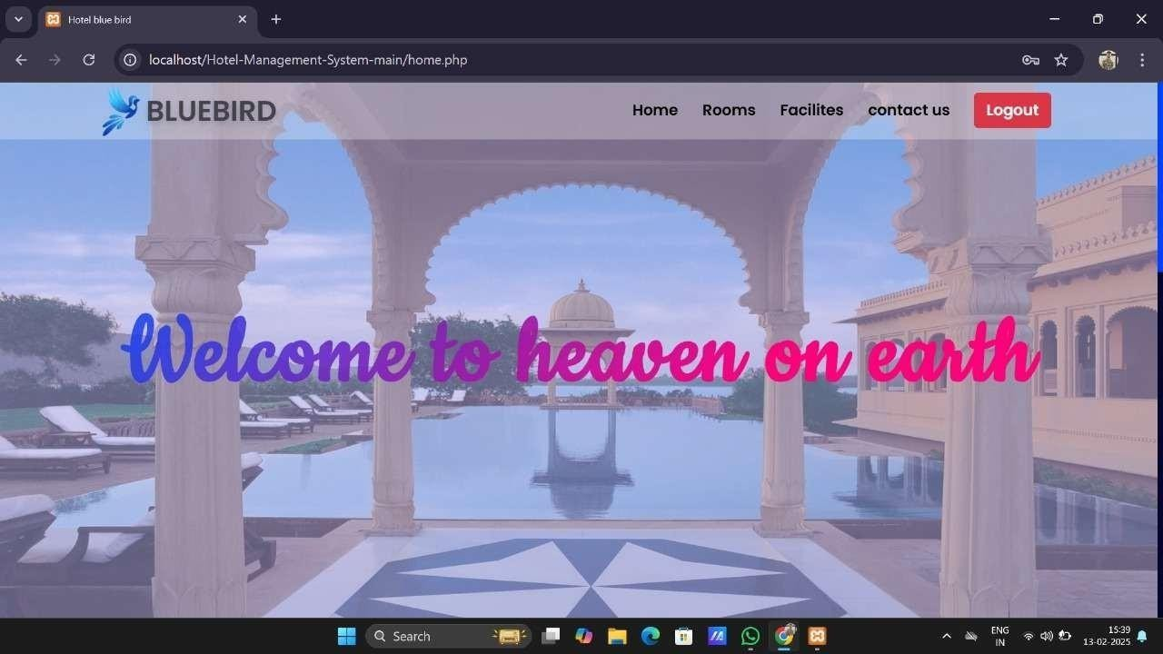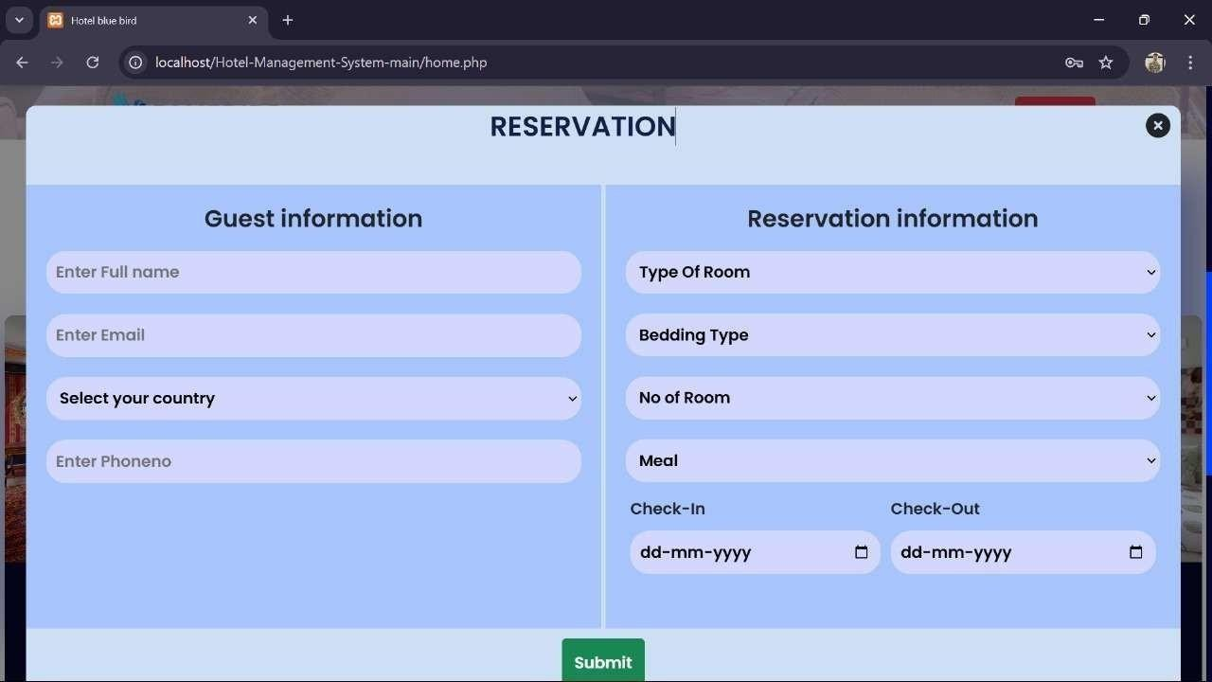

**HOME PAGE:**

**BOOKING PAGE:**

K.L.E’S C.B.KORE POLYTECHNIC, CHIKODI

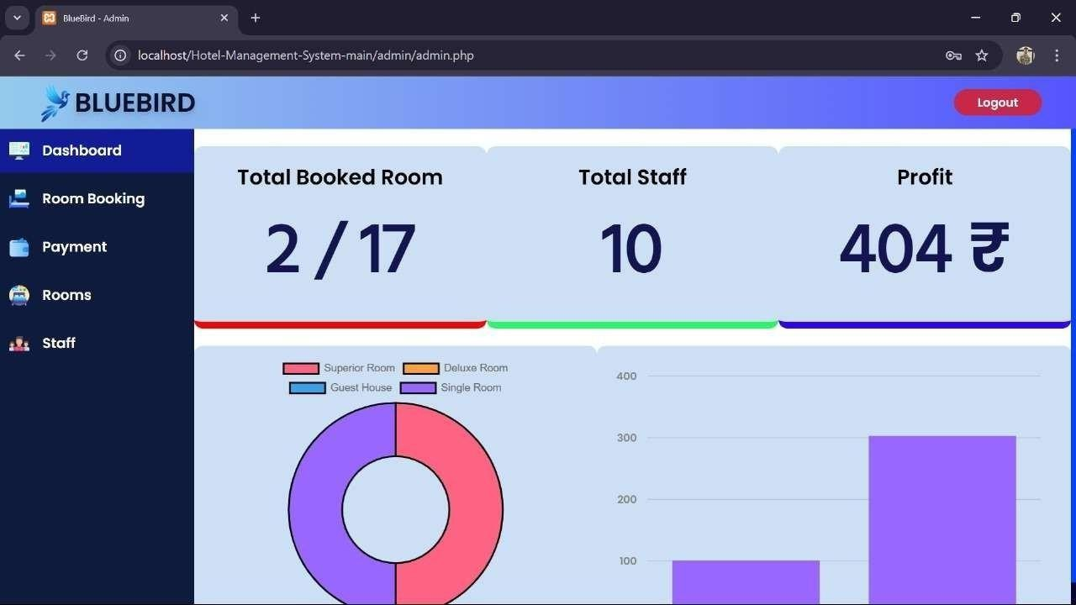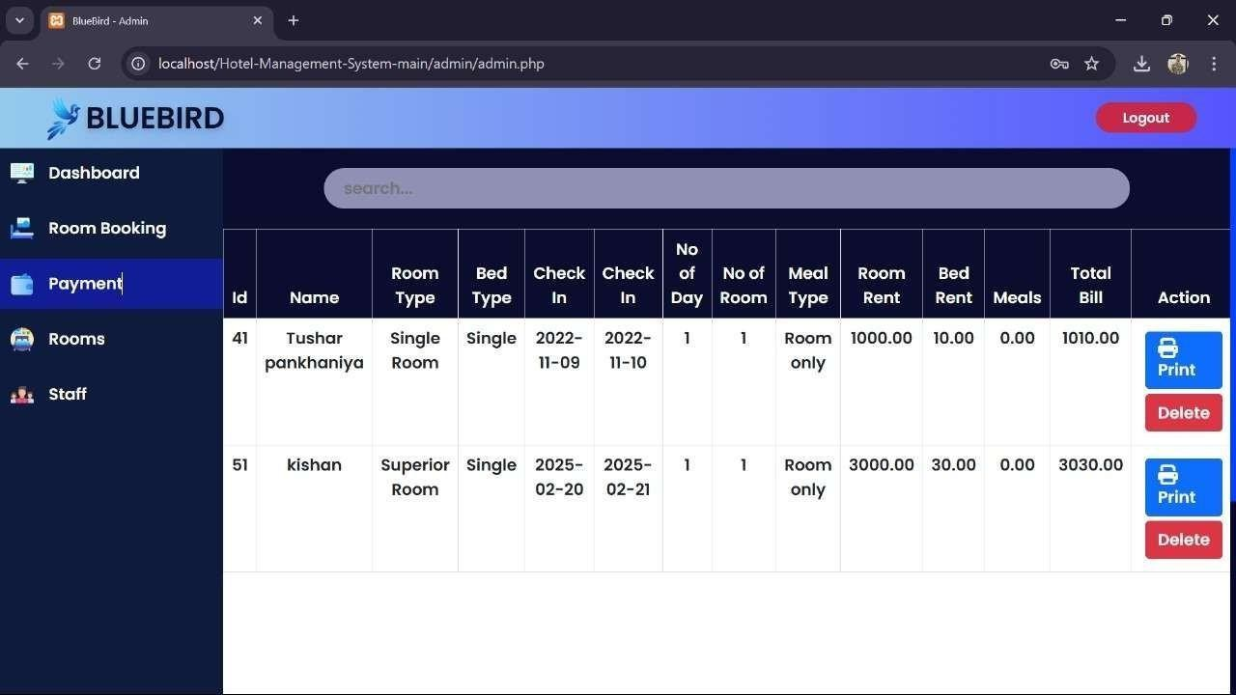

**STAFF DASHBOARD:**

**PAYMENT :**

K.L.E’S C.B.KORE POLYTECHNIC, CHIKODI

# CHAPTER-8 TEST-CASES

## Guest Registration

Test Case ID: TC_Guest_01 Title: Register a New Guest

Preconditions: The hotel system is up and running.

Test Steps:

1. Open the hotel management system.
2. Navigate to the guest registration form.
3. Enter valid guest details (name, email, phone number).
4. Submit the registration form. Expected Result:
   * A new guest profile is created.
   * The system assigns a unique Guest_ID.
   * A success message is displayed: "Registration successful." Postconditions: The new guest profile is stored in the database.

## Test Case 2: Search Available Rooms

Test Case ID: TC_Room_01 Title: Search for Available Rooms

Preconditions: The hotel system is up and running. The guest is registered.

Test Steps:

1. Open the hotel management system.
2. Login as a guest or visitor.
3. Enter check-in and check-out dates.
4. Apply room filters (e.g., room type, price range).
5. Click on the "Search" button. Expected Result:
   * The system displays a list of available rooms for the selected dates.
   * Each room shows basic details (e.g., price per night, room type). Postconditions: A list of available rooms is displayed for the guest.

K.L.E’S C.B.KORE POLYTECHNIC, CHIKODI

## Test Case 3: Make a Reservation

**Test Case ID**: TC_Reservation_01

**Title**: Make a Room Reservation

**Preconditions**: The guest has already registered. A room is available for the selected dates.

#### Test Steps:

1. Select an available room from the search results.
2. Click on "Book Now" or similar option.
3. Enter guest details (if not logged in already).
4. Confirm check-in and check-out dates.
5. Submit the reservation.

#### Expected Result:

* + The room is reserved for the guest.
  + The system updates the room status to "reserved".
  + A reservation ID is generated and stored.
  + The guest receives a confirmation message with reservation details.

**Postconditions**: A new reservation record is stored in the database.

## Test Case 4: Check-in Guest

**Test Case ID**: TC_Checkin_01

**Title**: Guest Check-in Process

**Preconditions**: The guest has a confirmed reservation.

#### Test Steps:

1. Open the hotel management system.
2. Navigate to the check-in page.
3. Search for the guest by name, reservation ID, or guest ID.
4. Select the guest’s reservation.
5. Click on "Check-in" button.

#### Expected Result:

* + The guest is checked in successfully.
  + The room status is updated to "occupied".
  + A success message is displayed: "Check-in successful."

**Postconditions**: The reservation status is updated to "checked-in" in the system.

K.L.E’S C.B.KORE POLYTECHNIC, CHIKODI

## Test Case 5: Check-out Guest

**Test Case ID**: TC_Checkout_01

**Title**: Guest Check-out Process

**Preconditions**: The guest has already checked in and is staying in an assigned room.

#### Test Steps:

1. Open the hotel management system.
2. Navigate to the check-out page.
3. Search for the guest by name, reservation ID, or guest ID.
4. Select the guest’s reservation.
5. Click on "Check-out" button.

#### Expected Result:

* + The guest is checked out successfully.
  + The room status is updated to "available".
  + A final bill is calculated and displayed to the guest.
  + A payment option is offered.

**Postconditions**: The reservation status is updated to "checked-out", and the room is marked as "available".

## Test Case 6: Payment Process

**Test Case ID**: TC_Payment_01

**Title**: Process Payment for Guest Check-out

**Preconditions**: The guest has checked out, and a final bill is calculated.

#### Test Steps:

1. Open the hotel management system.
2. Navigate to the payment page for the guest.
3. Enter payment details (credit card, cash, etc.).
4. Submit the payment.

#### Expected Result:

* + Payment is successfully processed.
  + A payment confirmation message is displayed: "Payment successful".
  + The payment record is stored in the database.

**Postconditions**: The payment is recorded in the system, and the guest’s bill is marked as "paid".

K.L.E’S C.B.KORE POLYTECHNIC, CHIKODI

## Test Case 7: Request Room Maintenance

**Test Case ID**: TC_Maintenance_01

**Title**: Request Room Maintenance

**Preconditions**: The guest is staying in the hotel, and the room is in an occupied or available state.

#### Test Steps:

1. Open the hotel management system.
2. Navigate to the "Maintenance Request" page.
3. Select the room requiring maintenance.
4. Specify the type of maintenance required (e.g., cleaning, repair).
5. Submit the request.

#### Expected Result:

* + The system marks the room as "under maintenance".
  + A confirmation message is displayed: "Maintenance request submitted."

**Postconditions**: The room status is updated to "under maintenance" in the system.

## Test Case 8: Update Room Status by Admin

**Test Case ID**: TC_Admin_RoomStatus_01

**Title**: Update Room Status (e.g., Occupied to Available)

**Preconditions**: The system is logged in by an admin. The room is either occupied or reserved.

#### Test Steps:

1. Open the hotel management system as an admin.
2. Navigate to the "Room Status" management section.
3. Select the room whose status needs to be updated.
4. Change the status from "occupied" to "available".
5. Submit the changes.

#### Expected Result:

* + The room status is updated successfully.
  + A success message is displayed: "Room status updated to available."

**Postconditions**: The room status is updated in the database.

K.L.E’S C.B.KORE POLYTECHNIC, CHIKODI

## Test Case 9: View Reservation History (Guest)

**Test Case ID**: TC_ReservationHistory_01

**Title**: View Guest Reservation History

**Preconditions**: The guest has made previous reservations.

#### Test Steps:

1. Open the hotel management system.
2. Log in as the guest (or use guest ID to view history).
3. Navigate to the "Reservation History" section.
4. View the past reservations list.

#### Expected Result:

* + The system displays all previous reservations made by the guest, including room type, dates, and status.
  + If no reservations exist, the system displays: "No reservations found".

**Postconditions**: The guest can view all their past reservations.

## Test Case 10: Admin View Financial Report

**Test Case ID**: TC_Admin_FinancialReport_01

**Title**: Generate and View Financial Report

**Preconditions**: Admin is logged in and there are completed payments in the system.

#### Test Steps:

1. Open the hotel management system.
2. Navigate to the "Financial Reports" section.
3. Select the time period for the report (e.g., weekly, monthly).
4. Click "Generate Report".

#### Expected Result:

* + The system generates the financial report showing total income, payment records, and any applicable taxes or discounts.
  + A detailed breakdown is displayed with figures for income, expenses, and profits.

**Postconditions**: The admin can view the generated financial report.

K.L.E’S C.B.KORE POLYTECHNIC, CHIKODI

# CHAPTER-9 FUTURE SCOPE

## Future Scope of Hotel Management System (HMS)

The **Hotel Management System (HMS)** is a continuously evolving domain, and there are numerous areas where future advancements can significantly improve operations, guest experience, and overall efficiency. Below are some key areas where the future scope of HMS can be expanded.

#### Artificial Intelligence (AI) Integration

* 1. **Predictive Analytics for Demand Forecasting**

AI and machine learning (ML) can analyze past guest data and trends to predict demand, optimize pricing, and forecast room occupancy rates.

* + - **Benefits**: Improved decision-making for room rates, better occupancy management, and reduced operational costs.

#### Virtual Concierge Services

AI-driven chatbots or virtual assistants could provide guests with personalized recommendations, concierge services, and real-time support during their stay.

* + - **Benefits**: 24/7 customer service, improved guest experience, and reduced human resource dependence.

#### Automated Customer Feedback Analysis

Natural language processing (NLP) tools could automatically process guest feedback, reviews, and survey responses to gain actionable insights into service quality and areas of improvement.

* + - **Benefits**: Real-time analysis, enhanced customer service, and proactive issue resolution.

#### Internet of Things (IoT) Integration

* 1. **Smart Room Technology**

Rooms can be equipped with IoT devices that allow guests to control lighting, temperature, entertainment systems, and even curtains using their smartphones or voice assistants (like Alexa or Google Home).

* + - **Benefits**: Enhanced guest comfort, energy efficiency, and the convenience of personalized room control.

#### Predictive Maintenance Using IoT

Sensors installed in hotel equipment (air conditioning, elevators, plumbing, etc.) can send alerts about potential issues before they escalate, helping maintenance teams act proactively.

* + - **Benefits**: Reduced downtime, fewer disruptions to guests, and cost-effective maintenance.

#### Smart Inventory Management

IoT devices can track and manage hotel inventory (e.g., linens, toiletries, minibar items) in real-time. This reduces waste and ensures that the hotel is always prepared to meet guest demands.

* + - **Benefits**: Streamlined operations, reduced operational costs, and minimized stockouts.

K.L.E’S C.B.KORE POLYTECHNIC, CHIKODI

#### Mobile App Integration

* 1. **Contactless Check-in/Check-out**

Guests can use their smartphones to check in, access their rooms via digital keys, and check out without ever having to visit the front desk.

* + - Benefits: Improved convenience, enhanced guest safety (especially in post-pandemic times), and reduced operational strain on front desk staff.
  1. In-Room Mobile Ordering and Service Requests

Guests can order room service, request housekeeping, or book amenities directly from their mobile phones.

* + - Benefits: Increased guest satisfaction, better service delivery, and upselling opportunities for the hotel.
  1. Loyalty Programs and Personalization

Hotels can integrate personalized loyalty programs via their mobile apps. These programs could reward guests for frequent stays, offer discounts, and tailor services based on preferences and past behaviors.

* + - Benefits: Increased customer retention, personalized guest experience, and better customer insights.

#### Blockchain for Secure Transactions and Data Management

* 1. Secure Payment Systems

Blockchain technology can enhance security in payment systems by ensuring that transactions are tamper-proof and reducing fraud.

* + - Benefits: Increased transaction security, faster payment processing, and reduced payment fraud.
  1. Transparent Booking and Reservation Management

Blockchain can ensure transparency in the booking process, enabling guests to verify the authenticity of their reservation and hotel availability.

* + - Benefits: Reduced booking fraud and improved trust between hotels and guests.
  1. Digital Identity Verification

Blockchain can help securely store and verify guest identities, reducing the time spent on check-in and preventing identity fraud.

* + - Benefits: Faster check-ins, secure guest data management, and reduced chances of identity theft.

K.L.E’S C.B.KORE POLYTECHNIC, CHIKODI

# CONCLUSION

The **Hotel Management System (HMS)** plays a critical role in optimizing the operations of a hotel by integrating various functions, from guest booking to check-out, room management, and payment processing. As we've explored in this project, an effective HMS enhances operational efficiency, ensures seamless guest experiences, and helps hotels maintain profitability while offering personalized services to guests.

In the context of today’s fast-paced, tech-driven world, the future of hotel management lies in embracing emerging technologies. With advancements in **AI**, **IoT**, **Blockchain**, **Cloud Computing**, and **Mobile Integration**, hotels can deliver innovative, personalized, and streamlined services, ensuring they stay ahead of the competition. The system’s scalability, flexibility, and automation help minimize human error, reduce operational costs, and improve decision-making.

K.L.E’S C.B.KORE POLYTECHNIC, CHIKODI



**CHAPTER-10 REFERENCE**

#### Ravichandran, R. (2020).

*Hotel Management Information Systems: Concept and Application.* International Journal of Advanced Science and Technology, 29(4), 1254-1260. Available at: **https://**[**www.sci-researcher.org**](http://www.sci-researcher.org/)

#### Sharma, A., & Rani, A. (2018).

*The Role of Information Technology in Hotel Management Systems.*

International Journal of Computer Applications, 179(12), 34-39. Available at: **https://**[**www.ijcaonline.org**](http://www.ijcaonline.org/)

#### Vargas, P., & Prieto, M. (2021).

*AI and Machine Learning Applications in Hotel Management.* Journal of Tourism Research and Hospitality, 45(6), 547-559. Available at: **https://**[**www.jtrh.com**](http://www.jtrh.com/)

#### Apps:

* 1. Google
  2. Chart Gpt(AI)
  3. You tube

K.L.E’S C.B.KORE POLYTECHNIC, CHIKODI

**K.L.E SOCIETY’S C.B KORE POLYTECHNIC, CHIKODI DEPARTMENT OF COMPUTER SCIENCE AND ENGINEERING.**

**RUBRICS FOR ASSESSMENT OF INTERNSHIP**

**NAME: KISHAN NINGANAGAUDA MANGASULE**

**REG NO: 339CS22024**

**SUBJECT/CODE: INTERNSHIP/20CS615**

|  |  |  |  |  |  |  |
| --- | --- | --- | --- | --- | --- | --- |
| **DIMENSION** | **SCALE** | | | | | **STUDENT SCORE** |
| **10** | **20** | **30** | **40** | **50** |
| **Beginner** | **Intermediate** | **Good** | **Advanced** | **Expert** |
| Organisation | Has not included relevant information | Has included few relevant information | Has included some  relevant information | Has included many  relevant information | Has included all relevant information |  |
| Full fill Team roles& duties | Does not performanc e duties  assigned | performance very little duties | performanc e particular duties | performanc e early all duties | performanc e all duties of assigned  team roles |  |
| Conclusion | Poor | Lesse Effective | Partialy Effective | Summarises but not exact | Most Effective |  |
| Convensions | Frequent Error | More Error | Some Error | Occasional Error | No Error |  |
| **Average Marks** | | | | | |  |

**Cohort Owner**