1. Dataset
The dataset used is the public thick blood smear malaria dataset from the National Library of Medicine (NLM, Lister Hill National Center for Biomedical Communications). All images are smartphone microscope photos of Giemsa-stained thick smears (4032 x 3024 pixels) with expert annotations. Three sets were used:
- NLM-Falciparum-Thick-150Patients: P. falciparum patients. Parasites and WBCs are annotated.
- NIH-NLM-ThickBloodSmearsPV: P. vivax patients. Only parasites are annotated.
- NIH-NLM-ThickBloodSmearsU: uninfected patients. Only WBCs are annotated.
Thick smears were used instead of the thin smear red blood cell dataset because the thin smear dataset has only P. falciparum, so it cannot separate falciparum from vivax.
Table 1. Dataset summary
Class | Patients | Photos | Photos per patient (min / avg / max) | Annotated parasites | Annotated WBCs
P. falciparum | 150 | 1,883 | 4 / 12.6 / 22 | 84,509 | 35,449
P. vivax | 150 | 3,014 | 15 / 20.1 / 30 | 43,101 | Not annotated
Uninfected | 50 | 1,141 | 11 / 22.8 / 33 | 0 | 27,340
Total | 350 | 6,038 | 4 / 17.3 / 33 | 127,610 | 62,789
Note: the vivax dataset does not include WBC annotations, and uninfected patients have no parasites.
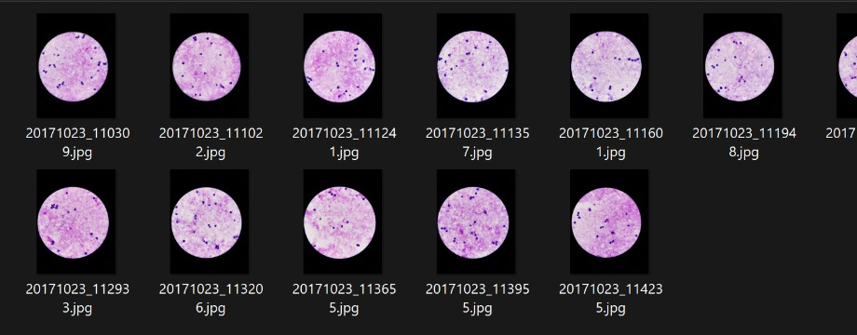
Figure 1. Sample photos of a P. falciparum patient
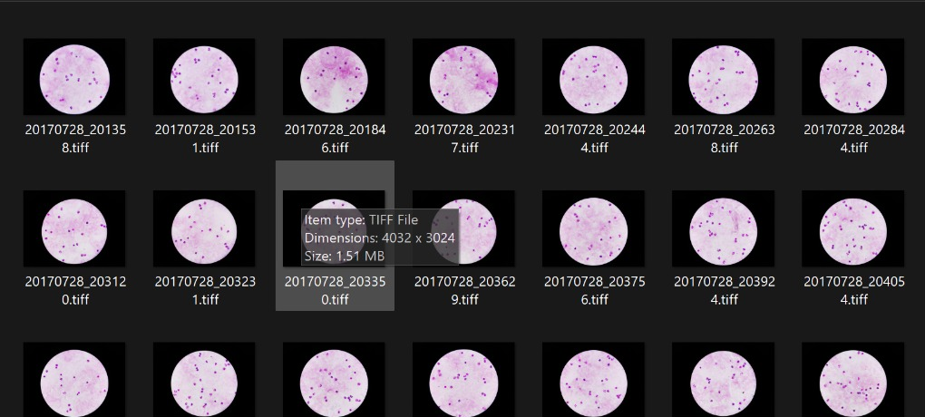
Figure 2. Sample photos of an uninfected patient
Annotation format
Every photo has a text file. The first line gives object count, width and height (e.g. 31,4032,3024). Each following line is one object: id, label, comment, shape, number of points and coordinates, e.g. 0-1,Parasite,No_Comment,Circle,2,2675.35,566,2678,579.25. A circle is stored as its centre and one point on the edge.
As given in the dataset ReadMe, the images must not be rotated, because the annotation coordinates depend on the original orientation. MATLAB imread does not apply the phone rotation tag, so the coordinates match. Every image size was checked against its annotation file and 0 images mismatched. No rotation is used in augmentation either.
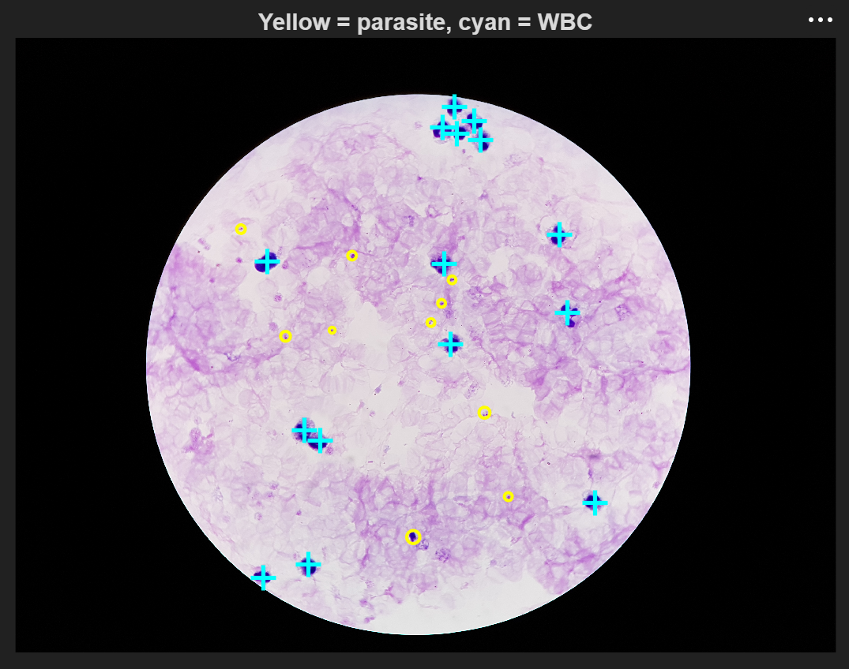
Figure 3. Annotations drawn on a falciparum photo (yellow = parasite, cyan = WBC)
For 60 of the 150 vivax patients the annotation file names have no underscore (e.g. 20190502110341.txt for 20190502_110341.jpg). The code handles both names.
2. Data Preparation
A whole photo has hundreds of cells, so 96 x 96 pixel patches were cut around the annotated objects:
- Falciparum: patches around parasites from falciparum patients
- Vivax: patches around parasites from vivax patients
- Uninfected: half around WBCs and half on random background, from uninfected patients
For the sample runs, about 3 patches per infected patient and 8 per uninfected patient were taken, giving 1,300 patches from all 350 patients.
The split was done by patient (70% train, 15% validation, 15% test, random seed 42), so the same patient never appears in two sets. The leakage check showed 0 shared patients.
Table 2. Train / validation / test split
Split | Falciparum (patients / patches) | Vivax (patients / patches) | Uninfected (patients / patches) | Total patches | Percent
Train | 105 / 315 | 105 / 315 | 35 / 280 | 910 | 70.0%
Validation | 23 / 69 | 23 / 69 | 8 / 64 | 202 | 15.5%
Test | 22 / 66 | 22 / 66 | 7 / 56 | 188 | 14.5%
Total | 150 / 450 | 150 / 450 | 50 / 400 | 1,300 | 100%

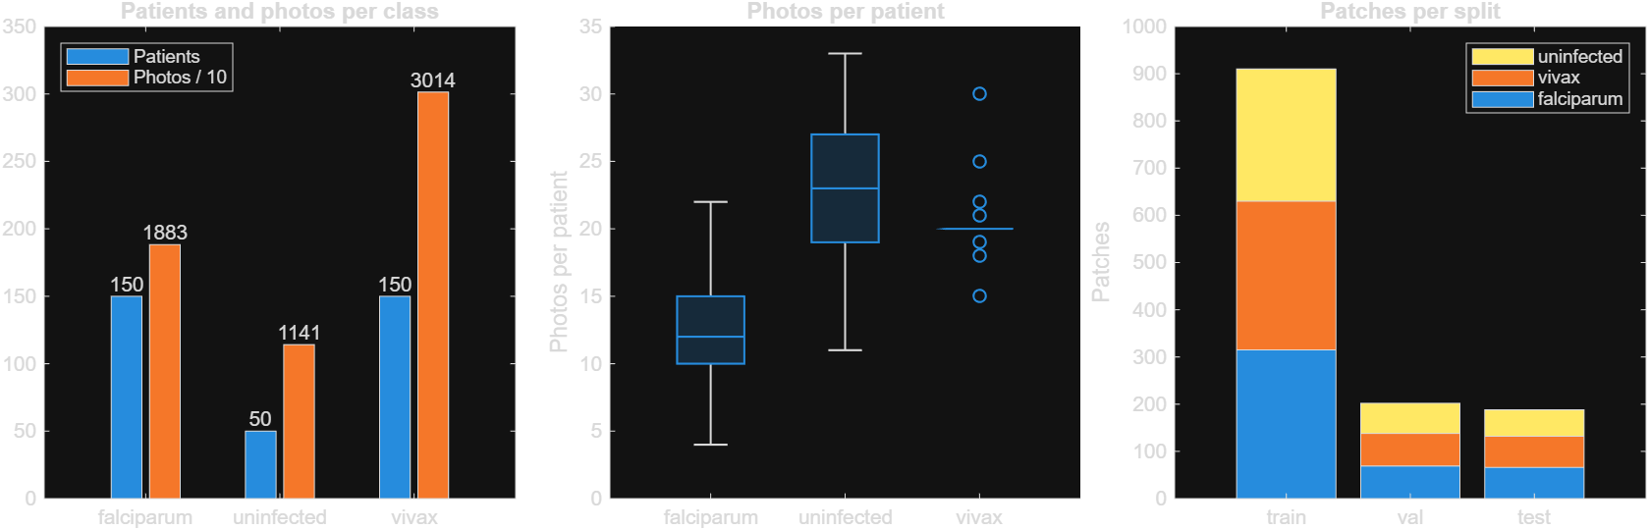
Figure 4. Patients and photos per class, photos per patient, and patches per split
3. Preprocessing
- CLAHE: contrast limited adaptive histogram equalisation on the L channel of Lab colour space (clip limit 0.01, 4 x 4 tiles). It increases the contrast between parasite and background.
- Reinhard stain normalisation: each Lab channel is shifted and scaled to match a reference mean and standard deviation, x' = (x - mean_patch) / std_patch x std_ref + mean_ref. It removes stain colour differences between slides.
The reference values were taken only from the training patients (L = 70.5, a = 19.9, b = -21.1), so no test data is used in preprocessing.
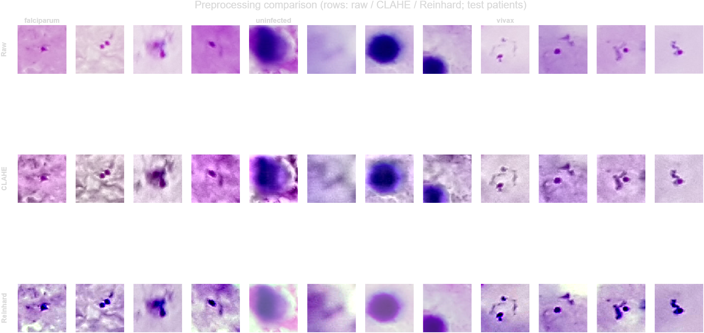
Figure 5. Rows: raw, CLAHE, Reinhard. Columns: falciparum, uninfected, vivax
Raw patches differ a lot in colour between slides. CLAHE makes texture sharper but also adds background noise. Reinhard gives all patches the same colour tone, and the parasites become clear dark dots. On large WBC patches Reinhard lightens the cell slightly.
4. Sample Runs for Model Selection
Six pipelines were tested on the 1,300 patch sample and scored on the same 188 test patches from 51 unseen patients. The CNNs were fine-tuned from ImageNet weights (Adam, learning rate 0.0001, 12 epochs, batch size 32, 224 x 224 input, flips only, no rotation) on an RTX 5060 GPU.
Table 3. Results of the sample runs on test patients
Pipeline | Preprocessing | Accuracy | Macro F1 | Recall falciparum | Recall vivax | Recall uninfected | Time (s)
P1 Colour histogram + GLCM, SVM | Raw | 68.1% | 0.685 | 62.1% | 69.7% | 73.2% | 3
P2 HOG + LBP, SVM | CLAHE | 84.6% | 0.852 | 86.4% | 78.8% | 89.3% | 1
P3 Colour + GLCM + HOG + LBP, Random Forest | Reinhard | 84.6% | 0.853 | 78.8% | 80.3% | 96.4% | 7
P4 ResNet-50 features, SVM | Reinhard | 88.3% | 0.888 | 87.9% | 84.8% | 92.9% | 49
P5 ResNet-50 fine-tuned | Reinhard | 95.2% | 0.954 | 87.9% | 98.5% | 100% | 102
P6 EfficientNet-b0 fine-tuned | Reinhard | 95.2% | 0.955 | 90.9% | 95.5% | 100% | 128

Selected model: Reinhard normalisation + fine-tuned EfficientNet-b0.
- Fine-tuned CNNs performed much better than handcrafted features (95% vs 68 to 85%).
- EfficientNet-b0 and ResNet-50 had the same accuracy, but EfficientNet-b0 trained more stably (ResNet-50 started overfitting after iteration 100), had higher falciparum recall (90.9% vs 87.9%) and is about 5 times smaller.
- EfficientNet is also the model used in the base paper (Mujahid et al., 2024).
- All uninfected patches were classified correctly. The remaining errors were between falciparum and vivax.
Since the test sample has only 188 patches, small differences of a few percent are not significant. The full dataset will be used in the next stages.

