1. Dataset
The dataset used is the public thick blood smear malaria dataset from the National Library of Medicine (NLM, Lister Hill National Center for Biomedical Communications). All images are smartphone microscope photos of Giemsa-stained thick smears (4032 x 3024 pixels) with expert annotations. Three sets were used:
- NLM-Falciparum-Thick-150Patients: P. falciparum patients. Parasites and WBCs are annotated.
- NIH-NLM-ThickBloodSmearsPV: P. vivax patients. Only parasites are annotated.
- NIH-NLM-ThickBloodSmearsU: uninfected patients. Only WBCs are annotated.
Thick smears were used instead of the thin smear red blood cell dataset because the thin smear dataset has only P. falciparum, so it cannot separate falciparum from vivax.
Table 1. Dataset summary
Class | Patients | Photos | Photos per patient (min / avg / max) | Annotated parasites | Annotated WBCs
P. falciparum | 150 | 1,883 | 4 / 12.6 / 22 | 84,509 | 35,449
P. vivax | 150 | 3,014 | 15 / 20.1 / 30 | 43,101 | Not annotated
Uninfected | 50 | 1,141 | 11 / 22.8 / 33 | 0 | 27,340
Total | 350 | 6,038 | 4 / 17.3 / 33 | 127,610 | 62,789
Note: the vivax dataset does not include WBC annotations, and uninfected patients have no parasites.
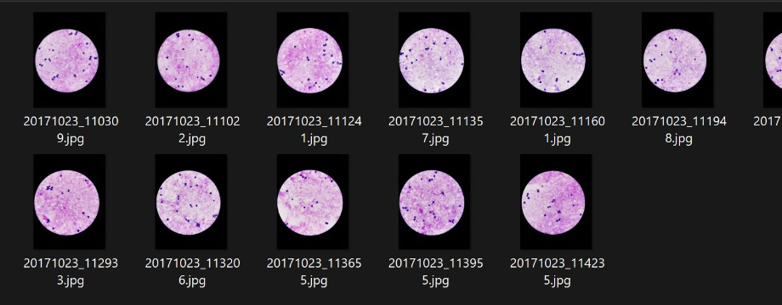
Figure 1. Sample photos of a P. falciparum patient
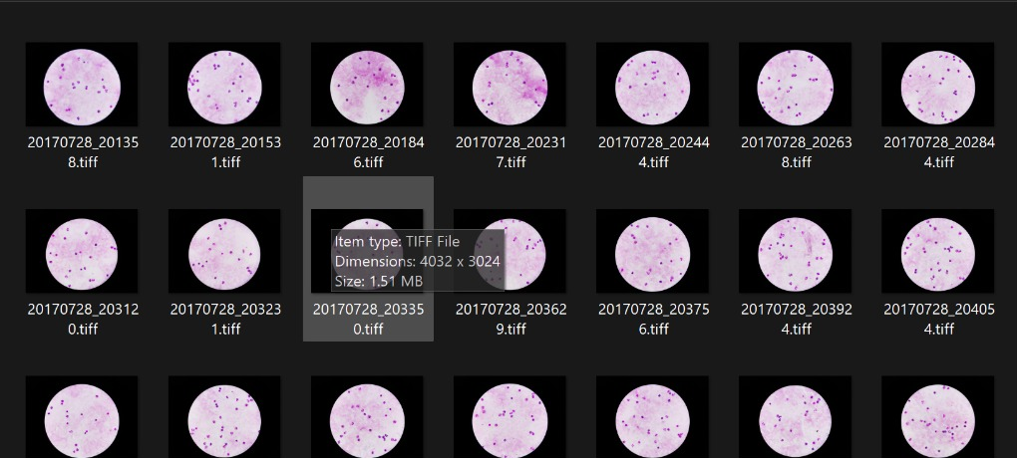
Figure 2. Sample photos of an uninfected patient
Annotation format
Every photo has a text file. The first line gives object count, width and height (e.g. 31,4032,3024). Each following line is one object: id, label, comment, shape, number of points and coordinates, e.g. 0-1,Parasite,No_Comment,Circle,2,2675.35,566,2678,579.25. A circle is stored as its centre and one point on the edge.
As given in the dataset ReadMe, the images must not be rotated, because the annotation coordinates depend on the original orientation. MATLAB imread does not apply the phone rotation tag, so the coordinates match. Every image size was checked against its annotation file and 0 images mismatched. No rotation is used in augmentation either.
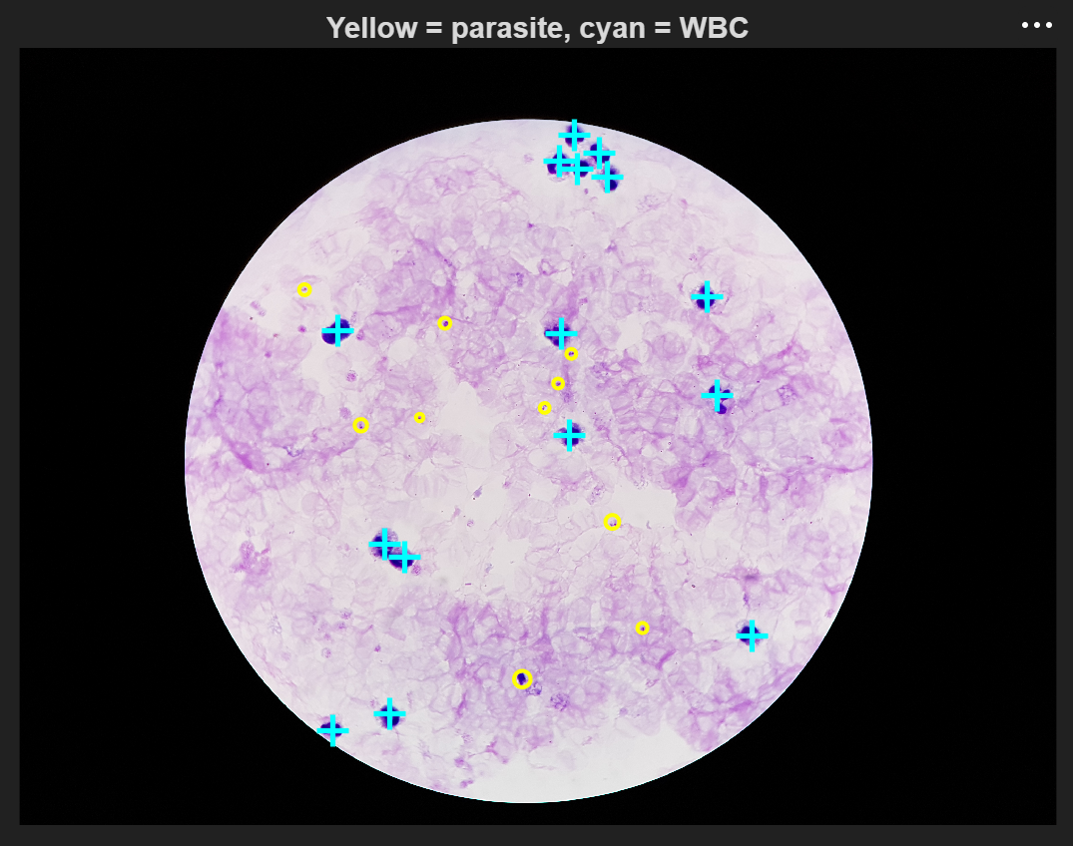
Figure 3. Annotations drawn on a falciparum photo (yellow = parasite, cyan = WBC)
For 60 of the 150 vivax patients the annotation file names have no underscore (e.g. 20190502110341.txt for 20190502_110341.jpg). The code handles both names.
2. Data Preparation
A whole photo has hundreds of cells, so 96 x 96 pixel patches were cut around the annotated objects:
- Falciparum: patches around parasites from falciparum patients
- Vivax: patches around parasites from vivax patients
- Uninfected: half around WBCs and half on random background, from uninfected patients
For the final run the whole dataset was used. Patches were cut from all 350 patients with a limit of about 25,000 patches per class and 30 patches per photo. Each patient gets an equal share of the class limit (167 patches per falciparum or vivax patient, 500 per uninfected patient), so no single patient dominates the data. This gave 63,713 patches from 4,327 of the 6,038 photos. Some patients have fewer parasites than their share, so falciparum (19,374) and vivax (20,219) are slightly below 25,000.
The 1,300 patch sample used for model selection (Section 4) was cut the same way, with about 3 patches per infected patient and 8 per uninfected patient.
The split was done by patient (70% train, 15% validation, 15% test, random seed 42), so the same patient never appears in two sets. The leakage check showed 0 shared patients.
Table 2. Train / validation / test split (full dataset)
Split | Falciparum (patients / patches) | Vivax (patients / patches) | Uninfected (patients / patches) | Photos used | Total patches | Percent
Train | 105 / 13,541 | 105 / 14,116 | 35 / 16,930 | 3,014 | 44,587 | 70.0%
Validation | 23 / 3,031 | 23 / 2,999 | 8 / 3,830 | 707 | 9,860 | 15.5%
Test | 22 / 2,802 | 22 / 3,104 | 7 / 3,360 | 606 | 9,266 | 14.5%
Total | 150 / 19,374 | 150 / 20,219 | 50 / 24,120 | 4,327 | 63,713 | 100%

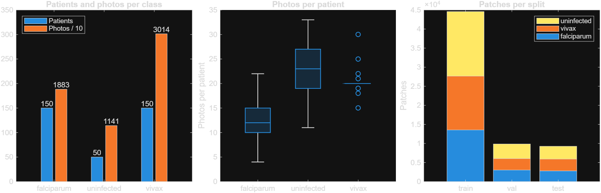
Figure 4. Patients and photos per class, photos per patient, and patches per split (full dataset)
3. Preprocessing
- CLAHE: contrast limited adaptive histogram equalisation on the L channel of Lab colour space (clip limit 0.01, 4 x 4 tiles). It increases the contrast between parasite and background.
- Reinhard stain normalisation: each Lab channel is shifted and scaled to match a reference mean and standard deviation, x' = (x - mean_patch) / std_patch x std_ref + mean_ref. It removes stain colour differences between slides.
The reference values were taken from 3,000 random patches of the training patients only (L = 69.4, a = 20.6, b = -22.5), so no validation or test data is used in preprocessing.
Both methods were compared on the sample. Reinhard was selected (Section 4), so for the full dataset only Reinhard copies were saved: all 63,713 patches (44,587 train, 9,860 validation, 9,266 test), keeping the same patient split.
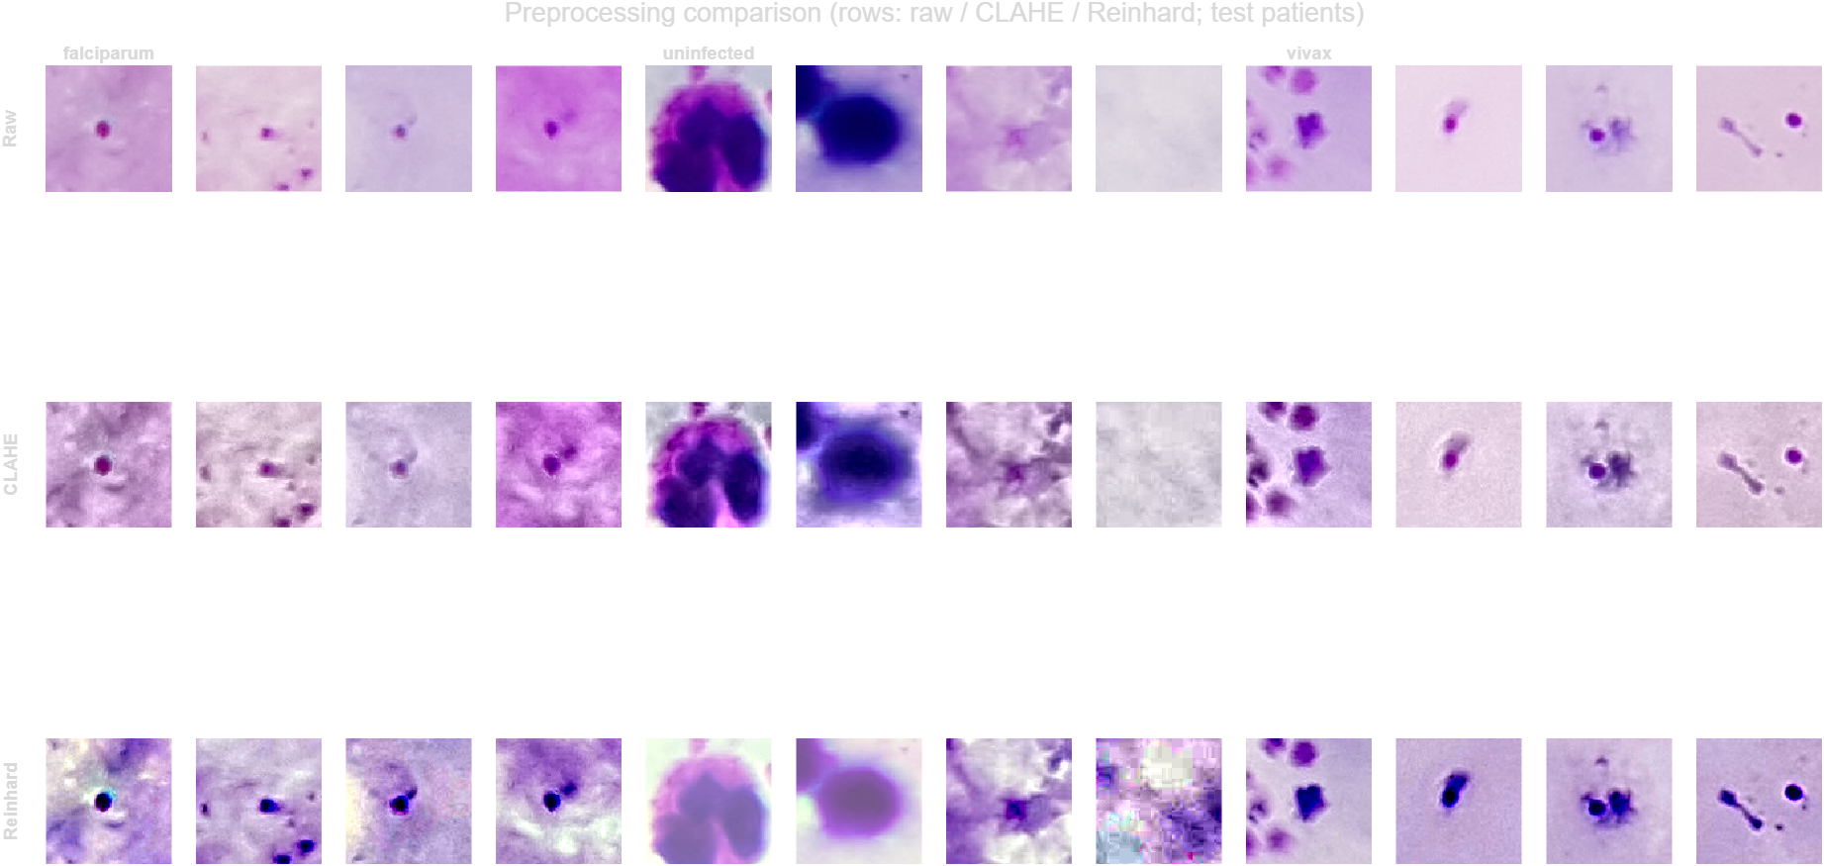
Figure 5. Test patient patches from the full dataset. Rows: raw, CLAHE, Reinhard. Columns: falciparum, uninfected, vivax
Raw patches differ a lot in colour between slides. CLAHE makes texture sharper but also adds background noise. Reinhard gives all patches the same colour tone, and the parasites become clear dark dots. On large WBC patches Reinhard lightens the cell slightly.
4. Sample Runs for Model Selection
Six pipelines were tested on the 1,300 patch sample and scored on the same 188 test patches from 51 unseen patients. The CNNs were fine-tuned from ImageNet weights (Adam, learning rate 0.0001, 12 epochs, batch size 32, 224 x 224 input, flips only, no rotation) on an RTX 5060 GPU.
Table 3. Results of the sample runs on test patients
Pipeline | Preprocessing | Accuracy | Macro F1 | Recall falciparum | Recall vivax | Recall uninfected | Time (s)
P1 Colour histogram + GLCM, SVM | Raw | 68.1% | 0.685 | 62.1% | 69.7% | 73.2% | 3
P2 HOG + LBP, SVM | CLAHE | 84.6% | 0.852 | 86.4% | 78.8% | 89.3% | 1
P3 Colour + GLCM + HOG + LBP, Random Forest | Reinhard | 84.6% | 0.853 | 78.8% | 80.3% | 96.4% | 7
P4 ResNet-50 features, SVM | Reinhard | 88.3% | 0.888 | 87.9% | 84.8% | 92.9% | 49
P5 ResNet-50 fine-tuned | Reinhard | 95.2% | 0.954 | 87.9% | 98.5% | 100% | 102
P6 EfficientNet-b0 fine-tuned | Reinhard | 95.2% | 0.955 | 90.9% | 95.5% | 100% | 128

Selected model: Reinhard normalisation + fine-tuned EfficientNet-b0.
- Fine-tuned CNNs performed much better than handcrafted features (95% vs 68 to 85%).
- EfficientNet-b0 and ResNet-50 had the same accuracy, but EfficientNet-b0 trained more stably (ResNet-50 started overfitting after iteration 100), had higher falciparum recall (90.9% vs 87.9%) and is about 5 times smaller.
- EfficientNet is also the model used in the base paper (Mujahid et al., 2024).
- All uninfected patches were classified correctly. The remaining errors were between falciparum and vivax.
Since the test sample has only 188 patches, small differences of a few percent are not significant. The full dataset will be used in the next stages.
5. Feature Extraction
Features were extracted from all 63,713 Reinhard normalised patches (train, validation and test separately). Two kinds of features were used: handcrafted features and deep features from the pretrained EfficientNet-b0 (the selected model, before fine-tuning).
Table 4. Extracted features
Feature | What it describes | Settings | Values
Colour | Stain colour of the patch | HSV histograms (16 bins per channel) + Lab mean and std | 54
GLCM | Texture | Contrast, correlation, energy, homogeneity in 4 directions (0, 45, 90, 135 degrees), 32 grey levels | 16
HOG | Shape and edges | 16 x 16 pixel cells, 9 orientation bins, 2 x 2 blocks | 900
LBP | Fine texture | 8 neighbours, radius 1, rotation invariant, 32 x 32 pixel cells | 90
Handcrafted total |  |  | 1,060
Deep (EfficientNet-b0) | Learned features | ImageNet weights, patch resized to 224 x 224, output of last global average pooling layer | 1,280
Extraction time on the full dataset: 213.6 s for the handcrafted features and 156.9 s for the deep features on the GPU (about 7 minutes in total).
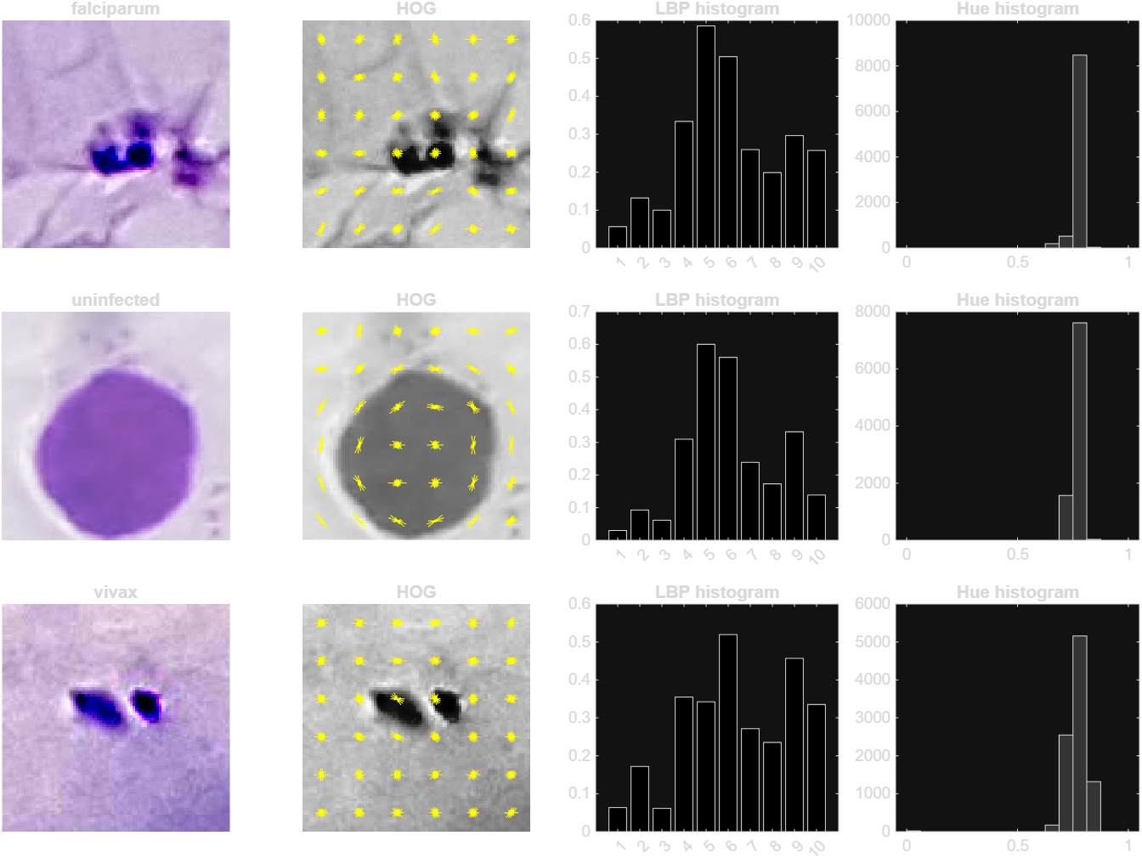
Figure 6. One training patch per class with its HOG, LBP histogram and hue histogram
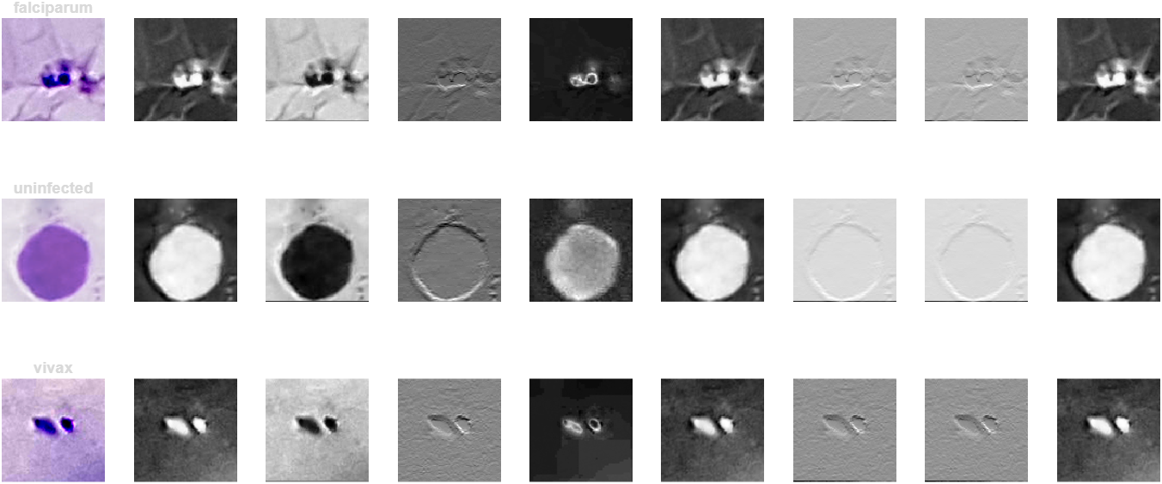
Figure 7. First 8 feature maps of the first convolution layer of EfficientNet-b0
In Figure 7 the first layer already picks out the parasite dots and the WBC outline as bright regions or edges.
Separability of the features
To check how well each feature set separates the three classes, the silhouette score was computed on 3,000 random training patches (features standardised and reduced to 50 dimensions with PCA). The score is between -1 and 1. Higher means the classes form separate groups, and around 0 means they overlap.
Table 5. Silhouette score of each feature set (training patients)
Feature set | Dimensions | Silhouette
Colour (HSV histogram + Lab stats) | 54 | 0.057
GLCM texture | 16 | -0.011
HOG | 900 | -0.056
LBP | 90 | 0.127
All handcrafted combined | 1,060 | -0.019
EfficientNet-b0 deep features | 1,280 | 0.083

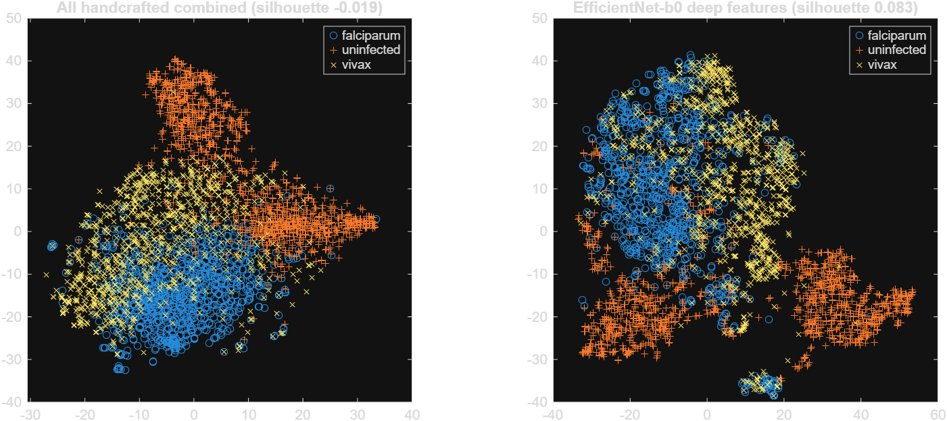
Figure 8. t-SNE of handcrafted (left) and deep (right) features, 3,000 training patches
- LBP gave the best score among the handcrafted features, then colour. HOG and GLCM alone do not separate the classes.
- Combining all handcrafted features gives a lower score than LBP alone, because the 900 HOG values dominate the combined vector.
- In the t-SNE plots the uninfected patches form their own groups in both feature sets. Falciparum and vivax overlap a lot in the handcrafted features, and are more separated in the deep features but still overlap at the border.
- All scores are low, because the pretrained network was trained on ImageNet and not on blood smears. This is why EfficientNet-b0 is fine-tuned in the training stage. The extracted features are also saved and used to train SVM baselines for comparison.

