1. Dataset
The dataset used is the public thick blood smear malaria dataset from the National Library of Medicine (NLM, Lister Hill National Center for Biomedical Communications). All images are smartphone microscope photos of Giemsa-stained thick smears (4032 x 3024 pixels) with expert annotations. Three sets were used:
- NLM-Falciparum-Thick-150Patients: P. falciparum patients. Parasites and WBCs are annotated.
- NIH-NLM-ThickBloodSmearsPV: P. vivax patients. Only parasites are annotated.
- NIH-NLM-ThickBloodSmearsU: uninfected patients. Only WBCs are annotated.
Thick smears were used instead of the thin smear red blood cell dataset because the thin smear dataset has only P. falciparum, so it cannot separate falciparum from vivax.
Table 1. Dataset summary
Class | Patients | Photos | Photos per patient (min / avg / max) | Annotated parasites | Annotated WBCs
P. falciparum | 150 | 1,883 | 4 / 12.6 / 22 | 84,509 | 35,449
P. vivax | 150 | 3,014 | 15 / 20.1 / 30 | 43,101 | Not annotated
Uninfected | 50 | 1,141 | 11 / 22.8 / 33 | 0 | 27,340
Total | 350 | 6,038 | 4 / 17.3 / 33 | 127,610 | 62,789
Note: the vivax dataset does not include WBC annotations, and uninfected patients have no parasites.
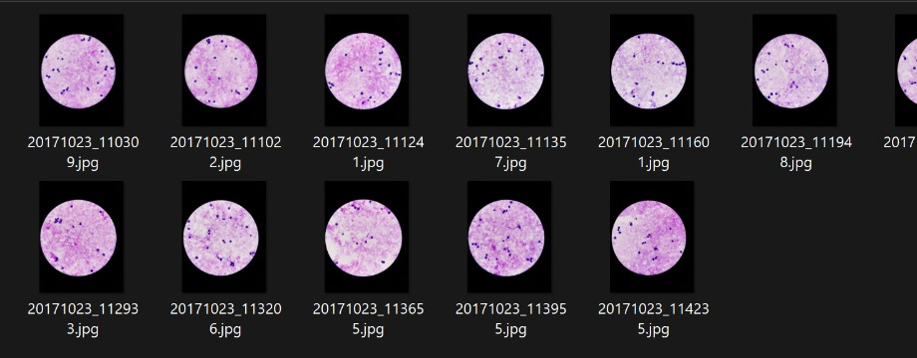
Figure 1. Sample photos of a P. falciparum patient
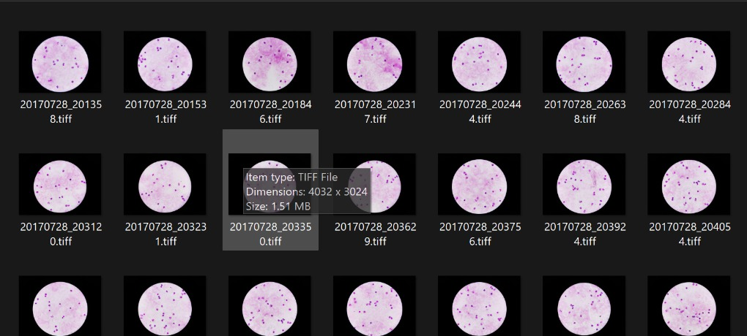
Figure 2. Sample photos of an uninfected patient
Annotation format
Every photo has a text file. The first line gives object count, width and height (e.g. 31,4032,3024). Each following line is one object: id, label, comment, shape, number of points and coordinates, e.g. 0-1,Parasite,No_Comment,Circle,2,2675.35,566,2678,579.25. A circle is stored as its centre and one point on the edge.
As given in the dataset ReadMe, the images must not be rotated, because the annotation coordinates depend on the original orientation. MATLAB imread does not apply the phone rotation tag, so the coordinates match. Every image size was checked against its annotation file and 0 images mismatched. No rotation is used in augmentation either.
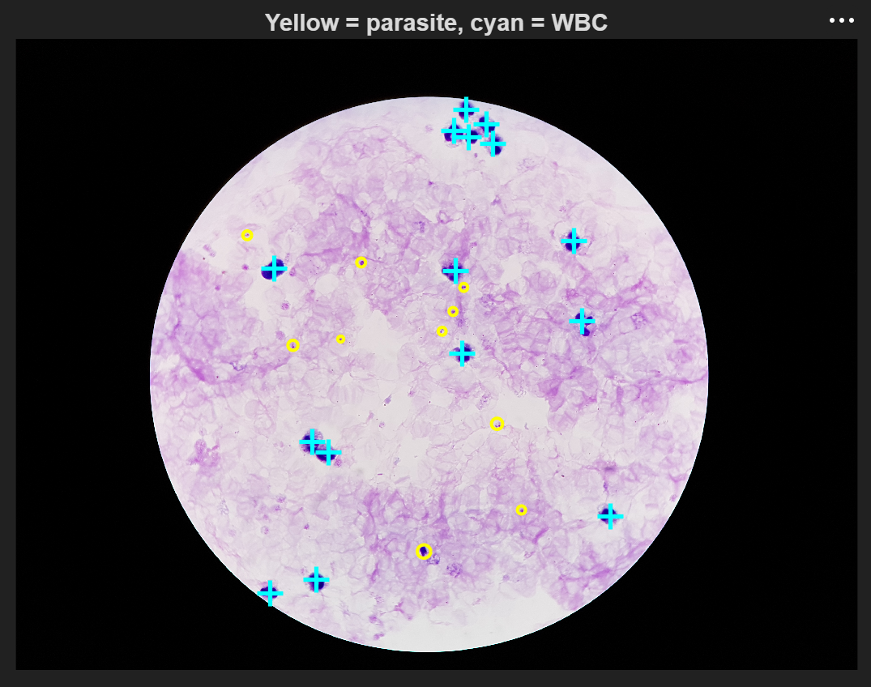
Figure 3. Annotations drawn on a falciparum photo (yellow = parasite, cyan = WBC)
For 60 of the 150 vivax patients the annotation file names have no underscore (e.g. 20190502110341.txt for 20190502_110341.jpg). The code handles both names.
2. Data Preparation
A whole photo has hundreds of cells, so 96 x 96 pixel patches were cut around the annotated objects:
- Falciparum: patches around parasites from falciparum patients
- Vivax: patches around parasites from vivax patients
- Uninfected: half around WBCs and half on random background, from uninfected patients
For the final run the whole dataset was used. Patches were cut from all 350 patients with a limit of about 25,000 patches per class and 30 patches per photo. Each patient gets an equal share of the class limit (167 patches per falciparum or vivax patient, 500 per uninfected patient), so no single patient dominates the data. This gave 63,713 patches from 4,327 of the 6,038 photos. Some patients have fewer parasites than their share, so falciparum (19,374) and vivax (20,219) are slightly below 25,000.
The 1,300 patch sample used for model selection (Section 4) was cut the same way, with about 3 patches per infected patient and 8 per uninfected patient.
The split was done by patient (70% train, 15% validation, 15% test, random seed 42), so the same patient never appears in two sets. The leakage check showed 0 shared patients.
Table 2. Train / validation / test split (full dataset)
Split | Falciparum (patients / patches) | Vivax (patients / patches) | Uninfected (patients / patches) | Photos used | Total patches | Percent
Train | 105 / 13,541 | 105 / 14,116 | 35 / 16,930 | 3,014 | 44,587 | 70.0%
Validation | 23 / 3,031 | 23 / 2,999 | 8 / 3,830 | 707 | 9,860 | 15.5%
Test | 22 / 2,802 | 22 / 3,104 | 7 / 3,360 | 606 | 9,266 | 14.5%
Total | 150 / 19,374 | 150 / 20,219 | 50 / 24,120 | 4,327 | 63,713 | 100%

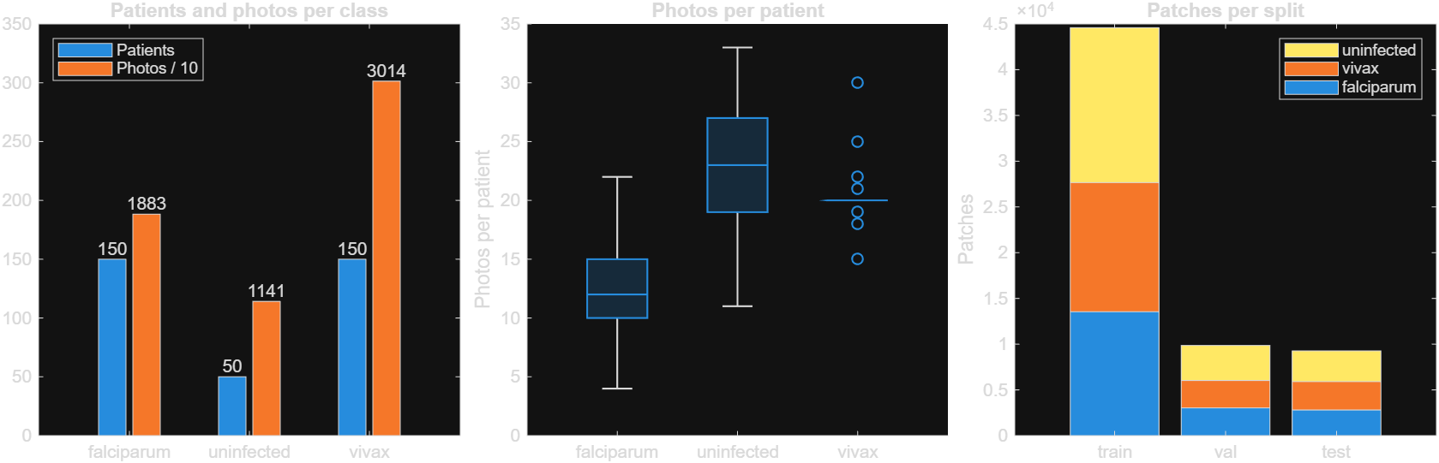
Figure 4. Patients and photos per class, photos per patient, and patches per split (full dataset)
3. Preprocessing
- CLAHE: contrast limited adaptive histogram equalisation on the L channel of Lab colour space (clip limit 0.01, 4 x 4 tiles). It increases the contrast between parasite and background.
- Reinhard stain normalisation: each Lab channel is shifted and scaled to match a reference mean and standard deviation, x' = (x - mean_patch) / std_patch x std_ref + mean_ref. It removes stain colour differences between slides.
The reference values were taken from 3,000 random patches of the training patients only (L = 69.4, a = 20.6, b = -22.5), so no validation or test data is used in preprocessing.
Both methods were compared on the sample. Reinhard was selected (Section 4), so for the full dataset only Reinhard copies were saved: all 63,713 patches (44,587 train, 9,860 validation, 9,266 test), keeping the same patient split.
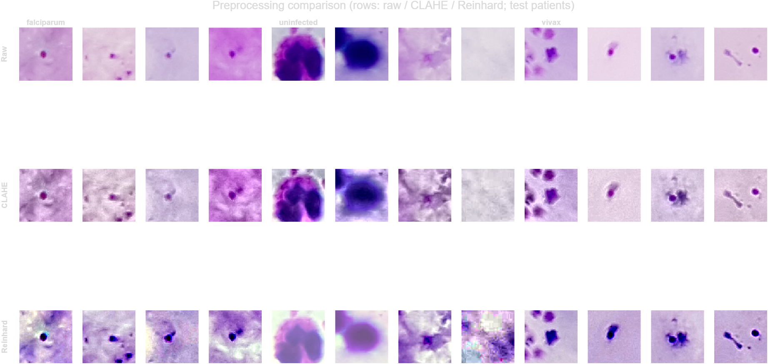
Figure 5. Test patient patches from the full dataset. Rows: raw, CLAHE, Reinhard. Columns: falciparum, uninfected, vivax
Raw patches differ a lot in colour between slides. CLAHE makes texture sharper but also adds background noise. Reinhard gives all patches the same colour tone, and the parasites become clear dark dots. On large WBC patches Reinhard lightens the cell slightly.
4. Sample Runs for Model Selection
Six pipelines were tested on the 1,300 patch sample and scored on the same 188 test patches from 51 unseen patients. The CNNs were fine-tuned from ImageNet weights (Adam, learning rate 0.0001, 12 epochs, batch size 32, 224 x 224 input, flips only, no rotation) on an RTX 5060 GPU.
Table 3. Results of the sample runs on test patients
Pipeline | Preprocessing | Accuracy | Macro F1 | Recall falciparum | Recall vivax | Recall uninfected | Time (s)
P1 Colour histogram + GLCM, SVM | Raw | 68.1% | 0.685 | 62.1% | 69.7% | 73.2% | 3
P2 HOG + LBP, SVM | CLAHE | 84.6% | 0.852 | 86.4% | 78.8% | 89.3% | 1
P3 Colour + GLCM + HOG + LBP, Random Forest | Reinhard | 84.6% | 0.853 | 78.8% | 80.3% | 96.4% | 7
P4 ResNet-50 features, SVM | Reinhard | 88.3% | 0.888 | 87.9% | 84.8% | 92.9% | 49
P5 ResNet-50 fine-tuned | Reinhard | 95.2% | 0.954 | 87.9% | 98.5% | 100% | 102
P6 EfficientNet-b0 fine-tuned | Reinhard | 95.2% | 0.955 | 90.9% | 95.5% | 100% | 128

Selected model: Reinhard normalisation + fine-tuned EfficientNet-b0.
- Fine-tuned CNNs performed much better than handcrafted features (95% vs 68 to 85%).
- EfficientNet-b0 and ResNet-50 had the same accuracy, but EfficientNet-b0 trained more stably (ResNet-50 started overfitting after iteration 100), had higher falciparum recall (90.9% vs 87.9%) and is about 5 times smaller.
- EfficientNet is also the model used in the base paper (Mujahid et al., 2024).
- All uninfected patches were classified correctly. The remaining errors were between falciparum and vivax.
Since the test sample has only 188 patches, small differences of a few percent are not significant. The full dataset will be used in the next stages.
5. Feature Extraction
Features were extracted from all 63,713 Reinhard normalised patches (train, validation and test separately). Two kinds of features were used: handcrafted features and deep features from the pretrained EfficientNet-b0 (the selected model, before fine-tuning).
Table 4. Extracted features
Feature | What it describes | Settings | Values
Colour | Stain colour of the patch | HSV histograms (16 bins per channel) + Lab mean and std | 54
GLCM | Texture | Contrast, correlation, energy, homogeneity in 4 directions (0, 45, 90, 135 degrees), 32 grey levels | 16
HOG | Shape and edges | 16 x 16 pixel cells, 9 orientation bins, 2 x 2 blocks | 900
LBP | Fine texture | 8 neighbours, radius 1, rotation invariant, 32 x 32 pixel cells | 90
Handcrafted total |  |  | 1,060
Deep (EfficientNet-b0) | Learned features | ImageNet weights, patch resized to 224 x 224, output of last global average pooling layer | 1,280
Extraction time on the full dataset: 213.6 s for the handcrafted features and 156.9 s for the deep features on the GPU (about 7 minutes in total).
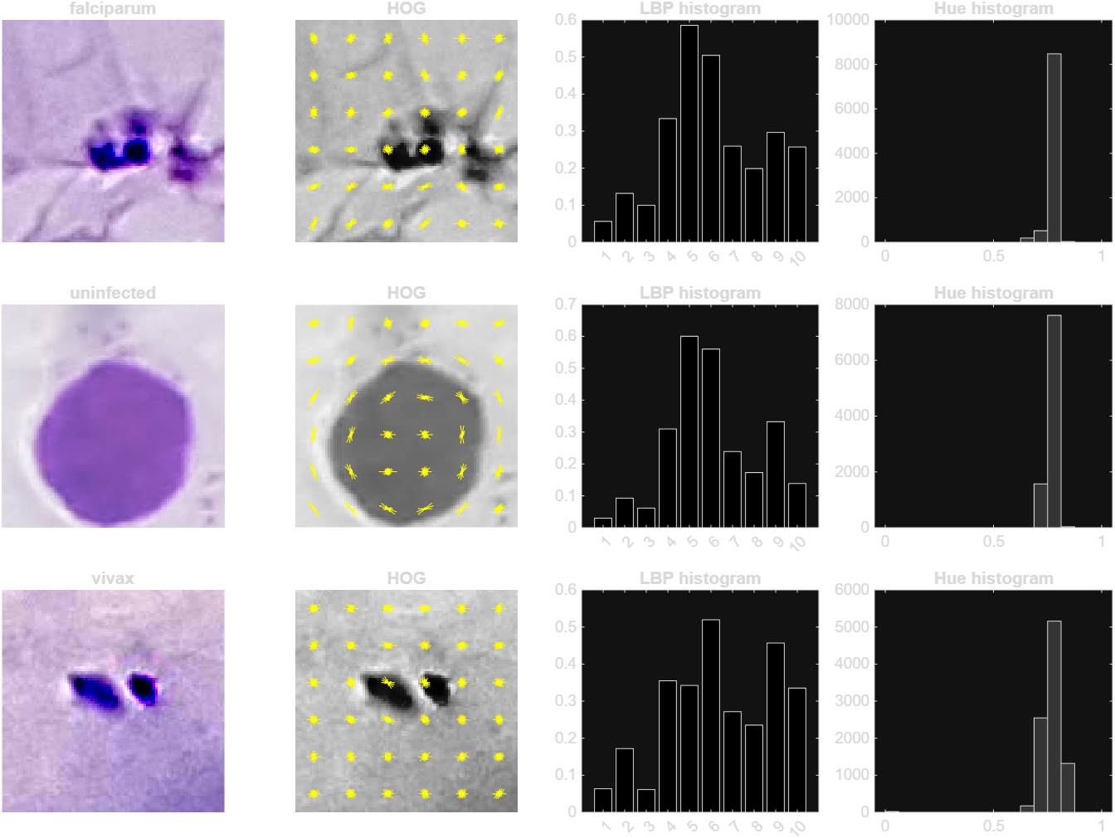
Figure 6. One training patch per class with its HOG, LBP histogram and hue histogram
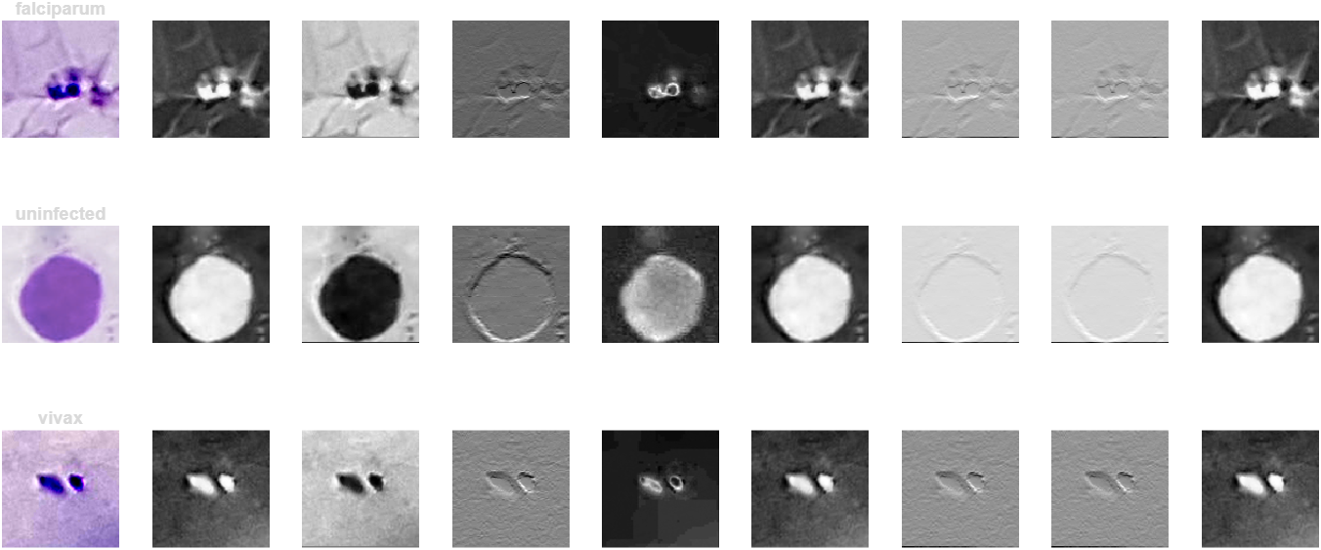
Figure 7. First 8 feature maps of the first convolution layer of EfficientNet-b0
In Figure 7 the first layer already picks out the parasite dots and the WBC outline as bright regions or edges.
Separability of the features
To check how well each feature set separates the three classes, the silhouette score was computed on 3,000 random training patches (features standardised and reduced to 50 dimensions with PCA). The score is between -1 and 1. Higher means the classes form separate groups, and around 0 means they overlap.
Table 5. Silhouette score of each feature set (training patients)
Feature set | Dimensions | Silhouette
Colour (HSV histogram + Lab stats) | 54 | 0.057
GLCM texture | 16 | -0.011
HOG | 900 | -0.056
LBP | 90 | 0.127
All handcrafted combined | 1,060 | -0.019
EfficientNet-b0 deep features | 1,280 | 0.083

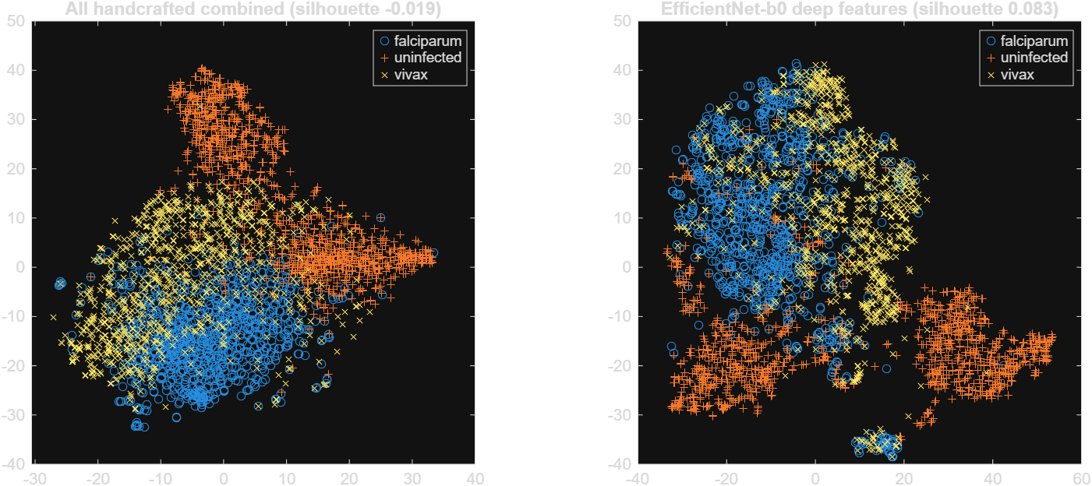
Figure 8. t-SNE of handcrafted (left) and deep (right) features, 3,000 training patches
- LBP gave the best score among the handcrafted features, then colour. HOG and GLCM alone do not separate the classes.
- Combining all handcrafted features gives a lower score than LBP alone, because the 900 HOG values dominate the combined vector.
- In the t-SNE plots the uninfected patches form their own groups in both feature sets. Falciparum and vivax overlap a lot in the handcrafted features, and are more separated in the deep features but still overlap at the border.
- All scores are low, because the pretrained network was trained on ImageNet and not on blood smears. This is why EfficientNet-b0 is fine-tuned in the training stage. The extracted features are also saved and used to train SVM baselines for comparison.
6. Training
Three models were trained on the training patients only (44,587 patches from 245 patients):
- M1: SVM with RBF kernel on the 1,060 handcrafted features (baseline)
- M2: SVM with RBF kernel on the 1,280 EfficientNet-b0 deep features (baseline)
- M3: EfficientNet-b0 fine-tuned end to end on the Reinhard patches (main model)
The SVMs use three one-vs-one classifiers, standardised inputs and automatic kernel scale. They were trained on 15,000 random training patches, because an RBF SVM on all 44,587 patches is very slow.
Table 6. M3 training settings
Setting | Value
Optimiser | Adam
Initial learning rate | 0.0001, multiplied by 0.3 every 10 epochs
Epochs | 35 (1,393 iterations per epoch, 48,755 in total)
Mini-batch size | 32
Input size | 224 x 224 x 3 (96 x 96 patches resized)
Loss | Cross-entropy
Augmentation | Random left-right and up-down flips (no rotation)
Validation | Once per epoch on the 54 validation patients
Model kept | Network with the lowest validation loss
Hardware | NVIDIA GeForce RTX 5060 Laptop GPU (8 GB)
Table 7. Training summary
Model | Input | Trainable part | Training accuracy | Training time
M1 SVM, handcrafted features | 1,060 features | 3 one-vs-one SVMs | 97.43% | 15 s
M2 SVM, deep features | 1,280 features | 3 one-vs-one SVMs | 97.75% | 22 s
M3 EfficientNet-b0 fine-tuned | 224 x 224 x 3 image | 4.03 million weights | 99.98% | 3 h 42 min
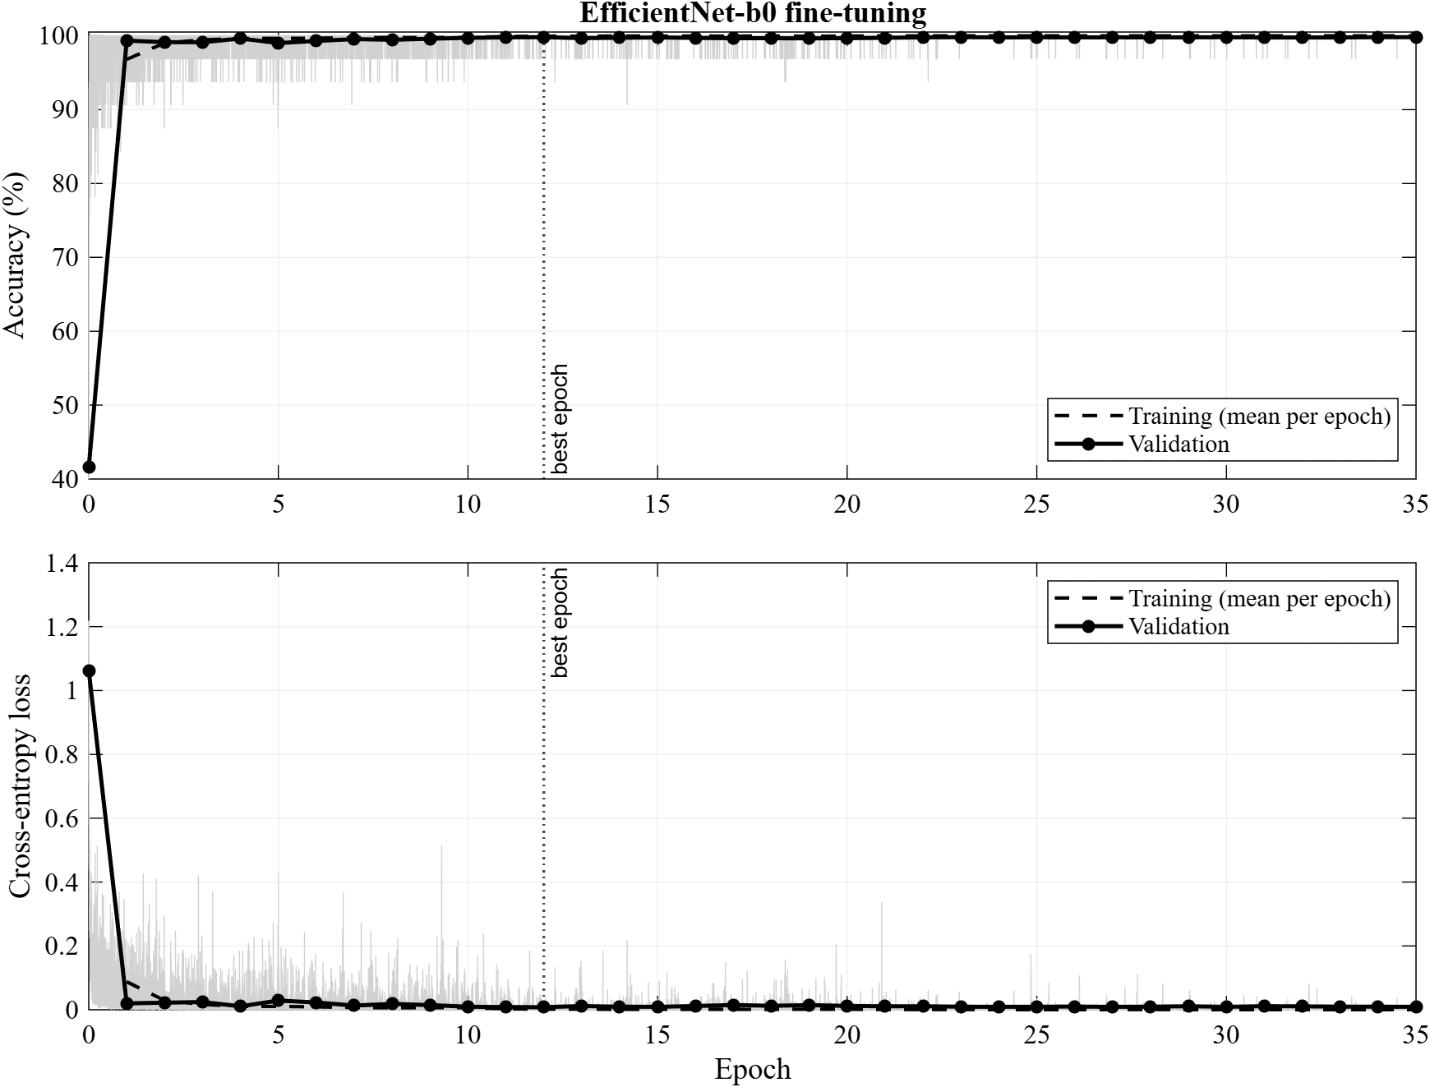
Figure 9. Training and validation accuracy and loss of M3
- Validation accuracy went above 99% after the first epoch, and the validation loss stayed low and flat after that, so there is no overfitting.
- The best network was at epoch 12 (iteration 16,716) with validation loss 0.0081 and validation accuracy 99.81%. This network was saved and used for validation and testing. Later epochs did not improve it.
7. Validation
All three models were evaluated on the validation set: 9,860 patches from 54 patients not used for training. Patient-level accuracy labels each patient with the majority vote of their patches.
Table 8. Validation results
Model | Patch accuracy | Macro F1 | Mean AUC | Patients correct
M1 SVM, handcrafted features | 92.66% | 92.08 | 0.9841 | 53 / 54
M2 SVM, deep features | 93.96% | 93.60 | 0.9902 | 54 / 54
M3 EfficientNet-b0 fine-tuned | 99.81% | 99.79 | 0.9999 | 54 / 54
Table 9. Validation results per class (%)
Model | Class | Precision | Recall | F1
M1 | Falciparum | 89.02 | 88.29 | 88.65
M1 | Uninfected | 97.62 | 99.66 | 98.63
M1 | Vivax | 89.78 | 88.13 | 88.94
M2 | Falciparum | 90.08 | 91.95 | 91.00
M2 | Uninfected | 98.73 | 97.57 | 98.15
M2 | Vivax | 91.92 | 91.36 | 91.64
M3 | Falciparum | 99.57 | 99.80 | 99.69
M3 | Uninfected | 100 | 100 | 100
M3 | Vivax | 99.80 | 99.57 | 99.68

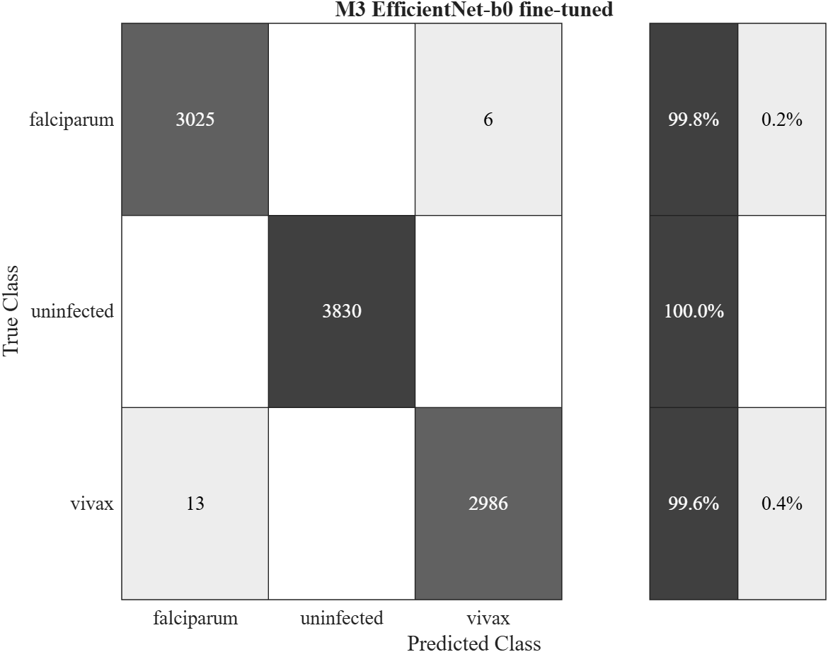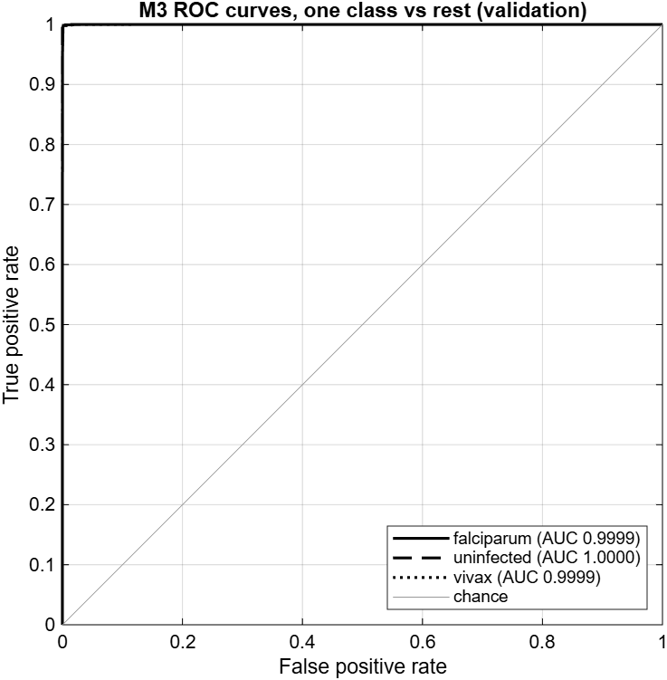
Figure 10. M3 on validation patients: confusion matrix (left) and ROC curves (right)
M3 made 19 errors out of 9,860 patches (6 falciparum predicted as vivax, 13 vivax predicted as falciparum). All uninfected patches were correct. Most errors of the SVMs were also between falciparum and vivax.
8. Testing
The final test used the 51 test patients (9,266 patches). These patients were never used for training, for choosing the model or for choosing the epoch.
Table 10. Test results
Model | Patch accuracy (95% CI) | Macro F1 | Mean AUC | Patients correct | Time per patch
M1 SVM, handcrafted features | 91.46% (90.88 - 92.02) | 91.10 | 0.9806 | 51 / 51 | 0.39 ms
M2 SVM, deep features | 91.72% (91.14 - 92.27) | 91.44 | 0.9834 | 50 / 51 | 0.51 ms
M3 EfficientNet-b0 fine-tuned | 99.44% (99.26 - 99.57) | 99.41 | 0.9998 | 51 / 51 | 2.56 ms
The 95% confidence interval is the Wilson interval. Time per patch for M1 and M2 does not include feature extraction.
Table 11. Test results per class (%)
Model | Class | Precision | Recall | F1 | AUC
M1 | Falciparum | 83.36 | 91.18 | 87.10 | 0.9713
M1 | Uninfected | 99.26 | 99.29 | 99.27 | 0.9996
M1 | Vivax | 90.99 | 83.25 | 86.94 | 0.9708
M2 | Falciparum | 83.19 | 92.93 | 87.80 | 0.9739
M2 | Uninfected | 98.89 | 97.80 | 98.34 | 0.9990
M2 | Vivax | 92.75 | 84.05 | 88.19 | 0.9774
M3 | Falciparum | 98.48 | 99.68 | 99.08 | 0.9998
M3 | Uninfected | 100 | 100 | 100 | 1.0000
M3 | Vivax | 99.71 | 98.61 | 99.16 | 0.9998
Table 12. Validation vs test
Model | Validation accuracy | Test accuracy | Validation macro F1 | Test macro F1
M1 SVM, handcrafted features | 92.66% | 91.46% | 92.08 | 91.10
M2 SVM, deep features | 93.96% | 91.72% | 93.60 | 91.44
M3 EfficientNet-b0 fine-tuned | 99.81% | 99.44% | 99.79 | 99.41

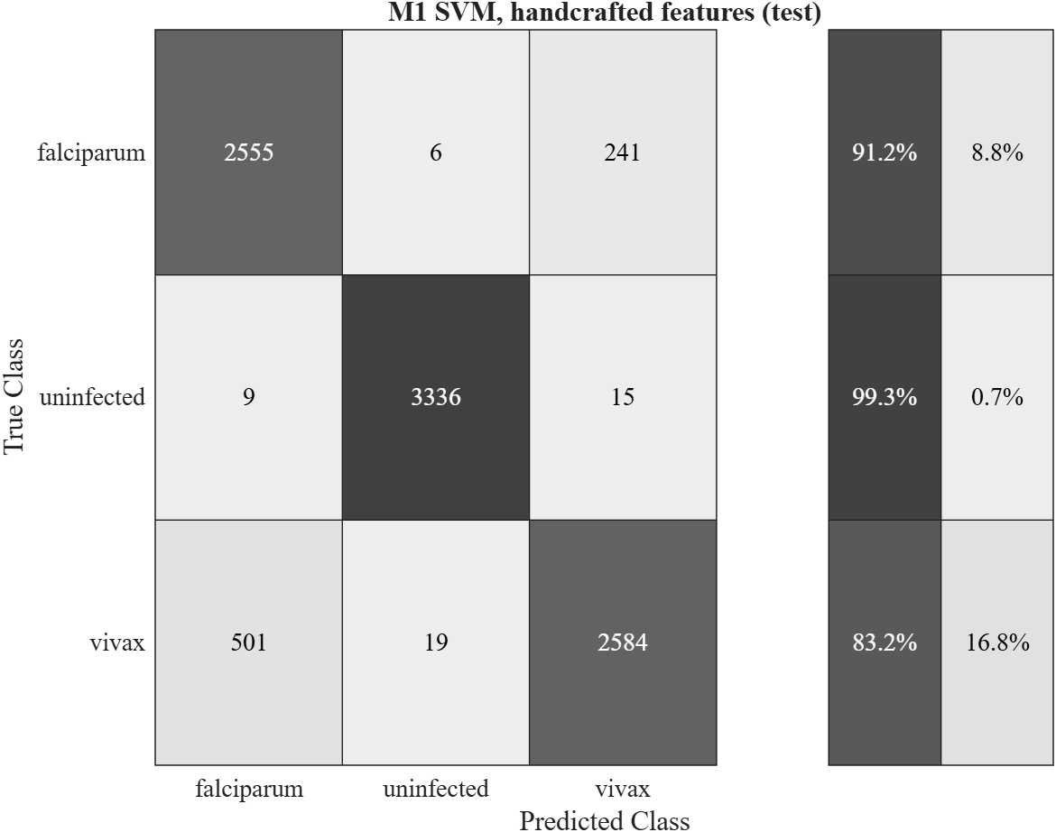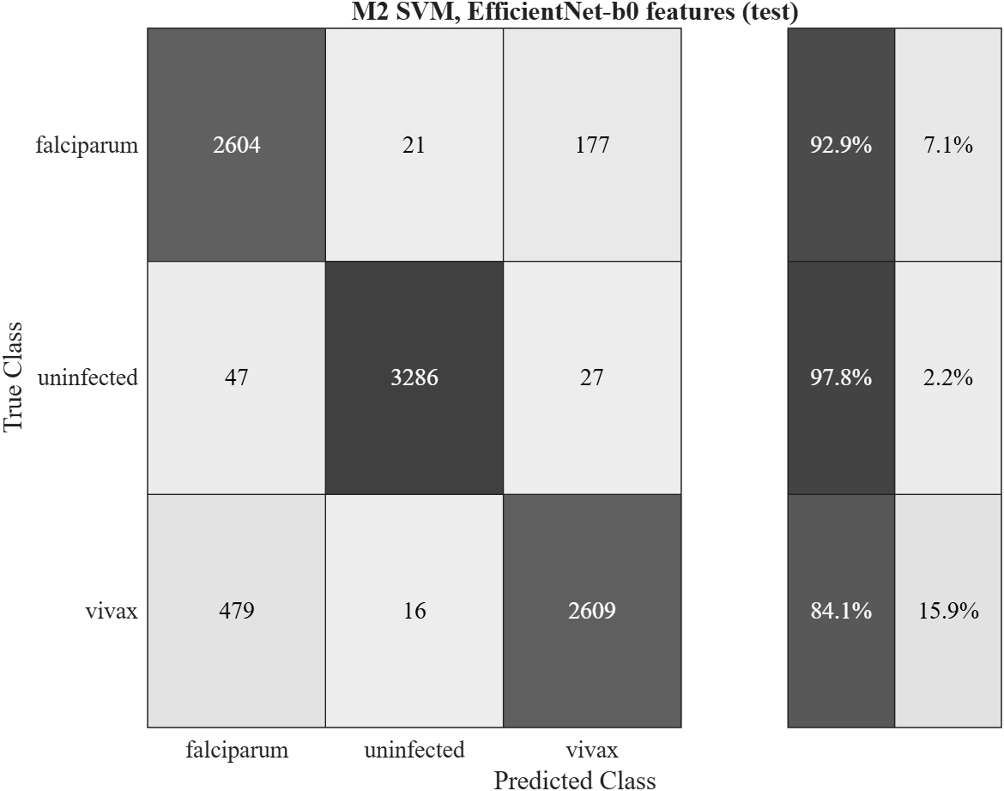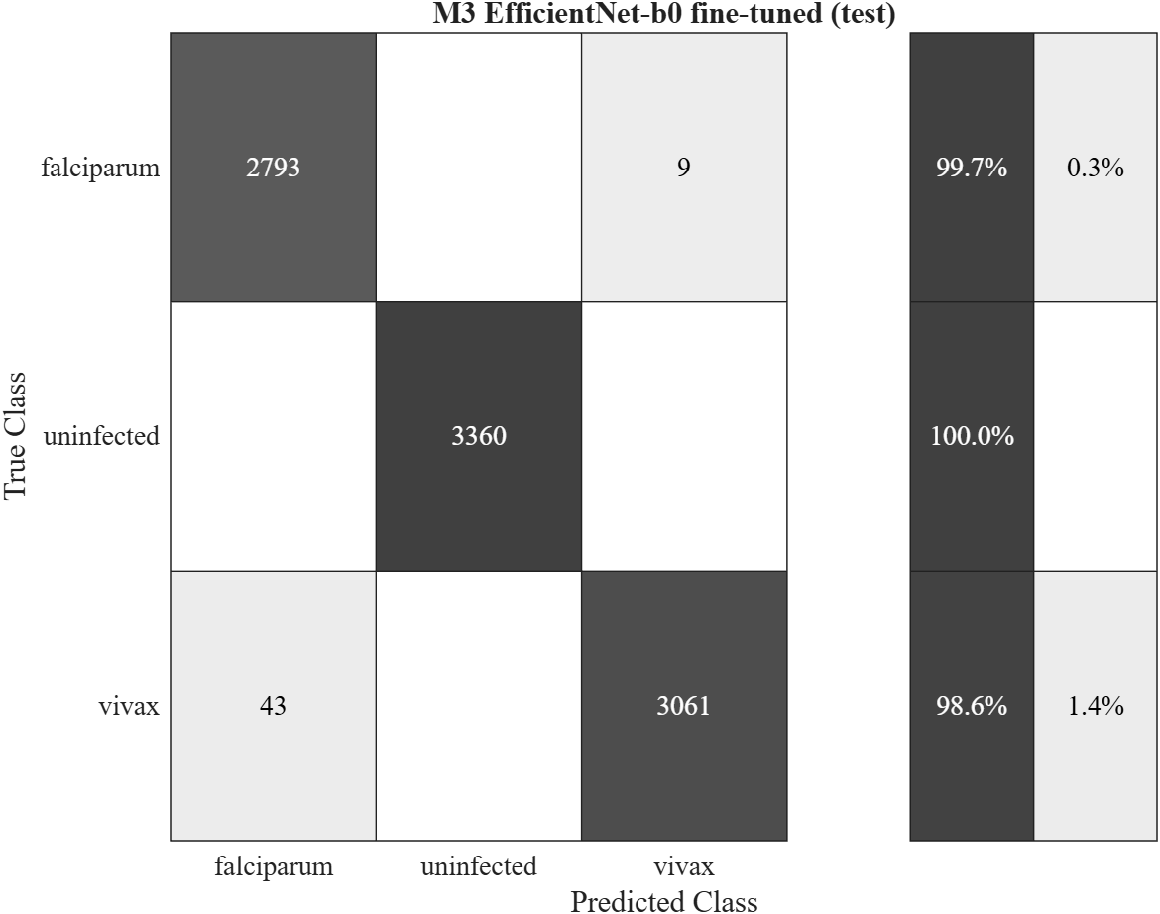
Figure 11. Confusion matrices on test patients: M1, M2, M3
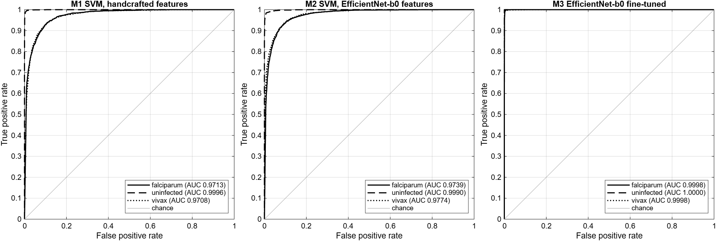
Figure 12. ROC curves on test patients, one class vs rest
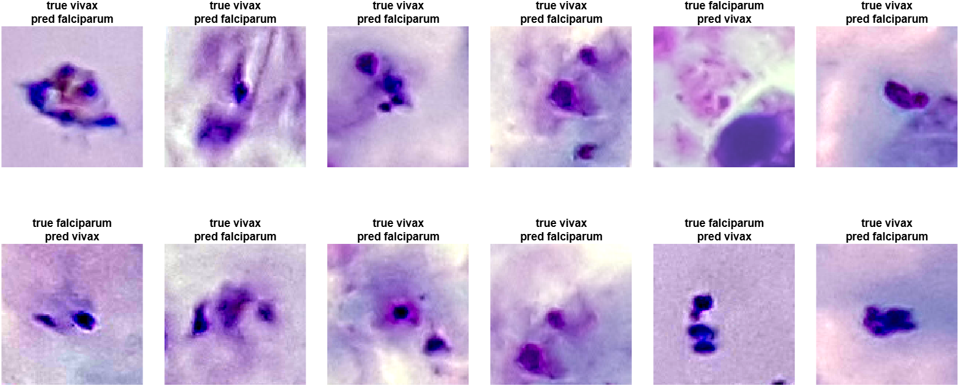
Figure 13. Random examples of test patches wrongly classified by M3
- M3 reached 99.44% accuracy on unseen patients, only 0.37% lower than on validation, so the model was not tuned to the validation set.
- M3 made 52 errors out of 9,266 patches: 43 vivax predicted as falciparum and 9 falciparum predicted as vivax. No infected patch was predicted as uninfected and no uninfected patch as infected.
- Every test patient was classified correctly by majority vote. For 36 of the 51 patients all patches were correct, and the lowest patient (TF90_15_60, falciparum) still had 91.4% of patches correct.
- Many of the wrong patches are blurred, have several overlapping parasites or show unusual shapes, which are hard to tell apart even by eye.
- The fine-tuned CNN was about 8% better than both SVM baselines. The SVMs mainly confuse falciparum and vivax (F1 about 87 to 88%).
9. Whole-Photo Detection and Diagnosis
Stages 3 to 8 used patches cut around expert annotations. To check the model on complete, unmarked photos, the following procedure was run on 3 random photos per patient (54 validation and 51 test patients):
- Candidate detection: dark stained spots were found automatically (pixels at least 20 grey levels darker than the local background, inside the field of view). A photo gave about 270 to 540 candidates.
- Each candidate was cut as a 96 x 96 patch, Reinhard normalised with the training reference and classified by M3. A candidate counted as a parasite only if M3 was at least 90% sure.
- Photo diagnosis: uninfected if fewer than T parasites were found, otherwise the species with the larger total parasite score. T was chosen on the validation photos (T = 1; every value from 1 to 39 gave 100% validation accuracy) and applied unchanged to the test photos.
- Patient diagnosis: majority vote of the patient's photos. Expert annotations were used only to score the detection.
Table 13. Whole-photo results on test patients (153 photos, 51 patients)
Measure | Result
Photo diagnosis accuracy | 98.0% (150 of 153 photos)
Patient diagnosis accuracy | 100% (51 of 51 patients)
Annotated parasites found (recall) | 95.5%
Detected parasites that match an annotation (precision) | 12.4%
False parasites per uninfected photo | 0
Mean parasites detected per falciparum / vivax photo | 440 falciparum / 189 vivax
Mean annotated parasites per falciparum / vivax photo | 45 / 15

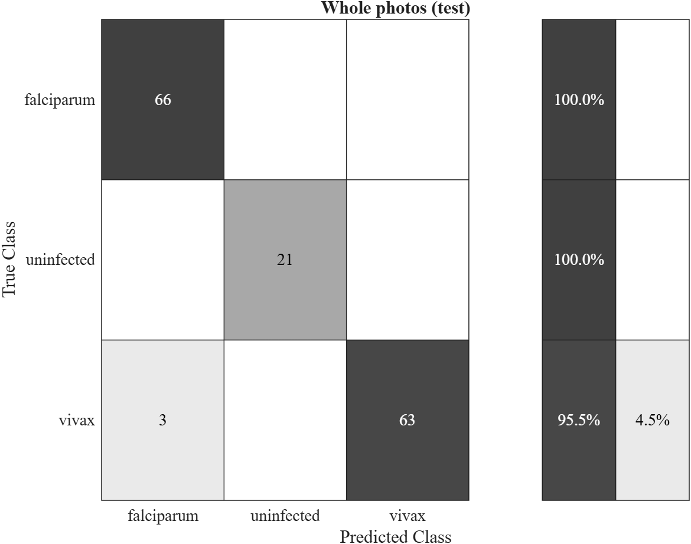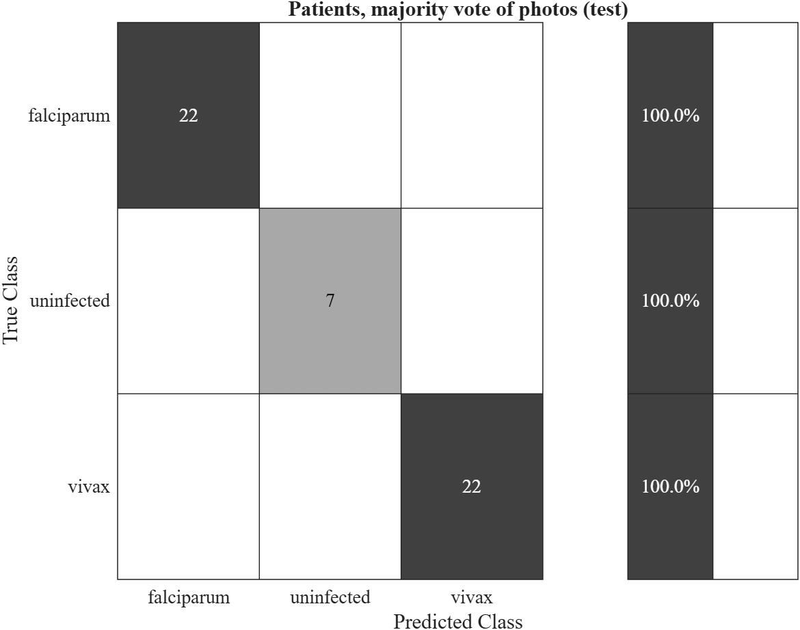
Figure 14. Whole-photo diagnosis on test patients: per photo (left) and per patient (right)
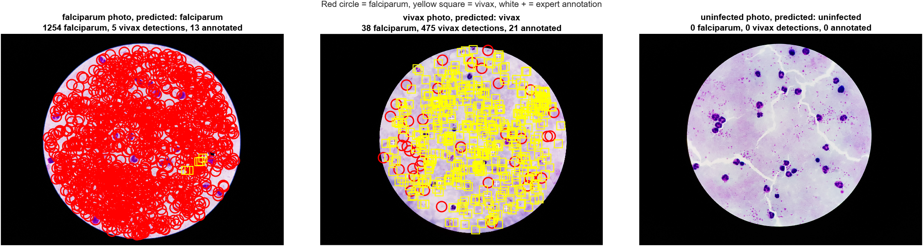
Figure 15. Detections on one test photo per class (red circle = falciparum, yellow square = vivax, white + = expert annotation)
The diagnosis of whole photos and patients was almost perfect, and the model found 95.5% of the annotated parasites. However, only 12.4% of the detections match an annotation. On infected photos the model labels most dark spots as parasites, including white blood cells and debris (Figure 15), while on uninfected photos it labels none of them, even the white blood cells.
The reason is how the classes were built. All uninfected training patches (white blood cells and background) came from uninfected patients, so the model never saw a white blood cell or background patch from an infected photo labelled as not a parasite. It therefore partly learned what kind of photo a patch comes from (stain, camera, background) instead of only whether the object is a parasite. This also explains part of the very high patch accuracy in Sections 7 and 8.
10. Grad-CAM Explanation
Grad-CAM shows which parts of a patch made M3 choose its class (red = most important). It was computed on test patches.
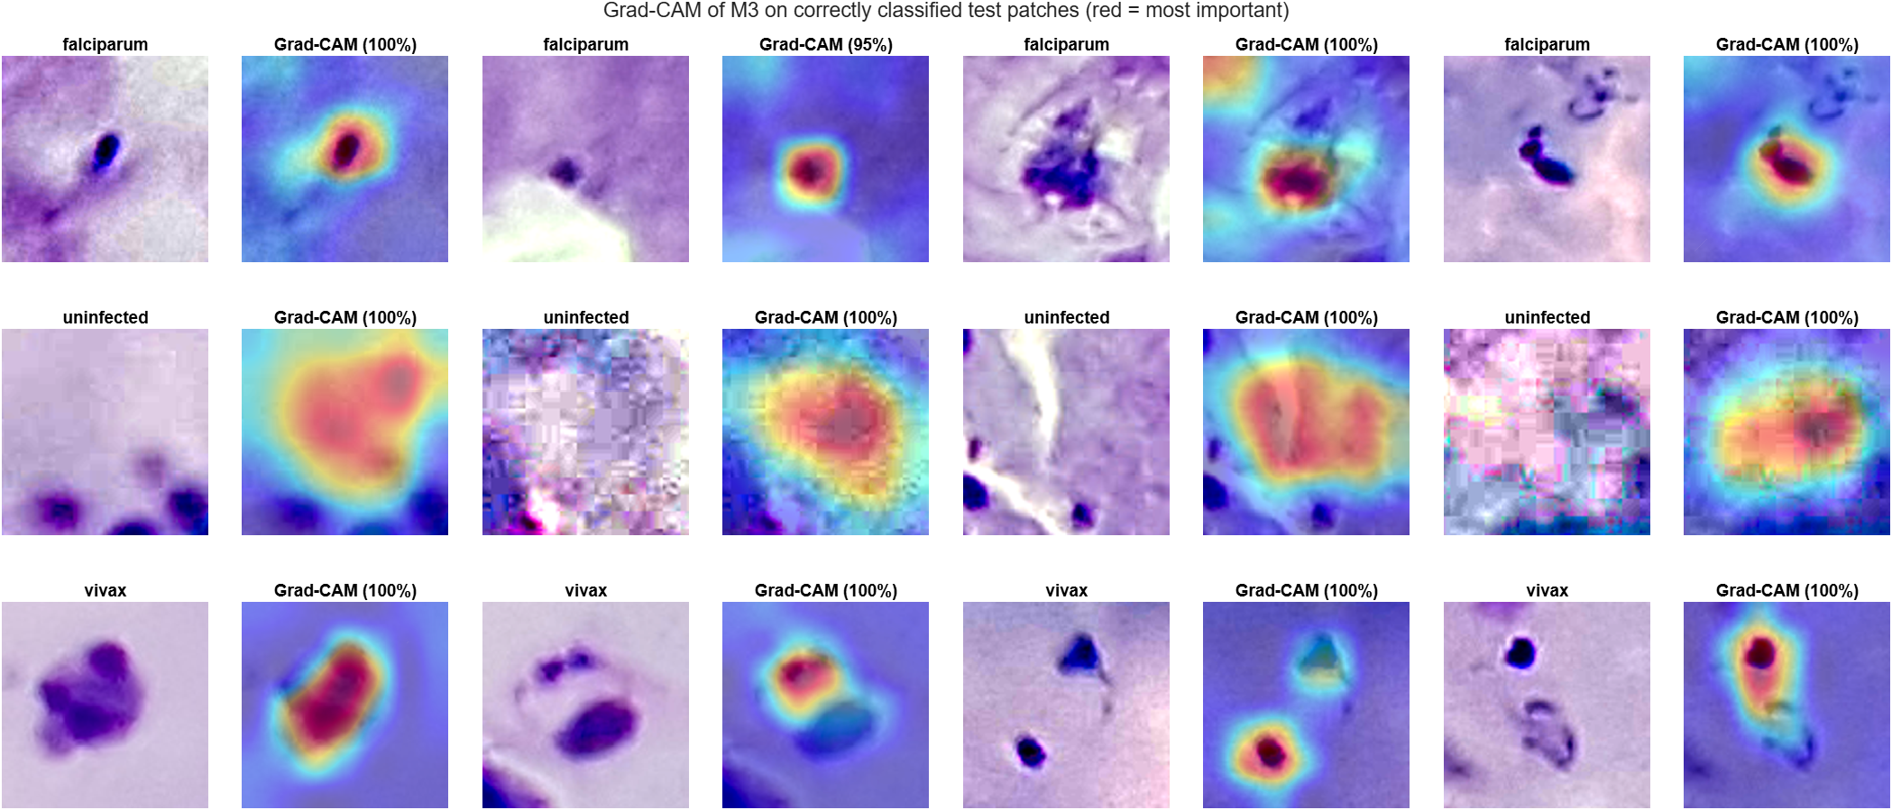
Figure 16. Grad-CAM on correctly classified test patches
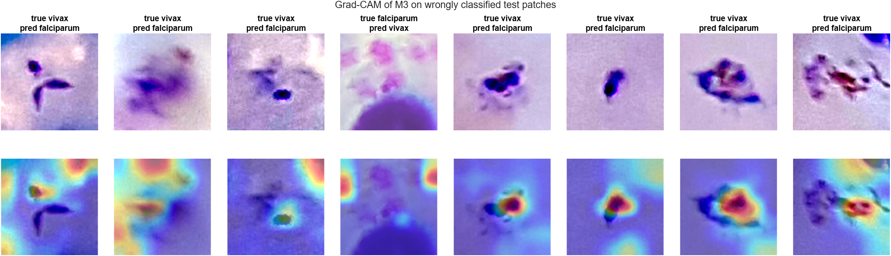
Figure 17. Grad-CAM on wrongly classified test patches
Since every parasite patch is centred on the annotated parasite, the share of Grad-CAM heat in the centre of the patch (circle of radius 24 px out of 96) was measured on 300 random correctly classified parasite test patches.
Table 14. Grad-CAM centre check (300 parasite test patches)
Measure | Result | Chance
Mean share of heat inside the centre circle | 42.5% | 19.6%
Patches whose hottest point is inside the centre circle | 83.0% | 19.6%

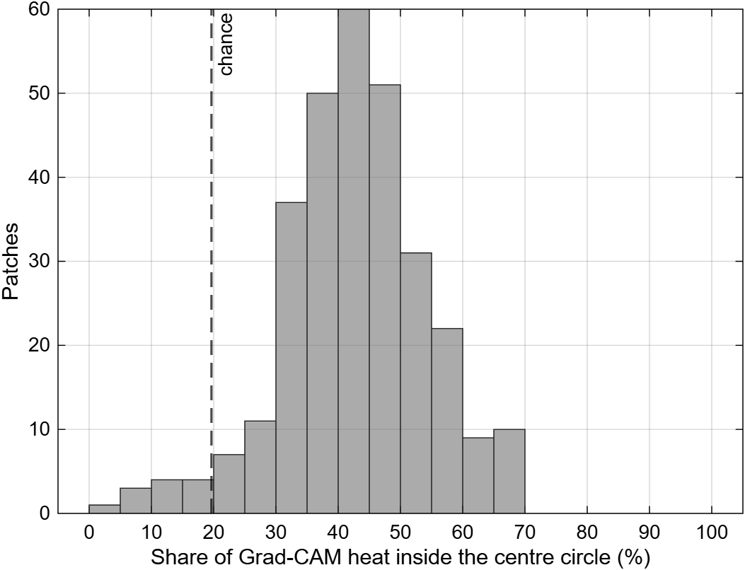
Figure 18. Share of Grad-CAM heat inside the centre circle
- For parasite patches the heat is mostly on the parasite itself (more than twice the chance level, and the hottest point is on the parasite in 83% of patches), so the species decision is mainly based on the parasite.
- For uninfected patches the heat is spread over a large area of the background, which agrees with the finding in Section 9 that the uninfected decision partly depends on the overall look of the photo.
- In the wrong cases the heat is often at the patch border or on another object instead of the centre parasite.
11. Conclusion and Limitations
Reinhard stain normalisation with a fine-tuned EfficientNet-b0 classified thick smear patches into P. falciparum, P. vivax and uninfected with 99.44% accuracy and macro F1 0.994 on 51 unseen patients, and all 51 patients were classified correctly. The base paper (Mujahid et al., 2024) reported 97.57% for a binary infected / uninfected task on thin smear cells. The two results are not directly comparable because the data and the task are different, but this work also separates the two species. On complete unmarked photos the photo and patient diagnosis stayed at 98% and 100%, and Grad-CAM shows that the species decision is based mainly on the parasite.
Limitations:
- The vivax images come from a different dataset collection than the falciparum and uninfected images. Part of the very high accuracy may come from differences between the collections and not only from the species. Reinhard normalisation reduces the colour difference but cannot remove it fully.
- On whole photos the diagnosis was 98% per photo and 100% per patient, but only 12.4% of detected parasites were real annotated parasites (Section 9). The model partly relies on the look of the photo, because uninfected training patches came only from uninfected patients. Retraining with a not-a-parasite class that includes white blood cells and background from infected photos (the falciparum photos have about 35,000 annotated white blood cells) should fix this.
- Only 51 test patients were used. Testing on images from another hospital would give a stronger check.

