**Deployment of PieEyeAssignment Project**

1. Pull the project from git hub repository.

<https://github.com/kishanc16/PieEyeAssignment>

1. Make a build war file using command – “mvn clean install”

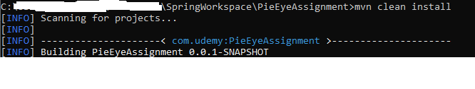

Once build success, refresh the project check target folder and confirm war file.

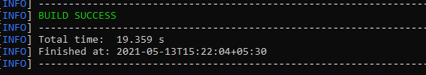

1. Launch an EC2 instance

<https://www.javacodegeeks.com/2019/09/how-to-launch-an-ec2-instance-in-aws.html>

1. Copy our war file from our local machine to EC2 instance

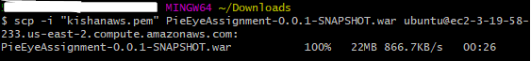

Command - scp -i "kishanaws.pem" PieEyeAssignment-0.0.1-SNAPSHOT.war ubuntu@ec2-3-19-58-233.us-east-2.compute.amazonaws.com:

1. Connect to EC2 instance using SSH

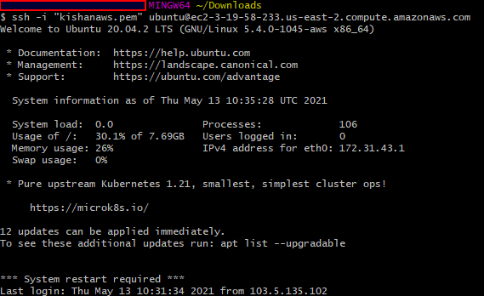

1. Install JDK over EC2 instance
2. Execute the spring boot war on EC2 instance

Command: nohup java -jar PieEyeAssignment-0.0.1-SNAPSHOT.war > ~/server.log &

1. Make sure your Security group allows the inbound traffic from internet over port 8080 and using TCP protocol in AWS console.
2. Test the Application by hitting the endpoint URL from browser

<http://ec2-3-19-58-233.us-east-2.compute.amazonaws.com:8080/login>

END