Bootstrap 4 Exercise
NOTE: full page should be in a container and use maximum class for a design where possible to use.
1. Implement below attached design. four cols on desktop, two cols in tablet view, and for mobile view only one col should be visible in a single row. - (10)
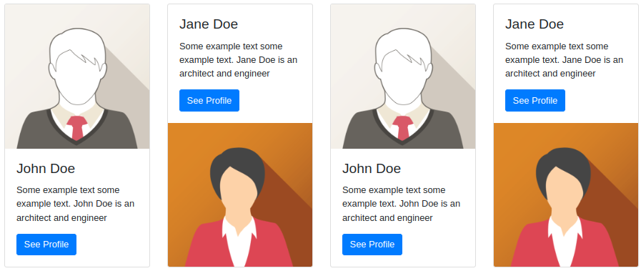

2. Write five lines with the text "Lorem ipsum dolor sit amet" and the background color should be blue, red, yellow, green, and black respectively with the white text color. - (5)
3. implement one table with odd/even row using class only. - (5)
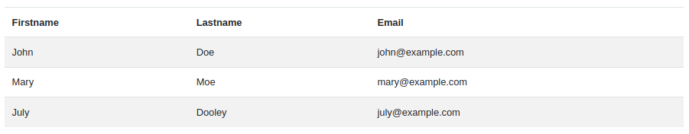
4. implement the below design using class only. - (5)
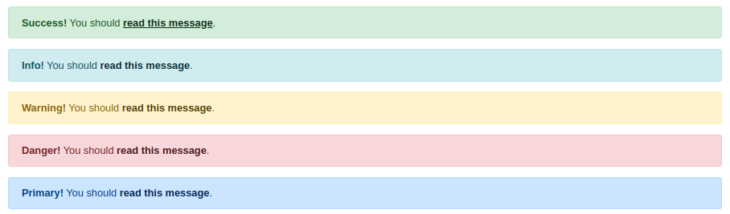
5. implement the below design button group with dropdown using class only. - (5)
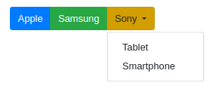
6. implement the below badge design using class only. - (5)

7. implement the below pagination, spinner, nav, progress bar, and tooltip. (5)

8. implement one checkbox, one radio button, and one selection functionality in Form. - (5)
9. implement one modal which should open on click of the open modal button. - (5)

Total Hours: 3 hours
Total Marks: 50 Marks

