---------------------------- Docker Tutorials --------------------------------
04/12/2025
Docker is a tool used to create, run, and manage applications inside lightweight, portable containers.
Docker Architecture –
Docker Engine / Docker Application -> It includes Docker Client; Docker Daemon; Container Runtime (runc); Networking; Storage system
Docker Daemon (dockerd) -> This is the brain of Docker. It runs in the background and is responsible for-Building images; Running containers; Managing containers; Pulling images from registries; Handling networking; Managing volumes. It receives commands from Docker Client using REST API. Docker CLI (Command Line Interface)/ Docker Client -> Eg - docker run; docker pull; docker build; These commands are sent to the Docker Daemon. Client does NOT run containers—it just sends instructions. Docker Registry -> This is where Docker images are stored. Examples: - Docker Hub (public); AWS ECR; Azure ACR; Private Registry; When you run:- docker pull Ubuntu; The image is downloaded from the registry. When you run:- docker push myapp; Your image is uploaded to the registry.
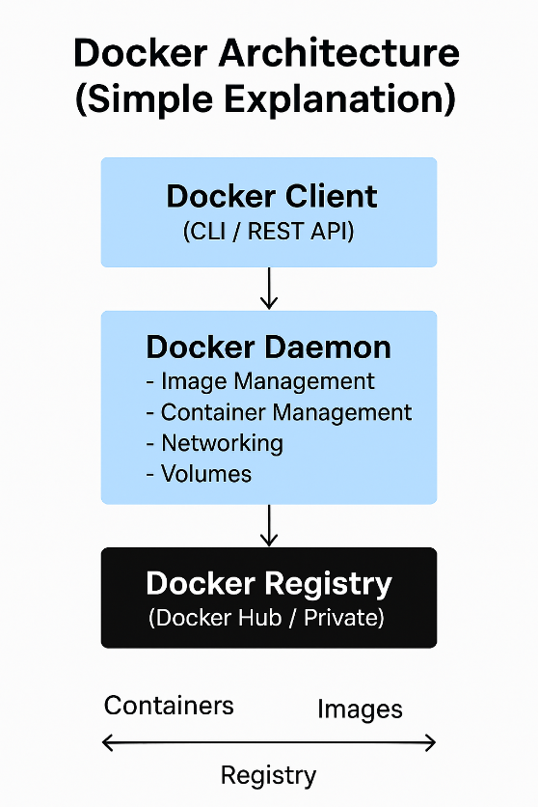

07/12/2025

Question – Difference between Virtualization & Containerization? Answer - Virtualization runs multiple operating systems on the same hardware, while Containerization runs multiple applications on the same OS kernel.
Virtualization | Containerization
Creates Virtual Machines (VMs) | Creates Containers
Heavy size and takes more time for Startup | Light weight and takes less time to startup
VMware, VirtualBox | Hyper-V Docker, Kubernetes
(needs more RAM/CPU) High resource usage | Low resource usage

PS C:\Users\ADMIN> docker ps is used to get the running cntainers
PS C:\Users\ADMIN> docker ps –a is used to get the running cntainers + stopped containers
PS C:\Users\ADMIN> docker images is used to get the images in docker
Dockerfile- It is a text file that contains step-by-step instructions to build a Docker image. It is editable. Dockerfile → docker build → Docker Image → docker run → Container Docker Image is a blueprint/template used to create Docker containers. It is readable/ non-editable.
docker pull ImageName – It is used to pull image from docker hub. C:\Users\ADMIN>docker pull hello-world - used to pull image name hello-world from docker hub C:\Users\ADMIN>docker run f7931603f70e – used to run docker image using its ImageId. We don’t need to run the docker pull image command all time if hma direct run karge docker run image name tho docker internally docker hub me jake docker ki image ko find karega and then us image ko run karega. C:\Users\ADMIN>dokcer stop 0899bf9616a4 – is used to stop the container using it’s containerId.
08-12-2025
Dockerfile name se ek file banao
Step1 – pull a base image which gives all required tools and libraries
FROM openjdk:26-oraclelinux9
Step2 – create a folder where the app code will be stored
WORKDIR /container/app
Step3- copy the source code from your HOST machine to your container
COPY src /container/app/src
Step4- compile the application code
RUN javac src/Test_1.java
Step5- Run the application, [] is used to inject the commands in docker
CMD ["java", "Test_1"]
#CMD ["java", "-cp", "src", "test.HelloWorld"]

Jis path pe hamne Dockerfile rakha hai usi path pe ham yh command fire karege
docker build –t application-name . yh command hamko image bana ke dega with application-name ke naam se and after run docker run imageId is used to run the image and making its container.
docker stop containerId is used to stop a running container.
13-12-2025 -
Test_1.java
package package1;
public class Test_1 {
public static void main(String[] args) { System.out.println("Hello World!! 2222222!!!"); } }
Dockerfile
FROM eclipse-temurin:11
WORKDIR /app
COPY src /app/src
RUN javac -d out src/package1/Test_1.java
CMD ["java", "-cp", "out", "package1.Test_1"]
Docker Networking -
docker network ls is used to see the available networks.
docker network create my-new-network-1 –d bridge is used to create a new network with name create my-new-network-1.
Docker network are of 7 types -
1. HOST – Docker container network and the HOST machine network are same. Host ka port no 80 ya etc port, jesa chal ra hai vaisa hi container ka port chale.
2. Default – Bridge between Host and docker container, this is the default bridge between docker
container and host.
3. User defined Bridge/ Custom Bridge – bridge with custom name.
4. None - no network between docker container, this container does not contain any network.
5. MACVLAN – communicating between two MAC address. (docker swarm),
6. IPVLAN, 7. Overlay [ 5,6,7 are generally used with docker swarm]
---------- start 25/12/2025
We will connect java application container with MySQL database Container.
Step1 – create a custom docker network.
D:\kishan.k\GitProject\MicroserviceProjects\Microservice_Practice\Docker\JavaProject\SimpleJavaProject\SimpleJavaProject>docker network create java-mysql-network-1
Step2- create an mysql container connected to docker network and run it
D:\kishan.k\GitProject\MicroserviceProjects\Microservice_Practice\Docker\JavaProject\SimpleJavaProject\SimpleJavaProject>docker run -d --name mysql-db-container --network java-mysql-network-1 -e MYSQL_ROOT_PASSWORD=root -e MYSQL_DATABASE=docker_java_mysql_1 -p 3307:3306 1f5b0aca09cf
D:\kishan.k\GitProject\MicroserviceProjects\Microservice_Practice\Docker\JavaProject\SimpleJavaProject\SimpleJavaProject>docker run -d --name containerName --network existingNetworkName -e MYSQL_ROOT_PASSWORD=rootPassword -e MYSQL_DATABASE=databaseName -p hostMachinePort:dockerPort imageId
-d likhne se mysql detach mode me on hota hai, that means yh background me chalta rahega.
-e MYSQL_ROOT_PASSWORD yh sab environment variables hai.
Step3- Create Java Application
package com.javaInterview.question;
import java.sql.Connection;
import java.sql.DriverManager;
public class MyApp {
public static void main(String[] args) throws Exception {
String url = "jdbc:mysql://localhost:3306/docker_java_mysql";
String user = "root";
String password = "root";
Connection con = DriverManager.getConnection(url, user, password); System.out.println("Connected to MySQL successfully using docker network!!");
con.close(); } }
Step4- Create Dockerfile for java application.
FROM eclipse-temurin:11
WORKDIR /app
COPY src /app/src
COPY mysql-connector-j-8.0.33.jar /app/lib/
RUN javac -d out src/package1/MyApp.java
CMD ["java", "-cp", "out:/app/lib/mysql-connector-j-8.0.33.jar", "package1.MyApp"]
Run the docker file and create docker image of it.
D:\kishan.k\GitProject\MicroserviceProjects\Microservice_Practice\Docker\JavaProject\SimpleJavaProject\SimpleJavaProject>docker build -t java-mysql-network-app-1 .
D:\kishan.k\GitProject\MicroserviceProjects\Microservice_Practice\Docker\JavaProject\SimpleJavaProject\SimpleJavaProject>docker build -t newImageKaNameLikho .
Step5- Run Java Container on same network. We have created the image of java now we will create its container and run.
D:\kishan.k\GitProject\MicroserviceProjects\Microservice_Practice\Docker\JavaProject\SimpleJavaProject\SimpleJavaProject>docker run --rm --name java-app --network java-mysql-network-1 c159d51211ff
D:\kishan.k\GitProject\MicroserviceProjects\Microservice_Practice\Docker\JavaProject\SimpleJavaProject\SimpleJavaProject>docker run --rm --name java-app --network network_name imageId
Always remember lib folder ke andar jar file hota hai jdbc connection ka.
docker stop containerId is used to stop a running container.
docker container prune –f is used to delete all the container from docker.
Hamara mysql container running hai and hamko uske andar jana hai tho-
Step1
docker exec -it 2e13662182b3 sh
docker exec -it containerId sh( running mysql containerId)
Step2
mysql -u root –p enter karke password likho, then fire query show databases;
----- end
---------- start 28/12/2025
Docker Volume & Storage
Container ke data ko host ke hard-disk me save kardete hai isko ham docker volume bolte hai docker volume.
C:\Users\ADMIN>docker volume ls is used to check the volumes in the system.
C:\Users\ADMIN>docker volume create mysql-data
C:\Users\ADMIN>docker volume create volume_name.
This command is used to create a volume in docker.
C:\Users\ADMIN>docker inspect mysql-data C:\Users\ADMIN>docker inspect volume-name
It is used to inspect/check the volume details.
[ {
"CreatedAt": "2025-12-28T06:16:56Z",
"Driver": "local",
"Labels": null,
"Mountpoint": "/var/lib/docker/volumes/mysql-data/_data",
"Name": "mysql-data",
"Options": null,
"Scope": "local"
} ]
Docker run command ke sath ham –v likhege
D:\kishan.k\GitProject\MicroserviceProjects\Microservice_Practice\Docker\JavaProject\SimpleJavaProject\SimpleJavaProject>docker run -d --name mysql-db-container --network java-mysql-network-1 –v mysql-data:/var/lib/mysql -e MYSQL_ROOT_PASSWORD=root -e MYSQL_DATABASE=docker_java_mysql_1 -p 3307:3306 1f5b0aca09cf
–v mysql-data:/var/lib/mysql - iska matlab mysql-data name ka volume hamare container ke mysql se bind hojaega. /var/lib/mysql hamare container ka mysql ka path hai.
"Mountpoint": "/var/lib/docker/volumes/mysql-data/_data", This is the path where our volume get stored in the hard-disk.

----- end
---------- start 28/12/2025
Docker Compose -
Docker compose is a tool used to run multiple Docker containers together using one YAML file.
docker-compose.yml file
Docker compose kaam ko automate karta hai, manually kaam kam padna pade.
Abhi ham sab work alag alag kar rhe the jese, image bana na, container bana na, container ko run karna etc. Docker compose sab kaam ek hi baar me kar deta hai.
Step1- version metion karo
Step2- services mention karo, eg kitne container hoge, container ka name, image, kounsa volume vo use karege, kounsa network, ports, environment variables, build, context, etc likho.
Step3 – volumes mention karo
Step4 – network mention karo
Step1 Abhi ham two ek java ka new class banae docker_compose_1.java
package one;
public class docker_compose_1 {
public static void main(String[] args) {
System.out.println("Hello World!! docker_compose_1.java from 1111111!!!"); } }
Step2 – Docker File banao
FROM eclipse-temurin:11
WORKDIR /app
COPY src /app/src
RUN javac -d out src/one/docker_compose_1.java
CMD ["java", "-cp", "out", "one.docker_compose_1"]
Step 3 – docker-compose.yaml file banao
version: "3.8"
services:
docker_compose_1:
build: .
container_name: docker_compose_1
dpends_on:
- mysql iska matlab jab tak mysql ka container na bane tab tak is container ko UP mat bano.
healthckeck:
test: interval: timeout: retries: start_period:
yh sab health check karne ke kaam aata hai.
test = isme ham cmd se ping command ke help se test karege connection
interval= 10s = har 10 seconds me retry karo.
timeout= 5s =
retries= 5 = s baar retry karo.
start_period= 60s
restart: always iska matlab healthcheck pass nhi huaa tho container ko vapas restart kardo
services: me 1. Container banao. 2. Container name likho. 3. Image ka name likho, 4. Environment variables pass karo, 6. Ports define karo, 7. Volumes define karo, 8. Networks define karo, 9. Restart: always karo, 10. Healthchecks define karo,
Step 4 - docker-compose up –build yh command fire karo to build the .yaml file
D:\kishan.k\GitProject\MicroserviceProjects\Microservice_Practice\Docker\JavaProject\SimpleJavaProject\SimpleJavaProject>docker-compose up –build
Output show karega hamko.
docker-compose.yaml file se kaam aasan hojaega am sirf ek hi command likhege docker compose up -d pura project run hoga container ban jaega and run hoega container/project.

----- end
------------------------------------------------------------28/12/2025-------------------------------
docker-compose.yaml file
version: "3.8"
services:
mysql:
container_name: mysql
image: mysql
environment:
MYSQL_Database: "devops"
MYSQL_ROOT_PASSWORD: "root"
ports:
- "3306"3306"
volumes:
- mysql-data:/var/lib/mysql
networks:
- two-tier
restart: always
healthcheck:
test: ["CMD", "mysqladmin", "ping", "-h", "localhost", "-uroot", "-proot"]
interval: 10s
timeout: 5s
retries: 5
start_period: 60s
-------------------------------------------------------------------------------------------
----------------------- 28/12/2025-------------------------
docker system prune is used to remove, 1. All stoped containers, 2. all networks not used by at least one container, 3. all dangling images, 4. all build cache
docker system prune -a –volumes 1. Removes All unused images (not just dangling), 2. All unused volumes (DB data lost!)
docker container prune Stop & remove only containers
docker image prune Remove unused images
docker image prune –a Remove all unused images
docker volume prune Remove unused volumes
docker network prune Remove unused networks
docker rmi imageId is used to dete image by its id
docker images –aq is used to get all the id’s of the images
docker rmi –f $(docker images –aq) is used to get all the image id’s and then it will delete all the images.
docker compose down is used to down the container’s and remove the containers.
docker compose up –d –build is used to build the image and make its container and run it.
------------------------------------ DOCKER REGISTRY
D:\kishan.k\GitProject\MicroserviceProjects\Microservice_Practice\Docker\JavaProject\SimpleJavaProject\SimpleJavaProject>docker image tag simplejavaproject-docker_compose_1:latest kushwahakishan99/kishan_java_1:latest
D:\kishan.k\GitProject\MicroserviceProjects\Microservice_Practice\Docker\JavaProject\SimpleJavaProject\SimpleJavaProject>docker image tag oldImageName:latest dockerUserName/newImageName:latest
ab hamri old image as it is rahegi and new ek ar image aaegi jiska name new iamge rahega.
docker push imageName is used to push the image in docker hub.
docker pull imageName is used to pull the image from dockerHub.
Ek baar image docker-hub pepouch jae tho ham hamare docker-compose.yml file me changes karke bolege ki ab image ko build hamare name se leke build kardo.
image: kushwahakishan99/kishan_java_1:latest
Abhi hamne docker public registry kiya hai ham chae tho private registry bhi kar sakte hai ki sirf hamare loog hi is image ko dekh pae.
------------------------------------- end

----------------------- 29/12/2025 START -------------------------
-------------- Multi-Stage Docker Build -------------------------------
If hamara project ka size bada hoga tho hamare project ki jo docker image banegi vo bhi badi hogi, image badi hogi tho container ka size jada hoga.
Multi Stage Docker Build hamare image ko stages me divide kar deta hai,
image is created with help of/ from Dockerfile. Dockerfile me jo code likha hai usko ham stages me divide kardete hai and build karte hai.
FROM eclipse-temurin:11 AS builder_1
WORKDIR /app
COPY src /app/src
RUN javac -d out src/package1/Test_1.java
CMD ["java", "-cp", "out", "package1.Test_1"]
FROM eclipse-temurin:11-slim
WORKDIR /app
COPY –from=builder_1 /usr/local/ /usr/local/
COPY . .
CMD ["java", "-cp", "out", "package1.Test_1"]
Stage1 – base image means from kha se ham image utha rahe hai, yha hamare libraries and packages build hoge
FROM eclipse-temurin:11 AS builder_1
WORKDIR /app
COPY src /app/src
RUN javac -d out src/package1/Test_1.java
--------
Stage2 base image less size use karo, slim image use karo
FROM eclipse-temurin:11-slim
WORKDIR /app
COPY –from=builder /usr/local/ – upar hamne RUN javac karke packages ko install kiya ab ham har samay new new package install nhi karege. Hamne upar RUN use karke jha local me java ka package store kiya hai suppose /usr/local path pe java ke packages store hai, usko hi ham vapas use karlege.
builder ke help se hamne us folder se us package ko le liya vapas.
COPY . . – copy source code from host machine.
CMD ["java", "-cp", "out", "package1.Test_1"]
Ab ham hamara docker run karege tho new image banegi vo thoda less memory consume karegi. This compression of image is known as MultiStageBuild, and Caching.
LOGS check karneke liye –
Step1 – docker ps command se running container ki list nikalo.
Step2 – docker logs container_id is used to check the logs of the running container.
We can rewrite all the logs in a file also -
Step1 – nohup – is used to run a container in background and generates its logs in a file.
nohup docker attach container_id & is used to running container in background. And storing all the logs in nohup.out file.
cat nohup.out is used to see the output/logs.
------------------------------------- end
---------------------- 30/12/2025 ------------ START ------------------
Orchestrating Docker with Kubernetes (Introduction)
Kubernertes- We are not using docker containers in production server. Here Kubernetes is playing a main role of managing this containers. If a Dokcer container get’s down, then another docker’s container gets up. Kubernetes me inside docker container work kar rhe hote hai unke paas auto-scaling and auto-healing capacity hoti hai.
Pods – It is a unit where one or more than one containers are running.
Deployment – collection of Pods( replica)
Service – connect the deployment to users
Ingress – It is used for routing.
---------------------- end ---------------------------------------------------
---------------------------- 15/01/2026 ---------------- START-----------------
Project 1 – 3 Tier Application with Docker Compose
Project 2 – Deploying a web application with Nginx and MYSQL
------------------------------
We will create project where we will use three containers- 1. Nginx server, 2. Java Web Application, 3. MYSQL database.
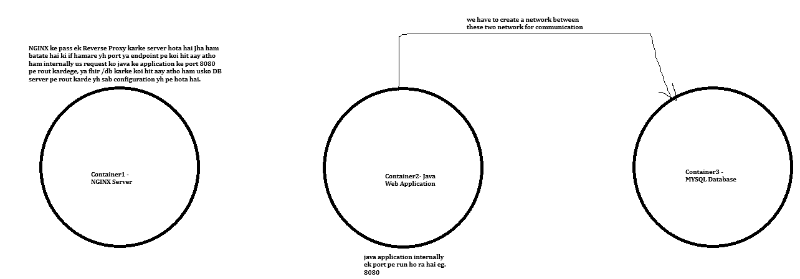
---------------------------- END -------------------------------
--------------------- 19/01/2026 --------------- START --------------------------------------
We have created a three-tier-backend application using spring boot in path -
D:\kishan.k\GitProject\MicroserviceProjects\Microservice_Practice\Docker-three-tier-application
We have three folders inside this folder-
1. Mysql folder inside it, we have written queries to create database and create table in database and insert data in table queries in the file init.sql.
2. Inside nginx folder we have nginx.conf file for configuration and Dockerfile to install the nginx server/container.
3. Inside three-tier-application folder we have Dockerfile to create and run the springBoot application.
URL – ( GET ) localhost:8080/api/app/v1/?name=KK
Response - Name [id=103, name=KK]
we have created a endpoint in spring boot project and we are saving name in database.
--------------------- END ------------------------------
------------------------------------ 20-01-2026 START ------------------------------------------------
We have docker-compose.yml file
It is a configuration file that tells docker, how many containers do I need, 2. Which imahe to use, how they talk with each other, and in which order they should start. Instead of writing multiple docker run commands we will write everything in one file and start all containers using docker-compose up
services: This is the main section in docker-compose.yml file, each entry under services represents a container
mysql:
image: mysql:8
container_name: mysql This pulls mysql from docker hub, container name will be mysql instead of auto-generated.
environment:
MYSQL_ROOT_PASSWORD: root
MYSQL_DATABASE: mydb sets mysql root user password, creates a database named mydb automatically at startup.
volumes:
- ./mysql/init.sql:/docker-entrypoint-initdb.d/init.sql
copies init.sql from your local machine into container. Mysql automatically runs all .sql file inside /docker-entrypoint-initdb.d/
healthcheck:
test: ["CMD", "mysqladmin", "ping", "-h", "localhost"] return success when DB is UP
interval: 10s checks every 10 seconds
timeout: 5s
retries: 5 if it fails 5 times service becomes unhealthy,
Health checks solve the problem of race conditions during container startup.
three-tier-application:
build: ./three-tier-application Docker build image using Dockerfile inside ./three-tier-application ( this is out spring boot/ java application), build means custom image not pulled from dockerHub.
container_name: three-tier-application
depends_on: Application start only if the mysql is healthy, prevent startup failure.
mysql:
condition: service_healthy
ports:
- "8080:8080" ( hostPort/LaptopPort : containerPort )
containerPort only accessible inside docker network, port where application run inside container.
hostPort exposed to outside world, access vioa Internet, Browser.
restart: always If the application crashes docker restart it automatically.
nginx:
build: ./nginx
container_name: nginx It act as a front-end server, It forward request to Java backend
depends_on:
- three-tier-application nginx start after backend application get started.
ports:
- "80:80" (HostPort : ContainerPort) Nginx listen on port 80 and forward to backend port.
Nginx listen on port 80, forward traffic to backend on 8080. Nginx works as a reverse proxy, handling incoming traffic and forwarding it to the backend services.
restart: always restart if the nginx server failed to restart.
----------------END ----------------------------------
------------------------------ START 25/01/2026
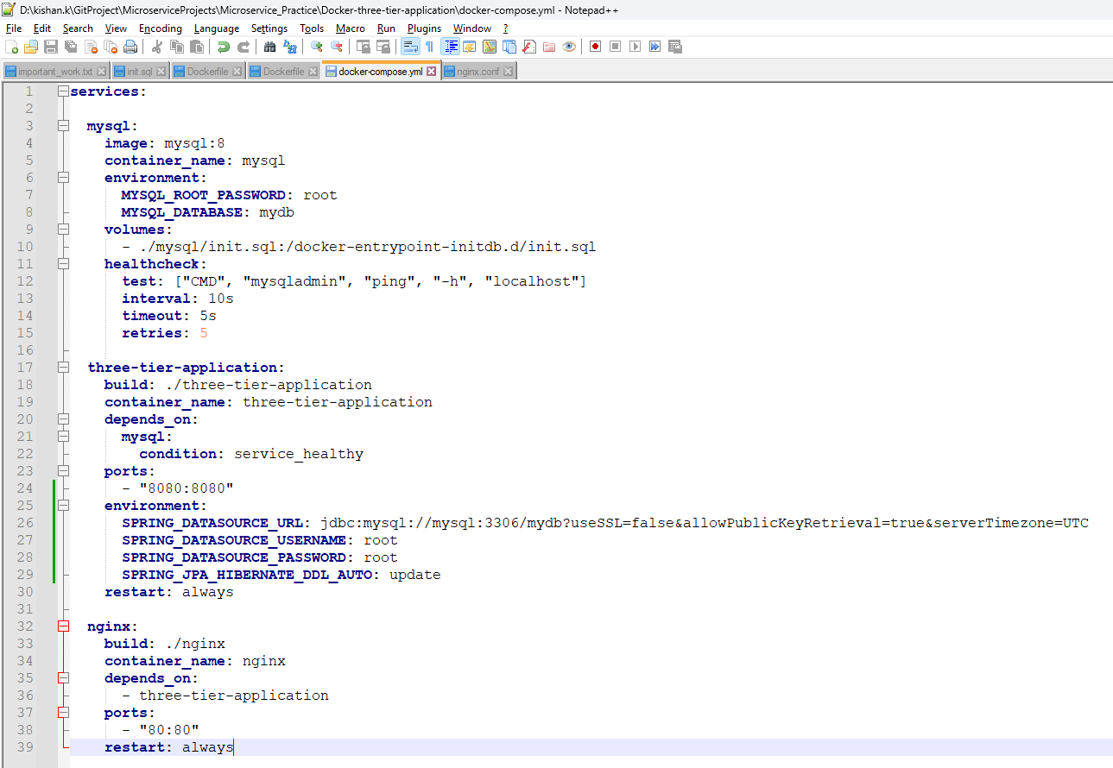
Important Point-
When we run spring boot application it always read env variables, env variables always override the application.properties file configurations.
application is up and access access it using url - http://localhost:8080/api/app/v1/?name=kishan
-------------------------------- END -----------------------------
---------------------------- START 26/01/2026 ---------------------------
docker scout and docker init automatically get installed, when we install docker desktop.
or else we have to manually install this two using plugins.
Docker Scout- It is an image scanning tool, which scans the docker image for security purpose.
Command-
docker scout quickview imageId This command is used to scan the image using the imageId.
docker scout cves imageId This command is used to scan docker image, detect known vulnerabilities, shows cves, severity, fixes and recommendations.
CVES – Common Vulnerabilities and Exposures.
Docker Init-
Jis folder me hamara application hai usi folder me cmd karke ham docker init command fire karke uske andar ke file create karte rahege. Vo bas hamse queston puchta rahega hamko bas yes no karke project create karna hai. Baki andar ke configuration sab automatic create hoga.
compose file, readme file sab automatic docker create kardega.
------------------- END ----------------------------

