--------------------- 27/01/2026 – START ---------------------------
Master Node- This are the node which give instruction to worker nodes for performing the work.
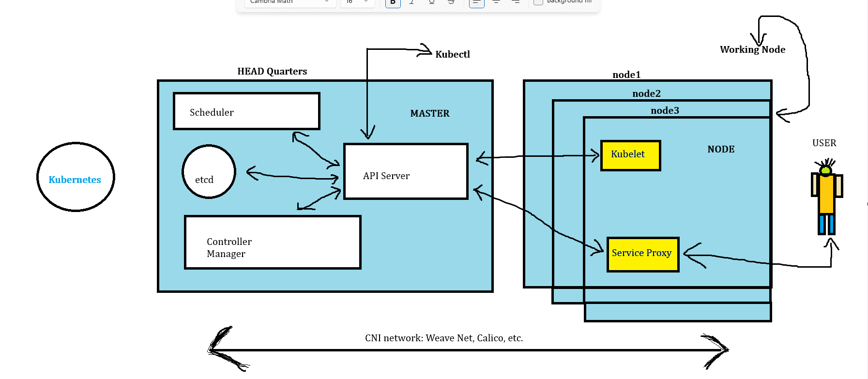
API Server – It is used to communicate between Kubernetes and clusters in the working nodes.
Schedulars – It is used to schedule containers in pods.

----------------------------------- END

