**A MINI PROJECT**

**ON**

**LIBRARY MANAGEMENT DATABASE**

**(USING ORACAL SQL)**

**(25/01/2023 – 05/02/2023)**

**SUBMITTED TO: SUBMITTED BY:**

**SKILL ACADEMY KISHAN KUMAR**

**(BUSSINESS ANALYST TRAINEE)**

**INDEX**

**Title Page no.**

1. Introduction 3

1.1)Problem Statement

1.2)Objective of the study

1. Database Schema 4
2. Database Creation (script) 5
3. Application of Database(cases) 10
4. Representation (Tables) 14
5. Result 26
6. Conclusion 26

1. **Introduction:-**

This presents implementation of cost effective Library Management Database with the use of SQL. This framework is intended to help and give help to satisfy the needs

of Library management.

* 1. **Problem Statement**

In the present day library management is becoming essential for the propose of improving services. There is complexity , not cost effective and easy of configure . Convenience and ease of using library what is offering library management database.

* 1. **Objective of Study**
* To develop a library management database by using oracle SQL
* To design a user friendly and a safe management database

1. **Database Schema:-**

A schema is a collection of database objects. Schema objects are logical structures created by users. Objects such as tables or indexes hold data.

**LMS_MEMBERS**

**LMS_SUPPLIER_DETAILS**

**LMS_BOOK_ DETAILS**

**LMS_FINE_ DETAILS**

**LMS_BOOK_ ISSUE**

1. **Database Creation:-**

**Table LMS MEMBERS**

CREATE TABLE LMS_MEMBERS

(

MEMBER_ID VARCHAR2(10 BYTE), // COLUMNS CREATED

MEMBER_NAME VARCHAR2(30 BYTE) NOT NULL ,

CITY VARCHAR2(20 BYTE),

DATE_REGISTER DATE NOT NULL ,

DATE_EXPIRE DATE,

MEMBERSHIP_STATUS VARCHAR2(15 BYTE) NOT NULL ,

CONSTRAINT PK_MBR_ID PRIMARY KEY (MEMBER_ID)

)

// INSERT VALUE

Insert into LMS_MEMBERS (MEMBER_ID,MEMBER_NAME,CITY,DATE_REGISTER,DATE_EXPIRE,MEMBERSHIP_STATUS) values ('LM001','Akshay','CHENNAI',to_date('12-06-18','DD-MM-RR'),to_date('26-10-20','DD-MM-RR'),'Temporary')

Insert into LMS_MEMBERS (MEMBER_ID,MEMBER_NAME,CITY,DATE_REGISTER,DATE_EXPIRE,MEMBERSHIP_STATUS) values ('LM003','Ashish','CHENNAI',to_date('12-06-18','DD-MM-RR'),to_date('17-08-20','DD-MM-RR'),'Permanent')

Insert into LMS_MEMBERS (MEMBER_ID,MEMBER_NAME,CITY,DATE_REGISTER,DATE_EXPIRE,MEMBERSHIP_STATUS) values ('LM002','Amruta','PUNE',to_date('02-03-20','DD-MM-RR'),to_date('03-06-20','DD-MM-RR'),'Temporary')

Insert into LMS_MEMBERS (MEMBER_ID,MEMBER_NAME,CITY,DATE_REGISTER,DATE_EXPIRE,MEMBERSHIP_STATUS) values ('LM005','Gautam','BANGALORE',to_date('12-06-18','DD-MM-RR'),to_date('06-11-20','DD-MM-RR'),'Temporary')

Insert into LMS_MEMBERS (MEMBER_ID,MEMBER_NAME,CITY,DATE_REGISTER,DATE_EXPIRE,MEMBERSHIP_STATUS) values ('LM004','Bhakti','CHENNAI',to_date('12-06-18','DD-MM-RR'),to_date('12-05-20','DD-MM-RR'),'Temporary')

**Table LMS SUPPLIERS DETAILS**

CREATE TABLE LMS_SUPPLIERS_DETAILS

(

SUPPLIER_ID VARCHAR2(3 BYTE),

SUPPLIER_NAME VARCHAR2(30 BYTE) NOT NULL ,

ADDRESS VARCHAR2(50 BYTE),

CONTACT NUMBER(10,0) NOT NULL ,

EMAIL VARCHAR2(15 BYTE) NOT NULL ,

CONSTRAINT PK_SP_ID PRIMARY KEY (SUPPLIER_ID)

)

Insert into LMS_SUPPLIERS_DETAILS (SUPPLIER_ID,SUPPLIER_NAME,ADDRESS,CONTACT,EMAIL) values ('S01','SINGAPORE SHOPPEE','CHENNAI',9894123555,'sing@gmail.com')

Insert into LMS_SUPPLIERS_DETAILS (SUPPLIER_ID,SUPPLIER_NAME,ADDRESS,CONTACT,EMAIL) values ('S02','JK Stores','MUMBAI',9940123450,'jks@yahoo.com')

Insert into LMS_SUPPLIERS_DETAILS (SUPPLIER_ID,SUPPLIER_NAME,ADDRESS,CONTACT,EMAIL) values ('S03','ROSE BOOK STORE','TRIVANDRUM',9444411222,'rose@gmail.com')

Insert into LMS_SUPPLIERS_DETAILS (SUPPLIER_ID,SUPPLIER_NAME,ADDRESS,CONTACT,EMAIL) values ('S04','KAVARI STORE','DELHI',8630001452,'kavi@redif.com')

**Table LMS BOOK DETAILS**

CREATE TABLE LMS_BOOK_DETAILS

(

BOOK_CODE VARCHAR2(10 BYTE),

BOOK_TITLE VARCHAR2(100 BYTE) NOT NULL ,

CATEGORY VARCHAR2(15 BYTE) NOT NULL ,

AUTHOR VARCHAR2(30 BYTE) NOT NULL ,

PUBLICATION VARCHAR2(30 BYTE),

PUBLISH_DATE DATE,

BOOK_EDITION NUMBER,

PRICE NUMBER(8,2) NOT NULL ,

RACK_NUM VARCHAR2(3 BYTE),

DATE_ARRIVAL DATE,

SUPPLIER_ID VARCHAR2(3 BYTE),

CONSTRAINT PK_BOOK_CODE PRIMARY KEY (BOOK_CODE),

CONSTRAINT FK_SP_ID FOREIGN KEY (SUPPLIER_ID) REFERENCES LMS_SUPPLIERS_DETAILS (SUPPLIER_ID)

)

Insert into LMS_BOOK_DETAILS (BOOK_CODE,BOOK_TITLE,CATEGORY,AUTHOR,PUBLICATION,PUBLISH_DATE,BOOK_EDITION,PRICE,RACK_NUM,DATE_ARRIVAL,SUPPLIER_ID) values ('BL000001','Java How To Do Program','JAVA','Paul J. Deitel','Prentice Hall',to_date('10-12-99','DD-MM-RR'),6,600,'A1',to_date('10-05-11','DD-MM-RR'),'S01')

Insert into LMS_BOOK_DETAILS (BOOK_CODE,BOOK_TITLE,CATEGORY,AUTHOR,PUBLICATION,PUBLISH_DATE,BOOK_EDITION,PRICE,RACK_NUM,DATE_ARRIVAL,SUPPLIER_ID) values ('BL000002','Java: The Complete Reference ','JAVA','Herbert Schildt','Tata Mcgraw Hill ',to_date('10-10-11','DD-MM-RR'),5,750,'A1',to_date('10-05-11','DD-MM-RR'),'S03')

Insert into LMS_BOOK_DETAILS (BOOK_CODE,BOOK_TITLE,CATEGORY,AUTHOR,PUBLICATION,PUBLISH_DATE,BOOK_EDITION,PRICE,RACK_NUM,DATE_ARRIVAL,SUPPLIER_ID) values ('BL000007','Let Us C','C','Yashavant Kanetkar ','BPB Publications',to_date('11-12-10','DD-MM-RR'),9,500,'A3',to_date('03-11-10','DD-MM-RR'),'S03')

Insert into LMS_BOOK_DETAILS (BOOK_CODE,BOOK_TITLE,CATEGORY,AUTHOR,PUBLICATION,PUBLISH_DATE,BOOK_EDITION,PRICE,RACK_NUM,DATE_ARRIVAL,SUPPLIER_ID) values ('BL000008','Python Cookbook: Recipes for Mastering Python 3','Python','Brian K. Jones','O''Reilly Media',to_date('10-05-13','DD-MM-RR'),3,350,null,to_date('10-06-19','DD-MM-RR'),'S02')

Insert into LMS_BOOK_DETAILS (BOOK_CODE,BOOK_TITLE,CATEGORY,AUTHOR,PUBLICATION,PUBLISH_DATE,BOOK_EDITION,PRICE,RACK_NUM,DATE_ARRIVAL,SUPPLIER_ID) values ('BL000012','C# 8.0 Pocket Reference: Instant Help for C# 8.0 Programmers','C#','Joseph Albahari ','O''Reilly Media',to_date('10-12-19','DD-MM-RR'),1,890,null,null,'S03')

Insert into LMS_BOOK_DETAILS (BOOK_CODE,BOOK_TITLE,CATEGORY,AUTHOR,PUBLICATION,PUBLISH_DATE,BOOK_EDITION,PRICE,RACK_NUM,DATE_ARRIVAL,SUPPLIER_ID) values ('BL000011','C# 8.0 and .NET Core 3.0 – Modern Cross-Platform Development','C#','Mark J. Price','Packt Publishing',to_date('31-10-19','DD-MM-RR'),4,410,'A3',to_date('10-06-19','DD-MM-RR'),null)

**Table LMS FINE DETAILS**

CREATE TABLE LMS_FINE_DETAILS

(

FINE_RANGE VARCHAR2(3 BYTE),

FINE_AMOUNT NUMBER(10,2) NOT NULL ,

MAX_DAYS_DELAYED NUMBER,

CONSTRAINT PK_FR PRIMARY KEY (FINE_RANGE)

)

Insert into LMS_FINE_DETAILS (FINE_RANGE,FINE_AMOUNT,MAX_DAYS_DELAYED) values ('R1',20,5)

Insert into LMS_FINE_DETAILS (FINE_RANGE,FINE_AMOUNT,MAX_DAYS_DELAYED) values ('R2',50,10)

Insert into LMS_FINE_DETAILS (FINE_RANGE,FINE_AMOUNT,MAX_DAYS_DELAYED) values ('R3',75,15)

Insert into LMS_FINE_DETAILS (FINE_RANGE,FINE_AMOUNT,MAX_DAYS_DELAYED) values ('R4',100,20)

**Table LMS BOOK ISSUE**

CREATE TABLE LMS_BOOK_ISSUE

(

BOOK_ISSUE_NO NUMBER,

MEMBER_ID VARCHAR2(10 BYTE) NOT NULL ,

BOOK_CODE VARCHAR2(10 BYTE) NOT NULL ,

DATE_ISSUE DATE NOT NULL ,

DATE_RETURN DATE NOT NULL ,

DATE_RETURNED DATE ,

FINE_RANGE VARCHAR2(3 BYTE),

CONSTRAINT PK_BOOK_ISSUE_NO PRIMARY KEY (BOOK_ISSUE_NO),

CONSTRAINT FK_MEM_ID FOREIGN KEY (MEMBER_ID) REFERENCES LMS_MEMBERS (MEMBER_ID) ,

CONSTRAINT FK_BOOKDETAIL FOREIGN KEY (BOOK_CODE) REFERENCES LMS_BOOK_DETAILS (BOOK_CODE) ,

CONSTRAINT FK_FINEDETAIL FOREIGN KEY (FINE_RANGE) REFERENCES LMS_FINE_DETAILS (FINE_RANGE) ,

CONSTRAINT CHK_DATE_ISSUE CHECK ( DATE_ISSUE < DATE_RETURN )

)

Insert into LMS_BOOK_ISSUE (BOOK_ISSUE_NO,MEMBER_ID,BOOK_CODE,DATE_ISSUE,DATE_RETURN,DATE_RETURNED,FINE_RANGE) values (1,'LM001','BL000001',to_date('01-05-12','DD-MM-RR'),to_date('16-05-12','DD-MM-RR'),to_date('16-05-12','DD-MM-RR'),null)

Insert into LMS_BOOK_ISSUE (BOOK_ISSUE_NO,MEMBER_ID,BOOK_CODE,DATE_ISSUE,DATE_RETURN,DATE_RETURNED,FINE_RANGE) values (2,'LM002','BL000002',to_date('01-05-12','DD-MM-RR'),to_date('06-05-12','DD-MM-RR'),to_date('16-05-12','DD-MM-RR'),'R2')

Insert into LMS_BOOK_ISSUE (BOOK_ISSUE_NO,MEMBER_ID,BOOK_CODE,DATE_ISSUE,DATE_RETURN,DATE_RETURNED,FINE_RANGE) values (3,'LM003','BL000007',to_date('01-04-12','DD-MM-RR'),to_date('16-04-12','DD-MM-RR'),to_date('20-04-12','DD-MM-RR'),'R1')

1. **Application of Database:-**

**Some cases**

1. To retrieve column on the basis of category java from table

SELECT * FROM LMS_BOOK_DETAILS

WHERE CATEGORY=’JAVA’;

1. To sort the column values in ascending or descending order

SELECT MEMBER_ID, MEMBER_NAME AS Member_name_in_Ascending_order, DATE_REGISTER, DATE_EXPIRE

FROM LMS_MEMBERS

ORDER BY MEMBER_NAME DESC;

1. To group the data on the basis of membership status column

SELECT MEMBERSHIP_STATUS, COUNT(MEMBER_ID) FROM LMS_MEMBERS

GROUP BY MEMBERSHIP_STATUS;

1. To find out books which price greater than 350 rupees

SELECT CATEGORY, SUM(PRICE) FROM LMS_BOOK_DETAILS

WHERE PRICE>350

GROUP BY CATEGORY;

1. To find ‘JAVA’ category books that are over 500 rupees

SELECT BOOK_TITLE, PRICE, CATEGORY FROM LMS_BOOK_DETAILS

WHERE CATEGORY=’JAVA’ AND PRICE>500;

1. To find out count of book code greater than 350 rupees

SELECT COUNT(BOOOK_CODE), PRICE, CATEGORY FROM LMS_BOOK_DETAILS

WHERE PRICE>350

GROUP BY CATEGORY;

1. Using user defined function to count the total members

CREATE OR REPLACE FUNCTION totalmember

RETURN NUMBER IS

total INT;

BEGIN

SELECT COUNT(*) INTO total

FROM LMS_MEMBERS;

RETURN total;

END;

SELECT totalmember() // call function

1. Making list of book code category basis

SELECT CATEGORY,

LISTAGG(BOOK_CODE) AS BOOK_LIST FROM LMS_BOOK_DETAILS;

1. To find out the count of book code and sum of price category basis

SELECT CATEGORY , COUNT(BOOK_CODE) AS count_book, SUM(PRICE) AS sum_price FROM LMS_BOOK_DETAILS,

GROUP BY CATEGORY;

1. To find out top or first value and price in descending order

SELECT * FROM

(

SELECT CATEGORY, BOOK_TITLE, PRICE, FIRST_VALUE(BOOK_TITLE)OVER(PARTITION BY CATEGORY

ORDER BY PRICE DESC) AS top_price

FROM LMS_BOOK_DETAILS )

WHERE BOOK_TITLE = top_price;

1. Find average price on rows between 2 preceding and current rows

SELECT CATEGORY, BOOK_TITLE, PRICE , AVG(PRICE) OVER(PARTITION BY CATEGORY ORDER BY BOOK_TITLE

ROWS BETWEEEN 2 PRECEDING AND CURRENT ROW)

FROM LMS_BOOK_DETAILS;

1. To find out member id which fine amount lesser than 50

SELECT MEMBER_ID FROM LMS_BOOK_ISSUE A INNER JOIN LMS_FINE_DETAILS B

ON A.FINE_RANGE = B.FINE_RANGE GROUP BY MEMBER_ID

HAVING SUM (FINE_AMOUNT) <50;

1. Create CTE to find average price in descending order book category wise

WITH avg_category_price AS

(

SELECT CATEGORY, AVG(PRICE) AS Avg_price FROM .MS_BOOK_DETAILS

GROUP BY CATEGORY

)

SELECT * FROM avg_category_price ORDER BY avg_price DESC;

1. To check the book in category if present then 1 else 0 in all books

SELECT CATEGORY,

CASE WHEN CATEGORY=’JAVA’ THEN 1 ELSE 0 END AS CATEGORY_JAVA,

CASE WHEN CATEGORY=’ALGORITHMS’ THEN 1 ELSE 0 END AS CATEGORY_ALGORITHMS,

1. To count the total number of a book in category

SELECT

SUM(CASE WHEN CATEGORY=’JAVA’ THEN 1 ELSE 0 END) AS CATEGORY_JAVA,

SUM(CASE WHEN CATEGORY=’C’ THEN 1 ELSE 0 END) AS CATEGORY_C,

SUM(CASE WHEN CATEGORY=’FUNDAMENTAL’ THEN 1 ELSE 0 END) AS CATEGORY_FUNDAMENTAL,

SUM(CASE WHEN CATEGORY=’Python’ THEN 1 ELSE 0 END) AS CATEGORY_Python,

SUM(CASE WHEN CATEGORY=’C#’ THEN 1 ELSE 0 END) AS CATEGORY_C#,

SUM(CASE WHEN CATEGORY=’ALGORITHMS’ THEN 1 ELSE 0 END) AS CATEGORY_ALGORITHMS,

SUM(CASE WHEN CATEGORY=’DATA.STRUCTURES’ THEN 1 ELSE 0 END) AS CATEGORY_DATA.STRUCTURES,

FROM LMS_BOOK_DETAILS;

1. Find running total for fine paid

SELECT MEMBER_ID, RUNNING_TOTAL_FINE FROM

(

SELECT MEMBER_ID, FINE_AMOUNT, SUM(FINE_AMOUNT) OVER (ORDER BY MEMBER_ID ASC )AS RUNNING_TOTAL_FINE FROM LMS_BOOK_ISSUE I INNER JOIN LMS_FINE_DETAILS D

ON I. FINE_RANGE = D. FINE_RANGE )

1. **Representation:-**

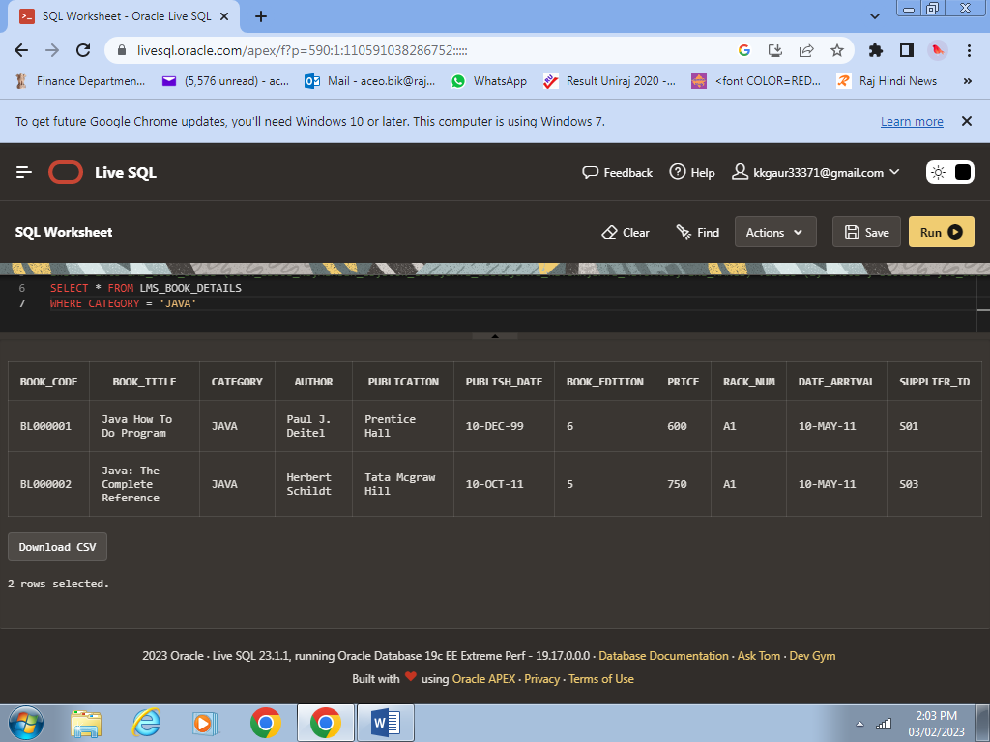

Case 1

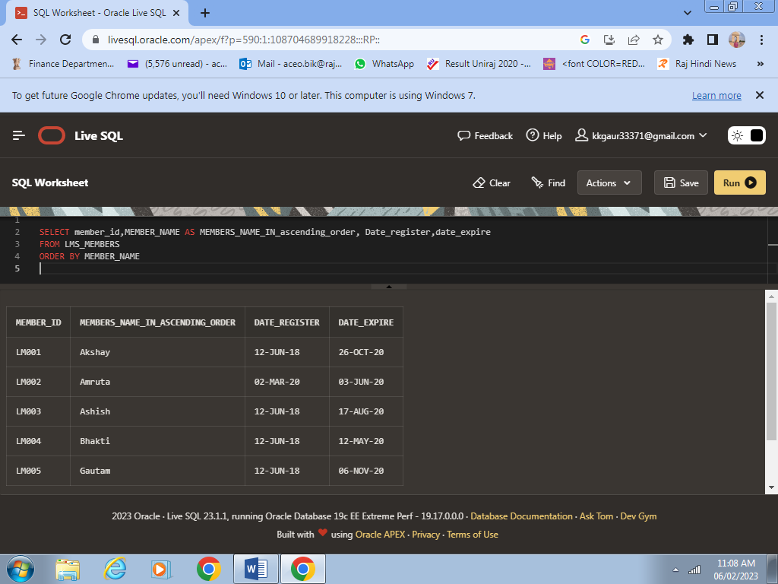

Case 2

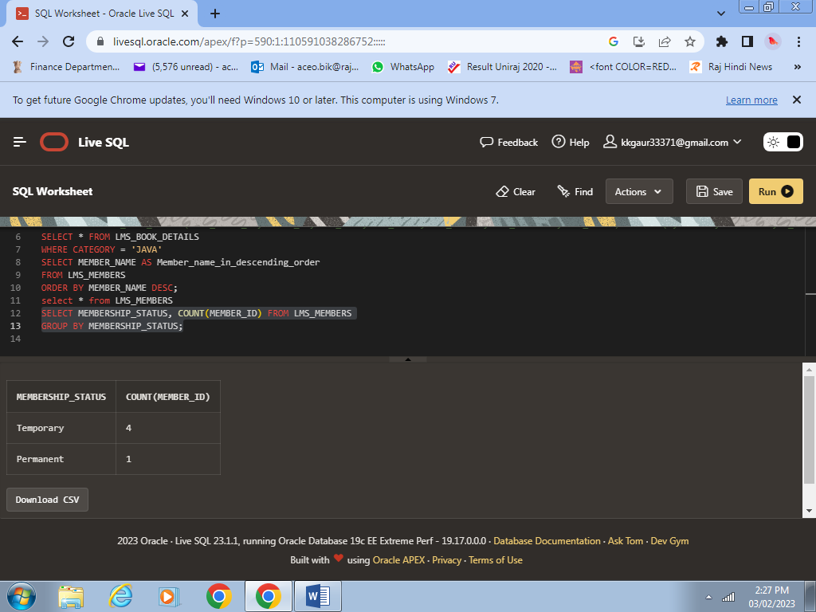

Case 3

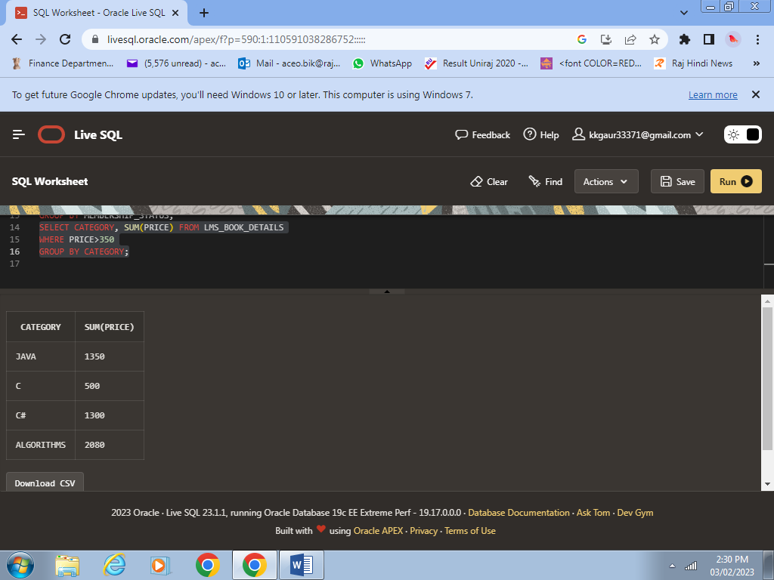

Case 4

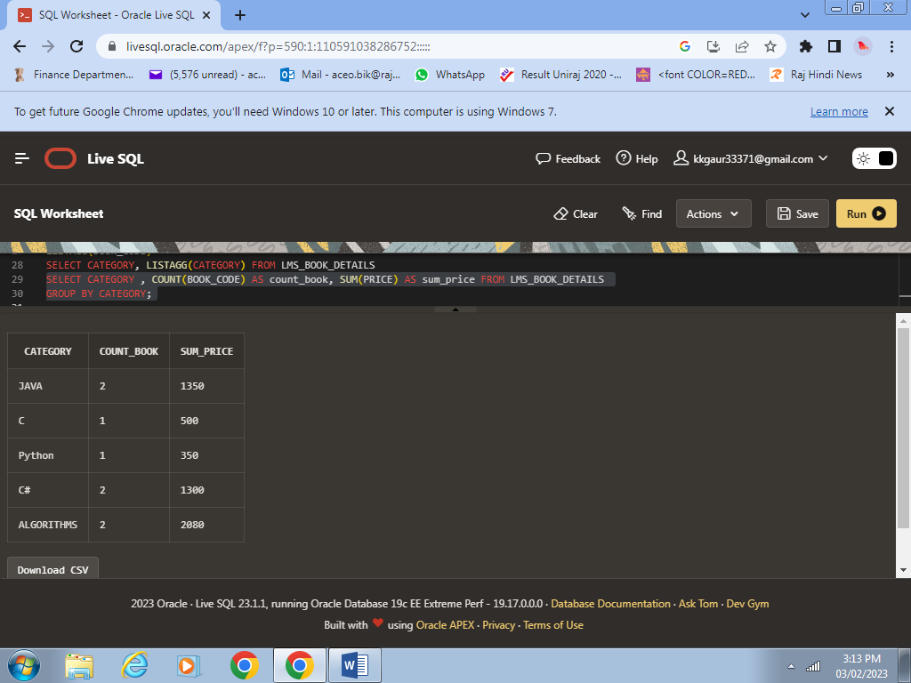

CASE 9

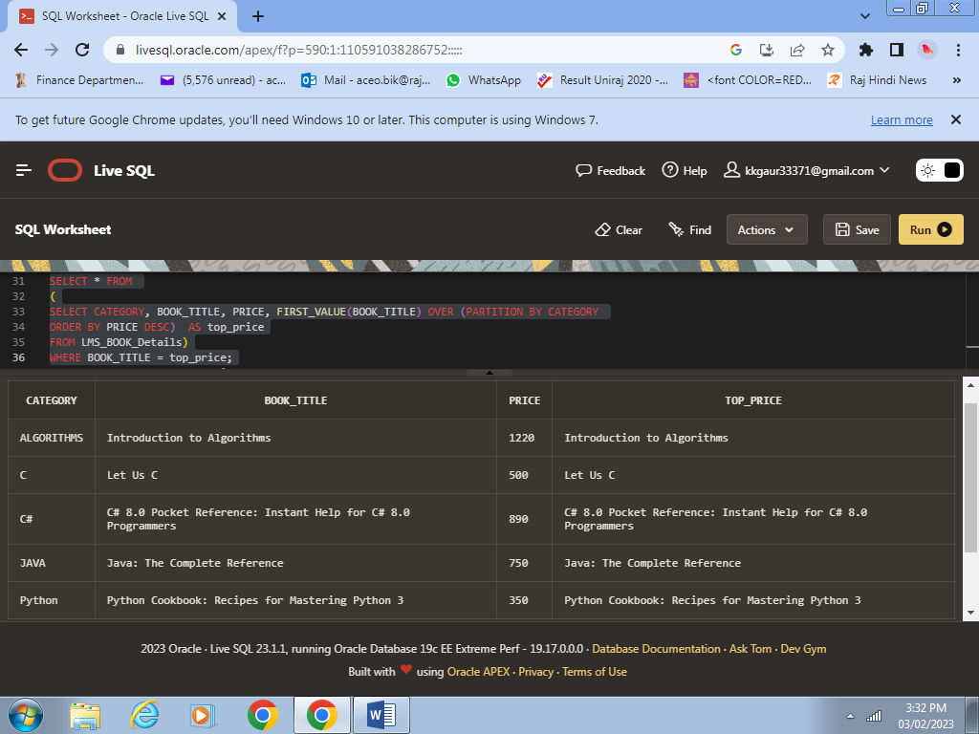

Case 10

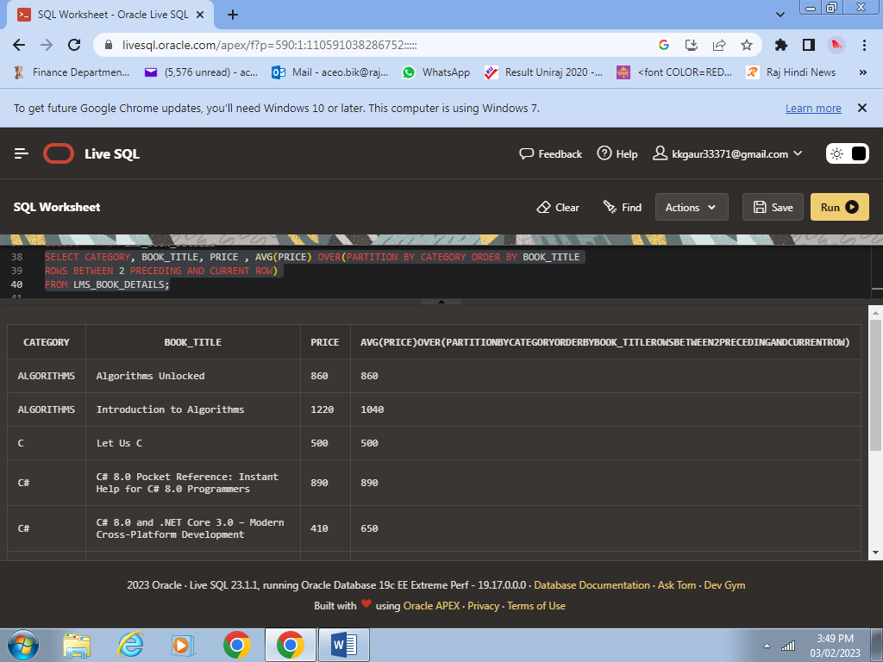

Case 11

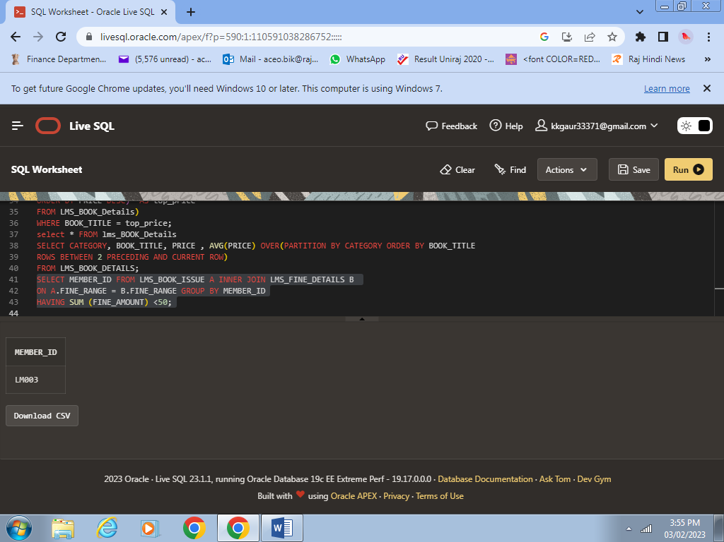

Case 12

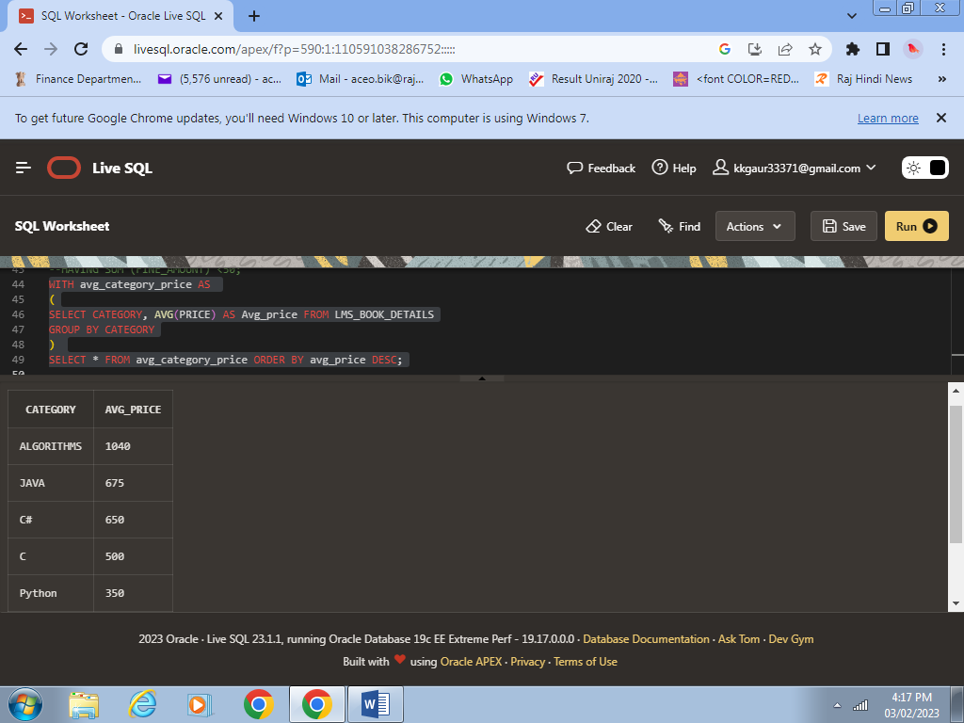

Case 13

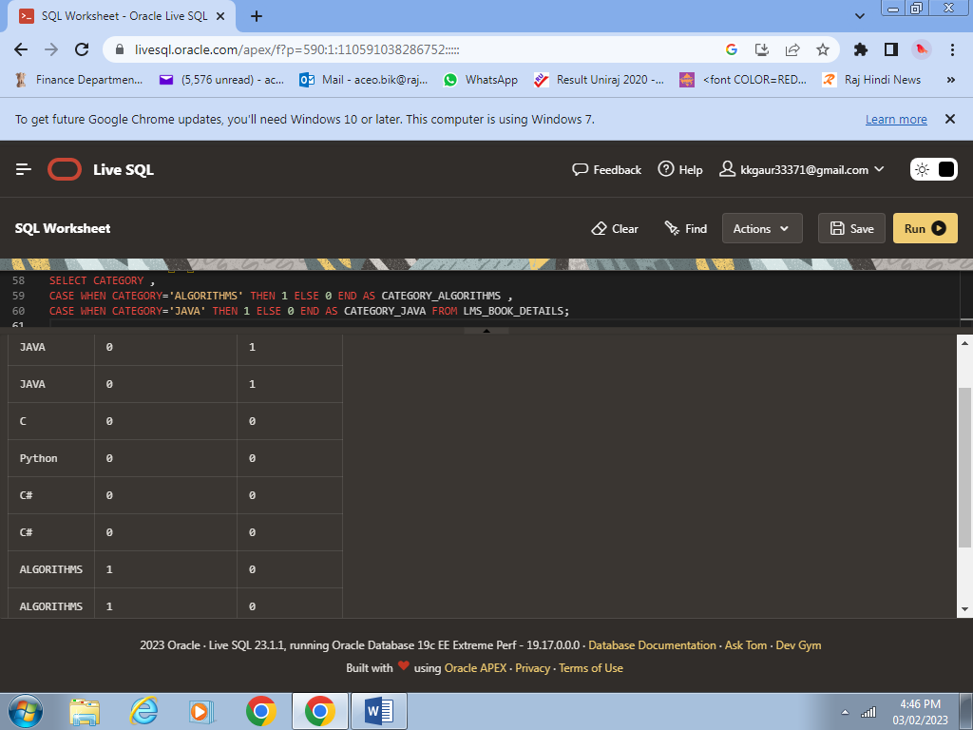

Case 14

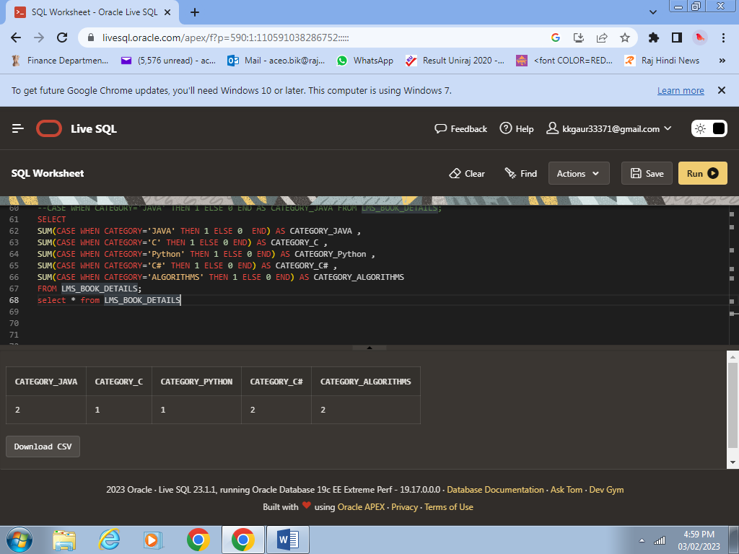

Case 15

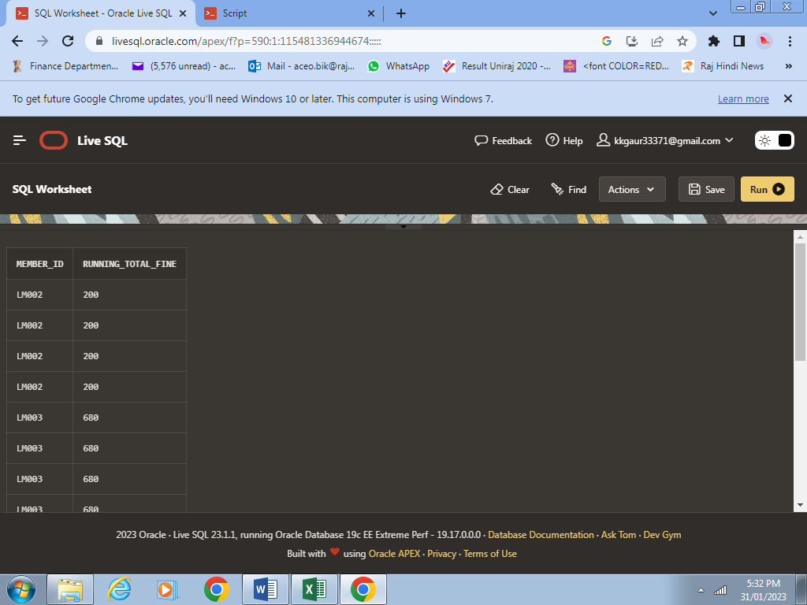

Case 16

1. **Result:-**

Managed to successfully create the LIBRARY MANAGEMENT DATABASE

USING ORACLE SQL and it was user friendly and cost effective.

Helpful in library management.

1. **Conclusion:-**

It can be concluded that LIBRARY MANAGEMENT DATABASE was a success.

This database created using SQL. It is user friendly and cost effective.

Low complexity and provide better services.