**Q.1.Differance between HTML AND HTML5.**

**🡪**

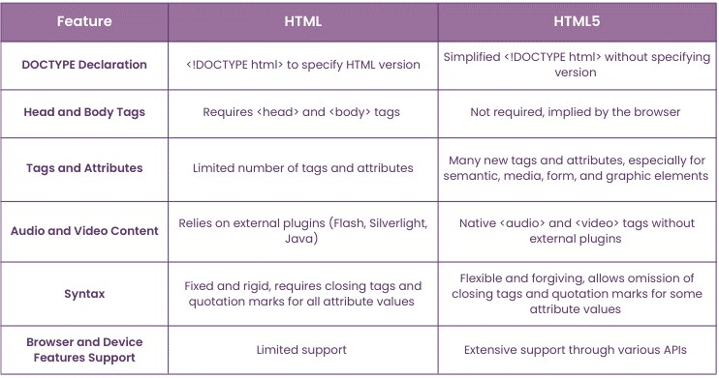

**Question 2: What are the additional tags used in HTML5?**

**🡪**

* <article> – Represents a self-contained piece of content.
* <section> – Defines a section in a document.
* <nav> – Defines navigation links.
* <header> – Represents introductory content, typically a group of navigational links or heading.
* <footer> – Defines a footer for a document or section.
* <aside> – Defines content aside from the main content (e.g. sidebar).
* <main> – Represents the main content of a document.
* <figure> – Wraps media (like images) with an optional caption.
* <audio> – Embeds sound content.
* <video> – Embeds video content.