ASSIGNMENT -1

1. What is software? What is software engineering?

-> Software: intruction of set(input)to be exicuted(procces) by to specifice task (output).

Software engineering : develop any software based in to engineering principal.

2. Explain types of software.

-> software types :

1. system software :

- its is the no need to the downlod by the user and its is already in system its call the inbuilt system.

Ex: -calculater ,calender.

2. application software:

- its is the need to install to use by the user.its is the devlop by the devloper.

Ex: - like play stored app ,whatsapp.

3. driver software :

- its already in the system built its has a audio & video software conect to the system.

Ex: -audio and video software.

4. middlewere software :

- its is the interection between the system software and app. software.

Ex: -

5. programing software :

- software has the interpreter & compiler to exicute the programe.

Ex: - visual studio.

3. What is SDLC? Explain each phase of SDLC.

-> SDLC is a step by step approach to developn any product/software with high quality, in shortest possible time and within the estimated budget.

time bound + budget + quality = successful software/product

Each phase of software develop life cycle :

1. planning / requirement gathering : developer takes a project from company or client and gathers requirement and planning project or product from the company or client.
2. Analysis : developer are analysis requirement company or client, developer create software requirement specification(SRS) does not change requirement company or client.
3. Designing : developer work from designing , different 3d model , ER diagram , usecase diagram , flowchart , data flow diagram etc..
4. Implementation/development/building : developer work from backend side a project implementation or development.
5. Testing : client meets the requirement and work as expected , defect testing.
6. Maintenance : maintain the project according to the developer timeprior.

4. What is DFD? Create a DFD diagram on Flipkart.

->DFD is the abbreviation for Data Flow Diagram. The flow of data of a system or a process is represented by DFD.

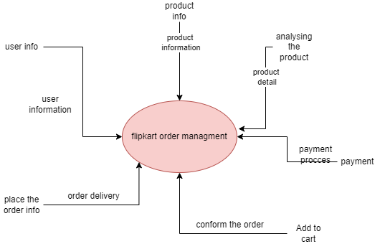Level-0

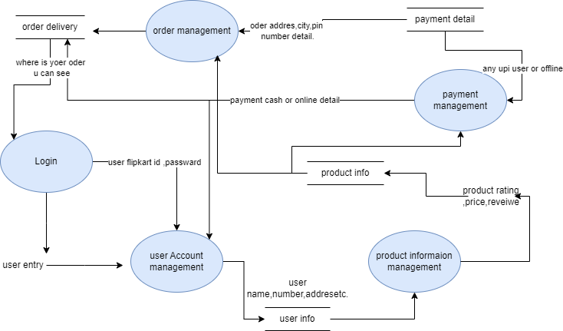

Level-1

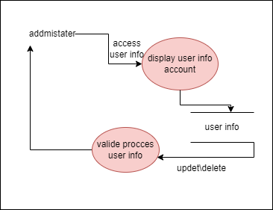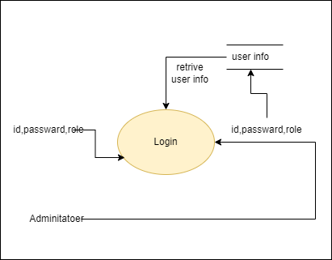

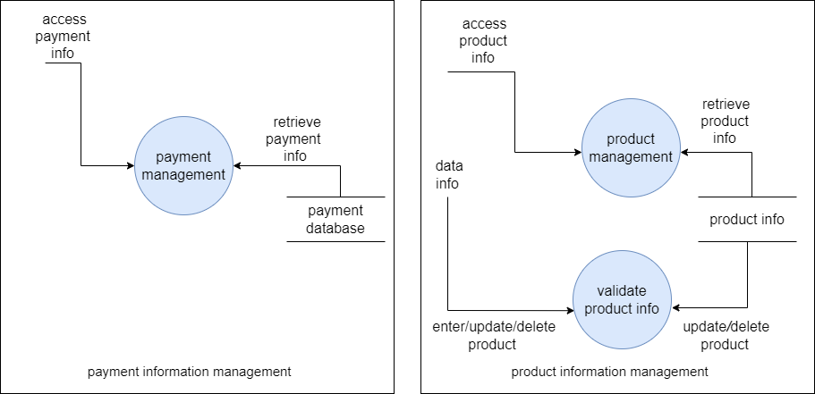

Level-2

5. What is Flow chart? Create a flowchart to make addition of two numbers.

-> Flow chart : Graphical representation about the algorithm.

- Addition of two numbers to make flowchart.

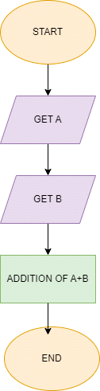

6.What is Use case Diagram? Create a use-case on bill payment on paytm.

-> Use case Diagram : sequence of actions performed by the actors.

- Use-case on bill payment on paytm.



